

Society of man

A Red Rising Saga Tabletop Role Playing Game



August 26, 2025

Initiative order

Herndon VA, 20170

Table of Contents

Setting and Story Hooks 4

Physical/Navigational Landscape by Faction 4

Chapter One: How to Play 5

Basic Needs 5

The Game Master and Players 5

Dice Set 5

D20 Tests 6

Ability Check 6

Saving Throw 7

Attack Roll 7

Doing Things: Explaining “Action Points” 8

Types of Encounters 8

Combat Encounters 8

Social Encounters (Roleplaying) 17

Social Encounter Glossary 18

Ship Encounters 21

Ship Crew Roles 22

Recovering From Encounters 26

Chapter Two: Character Creation 27

The Colors of Society 28

High Colors 29

Mid Colors 40

Low Colors 96

Choosing an Origin 114

Home Planet 114

Background Features 117

Languages 125

Abilities 126

Skills 128

Mastery Bonus, Mastery Points, and Mastery Trees 130

Understanding the Mastery Bonus 130

Mastery Points 131

Mastery Trees 131

Leveling Up 131

Chapter Three: Special Features (SPECS) & Forms 132

What is a Special Feature? 132

SPECS List 132

Rainbow SPECS 132

Gold SPECS 136

Blue SPECS 138

Yellow SPECS 141

Green SPECS 144

Orange SPECS 146

Gray SPECS 149

Obsidian SPECS 151

Red SPECS 154

Chapter Four: Equipment & Ships 156

Pulse Armor 157

Pulse Shields 175

Weapons 177

Heavy Weapons 177

Melee Weapons 179

Pistols 183

Pulse Fists 191

Razors 194

Rifles 201

Stims 209

Utility Items 215

Tools 219

Ships 220

Chapter Five: Enemies 228

Appendix XX: Gold Institute House Selection Table 324

Appendix XX: Titles and Honorifics Glossary **Error! Bookmark not defined.**

# Setting and Story Hooks

This rules book was written to reflect the solar system and its political alliances as it was at the end of the book *Dark Age* *(2019),* which is the 5th book in Pierce Brown’s best selling *Red Rising Saga.* While this was the written intent, GMs and players should feel free to adapt the rules to whatever period they wish to experience and shape. The following information is meant to help inform the story and backstory development processes and should not be considered all inclusive. Many online resources exist that discuss the story of the saga via blog, pod cast, or video. GM’s and players should feel free to utilize any of those resources as well as official resources (**Read the Books**) and interviews they find appropriate to gain additional background on the vast solar system Mr. Brown sculpted in his works.

## Physical/Navigational Landscape by Faction

**Solar Republic**

The Republic, formerly the Rising, controls the Inner Worlds: Mars, Phobos, Deimos, and the Asteroid Belt with Mercury and Luna being actively retaken by the Society Remnants. It maintains naval and ground forces, including roaming Free Legions, focused heavily on Mars and near-core zones.

**Society Remnant**

This faction is tied to breakaway Core Golds, Atalantia Au Grimmus, Atlas Au Raa, Lysander Au Lune, and house Gold alliances, who maintain footholds on Venus and select territories on Mercury and Phobos. They actively retake Mercury and Luna, challenge Republic advances and command elite legions loyal to the restoration of Society Gold as the sole power in the solar system.

**Rim Dominion**

The Rim Dominion, led by Dido au Raa, Diomedes, plus Governors of Io, Ganymede, Europa, Callisto, Titan, Rhea, and beyond, holds Jupiter, Saturn, Neptune, and other gas-giant moons, along with dwarf planets like Pluto. Though formally neutral in the beginning, they join the conflict, declaring an alliance of “equals” with the Society and deploying their fleets against the Republic forces.

# Chapter One: How to Play

## Basic Needs

To play the Society of Man (SoM) Tabletop Role Playing Game (TTRPG) you need a few basic tools, 3-4 players, a table or other gaming surface, and a willingness to use your imagination. There are additional things players may wish to buy, like multiple dice sets, character journals or even a dice tower, but those are optional and do not detract from the game. So, let’s dive into what you need to get started.

### The Game Master and Players

The most critical component of any TTRPG are the Game Master and Players, commonly referred to as “The Table”. The Game Master is the person who builds out the story for the players, the person who keeps track of the rules, and generally the person responsible for solving table disputes and moving the story forward. The Game Master is also responsible for playing all the Non-Player Characters or NPCs. These NPCs could be store owners, leaders, refugees, and anything else needed for the story. While doing voices is encouraged during role play, it is by no means necessary for the Game Master to adopt a voice for each NPC. GMs should thoroughly read and understand this book with specific attention paid to chapters one and two.

The other players at the table are each responsible for creating and roleplaying a Player Character or PC. Each PC is unique and designed by the Player with Game Master input on back story development points critical to the overall story being told at the table. PCs are responsible for making decisions that move the story the Game Master is trying to tell, often in unexpected ways, with the GM navigating those decisions on the fly. This type of play is called cooperative storytelling, and it is pivotal to playing SoM.

### Dice Set

To play SoM you will need a full set of dice consisting of a total of 7 dice. Those dice are used to determine things like hitting your enemies with an attack or using your many skills. In TTRPGs gaming dice are referred to as d20, d100, d12, d10, d8, d6, and d4. In gaming vernacular, the “d” means die and except for most d100s, the number refers to the number of faces on the die. The d100 is the d10 paired with another 10-sided die that has faces that number 00, 10, 20, 30, etc. and when rolled together they can represent numbers ranging from 1 to 100.

Dice decide most things in our game and decide the fate of the action players wish to take. No dice is more important than the d20. The d20 is used for everything from combat, social encounters, skill checks, and much more. It is typically the die you will roll to make attacks, or parry and block the attacks of your enemies. In SoM rolling a 20 or 1 on the die has special consequences. A 20 is considered a Critical Success or “Crit” and a 1 means a Critical Failure. Rolling a Critical Success on a Skill Check means an automatic success at the associated task while a Critical Failure means the Game Master may throw a wrench into the players’ plans, usually in a severe way. In combat rolling a Crit when attempting to hit an enemy means that you double the damage dice total when calculating your damage.

Outside of the d20 most of your dice will be used for damage rolls. While the d20 is used to determine if you hit on an attack your specific equipped weapon will state “2d8 slashing damage” or something similar. In that example, you would roll your d8 twice and total them for your damage output. Different weapon classes use different amounts of damage and associated dice, so be sure to check each time you equip a new weapon.

## D20 Tests

D20 Tests are the core mechanic for determining success or failure during actions that involve uncertainty. There are three primary types of d20 tests: Ability Checks, Saving Throws, and Attack Rolls. D20 tests can be made three ways: Normal, Advantage, and Disadvantage. A normal d20 roll sees the player roll 1d20 then add any modifiers before totaling. For advantage, the player rolls 2d20 and applies all modifiers and then chooses the higher roll. The opposite is true for disadvantage; the player takes the lower of the two totals. The following section provides a breakdown of each type of test and provides examples of each.

### Ability Check

An ability Check determines how well a character uses one of their core attributes, like Strength, to accomplish a task. It often involves adding a relevant skill modifier and may include a proficiency bonus if the character is trained in that skill.

* Example:
  + A Yellow attempting to stabilize a wounded ally under fire would make a Medicine (Wisdom) check.
  + A Red climbing a collapsing shaft might roll an Athletics (Strength) Check.
  + A Green hacking a door lock would use Technology (Intelligence).

### Saving Throw

A Saving Throw represents a character’s instinctive or trained ability to resist harmful effects, such as poisons, explosions, fear, or mind-altering tech. Each saving throw is tied to an ability score and might be affected by proficiencies granted by your chosen Color or Origin. If you roll a natural 20 on a saving throw you take no damage and suffer no effects from the attack or effect. A natural 1 results in you taking double the damage roll. Saving Throw scores are determined by the formula: ST = Ability Score + Mastery Bonus when you have Proficiency, Expertise, or Mastery in the ability.

* Example:
  + A Yellow resisting the effects of an enemy neurotoxin would make a Constitution saving throw.
  + A Gold trying to keep their footing in a sudden tremor might make a Dexterity saving throw.
  + A Green resisting an EMP might need to pass an Intelligence saving throw.

### Attack Roll

To hurt an enemy with a weapon or projectile you must first make a successful attack roll that is equal to or higher than your targets Armor Class (AC). All creatures and player characters in SoM have an Armor Class as well as most automated defenses. An Attack Roll determines whether an action taken in combat, usually one that uses a weapon, ability, or feature, hits a target. The roll includes the attacker’s proficiency bonus and a relevant ability modifier, usually Dexterity or Strength. More information is provided on combat rules and actions later in this chapter. In combat, rolling a Crit when attempting to hit an enemy means that you double the damage dice total when calculating your damage.

* Example:
  + A Yellow fires a Needle Gun effect at their chosen enemy, they would roll a Dexterity based attack roll to hit. (1d20 + Dex modifier + weapon “hit” modifier + any other bonuses = Total to Hit)
  + An Obsidian swinging a two-handed plasma axe would make a Strength based attack roll to hit. (1d20 + Str modifier + applicable weapon modifier + any other bonuses = Total to Hit)

## Doing Things: Explaining “Action Points”

In SoM, your ability to attack enemies or use your abilities relies on a core game mechanic known as Action Points. You have a total number of Action Points available to you per round of combat equal to your Mastery Bonus. These reset at the start of each of your turns during a round of combat. Your Action Point total is on page 2 of the character sheet. Most of the skills, abilities, and features you will use to defeat your enemies will require you to spend one or more of your Action Points to use.

To use an ability, you announce to the table what ability or weapon you are using, which enemy you are attacking, spend the appropriate Action Points, and then roll the appropriate dice associated with your chosen attack or effect. Action Points are used in all types of encounters, with a full list of standard actions provided for each of the 3 main encounter types provided later in this chapter.

## Types of Encounters

### Combat Encounters

Combat in SoM is designed to feel fast and fluid to capture the energy of the source material provided in the *Red Rising Saga*. Combat in SoM consists of rolling Initiative, using offensive actions and movement on your turn, defensive actions on other player or enemy turns, and using rolls of dice to determine the outcomes of those actions. Every character has a movement speed (number of feet that they can move) and can only move on their turn in Initiative Order unless a feature or ability otherwise specifies.

Combat encounters are broken into rounds of 6-second increments. A round of combat consists of each player and enemy conducting their turns until the character with the lowest initiative finishes their turn and a new round of combat begins with the character whose initiative roll was the highest.

The things you do during a combat encounter can be broken into three groups: Offensive Actions (Generally taken on your turn), Defensive Actions (Taken on your allies or enemies turns), and Attacks of Opportunity. These actions are fueled and limited by the number of Action Points a character has available to them each round of combat. A PC can choose to use all their Action Points on their turn for Offensive Actions or save some or all for Defensive Actions and Opportunity Attacks on other Player or enemy turns.

The below sections provide more detail for each of the elements that contribute to combat encounters including which actions you can take on your or other player turns.

#### Initiative

Every combat begins by players and the GM rolling a d20 to determine their place in the “Initiative Order”, the order in which player and enemy turns are executed. Initiative Order is decided by each player and enemies Initiative roll. To “Roll Initiative” a player rolls 1d20 die and adds their initiative bonus found on page 2 of the SoM Character Sheet. To calculate your initiative bonus, we use the formula: Initiative = 1d20 + Dexterity Modifier + Any other owned bonuses. When ties in the Initiative Order occur the player with the higher Dexterity score goes first, if that results in a tie, both characters roll 1d6 to determine who is higher in Initiative Order. Once each player has concluded calculating their role the GM will collect those numbers and alert the players to the Initiative Order. It is the GM’s responsibility to roll Initiative for each enemy in combat with each GM deciding whether to divulge the enemy Initiative order to the players or keep it secret until the enemies turn.

***Sample Initiative Order:***

1. Player 1 (Initiative 21)
2. Player 2 (Initiative 18, Higher Dex Score than Enemy 1)
3. Enemy 1 (Initiative 18)
4. Enemy 2 (Initiative 13)
5. Player 3 (Initiative 10)

#### Offensive Actions in Combat

During your turn in combat, you can move your character up to your movement speed, spend Action Points to attack, use features, or abilities, and use items or equipment. The actions you take on your turn are generally offensive in nature and deal damage or apply effects against your enemies. The following list provides the standard set of offensive actions a character may make in combat.

* **Attack:** Make a melee or ranged attack using a weapon or character feature.
  + Cost: 1 Action Point unless otherwise specified. Two handed weapons such as heavy axes or two-handed razors cost 2 Action Points.
  + Use: Your turn or as part of a counterattack.
* **Aim:** Focus on your next shot. You gain advantage on your next ranged attack.
  + Cost: 1 Action Point.
  + Use: Your turn.
* **Use Item:** Interact with a pierce of gear, such as using a healing stim or activating a shield generator.
  + Cost: Varies by item
  + Use: Your turn unless specified by the item.
* **Dash:** Double your movement speed for this turn.
  + Cost: 1 Action Point
  + Use: Your turn.
* **Disengage:** Move without provoking opportunity attacks.
  + Cost: 2 Action Points
  + Use: Your turn.
* **Change Weapon:** You quickly swap one of the weapons in your hand with one in your inventory.
  + Cost: 1 Action Point
  + Use: Your turn.
* **Use a Feature or Ability:** You may use any number of Offensive features or abilities available to you via your Color Mastery Tree, features, or other source that you possess the Action Points to use.
  + Cost: Varies by Feature
  + Use: Any turn, dependent on the ability or feature.
* **Make a Skill Check:** You may use any skill you wish during combat as needed. These are commonly Perception checks to survey the battlefield, Medicine checks to stabilize an ally, Technology checks to interact with tech, and more.
  + Cost: 1 Action Point or no cost depending on the situation.
  + Use: Your turn.
* **Unarmed Strike:** Some PCs like the Exo wearing Orange will sometimes prefer to attack with their fists. The formula for an Unarmed Strike is: Str Modifier + Dex Modifier = To hit. Unarmed Strikes use the same formula for calculating damage. Oranges wearing an Exo add their Mastery Bonus to the formula when calculating an attack or damage roll.
  + Cost: 1 Action Point
  + Use: Any turn
* **Use Pulse Fist:** Any character with a pulse fist may fire it once per round.
  + Cost: 2 Action Points
  + Use: Any turn

#### Defensive Actions in Combat

One of the key differences between SoM and other TTRPGs is that in SoM you are not limited to one opportunity attack or reaction per round of combat. In SoM, if you have Action Points available, you have reactions and the ability to do things on other player and enemy turns. Defensive actions are things like blocking and parrying attacks from enemies and using the Defensive features found on your chosen Colors skill tree. Some defensive actions like Block do not entirely stop damage but instead decrease it, reflecting the force of a strike ringing through your arms. The following list provides the standard set of defensive actions a character may take in combat.

* **Dodge:** You focus entirely on avoiding attacks. Until the start of your next turn all attack rolls against you are made at disadvantage. You also gain advantage on saving throws to resist physical effects of your enemies.
  + Cost: 2 Action Points.
  + Use: Can be used on your turn or as a reaction to an enemy attack.
* **Disengage:** You carefully withdraw from melee range of your enemies. Until the start of your next turn your movement does not provoke opportunity attacks.
  + Cost: 2 Action Points
  + Use: Can be used on your turn before moving.
* **Block:** You attempt to block an enemy attack. You may announce this action after you know an enemy attack hits your AC but before damage is determined. To use Block, both you and the attacker make an Athletics check, if yours is the higher roll the damage you receive is halved. If yours is the lower roll you receive damage as normal. If you roll a critical success on your Athletics check, you take no damage and may choose to use 1 Action Point to attempt a counterattack. Critical Hits are not block-able.
  + Cost: 1 Action Point
  + Use: Can be used when you are attacked by a melee attack.
* **Parry:** You attempt to parry an enemy attack. You may announce this action after you know an enemy attack hits your AC but before damage is determined. To use Parry both you and the attacker make an Acrobatics check, if yours is the higher roll the damage you receive is halved. If yours is the lower roll you receive damage as normal. If you roll a critical success on your Acrobatics check you take no damage and may choose to use 1 Action Point to attempt a counterattack. Critical Hits are not parry-able.
  + Cost: 1 Action Point
  + Use: Can be used when you are attacked by a melee attack.
* **Brace:** You plant your feet and prepare to absorb incoming force. As a reaction, you gain immediate resistance to all physical damage from one object or enemy attempting to push, crush, or trample you. Alternatively, you gain immediate advantage on one saving throw or skill check meant to resist being moved against your will.
  + Cost: 1 Action Point
  + Use: Can be used when an enemy attempts to damage you through push, crush, trample, or other momentum-based attack.
* **Guard Ally:** Take a protective stance over an ally within 5 feet of you. For 1 round, you may use the Block and Parry features against attacks targeting your designated ally.
  + Cost: 1 Action Point
  + Use: Can be used on your turn or on an allies turn as a reaction when that ally is within 5 ft of you.
* **Stabilize:** Make a dc16 Medicine check to stabilize a creature with 0 HP who is making Death Saving Throws. On a success, they no longer roll death saving throws but remain unconscious. If a stabilized creature takes new damage they begin death saves again.
  + Cost: 1 Action Point
  + Use: Your Turn
* **Use Pulse Shield:** Any character with a pulse shield equipped may use this feature whenever they are targeted with a pulse fist attack. This negates the pulse fist damage. When you are out of charges, pulse fists can hit you.
  + Cost**:** 2 Action Points
  + Use: Any turn

#### Reactions and Opportunity Attacks

A reaction is the player using applicable attacks, abilities, and features in response to actions taken by enemies on the battlefield. A reaction could be blocking an enemy attack or using a reactionary feature to blind an enemy right as they swing. Most Colors have features that can be used as a reaction. As long as you have an Action Point you may make a reaction.

An Opportunity Attack is a reflexive strike made when a hostile creature leaves your immediate melee range without disengaging. Typically, these attacks are simple weapon attacks made as an enemy tries to flee your space, or features and abilities whose text states they may be used. As long as you have an Action Point you may make a reaction.

#### Types of Damage

Bludgeoning

Piercing

Slashing

Acid

Bleed

Cold

Energy

Fire

Force

Poison

#### Conditions

**Burning**

* 1d8 fire damage at start of turn.
* -2 to DEX saves.
* Ends with full action spent to extinguish.

**Disoriented**

* Cannot use abilities that require targeting or complex direction.
* First attack each round is made with disadvantage.
* Ends on successful INT Save.  
  *Useful for flashbangs, trauma effects, or mind-rupturing tech.*

**Frightened**

* Cannot willingly move toward source of fear.
* Disadvantage on all attack rolls while source is in line of sight.
* Ends on save or when fear source is neutralized.  
  *Classic crowd-control, still potent in psychological warfare scenes.*

**Prone**

* 0 Movement Speed
* Costs 10 feet of movement to stand up.
* Melee attacks against you made at advantage.
* Melee attacks made by you made at disadvantage.

**Restrained**

* Movement = 0.
* Must succeed STR or DEX contest to escape.
* Certain enemies may drag or damage while grappling.

**Staggered**

* Movement halved.
* Disadvantage on DEX-based rolls.
* Ends after 1 round or CON Save (DC varies).  
  *Commonly caused by explosives, concussive damage.*

**Stunned:**

* Unable to attack or defend yourself.
* 0 Movement
* Attacks that hit you are considered critical hits.

**Unconscious:**

* You fall prone.
* Unable to take actions or move.
* Typically applied when you hit 0 HP and are in Death Rattle.

#### Wound and Killing Blow Mechanics

In SoM, wounding your enemies to slowly drain them of their life blood is a critical damage component and when stacked, can eventually lead to an early killing blow to an otherwise still alive enemy.

##### Minor Wounds

Minor wounds occur anytime a critical hit is scored with a weapon attack as well as many features across the Colors. Minor wounds deal 2d4 bleed damage at the start of the affected character’s turn until they either stop the bleeding with a med kit or another item or feature. When a character accumulates 3 minor wounds at once they become a major wound.

##### Major Wounds

Characters who accumulate 3 minor wounds at once lose those wounds and gain a major wound. Major wounds deal 2d6 bleed damage at the start of the affected character’s turn until they are treated by a Yellow medics features or are treated by a med kit 3 times. If you score a Critical Hit on a character with a major wound, you may deal a Killing Blow.

##### Killing Blow

In SoM, death can come quickly. Scoring a Critical Hit on a character with a major wound allows you to deal a decapitating strike or kill shot to your target. Some features and abilities in SoM allow countering of these blows, but they are rare. Killing blows can also be achieved by enemy characters on friendly PCs.

#### Death Rattle

When a character drops to 0 HP, they do not simply teeter on the edge—they enter a state called Death Rattle: a final gasp of violence, willpower, or whispering defiance before the dark takes them.

Instead of rolling passive death saves each turn, the downed character performs a Death Rattle Test at the start of each of their turns. Creatures in Death Rattle have no movement and may only take the Rattle Actions listed below.

**The Death Rattle Test**

Roll a d20 + CON Modifier + Mastery Bonus against a Rattle DC of 15.

* Success (15+): You clutch life a little longer. You may take one of the following Rattle Actions this turn, then collapse back into a dying state.
* Fail (1–14): You gain 1 Rattle Mark.
* Nat 20: You snap awake at 1 HP and regain 1 Action Point. Can only happen once per long rest.
* Nat 1: You suffer 2 Rattle Marks instead of 1.

**Rattle Marks**

You may accrue up to 3 Rattle Marks.

At 3 Rattle Marks, you die.

Healing or stabilizing removes all Rattle Marks and ends the Death Rattle.

**Rattle Actions (choose one on a success)**

1. **Spit Blood, Not Words**: Make one weapon attack at disadvantage, or throw a grenade you’re holding.
2. **Final Warning**: Deliver one line of speech (can include secrets, passwords, orders).
3. **Clutch the Wound**: Make a free Stabilization check on yourself (DC 18). Success ends Death Rattle and gives you 1 HP.
4. **Bite Down**: Ignore pain and crawl 5 feet toward an ally or target.
5. **Trigger the Detonator**: Activate one carried item.
6. **Hold the Line**: If downed within 5 feet of an ally, impose Disadvantage on the next attack made against them.

## Social Encounters (Roleplaying)

Not all victories in the Society are won with steel and stims. Words, influence, and perception are just as deadly, and often more permanent. Social encounters represent moments where diplomacy, deception, intimidation, or cunning are wielded like weapons. Whether you're negotiating a ceasefire with a Rim envoy, maneuvering within a Syndicate power structure, or exposing a Gold's hidden scandal at a gala, these interactions test your character’s insight, presence, and wit.

Social encounters are more than persuasion checks—they’re dynamic, shifting battles of status and subtext. A character’s Color, origin, affiliations, and personal choices all shape how they are perceived and how much sway they have in the conversation. Tension may build slowly across rounds or snap in a single miscalculated insult. The rules may guide you, but in the worlds of courtrooms, war rooms, and backroom deals, the players who shape the outcome are those who understand the game behind the game.

The *Society of Man* thrives on hierarchy, legacy, and perception. Every social encounter reflects a greater truth: who you are, and who the world believes you to be. Where you were born, Mars, Luna, the Rim matters. Your Color, training, and reputation matter. But most importantly, how you carry yourself in these moments defines your place in the power structure.

Social Encounters in *SoM* function like a form of social combat, structured in Rounds where characters exchange social blows, maneuver for control, and attempt to win over a crowd, target, or adversary. The encounter continues until one party accumulates enough Social Points (SP) to win the exchange or the other retreats, collapses, or loses face.

Players are encouraged to engage in these moments fully, not just to roll dice, but to explore what their character believes, fears, and aspires to. Social encounters are opportunities to forge alliances, tear down institutions, or elevate your own myth. In a world ruled by masks and maneuvers, character development and roleplay aren’t just storytelling, they are tactical advantages.

**Social Encounter Example:**

Player: Initiates a Social Encounter for a discount on an item

Player: Roleplays their argument

NPC: Roleplays their counter argument

Both: Player and GM roll a Social Test. Best score wins the round.

Player: With the higher total, the player wins the round and rolls a tier die.

Player: Rolls an 8 on their die. They keep track of their points until they hit 20.

*This process continues until one side has 20 points.*

### Social Encounter Glossary

**Social Encounter:**  
A structured roleplay scenario treated like combat, where characters engage in status-driven negotiations, debates, confrontations, or manipulations. Played in rounds, with a target 20 Social Points (SP) total representing victory.

**Social Test:**  
A contested d20 roll using Social Skill and relevant modifiers. Opposing parties roll, and the higher result wins that round. Tied rolls are treated as a push, no SP gained.

**Social Skill (Modifier):**  
A character’s ability to manipulate, persuade, threaten, or charm. It is the core skill used in all Social Tests unless otherwise specified.

**Social Tier:**  
A numeric reflection of a character’s Color-based social standing. Social Tier can be increased by special achievements, awards, or daring feats. Your Social Tier can be decreased by having a reputation as a liar, a cheat, or a craven to name a few. The information below is reflective of just the Colors effect on your social standing.

* **Tier I** – Gold
* **Tier II** – High Colors (Silver, White, Copper)
* **Tier III** – Mid Colors (Blue, Yellow, Green, Violet, Orange, Gray)
* **Tier IV** – Low Colors (Obsidian, Red, Pink, Brown)

Used to determine SP dice size and tier penalties.

**Social Points (SP):**  
Abstract currency representing social momentum, control of the conversation, and narrative dominance. Accumulated by winning Social Tests. First to reach 20 SP (default) wins the encounter.

**SP Die:**  
The die rolled upon winning a Social Test to determine how many SP are gained. This die is based on your Tier:

* Tier I (Gold) – **d10**
* Tier II (High Colors) – **d8**
* Tier III (Mid Colors) – **d6**
* Tier IV (Low Colors) – **d4**

**Tier Penalty:**  
A negative modifier applied to Social Skill rolls when a character attempts to influence someone of a higher Tier. The greater the gap, the harsher the penalty.

Example: In a Social Encounter involving a Gold and a Silver, the Silver receives a -1 modifier to its Social Skill checks due to the difference in Social Tier. A Red would receive a -3 penalty vs a Gold. These examples assume normally tiered Colors.

**Social Consequence:**  
A penalty suffered when losing a Social Test by 5 or more. It can affect standing, momentum, or narrative outcomes. Critical losses may result in Social Wounds.

**Social Wound:**  
A lasting narrative setback suffered after a catastrophic loss. Can include public disgrace, loss of reputation, severed alliances, or permanent hostility from a faction.

**Leverage Token:**  
A mechanical representation of blackmail, dirt, favors, or political clout. Spent to gain advantage on all Social Tests against the target. Leverage Tokens are items or information gained through the story.

**Knowledge Roll:**  
A secondary skill check (typically History or Religion) used to recall customs, legal precedent, or cultural nuance. Success can mitigate Tier penalties.

**Support Check:**  
An allied attempt to assist during a public encounter. You may roll this rounds Social Test at advantage. If successful, your ally may roll their SP die and add half the total to your SP Total for this encounter. If unsuccessful, your ally rolls their SP Die and subtracts half the total from your SP Total for this encounter.

**Momentum:**  
A tactical bonus earned by winning two consecutive Social Tests. Temporarily increases your SP die size by one tier for the next round.

**Consequences & Risk:**

When you lose a round by 5 or more, you suffer a Social Consequence picked by the GM. These are thematic, not mechanical injuries (though they may lead to mechanical penalties).

**Minor Consequences:**

* Reputation bruised: -2 to Social Tests next round
* Embarrassed: Disadvantage on next Social Test
* Crowd turns: Your allies may not aide you next round

**Major Consequences:**

* You suffer a Social Wound: Permanent faction hostility or major narrative setback
* You are silenced, ejected, or labeled a liar/heretic/coward
* Loss of a contact, asset, or status symbol

**Social Crits:** On a Natural 20 you automatically win the round and double your Tier Die roll for this round. If both you and your opponent roll Natural 20s the round is a push.

## Ship Encounters

Many notable space battles unfold in the pages of the *Red Rising Saga* and SoM allows for players to take to the stars in their very own Skiff Class vessel. These ships are scout craft with middling combat power and are meant to quickly and quietly deliver elite fire teams to their destinations. In SoM each ship available for your team to own and pilot has designated ship roles for each Color. In practice this means Golds and Blues will always be in the pilot or copilot chair and Greens are responsible for electronic attacks and countermeasures while the other colors round out the ships crew positions. Each ship in the items section designates what offensive and defensive actions your crew position can take during a ship encounter.

Ship encounters in SoM are designed to feel similar to typical “Chase Sequences” or “Chase Encounters” in other TTRPGS. A typical Ship Encounter could see your Blue pilot navigate an invisible sensor field being led to their target by your green cyber effects tech who can only identify the safe path thanks to your Orange engineer overpowering your ships sensors. A GM can have the Orange make an engineering check that could grant advantage to the Green’s Technology check, which in turn could be used to grant advantage to the Blue’s Piloting check as they navigate space. In reverse, if the Orange’s check goes terribly wrong the Blue could eventually end up navigating the ship into the sensor field, setting off alarms at nearby space station that begins to spew out small attack craft. In this scenario, a simple drop off at a landing zone could result in easy success, or it could go extremely poorly based on your rolls.

Your Skiff will also have limited offensive capabilities that match its designed scout activities for a fleet. Skilled crews can easily manage fights 1 on 1 against similar sized vessels, but will struggle against advanced crews or vessels, or against several vessels of their size. Skiffs are not designed to serve as major players in massive fleet skirmishes, but instead are meant to navigate that skirmish silently, dropping off its crew to sabotage a key enemy vessel or position. If your table desires a larger roll in ship combat, or more lethality, we recommend upscaling the attributes of one of the ships provided within this book.

### Ship Crew Roles

Each Color has specified Crew Roles within every ship. Regardless of the ship your fire team has, these Crew Roles remain the same, unless there is specific text in the ships’ stat card that states otherwise. Some ships will have roles that are “Multi-Colored” meaning several Colors can fill that role.

#### Gold

**Deck Commander:** The Deck Commander stands within the holographic control center of the ships deck, relaying orders and assisting the crew in their tasks. Gold PCs may spend their Action Points on the following actions.

* **Share Action Point:** The Deck Commander spends 2 AP and gives one allied crew member +1 AP until the start of the Deck Commander’s next turn.
* **Aide Crew:** The Deck Commander spends 1 AP to give one crew member Advantage on 1d20 test this turn.
* **Emergency Command:** The Deck Commander spends 3 AP to aid one crew member on 1d20 test this round. Whenever you use this ability, you roll 1d6 and add it to the crew members d20 roll.

**Gunner:** The Gold Gunner sits within the ships auxiliary gun nest and is responsible for dealing with Leach Craft carrying enemy boarding parties, enemy ships, and drones. Gold PCs may spend their Action Point on the following actions.

* **Attack Target:** Spend 2 AP and engage an enemy within range of your ships auxiliary guns. This feature may be used twice per round unless enhanced by an Orange crew member (See Orange Crew Member).
* **Deploy Chaff:** Spend 2 AP to deploy a chaff cloud to damage and destroy enemy ships and equipment. Your ship stat card specifies the range and damage of your chaff weapon. This feature may be used once per round unless enhanced by an Orange crew member (See Orange Crew Member).
  + When a character, vehicle, or ship is targeted by a ranged physical attack (missile, drone, smart munition, etc.) that **requires a roll to hit**, a Chaff Cloud may be deployed as a **Reaction** before the attack resolves.
  + **The defender rolls an attack roll using their ships stat card information. If the defenders attack roll is equal to or greater than the attackers attack roll the attack fails. If the attackers roll is higher, both attacker and defender roll damage. You then subtract the defender damage from the attacker damage, the remaining damage is dealt to the defender.**

**Pilot:** Golds are more than capable of flying a skiff class vessel, with many preferring to fly their private super luxurious skiffs on their own. In combat, Gold’s hawklike vision and quick reflexes make them deadly pilots. Gold Pilots may spend their Action Points on the following actions.

* **Move Ship:** The Pilot moves the ship in accordance with its stated movement speed.
* **Engine Boost:** The Pilot spends 2 AP and moves the ship up to its full movement speed. This feature may be used once per round unless enhanced by an Orange crew member (See Orange Crew Member).
* **Acrobatic Dodge:** The Pilot sends the ship into a dodge maneuver to dodge an incoming attack. Whenever an enemy attacks and hits your ship you may spend 3 AP and roll an Acrobatics Check with the enemy attack roll setting the DC. On a success the enemy attack instead misses. This feature may be used twice per round unless enhanced by an Orange crew member (See Orange Crew Member).

#### Blue

**Pilot:** Blue Pilots are not just stick jockeys like their Gold counterparts, they meld with the ship using their “Ship Synch” ability to essentially become one with the systems. This synch is so powerful that some blues experience shock and seizure symptoms when suddenly disconnected during ship death.

* **Move Ship:** The Pilot moves the ship in accordance with its stated movement speed.
* **Engine Boost:** The Pilot spends 2 AP and moves the ship up to its full movement speed. This feature may be used once per round unless enhanced by an Orange crew member (See Orange Crew Member).
* **Acrobatic Dodge:** The Pilot sends the ship into a dodge maneuver to dodge an incoming attack. Whenever an enemy attacks and hits your ship you may spend 3 AP and roll an Acrobatics Check with the enemy attack roll setting the DC. On a success the enemy attack instead misses. Blues make this check at Advantage. This feature may be used twice per round unless enhanced by an Orange crew member (See Orange Crew Member).

#### Yellow

**Life Support Tech:** While on a spec ops ship, Yellows sever two primary rolls: managing the med bay and monitoring the ship’s life support systems. As the Life Support Tech, Yellows are responsible for managing the ships vital systems that keep the crew alive. This includes managing oxygen levels, gravity, and emergency fire systems. Yellows also actively aide their crew with enhancing stims.

* **Extinguish Fire:** Spend 2 AP to utilize the ships fire suppression system. This feature may be used twice per round unless enhanced by an Orange crew member (See Orange Crew Member).
* **Seal Oxygen Leak:** Spend 1 AP to utilize the ships emergency bulkhead system. This feature may be used once per round unless enhanced by an Orange crew member (See Orange Crew Member).
* **Correct Grav:** Spend 2 AP to utilize the ships grav engine to correct a gravitational malfunction. This feature may be used once per round unless enhanced by an Orange crew member (See Orange Crew Member).
* **Stim Crew Member:** Spend 2 AP to inject performance enhancement sims into an ally. For the next round that ally may make any 1 d20 test at advantage. This effect expires at the start of your next turn or when you use it.

#### Green

**Electronic Warfare Tech:** The Green crew member is responsible for managing the offensive and defensive aspects of ship-to-ship cyber warfare. This includes jamming, hijacking, and EMP attacks.

* **Hunt and Kill Effect:** The Green crew member may use their inherent ability to hunt for enemy hacks and cyber effects as normal but using the range of their ships cyber weapons stated on their ship’s stat card.
* **Defend Effect:** The Green crew member may use their inherent ability to place and defend their cyber effects as normal but using the range of their ships cyber weapons stated on their ship’s stat card.
* **Use Ship EW Weapon:** The EW Tech may use one of the ships EW weapons or effects as stated on the ship’s stat card. If no cost is listed, treat the cost as 2 AP. This feature may be used once per round unless enhanced by an Orange crew member (See Orange Crew Member).

#### Orange

**Ship Engineer:** Oranges on a ship sever as Engineers and are responsible for controlling power for essential ship systems to include weapons, shields, engines, life support, and the EW suite. Ship Engineers surge power to different parts of the ship to allow other crew members additional uses of certain features.

* **Power To Guns:** Spend 1 AP to enhance one Gun feature. This allows for 1 additional use this round.
* **Power To Engines:** Spend 1 AP to enhance either the Acrobatic Dodge or Engine Boost features. This allows for 1 additional use this round.
* **Power to Life Support:** Spend 1 AP to enhance either the Extinguish Fire, Seal Oxygen Leak, or Correct Grav features. This allows for 1 additional use this round.
* **Power to EW Suite:** Spend 1 AP to enhance the ships EW weapon. This allows for 1 additional use this round.
* **Shield Surge:** Spend 3 AP to increase your ships armor class by +5 in reaction to one enemy attack.

#### Gray, Obsidian, and Red

Grays, Obsidian, and Reds serve a few roles within a spec ops ship. From ship security against boarding parties, gunners manning the ships weapons, to medical support or prisoner guards. These Colors are often sent by Leechcraft or Starshell to board enemy ships.

**Gunner:** The Gunner sits within the ships auxiliary gun nest and is responsible for dealing with Leach Craft carrying enemy boarding parties, enemy ships, and drones.

* **Attack Target:** Spend 2 AP and engage an enemy within range of your ships auxiliary guns. This feature may be used twice per round unless enhanced by an Orange crew member (See Orange Crew Member).

## Recovering From Encounters

After a tough fight you will want to recover your health, repair gear, and prepare for your next engagement. Those activities are completed over rest periods called Short Rests and Long Rests. Short Rests are 30 minutes long and allow you to roll any number of your hit point die to heal and resupply your features, abilities, and weapons using 1 Minor Supplies per fireteam member. To recover HP you simply choose a number of hit die available to you, roll and add the total to your current HP total. Some features you own will say “Per Short Rest” in their cooldown text. Completing a Short or Long Rest will satisfy those requirements. Once you have spent a hit die you must complete a Long Rest before it is once again available for use.

Long Rests are at least 4 hour periods of relative downtime where you complete no laborious tasks. Long Rests require either 1 Major Supplies or 3 Minor Supplies per fireteam member. Long Rests can be used to recover HP and reset your feature cooldown timers just like Short Rests but completing a Long Rest also resets any of your spent HP Die. You must possess supplies to take advantage of the rest system. If you are out of supplies you should either return to a allied base or starship, or may call in a tactical resupply using any available features. Some missions will have planned resupply missions and points for you to access.

**Minor Supplies:** 1 Minor Supplies is required per fireteam member to initiate and benefit from a long rest. 3 Minor Supplies are equal to 1 Major Supplies and can initiate a Long Rest.

**Major Supplies:** 1 Major Supplies is required per fireteam member to initiate and benefit from a Long Rest.

# Chapter Two: Character Creation

Character Creation is a core mechanic of any TTRPG and in SoM represents the players building their physical character, accompanying personality traits and backstory. The character-building process boils down to a handful of decisions made by the player with the GM consulting as needed. In SoM, this process involves choosing your Color, Home Planet, and background. You also roll your ability scores and select proficiencies as needed. Each of these choices come with benefits that change the way your character plays and interacts with the story components chosen by the GM. We recommend creating your first character in the order the material is presented in this book.

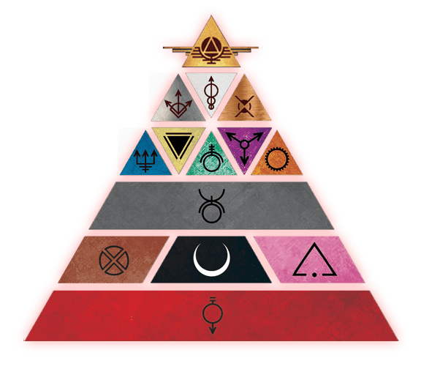

On the Foundation of the Colors

When the first colonists ventured forth from earth to make their home on the moon, they created a hierarchy for labor. In time, they improved this hierarchy through genetic and surgical manipulation of their fellow man. The result was a color-coded Society of perfect efficiency, one dominated by a superior breed of humanity, the Golds.

## The Colors of Society

In the universe of the Red Rising Saga humanity has been genetically manipulated into 14 distinct subspecies of humanity who are color coded based on the role they play in Society. From the god-like Golds to the lowly Red miner, the colors of society are arranged in a pyramid that represents their place in the established caste system. At birth, each of the colors is implanted with a set of sigils on their hands that represent their color. In the Red Rising Saga, the colors are further binned into groups of High, Mid, and Low Colors. The High Colors are Gold, Silver, White, and Copper and represent the colors who sit at the top of the societal pyramid, with the lowest Gold having more inherent societal value than the highest standing Silver. The Mid Colors are Blue, Yellow, Green, Violet, Orange, and Gray. The Mid Colors enjoy a comfortable position in society if they contribute to the power and goals of their Gold leaders. The Low Colors, represented by Brown, Obsidian, Pink, and Red are the very bottom of Gold society with Obsidians, Pinks, and Reds essentially being enslaved under Golden Society rule.

SoM takes place during the civil war known as the Rising that starts during book two of the Red Rising Saga and sees the Red protagonist of the saga, Darrow of Lykos, wage a brutal war of liberation against the Society Golds to free the Low Colors from enslavement. During this civil war, citizens from all colors including Golds, band with the Rising to free humanity from its tyrannical self-rule.

In SoM, choosing your color is akin to choosing your species and class in other TTRPGs. Here, the Colors each contain different skills, abilities, and benefits that can be chosen while creating and leveling your character. These choices are represented by 3 distinct Mastery Trees for each color, with the trees loosely binned into Offensive, Defensive, and Utility like options. These options differ by color but some abilities, like the Enhanced Parry, are represented across multiple colors.

When creating a level 1 character, you are given 5 Mastery Points and forced to pick from one of the three Mastery Skills that start your color’s mastery tree but can choose to purchase skills from one of the other two trees when leveling up if you meet the specified prerequisites. At level 20, a PC will have unlocked 80 Mastery Points to spend on Mastery Skills. Each color has a total skill tree value of 216, meaning that players will only be able to use roughly a third of the skills and abilities available to their selected Color in any one play through.

### High Colors

#### Gold

The Golds have ruled society since humanity spread to Luna and sit atop the societal pyramid with the Sovereign or Dictator ultimately responsible for leading society. Golds are 7-8 foot tall genetically altered humans who present with golden blonde hair and eyes and golden pyramid sigils on their hands. Golds are nearly perfect humans that excel at all aspects of personal warfare and possess genius level intelligence. While most Golds fight for the Gold Society, there are plenty of Golds, mostly those from Mars, that fight to tear down the pyramid and free the colors from enslavement. Golds serve a variety of roles in the military from front line shock troop to black operators behind enemy lines, to ship and fleet commanders.

Golds are the architects of empire—genetically perfected and sculpted to rule with a divine hand. Towering and golden-eyed, they were bred to command armies, shape policy, and dictate the fates of lesser Colors from citadels and Senate floors. Before the Rising, their word was law, their will an absolute. A single Gold could lead fleets, wage war across moons, and dispense death with a nod. They were taught to believe they were gods—and too many believed it.

But the Rising broke their throne. In the Solar Republic, Golds are fractured. Some serve the new order as generals and advisors, seeking redemption through leadership. Others slink into shadow, nursing wounded pride and plotting restoration. For many, the age of divine right is dead—and the age of earned loyalty begins. Still, a Gold in a room turns heads. Some reputations do not wash off.

Gold names carry the weight of legacy. Their full names begin with a given name, followed by “au” (of) and their familial house. Sometimes they append a third title reflecting honor, territory, or mythic descent.

* *Cassius au Bellona* – A name heavy with martial legacy.
* *Atalantia au Grimmus* – Cold beauty with a warlord’s pedigree.
* *Tyria au Mars* – A newer name, with roots in old Martian conquests.

**Core Gold Traits**

|  |  |
| --- | --- |
| Primary Ability | Intelligence |
| Starting Hit Points | 20 + Constitution Modifier |
| Hit Point Die | D10 per Gold level |
| Speed | 45 Feet per round |
| Saving Throw Proficiencies | Intelligence, Dexterity |
| Skill Proficiencies | Choose 2: Acrobatics, Athletics, History, Investigation, Piloting, Social |
| Weapon Proficiencies | Simple (Pistol, Dagger) and Martial Weapons (All other weapons) |
| Armor Training | Light, Medium, and Heavy Armor |
| Armor Class Formula | 10 + Dex Modifier + Str Mod (Max +2) = Base AC  (Replaced when wearing Pulse Armor) |
| Starting Equipment | 1 x set of D Tier Pulse Armor  1 x D Tier Razor  1 x D Tier Pistol |
| Mastery Points | 5 at character creation, gain additional Mastery Points at each level up. |
| Effects Save DC | 8 + Mastery Bonus + Intelligence modifier |

**Choosing Gold**

As a level 1 character you gain all Core Gold Traits found in the Core Gold Traits Table.

Spend your initial 5 Mastery Points on any of the available Mastery Skills presented below.

Input your selected options into your character sheet.

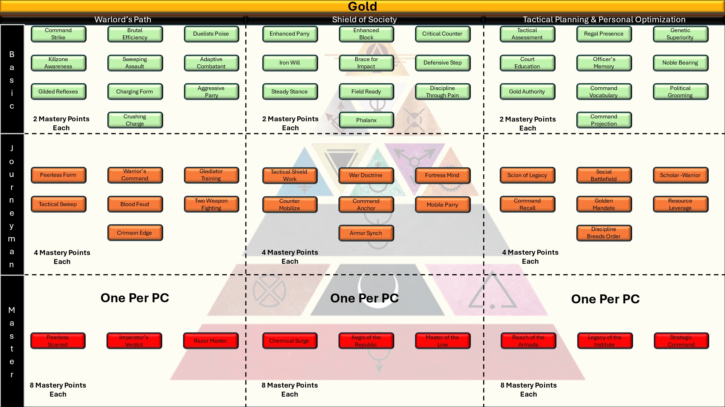

***Warlords Path (Offensive)***

Basic (10) – 2 pts each

1. **Command Strike** – When you hit, one ally within range can immediately attack the same enemy without spending an Action Point.
2. **Brutal Efficiency** – +1 to damage rolls with melee weapons.
3. **Duelist’s Poise** – After a successful parry, gain +2 to your next melee attack. This bonus lasts until the end of your next turn or until you use it, whichever is first.
4. **Killzone Awareness** – +1 to hit against flanked or surrounded targets.
5. **Sweeping Assault** – Once per round, after a successful hit, you may spend an action point to deal half damage to an additional enemy within 5 feet or your original target.
6. **Adaptive Combatant** – Draw/stow a weapon as a free action once per round on your turn.
7. **Gilded Reflexes** – Reroll 1s on melee weapon damage once per turn.
8. **Charging Form** – +1 AC immediately after moving at least 20ft in a single round. This effect lasts for 1 round.
9. **Aggressive Parry** – If you parry successfully, gain advantage on your next attack against that target.
10. **Crushing Charge –** Spend an Action Point, you spend up to your current movement charging toward an enemy to crush them with your mass in full battle armor. Make an attack roll where the bonus modifier used is equal to your Dexterity or Strength modifier, whichever is higher. On a hit you deal 2d10 bludgeoning damage for every 10ft traveled before striking your target. While charging in this way you are unable to use the block or parry maneuver.

Journeyman (7) – 4 pts each

1. **Peerless Form** – Spend 2 Action Points, you gain advantage on your melee attacks this round.
2. **Warrior’s Command** – Spend an action point, grant allies +1 to attack rolls until the start of your next turn.
3. **Gladiatorial Training** – You gain an additional hit die, immediately roll the hit die and add it to your permanent hit point total. You gain that hit die for rest periods as well.
4. **Tactical Sweep** – On a successful hit you may spend an Action Point to attempt to sweep the legs of your target and knock them prone. Target must succeed on a Dexterity saving throw against the damage total from the hit or 15, whichever is higher. On a failure the target falls prone and must remain that way until the start of their next turn.
5. **Blood Feud** – +2 to hit any foe that damaged you within the last round.
6. **Two Weapon Fighting** – You master the art of two weapon fighting and may wield a one-handed weapon in each hand. While wielding two weapons in this way, you gain one additional Action Point each round.
7. **Crimson Edge** – Your melee crits cause 2d6 bleeding damage at the start of each of the affected enemies turns.

Master (3) – 8 pts each

1. **The Scarred Path** – Once per long rest, enter a battle trance: +2 AC, auto-save once (Player Choice), +3 to hit for 1 min.
2. **Imperator’s Verdict** – After you deal the final blow to an enemy, all allies gain advantage on their next attack.
3. **Duel Master’s Edge** – +3 to AC and to hit rolls when only one enemy is within 5 feet of you.

***Shield of Society (Defensive)***

Basic (10) – 2 pts each

1. **Enhanced Parry** – Your parry attempts are made at advantage.
2. **Iron Will** – Spend an action point to add your Wisdom modifier to any saving throw that does not already use it.
3. **Enhanced Block** – Your block attempts are made at advantage.
4. **Brace for Impact** – Reduce fall or knockback damage by half.
5. **Critical Counter** – When you roll a critical success on a block or parry attempt you take no damage from the attack, gain 1 additional Action Point for use on this opponent turn, and may attack offensively with any remaining Action Points you have. An enemy who has been Critically Countered may not make any additional attacks against you during its turn this round.
6. **Defensive Step** – After taking damage, you may immediately move 5 ft without provoking opportunity attacks.
7. **Steady Stance** – Spend an Action Point to gain advantage on checks against being shoved or tripped or knocked prone.
8. **Field Ready** – Opportunity attacks against you have disadvantage.
9. **Discipline Through Pain** – When hit, +1 AC until start of your next turn. This does not stack with itself.
10. **Phalanx** – When adjacent to more than one ally, you all gain +1 AC. This may stack up to three times for a total of +3 to AC for those affected.

Journeyman (7) – 4 pts each

1. **Tactical Shield Work** – You gain an additional charge of use on your armors equipped Aegis.
2. **War Doctrine** – Once per long rest, you may spend 2 Action Points to surge emergency power to your armor and prevent all damage from a single attack. Turning a hit into a miss.
3. **Fortress Mind** – Spend an Action Point to gain advantage on Wisdom and Intelligence saving throws for 1 minute.
4. **Counter-Mobilize** – Whenever an enemy who is more than 15 feet from you moves to within 5 feet of you, you may spend 2 Action Points to move up to your full current movement speed without provoking an opportunity attack from that enemy.
5. **Command Anchor** – While you’re conscious, allies within 10 ft cannot be moved unwillingly.
6. **Mobile Parry** – Spend an Action Point to Parry an enemy attack and then move up to 10 feet without provoking opportunity attacks. Damage from the parry action is calculated before you move.
7. **Armor Sync** – Armor weight does not reduce movement.

Master (3) – 8 pts each

1. **Chemical Surge** – Once per long rest, you spend an Action Point to inject yourself with a cocktail of chemical combat enhancers. You immediately gain HP equal to half your hit point total and gain 2 additional action points for the next minute.
2. **Aegis of the Republic** – Allies within 5 feet of you can use your AC instead of their own.
3. **Master of the Line** – When you are targeted by a melee attack and that attack misses, is blocked, or parried, that attacker suffers disadvantage on their next attack.

***Tactical Planning & Personal Optimization (Utility)***

Basic (10) – 2 pts each

1. **Tactical Assessment** – Gain advantage on Investigation or Perception rolls related to combat or scouting activities.
2. **Regal Presence** – Gain proficiency in the Social Skill.
3. **Genetic Superiority** – Gain +1 to one ability score.
4. **Court Education** – Gain +1 to either the Wisdom or Intelligence ability score.
5. **Officer’s Memory** – You have a near-perfect memory and gain advantage on History checks.
6. **Noble Bearing** – Spend an Action Point to reduce the DC of a single Social skill check by -2.
7. **Gold Authority** – You gain advantage on Social skill checks against Colors other than Gold.
8. **Command Vocabulary** – Spend an Action Point, you may grant 1 of your unspent Action Points to an ally you can see. This effect lasts until the start of your next turn.
9. **Political Grooming** – Gain +1 to Social or Insight when in noble company.
10. **Command Projection** – Your communication distance is doubled and you gain advantage on saving throws against enemy attempts to jam your communications.

Journeyman (7) – 4 pts each

1. **Scion of Legacy** – Gain one Mastery Skill from another High Color. This selection must be made from Basic or Journeyman skills.
2. **Social Battlefield** – Gain advantage in Social skill checks within 1 minute of defeating an enemy.
3. **Scholar-Warrior** – You gain proficiency in the History Skill. If you already possess History proficiency you gain expertise in the History Skill.
4. **Command Recall** – Store one Action Point for use in the next round.
5. **Golden Mandate** – 25% reduction in store and resupply costs.
6. **Resource Leverage** – Once per day, “call in” minor supplies as a resupply. Roll 1d4, you gain that many minor supplies.
7. **Discipline Breeds Order** – Long rest cooldowns are reduced by 1 hour for your Fire Team. This reduction may stack with other long rest cooldown reductions.

Master (3) – 8 pts each

1. **Reach of the Armada** – Once per long rest you may spend three Action Points, you designate a spot on the terrain you can see. At the start of your next turn, a beam of white hot plasma streaks a 60ft sphere area centered on your designated point. All creatures within the sphere must succeed on a DC20 Dexterity saving throw or suffer 10d12 fire damage on a failure and half as much on a success. Only one Reach of the Armada ability may be used per round.
2. **Legacy of the Institute** – For 1 minute, all Social or Intelligence checks related to leadership are treated as crits (auto 20). Additionally, you gain expertise in the Social skill if you do not already possess it.
3. **Strategic Command** – In combat, once per day, you can ask and the GM must tell you the full initiative order, including enemies. You can then rearrange the initiative order of your allies.

#### Silver

Silvers were the accountants of empire—cloistered in vaults and glass towers, watching markets like hawks and bleeding value from every interaction. Where Gold ruled and warred, Silver counted and controlled, turning the gears of commerce, taxation, and bureaucratic policy. They were master manipulators of merit and debt. And in the Society, merit was measured in blood and credits alike.

In the Solar Republic, some Silvers thrive. Others flounder, struggling to adjust to a world where connections don’t always translate to power. They remain essential in Republic finance, infrastructure, and intelligence services—but must now prove their value rather than inherit it. Some adapt; some cheat. The Republic may have abolished their monopolies, but not their ambition.

Silvers bear sleek, modern names that often evoke sharpness, precision, or status. A touch of flair is common, as is a surname linked to banking dynasties or market houses.

* *Vel Arcon* – “Vel” hinting at elevated status; Arcon, an old accounting house.
* *Nyra of Rhombus* – Named for the geometric perfection her House idealized.
* *Kae Prism* – Reflective and calculated, like the name itself.

**Silvers are not a playable class in SoM but are common as NPCs.**

#### White

Whites were the priests and judges of Society—keepers of law, doctrine, and death. They served as executioners and moral architects, presiding over courts with quiet cruelty and leading rituals that sanctified war and punishment. Clad in pale robes and trained in mental rigor, they were terrifying in their detachment. Mercy was not a trait they valued.

In the Republic, some Whites reinvent themselves as therapists, scientists, or spiritual guides—but many find the leash of morality foreign. A few have emerged as defenders of Republic law, haunted and humbled by past sins. Others wander, unanchored, seeking meaning in a world without the Society’s black-and-white moral frame.

White names are often ascetic and solemn, drawn from old languages or chosen to reflect concepts of balance, clarity, or judgment. True believers rarely adopt surnames.

* *Seraph* – Chosen for the angelic connotation.
* *Judic* – Derived from “judicium,” the act of judgment.
* *Eira Vale* – A White turned counselor, adopting a surname only after the Rising.

**Whites are not a playable class in SoM but are common as NPCs.**

#### Copper

Coppers were the archivists and record-keepers, bureaucrats with perfect memories and minds like vaults. They maintained the Society’s rigid legal code, tracked lineage and offense, and enforced laws not with weapons, but with records. Coppers knew what you owned, who you were, and how to destroy you on paper.

In the Republic, Coppers remain crucial but no longer untouchable. The new order demands transparency, and many Coppers now work for Republic intelligence, court systems, or as researchers, adapting their near-perfect memory to serve open governance rather than opaque tyranny. Still, old habits linger—and some Coppers still dream of ironclad order.

Their names are practical, usually sharp and phonetic. Many take surnames referencing roles or memory—though some adopt titles to reflect pride in mental prowess.

* *Toll Vex* – A records master known for meticulous cruelty.
* *Nami Cipher* – “Cipher” adopted to reflect her cryptographic specialty.
* *Orran Lex* – A data archivist turned Republic analyst.

**Coppers are not a playable class in SoM but are common as NPCs.**

### Mid Colors

#### Blue

Blues are Society’s tactical coordinators, fleet specialists, and aerospace officers. Genetically bred for intelligence, obedience, and cool rationality, they serve as navigators, mission analysts, and precision strike controllers across the Solar System. While many Blues are neurally wired into spacecraft and command consoles, a rare few are trained for battlefield deployment as combat controllers, these are combat Blues, equipped with advanced HUDs, uplink beacons, and personal firearms to support their allies with cold efficiency.

On the ground, Blue characters serve as ranged combatants who augment the battlefield with air support, drone coordination, and precision fire. Their **Offensive** tree emphasizes tactical targeting and atmospheric strikes, supporting allies and punishing enemy positions with deadly accuracy. Their **Defensive** abilities control engagement zones through smoke, heat masking, and drone countermeasures. The **Utility** path boosts situational awareness, command communication, and skill synergy. Blues don’t lead the charge — they calculate the moment, pull the trigger, and let others seize the breach.

The Blue were starsick dreamers and neural tacticians—bred for aerospace command, orbital warfare, and fleet coordination. They did not scream in battle; they sang into the void through data streams and algorithmic decisions. Connected directly to systems through neural implants, Blues served as Society’s star pilots, atmospheric analysts, and strike coordinators. Cold, efficient, indispensable.

Now, many Blues still serve in fleet roles—but with choice, not compulsion. Some have severed their implants entirely, preferring quiet lives planetside. Others found their true calling only after the Rising, using their gifts in engineering, astrophysics, or even music. The Republic values their precision—but demands they be people, not machines.

Blues favor structured names with technical or poetic resonance. Many kept designation codes in the Society, but some now choose their own.

* *Kael 7.3* – Retains her neural registry, even in freedom.
* *Rinn Vostra* – A name chosen post-Rising to mean “calm vector.”
* *Iri Cadence* – A pilot who renamed herself after a rhythm she heard during a burn dive.

**Core Blue Traits**

|  |  |
| --- | --- |
| Primary Ability | Intelligence |
| Hit Point Die | D6 per Blue level |
| Starting Hit Points | 16 + Constitution Modifier |
| Speed | 30 Feet per round |
| Saving Throw Proficiencies | Intelligence, Dexterity |
| Skill Proficiencies | Piloting, plus choice of 1 of the following: Engineering, Perception, Technology |
| Weapon Proficiencies | Simple (Pistol & Dagger) |
| Armor Training | Light |
| Armor Class Formula | 10 + Dex Modifier + Int Mod (Max of +2) = AC  (Replaced when wearing Pulse Armor) |
| Starting Equipment | 1 x D Tier Pistol  1 x D Tier Pulse Armor  1 x D Tier Melee Weapon |
| Mastery Points | 5 at character creation, gain additional Mastery Points at each level up. |
| Effects Save DC | 8 + Mastery Bonus + Intelligence modifier |

**Choosing Blue**

As a level 1 character you gain all Core Blue Traits found in the Blue Core Traits Table.

Spend your initial 5 Mastery Points on any of the available Mastery Skills presented below.

Input your selected options into your character sheet.

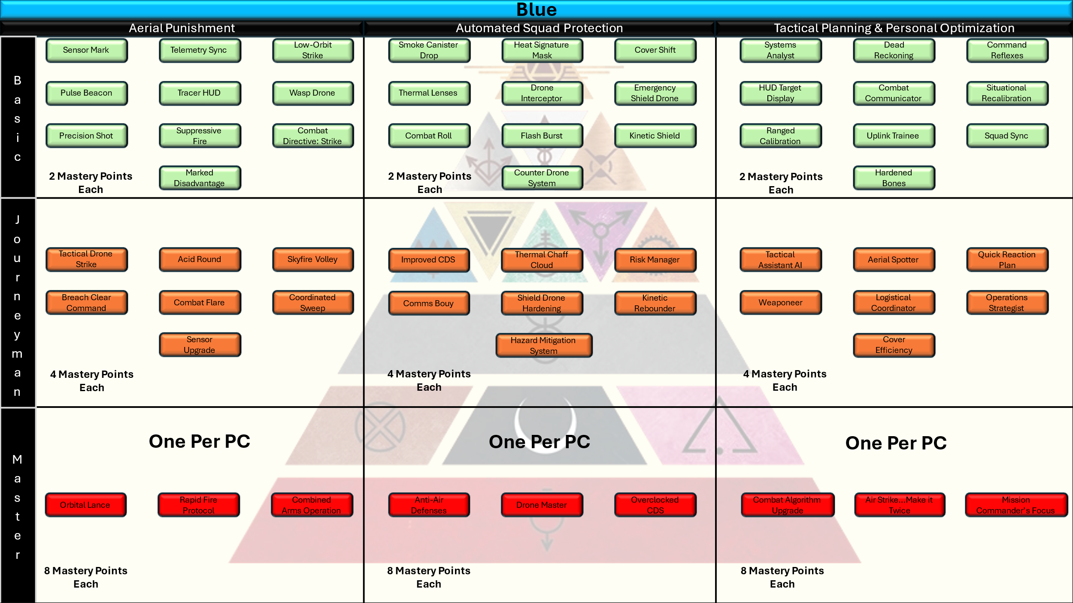

**OFFENSIVE TREE – *“Coordinated Fire & Aerial Punishment”***

**Basic Tier (2 pts each):**

* **Sensor Mark** – You Sensor Mark an enemy target for 1 minute. While Sensor Marked, you gain advantage on attack rolls to hit that target, and you and your allies gain +1 to hit against that target. You may use this feature a number of times per short rest equal to your Mastery Bonus.
* **Telemetry Sync** – Gain +1d4 weapon damage against Sensor Marked targets.
* **Low-Orbit Strike** – Spend 2 Action Points, call in a low-power orbital blast against one target you can see. Target must succeed on a Dexterity saving throw against your Effects Save DC or suffer 3d6 fire damage. If your target is Sensor Marked they make this save at disadvantage. Targets take half damage on a success. You may use this feature a number of times per short rest equal to your Mastery Bonus.
* **Pulse Beacon** – Once per day during a rest, you may spend 10 minutes requesting an aide package from your higher command or allies. This package can be Combat or Support supplies and is delivered via rail gun burst to your location within 10 mins of the request. The GM is responsible for determining the contents and value of the items based on level and story but it will at least contain enough supplies to allow your Fire Team a short rest.
* **Suppressive Fire** – When you miss on a ranged attack roll you may spend an Action Point to give that target disadvantage on its next ranged attack.
* **Tracer HUD** – Successfully hitting a target highlights that enemy on your allies’ HUDs. The next allied range attack made at that target is made at advantage.
* **Wasp Drone** – You gain a small wearable drone pack. You have a number of collapsable Wasp Drones available to you per long rest equal to your Mastery Bonus. These drones have a movement speed of 60 feet, an AC of 15, 30 HP and a mounted sniper rifle (+3 to hit, 3d6 piercing damage). On your turn you can Spend an Action Point to release a small drone from its charger on your back. On your turn in initiative, you may use your drone’s movement freely to scout the area, but you must use your own pool of Action Points to use its attack.
* **Hardened Wasp** – Your Wasp Drones now have an AC of 17 and 40 HP.
* **Precision Shot** – Your Wasp Drones are outfitted with gyroscopically stabilized barrels. When you make an attack with your Wasp Drone you may spend an additional Action Point to make the attack at advantage with a +5 modifier.
* **Combat Directive: Strike** – Whenever an ally you can see misses on a ranged attack you can spend an Action Point and allow the ally to reroll the attack.
* **Marked Disadvantage** – When an ally ability or effect forces a Sensor Marked target to make a saving throw, you may choose to lose your Sensor Mark and in exchange give that target disadvantage on the saving throw.

**Journeyman Tier (4 pts each):**

* **Tactical Drone Strike** – Your Wasp Drones are outfitted with micro ballistic missiles designed to pop bunkers and heavily armored knights. On your turn you may spend 3 Action Points and designate a target or spot on the ground you can see. Your drone immediately launches a micro ballistic missile, dealing explosive fire damage in a 20ft radius sphere centered on your designated point. All creatures within the area must succeed on a Dexterity saving throw against your Effects Save DC or suffer 3d10 piercing damage and 3d6 fire damage on a failure, or half as much on a save. Sensor Marked creatures make this save at disadvantage. You have a number of strikes available per long rest equal to your Mastery Bonus.
* **Acid Round** – Spend 2 Action Points, your Wasp Drone attacks a target with an acid round. On a hit, that targets AC is reduced by -1 until they complete a short rest to repair their armor.
* **Skyfire Volley** – Spend 3 Action Points to signal an orbital bombardment in a 30-ft radius area centered on a point you can see. All creatures within the sphere must succeed on a Dexterity saving throw against your Effects Save DC or take 6d6 fire damage. Targets who succeed the saving throw take half damage. You may use this feature once per long rest.
* **Breach Clear Command** – Spend an Action Point to grant an ally a free ranged weapon attack against an enemy within 10 ft of you. They must immediately make the attack. You may use this feature a number of times per short rest equal to your Mastery bonus.
* **Combat Flare** – When an ally is attacked within 30 feet of you Wasp Drone, spend an Action Point to have your drone launch a flare to blind the attacker. Target must succeed on a Wisdom save against your Effects Save DC or make the attack at disadvantage. You have a number of flares available per short rest equal to your Master Bonus.
* **Coordinated Sweep** – Spend 2 Action Points, all allies gain +2 to hit marked targets until the start of your next turn. You may use this feature a number of time per long rest equal to your Mastery Bonus.
* **Sensor Upgrade** – You may now mark up to 2 targets simultaneously.

**Master Tier (8 pts each):**

* **Orbital Lance** – Spend 4 Action Points and designate a point you can see; at the start of your next turn a maelstrom of metal screams into a 60-ft radius sphere as ships in orbit or long-range rail cannons rain down support. All creatures within the sphere must succeed on a Dexterity saving throw against your Effects Save DC or suffer 10d10 piercing damage and gain 3d6 bleed damage at the start of each of their turns for 1 minute. Creatures who succeed take half damage only. You may use this feature once per long rest.
* **Rapid Fire Protocol** – From now on, whenever you use a pistol to attack an enemy within 15 feet of you, each Action Point you spend allows you to attack twice.
* **Combined Arms Operation** – Choose 3 allies; for the next minute you and they gain +1 to AC, roll 1 additional damage die when calculating weapon damage and gain an additional 10 feet of movement. You can use this feature once per long rest.

**DEFENSIVE TREE – *“Environmental Control & Squad Protection”***

**Basic Tier (2 pts each):**

* **Smoke Canister Drop** – Spend an Action Point, deploy a smoke screen in a 10-ft line that shields you and your allies from enemy vision. Thermal vision can see through this smoke. The smoke dissipates at the end of your next turn.
* **Heat Signature Mask** – Spend an Action Point, you or an ally cannot be targeted by heat-based tracking or sensor systems until the start of your next turn.
* **Cover Shift** – Spend an Action Point to move 10 ft as a reaction when you’re missed by a ranged attack.
* **Thermal Lenses** – Gain a pair of permanent Thermal Lenses that are toggled on and off through a small switch in your molar. You gain innate thermal vision out to (60 ft). This thermal vision is not reliant on armor optics and can be used in most settings without drawing attention.
* **Drone Interceptor** – Spend an Action Point, you launch a small wrist mounted rocket at a drone you can see. Make a ranged weapon attack using a +5 modifier to hit. On a hit the drone suffers 4d8 piercing damage and 3d6 fire damage. You have a number of rockets per long rest equal to your Mastery Bonus.
* **Emergency Shield Drone** – You gain a small wearable drone pack. You have a number of Shield Drones available to you per long rest equal to your Mastery Bonus. Spend an Action Point, you deploy a drone capable of deploying an Aegis. This drone has 3 charges; you may spend one of the charges to have the drone grant +1to AC for you or one ally within 5 feet of the drone. This effect lasts for 1 round. The drone has an AC of 14, 30 HP, and can fly 30ft per round. You may have up to two shield drones deployed at any time. The drone lasts for 1 minute, at which point it falls harmlessly to the ground.
* **Combat Roll** – After taking melee damage you may spend an Action Point and move 5 feet without provoking opportunity attacks.
* **Flash Burst** – Spend 3 Action Points, you call in a Flash Burst strike on a point you can see. At the start of your next turn, supersonic rounds explode 10 feet above the point you designated. All creatures within 30 feet of the explosion must succeed on a Constitution saving throw or become blinded for 1 minute. You may call in two Flash Burst effects per day.
* **Kinetic Shield** – Spend an Action Point, you gain resistance to piercing damage until the start of your next turn.
* **Counter Drone System (CDS)** – During your turn you may spend two action points to place an unmanned Counter Drone System (CDS) into the ground that detects and engages enemy drones who enter its zone. For the next minute, anytime an enemy drone comes within 50 feet of the CDS it makes a ranged weapon attack (+3 to hit, 2d8 piercing damage). You may only have one CDS active at a time. The CDS can be attacked and destroyed (AC 15, 20 HP). The CDS last until it attacks 5 targets or 1 minute has passed, at which point it harmlessly deactivates. You have a number of CDS per long rest equal to your Mastery Bonus.

**Journeyman Tier (4 pts each):**

* **Improved CDS –** Your CDS now have an AC of 17 and 40 HP. Additionally they now have +5 to hit and deal 4d8 piercing damage per hit.
* **Thermal Chaff Cloud** – Spend 3 Action Points and designate a spot on the terrain you can see. At the start of your next turn, fleet support or long-range cannons fill a 30-foot sphere centered on your designated point with super-heated nano particles. These particles last for 1 minute and any creature who enters the area for the first time or begins its turn in the area must succeed on a Constitution saving throw against your Effects Save DC or take 5d6 fire damage immediately and 2d6 fire damage at the start of each of their turns. Targets who succeed take half damage. Drones and other automated defenses automatically fail this save and take double damage. You may use this feature twice per long rest.
* **Risk Manager**– Whenever an enemy you can see begins an attack of opportunity against an ally you may spend an Action Point to make a single ranged attack. On a hit you calculate damage as normal, and that enemy cannot take opportunity attacks for the remainder of the current turn.
* **Comms Bouy** – You have in depth knowledge of comms system architecture across the solar system and can access a network of communications buoys. Spend an Action point, for the next minute you and your allies gain advantage on attempts to resist cyber effects targeting communications.
* **Shield Drone Hardening** – Your shield drones now have an AC of 16 and 40 HP.
* **Kinetic Rebounder –** Whenever an enemy makes a ranged attack against you or an ally affected by your shield drone and misses, you may ricochet the attack back at the enemy by expending one of the drones’ charges. If the enemy’s attack roll is higher than the enemy’s AC the GM must roll the associated damage dice for the attack, this damage is then applied to the enemy attacker.
* **Hazard Mitigation System** – Your emergency shield drones have been upgraded to mitigate battlefield hazards. You may now spend 1 of the shield drone's charges to give you or an ally +1 to saving throws of a specified type. When you use this feature, you must choose which saving throw receives the benefit, which lasts for one round.

**Master Tier (8 pts each):**

* **Anti-Air Defenses** – On your turn you may spend 4 Action Points to deploy a small anti-air flak cannon designed to shoot enemy ballistics from the sky before they can harm you or your allies. For the next minute any Area of Effect (AoE) damage that is not energy based is halved to any ally within 30 feet of the cannon. The cannon can be attacked and destroyed (AC 19, 70 HP). You may only have on cannon of this type active at a time. You may use this feature twice per long rest.
* **Drone Master –** Your Shield Drones gain the following permanent effects:
  + You may deploy a total of 3 shield drones at a time.
  + Your shield drones now have an additional 10 hp.
  + Your shield drones increase AC by +2.
  + Your Hazard Mitigation System ability now grants +2 to a specified type of saving throw.
  + The kinetic Rebounder ability now has no cost to use, and you may add your Intelligence modifier to the damage roll.
* **Overclocked CDS** – The smartest Green you know has customized your CDS operating system to provide a single use burst of extra protection. Whenever your CDS halves the damage of an enemy AoE attack you may spend 4 Action Points and negate all damage from that attack for all allies it would effect. When you use this ability your CDS burns out its CPU and crumples harmlessly to the ground.

**UTILITY TREE – *“Tactical Planning & Personal Optimization”***

**Basic Tier (2 pts each):**

* **Systems Analyst** – +1 to any ability score.
* **Dead Reckoning** – You have learned to perfectly navigate the battlefield using only key pieces of terrain for reference. Gain advantage on Survival checks.
* **Command Reflexes** – Spend an Action Point, reroll 1 saving throw. You cannot use this ability multiple times for the same saving throw.
* **HUD Target Display** – Whenever you or one of your drones deals damage to an enemy you may spend an Action Point to highlight that target in your allies’ HUD. When you do, all allies gain +1 to hit that enemy for 1 round.
* **Combat Communicator** – You gain advantage on saving throws to resist enemy jamming attempts.
* **Situational Recalibration** – Spend an action point, choose one ally; they gain +2 to their next saving throw. You may use this feature a number of times per day equal to your Mastery Bonus.
* **Ranged Calibration** – You may reroll the first ranged attack you miss each combat with an additional +1 to hit.
* **Uplink Trainee** – +1 to any ability score.
* **Squad Sync** – Choose one skill you possess proficiency, expertise, or mastery in; allies match your proficiency in that skill until they make an associated roll or finish a rest.
* **Hardened** **Bones –** You visit a Violet carver who hardens your skeleton with metal alloy. You gain a permanent +1 to AC.

**Journeyman Tier (4 pts each):**

* **Tactical Assistant AI** – +2 to any ability score.
* **Aerial Spotter** – Whenever you have a drone active you may spend an Action Point to give one ally advantage on their next ranged attack.
* **Quick Reaction Plan** – Spend an action point, you and an adjacent ally may swap initiative order. You may use this feature a number of times per day equal to your Mastery Bonus.
* **Weaponeer** – Gain proficiency in the Engineering skill. If you already have proficiency, you may gain expertise.
* **Logistical Coordinator** – You may take a long rest using 2 minor supplies instead of the standard 3. Additionally, your major supplies can support 2 long rests instead of the standard 1. This effect applies to your Fire Team.
* **Operations Strategist** – You may select 1 basic feature from another mid-colors Utility Tree and use it as you would your own feature. You may not select a feature that requires a pre-requisite ability or feature to use.
* **Cover Efficiency** – When using cover, gain an additional +1 AC and advantage on ranged weapon attacks targeting enemies using cover.

**Master Tier (8 pts each):**

* **Combat Algorithm Upgrade** – +3 to any ability score.
* **Air Strike…make it twice** – Your airstrike and other strike support abilities (Space/Cannon) gain +1 charges. Those charges reset as normally described in each ability. This does not affect your Drone abilities.
* **Mission Commander’s Focus** – Once per day spend 4 Action Points and choose one ally or enemy you can see.
  + **Ally**: Your chosen ally gains +2 to AC, +1 to all saving throws, and 1 additional action point per round. This effect lasts for 1 minute.
  + **Enemy**: All attacks against your designated target gain advantage and +1 to hit. This effect lasts for 1 minute.

#### Yellow

Yellows are the stewards of biology, chemistry, and cognitive mastery across the Society. Trained in elite surgical academies, military medical labs, and neurochemical institutes, they are more than mere doctors—they are battlefield engineers of flesh and thought. Whether operating in sterile labs or under fire in cratered trenches, Yellows wield their intellect as a scalpel and their **Needle Guns** as tools of both mercy and menace.

In combat, Yellows stand behind the front lines, but they are far from passive. Offensive Yellows load their Needle Guns with poisons, neurotoxins, and destabilizing compounds that slip past armor and sow chaos in enemy ranks. Defensive specialists, meanwhile, deliver potent **Stims**—chemical boons that mend flesh, dull pain, and push allies beyond their natural limits. With battlefield precision, a single Yellow can stabilize a dying comrade, cripple an enemy commander, or reverse the tide of war through biochemical ingenuity.

Their skill trees reflect this duality: offense is lethal and strategic, defense is lifesaving and empowering, and utility enhances both while granting unparalleled knowledge of science, medicine, and battlefield triage. The Needle Gun is core to the functionality of Yellow and is a special piece of equipment that can be used to fire normal weapon fire or special syringes carrying harm to enemies and healing to allies. When a Yellow enters the field, every heartbeat, every breath, becomes a tool to be manipulated—for harm or for hope.

Yellows were the surgeons, the chemists, the body mechanics of Society. They healed wounds and dissected rebellions, stitching flesh with one hand and crafting toxins with the other. Coldly brilliant, they were trusted with the mind and body alike—administering stims, dissecting pathology, and creating bioforms for Gold whims.

In the Republic, Yellows hold immense value as healers and researchers. Many have thrown themselves into studying the true biology of the Colors, untainted by Gold design. Others walk the battlefield still, stims strapped to their belts, bringing comrades back from the brink. A Yellow with a Needle Gun is a medic—or a menace.

Yellows choose names drawn from biology, science, or personal obsessions. Some adopt names based on chemical formulas or surgical tools.

* *Thia Cortex* – Neuro-specialist; “Cortex” adopted after her mentor’s death.
* *Vexel* – A minimalist field surgeon, no surname needed.
* *Dr. Hume Lehnox* – A Yellow who reclaimed his title with pride.

**Core Yellow Traits**

|  |  |
| --- | --- |
| Primary Ability | Wisdom |
| Hit Point Die | D6 per Yellow level |
| Starting Hit Points | 16 + Constitution Modifier |
| Speed | 30 Feet per round |
| Saving Throw Proficiencies | Intelligence, Constitution |
| Skill Proficiencies | Medicine, plus choice of 1 of the following: Perception, Investigation, Performance |
| Weapon Proficiencies | Simple (Pistol & Dagger) |
| Armor Training | Light |
| Armor Class Formula | 10 + Dex Modifier + Wis Mod (Max of +2) = Base AC  (Replaced when wearing Pulse Armor) |
| Starting Equipment | Needle Gun: *Range 60ft/90ft,* *Dex Modifier + Master Bonus = Hit Modifier, 2d6 piercing damage*  1 x D Tier Pulse Armor  1 x D Tier Pistol  1 x D Tier Melee Weapon  2 x Basic Healing Stim |
| Mastery Points | 5 at character creation, gain additional Mastery Points at each level up. |
| Effects Save DC | 8 + Mastery Bonus + Wisdom modifier |

**Choosing Yellow**

As a level 1 character you gain all Core Yellow Traits found in the Yellow Core Traits Table.

Spend your initial 5 Mastery Points on any of the available Mastery Skills presented below.

Input your selected options into your character sheet.

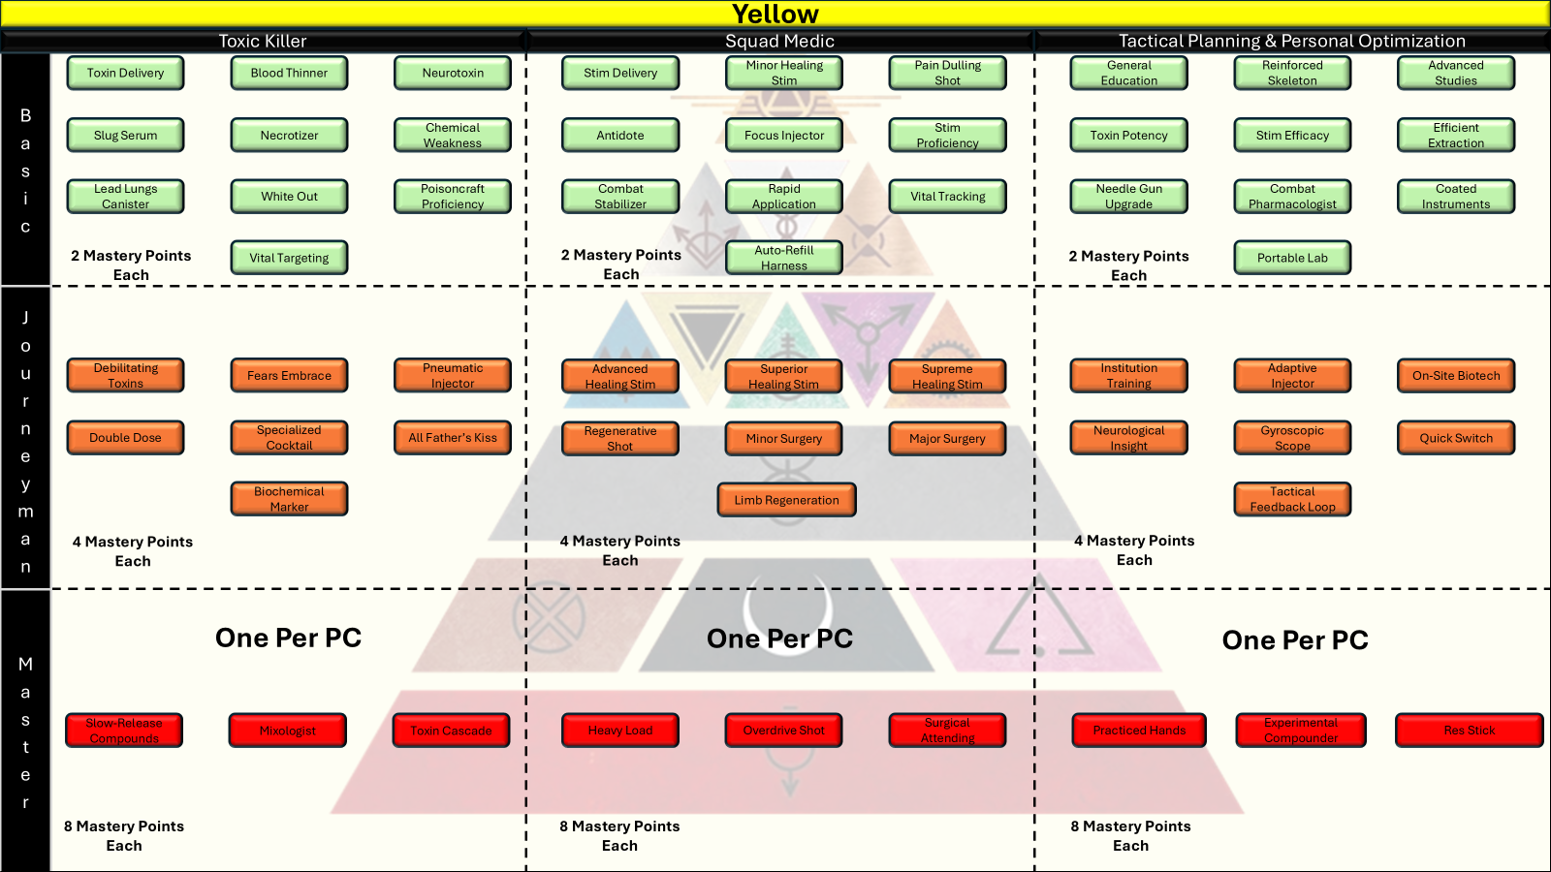

**Basic Tier (10) “Toxic Killer”**

1. **Toxin Delivery** – Unlocks a Needle Gun feature that can deliver basic poisons and toxins. These poisons and toxins can either be from the “Utility Items” section of this manual or granted from features in this chapter. When you use your Needle Gun to deliver an effect the target must succeed on a Constitution saving throw against your Effects Save DC or suffer the designated effects.
2. **Blood Thinner** – You gain knowledge on how to mix blood thinning chemicals that cause your enemies to bleed out on the battlefield. Spend 2 Action Points, you make an attack with your Needle Gun. On a failed saving throw, each time your enemy takes damage from any source they also take an additional 2d6 bleed damage. This effect lasts for 1 round. You gain a number of uses of this feature per short rest equal to your Mastery Bonus.
3. **Neurotoxin** – You gain knowledge on how to mix a neurotoxin that cause your enemies to suffer temporary loss of cognitive ability. Spend 2 Action Points, you make an attack with your Needle Gun. On a failed saving throw, your enemy makes all Intelligence saving throws at disadvantage. This effect lasts for 1 round. You gain a number of uses of this feature per short rest equal to your Mastery Bonus.
4. **Slug Serum** – You gain knowledge on how to mix a compound that cause your enemies to suffer debilitating pain in their joints. Spend 2 Action Points, you make an attack with your Needle Gun. On a failed saving throw, your enemies movement is halved. This effect lasts for 1 round. You gain a number of uses of this feature per short rest equal to your Mastery Bonus.
5. **Necrotizer** – You gain knowledge on how to mix a necrotizing agent that eats away at your enemies’ flesh to deal damage. Spend 2 Action Points, you make an attack with your Needle Gun. On a failed saving throw, your enemy takes 2d6 bleed damage at the start of its turns. This effect lasts for 1 minute. You gain a number of uses of this feature per short rest equal to your Mastery Bonus.
6. **Chemical Weakness** – You and your allies have +1 to hit enemies who are poisoned from any source.
7. **Lead Lungs Canister** – Spend an Action Point, you toss a can of lung burning gas at a point you can see within 60 feet of you. When you do, all creatures within 15 feet of the cannister must succeed on a Constitution saving throw against your Effects Save DC or suffer 3d6 poison damage and Disadvantage on Constitution saving throws for 1 minute. Creatures who start their turn in or enter the gas for during their turn must also make this saving throw. This gas persists until the start of your next turn.
8. **White-Out** – You gain knowledge on how to mix an agent that causes partial blindness in your enemies. Spend 3 Action Points, you make an attack with your Needle Gun. On a failed saving throw, your enemy suffers from partial blindness. This effect lasts for 1 round. While blinded in this way your enemy makes all attacks and defensive maneuvers at disadvantage. You gain a number of uses of this feature per short rest equal to your Mastery Bonus.
9. **Poisoncraft Proficiency** – Gain proficiency in the Science skill, if you already have proficiency, gain expertise in the Science skill instead.
10. **Vital Targeting** – Once per combat, the first saving throw made to resist effects from your Needle Gun is made at disadvantage. This disadvantage cannot be changed in any way.

**🔸 Journeyman Tier (7)**

1. **Debilitating Toxins** – Targets poisoned by your Needle Gun effects now suffer disadvantage on Dexterity saving throws in addition to their other effects.
2. **Fear’s Embrace** – You gain knowledge on how to mix Fears Embrace, a poison capable of inducing fear in your enemies by activating their natural flight response. Spend 3 Action Points, you make an attack with your Needle Gun. On a failed saving throw, your enemy gains the fear condition. While affected by fear, enemies make all attacks and defensive maneuvers at disadvantage. This effect lasts for 1 round. You gain a number of uses of this feature per short rest equal to your Mastery Bonus.
3. **Pneumatic Injector** – When an enemy fails a saving throw to resist an effect from your Needle Gun they immediately take 2d8 piercing damage in addition to any other applied effects.
4. **Double Dose** – Whenever you declare an attempt to apply an affect from your Needle Gun to an enemy you may spend 1 additional Action Point to give that enemy disadvantage on the Constitution saving throw.
5. **Specialized Cocktail** – Whenever an enemy fails a saving throw to resist one of your Needle Gun effects, you may spend an Action Point and declare a type of saving throw. That enemy has disadvantage on that type of saving throw for 1 round.
6. **All Father’s Kiss** – You gain knowledge on how to mix a hallucinogenic agent derived from mushrooms commonly used by Obsidian shaman and wise women. Spend 3 Action Points, you make an attack with your Needle Gun. On a failed saving throw, your enemy gains the Confused condition. While confused in this way an enemy cannot discern friend from foe and will spend its turn attacking the closest creature near it. This effect lasts for 1 round. You gain a number of uses of this feature per short rest equal to your Mastery Bonus.
7. **Biochemical Marker** – Enemies affected by your Needle Gun are identified in your HUD by a small positional marker. While marked in this way you always know where an enemy within 100 feet is regardless of Stealth skill or associated rolls. Jamming may still interfere with this ability.

**🔺 Master Tier (3)**

1. **Slow-Release Compounds** – You have learned how to prolong the effects of your offensive Needle Gun effects. Abilities that had a timer of 1 turn now last 1 round, those that had timers of 1 round now have an expiration of 1 minute. Abilities that had a timer of 1 minute now have an expiration of 1 hour.
2. **Mixologist** – You may apply the effects of 2 basic offensive Needle Gun abilities in one attack. Example, Whiteout + Necrotizer may now be applied in a single failed saving throw. You may also mix the effects of any 1 basic offensive Needle Gun ability with the effects of a journeyman offensive Needle Gun Ability. Example, Whiteout + Fear’s Embrace.
3. **Toxin Cascade** – If a poisoned target drops to 0 HP, their death rattle releases an airborne contagion containing the same poison and effects. When the poisoned target drops to 0 HP, all creatures within 10ft must succeed on a Constitution saving throw against your Effects Save DC or become affected by the same poison effects that contributed to the dead enemies demise.

**Yellow – Squad Medic**

*Yellows use modified Needle Guns to fire* ***Stims*** *that heal and boost allies with fast-acting combat drugs.*

**🔹 Basic Tier (10)**

1. **Stim Delivery** – Unlocks Stim functionality in your Needle Gun. Allows you to fire any stim found in the “Items and Inventory” (1 Action Point) chapter of this book from your Needle Gun. You may spend the necessary Action Points and fire 1 stim or below effect at a friendly target you can see and then apply the specified effects. You may use the stim features found below a number of times per long rest equal to your Mastery Bonus, unless otherwise specified.
2. **Minor Healing Stim** – Spend an Action Point and target 1 allied creature, they receive HP equivalent to 2d4 + your Wisdom modifier.
3. **Pain Dulling Shot** – Spend 2 Action Points, Target gains resistance to physical damage for 1 round.
4. **Antidote** – Spend an Action Point, you fire a syringe caring an antidote serum. Select one poison or toxin effect affecting an ally you can see and remove it.
5. **Focus Injector** – Spend 2 Action Points, grants +1 to attack rolls for 1 minute, creatures can only benefit from one Focus Injector ability at a time.
6. **Stim Proficiency** – You apply double your Wisdom Modifier when calculating healing effects.
7. **Combat Stabilizer** – Spend 3 Action Points, you fire a stabilizing agent at one unconscious ally who is making Death Saving Throws. That ally immediately stabilizes through a series of coagulants, epinephrine, and calming agents. They do not regain HP, nor consciousness, but are no longer in danger of dying via Death Saving Throws. Any creature stabilized in this way who takes damage before regaining HP begins Death Saving Throws again.
8. **Rapid Application** – Whenever you successfully apply a Needle Gun effect to an ally you may apply a stim item from your inventory to one creature within 5 feet of you at no Action Point cost.
9. **Vital Tracking** – You outfit your Fire Team with vitals monitoring technology that displays your team’s health information in your HUD. You may ask your Fire Team members directly about their HP, including total, and remaining HP. You are also aware of any status conditions afflicting your Fire Team members.
10. **Auto-Refill Harness** – Once per day, the first stim item used in combat does not consume the item.

**🔸 Journeyman Tier (7)**

1. **Advanced Healing Stim** – Spend 2 Action Points and target 1 allied creature, they receive HP equivalent to 4d4 + your Wisdom modifier. You may use this feature twice per long rest due to the time it takes to mix and prepare.
2. **Superior Healing Stim** – Spend 3 Action Points and target 1 allied creature, they receive HP equivalent to 8d4 + your Wisdom modifier. You may use this feature twice per long rest due to the time it takes to mix and prepare.
3. **Supreme Healing Stim** – Spend 4 Action Points and target 1 allied creature, they receive HP equivalent to 12d4 + your Wisdom modifier. You may use this feature once per long rest due to the time it takes to mix and prepare.
4. **Regenerative Shot** – Spend 2 Action Points and designate one ally you can see, they gain 1d8 HP per round for 1 minute.
5. **Minor Surgery** – During a rest or down time, you may spend 1 hour performing minor surgery on 1 ally. At the end of the surgery the ally regains 5d8 hit points and removes all minor negative effects such as bleed damage over time, poisons, toxins, or other effects as designated by the GM. You may perform a number of Minor Surgeries per day equal to your Mastery Bonus.
6. **Major Surgery** – During a rest or down time you may spend 4 hours performing major surgery on 1 ally. At the end of the surgery the ally regains all hit points, up to one severed limb (Natural or Prosthetic), and removes all negative effects. You may perform 2 Major Surgeries per day.
7. **Limb Regeneration** – Carvers are fast but expensive. You have studied cellular limb regrowth and are capable of injecting a regimen of stem cells and nanobots that can restore limbs “naturally” over a 30-day period. At the end of the 30 days the affected creature regrows all arms, legs, and minor digits. This ability cannot reattach or restore a severed head, a decapitated enemy can only be restored to life by cloning them.

**🔺 Master Tier (3)**

1. **Heavy Load** – All healing stims fired from your Needle Gun heal an additional 2d4 of HP.
2. **Overdrive Shot** – Whenever you apply a Needle Gun effect to an ally they gain 1 additional Action Point for use on their next turn. This ability can stack three times.
3. **Surgical Attending** – You have completed a surgical fellowship and can complete surgeries with a practiced hand. You may now perform +1 additional Minor and +1 additional Major Surgery per day. Additionally, your Limb Regeneration feature takes 15 days to complete a limb regeneration.

**🧪 Yellow – Tactical Planning & Personal Optimization**

*Yellow utility skills enhance healing output, fine-tune toxin/stim mechanics, and boost core performance.*

**🔹 Basic Tier (10)**

1. **General Education:** +1 to Intelligence
2. **Reinforced Skeleton:** +1 to Constitution
3. **Advanced Studies:** +1 to Wisdom
4. **Toxin Potency** – Add +1 to your Effects Save DC.
5. **Stim Efficacy** – Add an additional +2 to all healing rolls when you apply healing stims.
6. **Efficient Extraction** – Roll Science or Medicine with advantage when interacting with toxins/stims.
7. **Needle Gun Upgrade** – Your normal Needle Gun attacks now deal an additional 2d6 poison damage.
8. **Combat Pharmacologist** – You make Science checks to Identify unknown chemical substances at advantage.
9. **Coated Instruments** – Your Medicine skill checks never fail critically. You treat a 1 as a 2.
10. **Portable Lab** – You are issued a small portable lab. During a rest you can use the lab and spend 1 minor supply to create 1 Minor Healing Stim. You can create 2 stims this way per 1 hour spent crafting.

**🔸 Journeyman Tier (7)**

1. **Institution Training -** +2 to Intelligence
2. **Adaptive Injector** – Healing stim items you use to restore HP restore 1 additional dice of health.
3. **On-Site Biotech** – Once per day, when you use your portable lab to create a healing stim you can create one additional stim for free.
4. **Neurological Insight** – Gain advantage on Insight checks involving living targets.
5. **Gyroscopic Scope** – When attacking with a Needle Gun, roll 1d4 and add to your hit modifier.
6. **Quick Switch** – Change ammo type as a free action once per day.
7. **Tactical Feedback Loop** – Once per day, force an enemy to reroll a saving throw to resist an effect from your Needle Gun.

**🔺 Master Tier (3)**

1. **Practiced Hands - +**3 to Wisdom
2. **Experimental Compounder** – Once per day, when you use your portable lab to create a healing stim you can create two additional minor stims for free. Additionally, you may now spend major supplies to create Superior Healing Stim items at a rate of 1 major supply to 1 Superior Healing Stim.
3. **Res Stick** – You are issued 3 highly experimental and expensive Res Sticks that are restocked during a long rest. You can spend 3 Action Points using one of these Res Sticks to return a dead character to life as long as their head is still attached and they have been dead for 1 minute or less. The character is restored to life with all of its action points, all of its movement, and 10 HP. Res Sticks can also be purchased at quartermasters or shops using the Merit or Credit currencies but should be treated as moderately expensive and very rare.

#### Green

Greens are the cyber architects of warfare, masters of intrusion, data manipulation, and real-time electronic sabotage. Unlike Blues, who command battlefield assets and coordination, Greens interface directly with enemy systems, rewriting the rules of combat in real-time. Their battles are fought in invisible wavelengths—hijacking drones, crashing shields, and overheating weapons through a signature core technique: Wireless Hacking. All Special Operations Greens and many Green Freelancers have upgraded their tech stack to allow wireless connectivity to many electronic devices such as computers, doors, drones, and weapons.

Wireless Hacking allows Greens to penetrate and manipulate enemy tech from a distance. Every strike they make is silent, precise, and disruptive, often turning the enemy’s own tools against them. Their offensive tree expands this ability with specific targets, like drones, personal shields, or smart weapons. Their defensive tree mirrors principles of real

world cyber defense: intrusion detection, signal scrambling, packet filtration, and tracebacks to nullify hostile code or reroute attacks. The utility tree sharpens their edge, increasing their bandwidth, boosting digital reflexes, and enhancing their core skills through system upgrades and neural feedback.

Greens were Society’s data sculptors, cyber-specialists, and Technomancer—lesser than Blues in hierarchy, but no less vital. They built systems, monitored populations, and wrote the code that kept the Society’s hierarchy humming. In a world of control, Greens made the chains.

After the Rising, some Greens turned hackers, freedom-fighters, or saboteurs. Others slipped into Republic infrastructure or freelance work, chasing the freedom of open systems. Among the Colors, Greens may be the best suited to the Republic’s chaos. They understand that data, like people, resists control.

Their names often mimic code snippets, programming syntax, or digital slang. Some Greens adopt compound names or network handles they used underground.

* *Hex Null* – “Null” is a chosen surname denoting rebellion.
* *Ravi.exe* – Retains his old net handle; refuses to answer to anything else.
* *Kora Shell* – “Shell” denoting both a software shell and a defensive persona.

**Green Specific Combat Rules**

Green play relies on a cat-and-mouse game of offensive Greens using features attempting to place debilitating cyber effects on enemies while enemy greens attempt to stop you and use effects of their own. Greens are often slightly removed from the fight in a position to see as much of the battlefield as possible and apply a wide range of wireless cyber effects. Green features often last for more than one turn. When they do, opposing Greens can hunt down these cyber effects and attempt to destroy them with their own defensive abilities. At the table, you can attempt to remove a negative effect placed on you or an ally by an enemy Green by hunting for the negative effect and killing it. You can also defend your own effects placed on enemies by rolling head-to-head Technology skill checks. Apply the following rules in combat when choosing Green.

**Hunt Effect:** To eliminate a cyber effect placed on yourself or an ally you must first find it within the local network and code. Spend an Action Point and designate one creature you can see being affected by a designated Green cyber effect. The Green who placed the effect rolls a Stealth check while the Green hunting the effect roles an Investigation check. If the hunting Green’s roll is higher, the GM must tell them the cost to kill the effect. If there is more than 1 effect present the GM divulges all effects.

**Kill Effect:** After successfully hunting an enemy cyber effect, you may attempt to kill it. To kill a cyber effect, you must spend Action Points equal to the cost to create the enemy cyber effect +1 Action Point. Whenever you successfully kill an enemy effect, the Green who placed it takes 2d8 Electric damage.

**Defend Effect:** You attempt to defend one of your cyber effects being attacked by an enemy green. Whenever an enemy Green attempts to kill one of your cyber effects, you may spend an Action Point. If you do, both you and the enemy Green roll Technology skill checks. If yours is the higher total roll your effect persists as intended. If the enemy’s roll is higher your effect immediately ends. Whenever you successfully defend an effect, the enemy Green takes 2d6 Electric damage.

**Core Green Traits**

|  |  |
| --- | --- |
| Primary Ability | Wisdom |
| Hit Point Die | D6 per Green level |
| Starting Hit Points | 16 + Constitution Modifier |
| Speed | 30 Feet per round |
| Saving Throw Proficiencies | Intelligence, Constitution |
| Skill Proficiencies | Stealth, plus choice of 1 of the following: Perception, Investigation, Technology |
| Weapon Proficiencies | Simple (Pistol & Dagger) |
| Armor Training | Light |
| Armor Class Formula | 10 + Dex Modifier + Int Mod (Max of +2) = Base AC  (Replaced when wearing Pulse Armor) |
| Starting Equipment | 1 x D Tier Pulse Armor  1 x D Tier Pistol  1 x D Tier Melee Weapon |
| Mastery Points | 5 at character creation, gain additional Mastery Points at each level up. |
| Effects Save DC | 8 + Mastery Bonus + Intelligence modifier |

**Choosing Green**

As a level 1 character you gain all Core Green Traits found in the Green Core Traits Table.

Spend your initial 5 Mastery Points on any of the available Mastery Skills presented below.

Input your selected options into your character sheet.

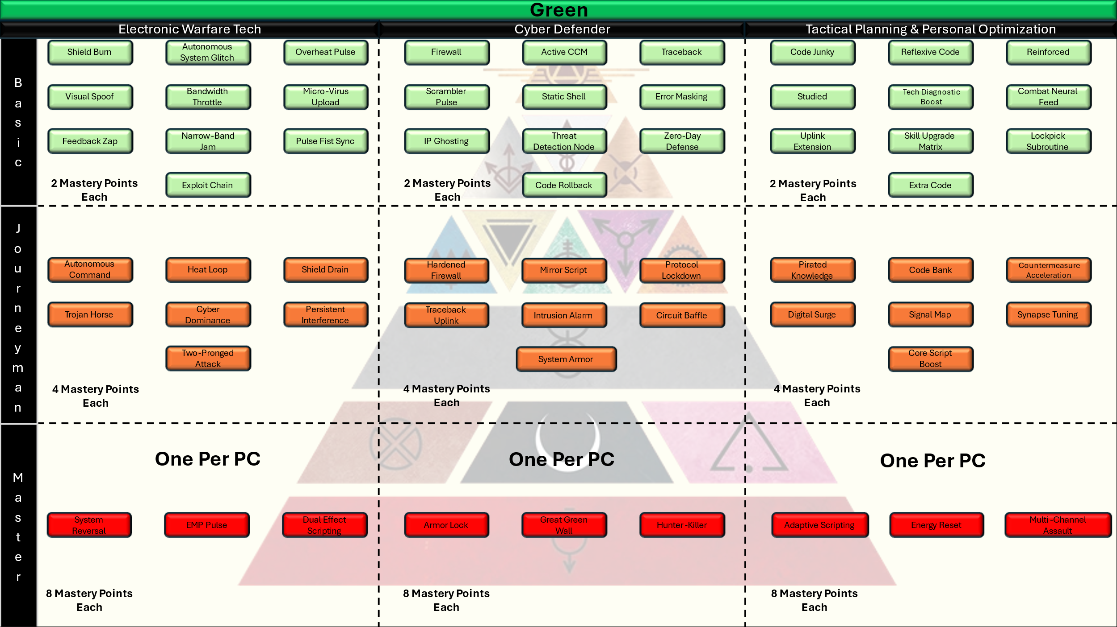

**GREEN – Electronic Warfare Tech**

**Basic Tier (10 Options)**

* *Shield Burn:* Spend an Action Point, you target one enemy you can see and force them to save on an Intelligence saving throw against your Effects Save DC. On a failure, their next use of a pulse shield or other electronic shield device is double the cost to use. Any Color except Green makes this saving throw at disadvantage unless some feature or effect grants advantage, which makes the saving throw a normal roll.
* *Autonomous System Glitch:* Spend an Action Point, target one autonomous system you can see, the creature controlling the system must succeed on an Intelligence saving throw against your Effects Save DC or the drone loses signal and becomes unusable for 1 round. Any Color except Green makes this saving throw at disadvantage unless some feature or effect grants advantage, which makes the saving throw a normal roll.
* *Overheat Pulse:* Spend an Action Point, you target one enemy you can see and attempt to cause their armor systems to overheat. Target creature must succeed on an Intelligence saving throw against your Effects Save DC or take 2d6 fire damage on the start of each of their turns for 1 minute. Any Color except Green makes this saving throw at disadvantage unless some feature or effect grants advantage, which makes the saving throw a normal roll.
* *Visual Spoof:* Spend an Action Point, choose an enemy you can see and attempt to create visual interference in their helmet optics. Target must succeed on an Intelligence saving throw against your Effects Save DC or must make their next attack roll at disadvantage. Any Color except Green makes this saving throw at disadvantage unless some feature or effect grants advantage, which makes the saving throw a normal roll.
* *Bandwidth Throttle:* Spend 2 Action Points, choose an enemy or piece of autonomous enemy equipment you can see such as a drone and attempt to drastically decrease the bandwidth of the user. Target must succeed on an Intelligence saving throw against your Effects Save DC or be restricted to 1 piece of autonomous equipment at a time for 1 minute. If the target is controlling more than one piece of autonomous equipment when it fails this saving throw you choose which equipment remains, and which are harmlessly deactivated. This affects features like the Blue’s drones and other autonomous systems. Any Color except Green makes this saving throw at disadvantage unless some feature or effect grants advantage, which makes the saving throw a normal roll.
* *Micro-Virus Upload:* Spend an Action Point, you attempt to infect an enemies cyber defense system to grant disadvantage on their next attempt to defend one of their effects. Target must succeed on an Intelligence saving throw against your Effects Save DC or gain disadvantage on their next Defend Effect skill check. Any Color except Green makes this saving throw at disadvantage unless some feature or effect grants advantage, which makes the saving throw a normal roll.
* *Feedback Zap:* You cause electrical currents to damage the brain of an enemy. Spend 2 Action Points, make an attack roll (Hit Modifier = 1d20 + Intelligence Mod + Mastery Bonus), on a hit the target takes 2d6 psychic damage.
* *Narrow-Band Jam:* You attempt to apply jamming effects across a single targets system. Spend 2 Action Points and designate a target you can see and force them to succeed on an Intelligence saving throw against your Effects Save DC. Any Color except Green makes this saving throw at disadvantage unless some feature or effect grants advantage, which makes the saving throw a normal roll. On a failure the target cannot communicate using electronic means for 1 round. This counters any enemy effect, like airstrikes, that call in effects using digital signals.
* *Pulse Fist Sync:* Spend an Action Point and designate 1 ally you can see. You surge electrical currents through their system, granting power to their Pulse Fist. The next attack that ally makes with their Pulse Fist is made at advantage and scores a critical hit on a 19-20.
* *Exploit Chain:* If you successfully apply a cyber effect, you may spend an Action Point and force that target to make its next saving throw to resist a Green cyber effect at disadvantage.

**Journeyman Tier (7 Options)**

* *Autonomous Command:* Fully hijack one enemy autonomous system. Whenever a target fails its saving throw against your Autonomous System Glitch feature you may spend 2 additional Action Points to take control of the system for 1 round.
* *Heat Loop:* You overheat pulse now deals 4d6 fire damage at the start of each enemy turn.
* *Shield Drain:* Siphon enemy shield energy to yourself and allies. When you successfully apply the effect of your Shield Burn ability you may spend an additional Action Point to wirelessly siphon energy from your enemies shield systems to one friendly target within 10 feet of the enemy. When you use this affect your chosen ally gains +1 charges to their Aegis or other electronic shield.
* *Trojan Horse:* Spend 3 action points and choose an enemy you can see, you attempt to place a back door into that enemy’s systems. The target must succeed on an Intelligence saving throw against your Effects Save DC. On a failure the target makes all saving throws to resist your Green cyber effects at disadvantage for the next minute. Any Color except Green makes this saving throw at disadvantage unless some feature or effect grants advantage, which makes the saving throw a normal roll.
* *Cyber Dominance:* Whenever you make a roll associated with applying or defending a Green cyber effect you may add your Technology Skill modifier to that roll. You may use this feature after your roll but before the GM has declared a pass or fail. You may use this feature 3 times per day.
* *Persistent Interference:* The effects of your Visual Spoof and Micro Virus Upload feature now last for 1 round.
* *Two-pronged Attack:* If you have purchased the Feedback Zap basic feature, all your successful attempts to place cyber effects on an enemy now also grant advantage and +2 to hit that target on your next Feedback Zap attack roll.

**Master Tier (3 Options)**

* *System Reversal:* The effects of your Autonomous System Glitch and Autonomous Command features last for 1 minute. Your attempts to defend and retain control of the autonomous system are made at advantage while enemy attempts to retake control of the system are made at disadvantage.
* *EMP Pulse:* Spend 6 Action Points and designate a creature or spot on the terrain you can see. Orbiting cyber support ships or local cyber systems target all technology within 60 ft of your designated point. All creatures within 60 feet must succeed on an Intelligence saving throw against your Effects Save DC. On a fail, creatures cannot use cyber features, autonomous systems, pulse shields, communications equipment, or digital targeting systems for 1 minute. This effectively grants disadvantage on any affected creature roll using technology.
* *Dual Effect Scripting:* Whenever you successfully apply any of your basic offensive cyber effects to a target that fails a saving throw, you can apply a second basic effect without cost or triggering a saving throw.

**Green – Cyber Defender**

**Basic Tier (10 Options)**

* *Firewall:* As a reaction to an enemy attempt to apply a cyber effect, you may spend an Action Point and grant +1 to you or one allies saving throw to resist that effect.
* *Active CCM:* Whenever you or an ally successfully resists an enemy cyber effect, you may spend 2 Action Points to deploy a Cyber Counter Measure (CCM), dealing 3d6 psychic damage to the instigating enemy.
* *Traceback:* When you or your allies are targeted by an enemy Green effect you may spend an Action Point to trace the effect back to its host’s Local Area Network, revealing any enemy autonomous systems within 30 feet of the Green. When you identify an enemy system in this way you may immediately spend the appropriate Action Points to use your Autonomous System Glitch or Trojan Horse features if you possess them.
* *Scrambler Pulse:* Spend 2 Action Points and designate yourself or one ally. For the next round, all autonomous systems have disadvantage on attack rolls against that creature.
* *Static Shell:* Spend 3 Action Points, for the next minute all allies within 15 feet of you gain resistance to psychic damage.
* *Error Masking:* Whenever you are attempting to kill an enemy cyber effect and fail, you may spend 2 Action Points to reroll.
* *IP Ghosting:* Gain advantage on Stealth checks to hide your effects when they are being Hunted by enemy Greens.
* *Threat Detection Node:* Spend 2 Action Points and designate one ally you can see to deploy a block of code meant to detect and actively resist enemy cyber effects. For the next minute, every saving throw made by that ally to resist enemy cyber effects is made as a normal roll (no disadvantage). You can only maintain 1 Threat Detection Node at a time.
* *Zero-Day Defense:* During the first round of every combat, You and your allies add +1 to all rolls associated with resisting the effects of enemy cyber features and effects.
* *Code Rollback:* Spend 3 action points, you target yourself or one ally you can see and attempt to cycle their system code to remove all beneficial and harmful cyber effects. This automatically succeeds but the process of restarting digital systems denies them the use of any technology like Pulse Fists, Shields, automated defenses, cyber effects, and communications equipment. This also denies Greens the ability to Hunt, Kill, and Defend cyber effects. This effect lasts until the end of your next turn. GMs are responsible for determining which abilities, features, and items are affected by this.

**Journeyman Tier (7 Options)**

* *Hardened Firewall:* The bonus granted by your Firewall feature is now +2. Additionally, when you use this feature the bonus now lasts for 1 round instead of 1 turn.
* *Mirror Script:* When you successfully Hunt and Kill an enemy cyber effect, you can instead spend 3 Action Points to turn that effect on your enemy using the effect text found on the enemy stat card. Your Effects Save DC replaces the save DC for any associated roll and you apply the effects as written to the enemy. GMs are responsible for determining which special enemy effects can be used in this way.
* *Protocol Lockdown:* When you or an ally successfully resist a cyber effect you may spend 2 Action Points to prevent that enemy from using that effect until the end of their next turn.
* *Traceback Uplink:* Your Traceback feature now identifies autonomous systems within 60 feet of a Green. Additionally, when you use your Traceback feature to trigger your Autonomous System Glitch feature, you ignore the cost.
* *Intrusion Alarm:* Spend 2 Action Points, the next enemy attempt to hide an effect (Stealth Check) from your attempts to hunt it is made at disadvantage.
* *Circuit Baffle:* Spend 3 Action Points, Reduce any lightning damage you would take by half for 1 min.
* *System Armor:* Gain +1 on Technology checks used to kill enemy cyber effects.

**Master Tier (3 Options)**

* *Armor Lock:* You spend 4 Action points and target one armored enemy you can see. They must succeed on an Intelligence saving throw against your Effects Save DC. On a failure, the targets movement speed is zero, they make all melee attacks at disadvantage, they make all blocks and parries at disadvantage, cannot take reactionary attacks, and automatically fail Dexterity saving throws. These effects persist until the start of your next turn. You may use this feature 3 times per day.
* *Great Green Wall:* Spend 4 Action Points and select one of the basic cyber effects listed below. For the next minute, you and any ally within 30 feet of you are immune to that cyber effect. This effect can only be removed by a system reset or an EMP pulse. You may only use 1 Great Green Wall feature at a time.
  + *Shield Burn*
  + *Autonomous System Glitch*
  + Overheat Pulse
  + Feedback Zap
  + Visual Spoof
* *Hunter-Killer:* Hunting and Killing an enemy cyber effect plaguing yourself or an ally kills every enemy effect on that creature at no extra Action Point cost.

**🧠 GREEN – Tactical Planning & Personal Optimization**

**Theme: Enhances Wireless Hacking, Defensive Countermeasures, and Skill Utility**

**Basic Tier (10 Options)**

* *Code Junky: +1 to Intelligence*
* *Reflexive Code: DEX+1 to Dexterity*
* *Reinforced: +1 to Constitution*
* *Studied: +1 to Wisdom*
* *Tech Diagnostic Boost:* Add +1 to Technology or Engineering skill modifier.
* *Combat Neural Feed:* Roll Initiative with Advantage once per rest and add your Intelligence modifier to the roll.
* *Uplink Extension:* Wireless Hacking range increased by 10 ft.
* *Skill Upgrade Matrix:* Gain temporary proficiency in one skill for 24 hours. You may change this temporary proficiency at the beginning of each day
* *Lockpick Subroutine:* You attempt to digitally unlock one electronic door. Make a Technology check against a DC set by the GM. On a success, the door opens.
* *Extra Code:* You may save 1 Action Point per round for use on the next round. This Action Point expires at the end of your next turn.

**Journeyman Tier (7 Options)**

* *Pirated Knowledge: +2 to Intelligence*
* *Code Bank:* Your Extra Code feature now allows you to save 2 Action Points for use on the next round.
* *Countermeasure Acceleration:* Whenever you successfully defend an effect you have placed on an enemy you may spend any number of your Action Points to deal 2d6 lightning damage per Action Point spent in this way to the enemy Green hunting your effect.
* *Digital Surge:* Once per long rest, act first in Initiative regardless of your place in initiative order.
* *Signal Map:* Advantage on Survival checks to find your way to a location as long as it is broadcasting signals.
* *Synapse Tuning:* Add your Intelligence modifier to your normal ranged weapon attacks.
* *Core Script Boost:* Increase duration of all cyber-based status effects by 1 round.

**Master Tier (3 Options)**

* *Adaptive Scripting: +*3 to any Ability Score
* *Energy Reset:* You wirelessly reset the Pulse Shield and Pulse Fist energy levels of yourself or one ally you can see. You or an ally regain all charges on an equipped Pulse Shield and Pulse Fist. You can use this feature once per day.
* *Multi-Channel Assault:* When you use your Autonomous System Glitch, Overheat Pulse, Firewall, or Scrambler Pulse abilities you may apply the effects to a second target who meets the criteria.

#### Violet

Violets were the artists of the Society—designers of skin and mind, crafting beauty, spectacle, and identity for every Color. They were the Carvers, altering bodies with gene-splicing and aesthetic precision. They were the performers and provocateurs, the painters of dreams—and sometimes nightmares.

In the Republic, Violets are some of the freest. Many have embraced chaos, tearing down Gold ideals of symmetry and control. Others continue their work in healing, modification, and reconstruction—offering body autonomy as a right, not a service. Some still create for war, painting armor and myth in equal measure.

Violet names are expressive and often self-chosen. They mix flamboyance with function—sometimes given, often earned.

* *Astra Skem* – “Skem” short for schematics; a battlefield tattooist.
* *Lune Fade* – A carver of memories, known for dream-crafting.
* *Vyx of the Iridescent Fold* – Full performance name, worn like armor.

**Violets are not a playable class in SoM but are common as NPCs.**

#### Orange

Oranges are the industrial titans of the Society—mechanics, machinists, engineers, and combat technicians. Where Greens interface with code, Oranges build the hardware. Their strength lies in machines made manifest—exosuits, autonomous turrets, and power-reinforcing systems that make them living engines of war. They are field tacticians with grease-stained hands, reinforcing allies while deploying tools of devastation.

Oranges don’t fight with elegance; they fight with tools, torque, and tenacity. Their Offensive Mastery tree unlocks a lightweight Mech Suit Frame and a 30-ft Auto Turret, each of which evolves into more destructive tools through enhancement skills. The Mech Suit adds raw power, while the turret provides field control and suppressive fire. Defensively, Oranges serve as mobile recharging stations—extending the life of Pulse Shields and Pulse Fists across the battlefield. Their Utility tree upgrades their wargear and physical resilience, while also offering traditional ability score and skill improvements.

In any battle, the Orange is the spine of the strike team, armored in steel and backed by automated vengeance.

Oranges were the builders and breakers. They designed ships, mechs, weapons, and war machines—and dismantled revolts with equal efficiency. They were engineers, sappers, and mechanics born into cramped workshops and taught to love the hiss of steam and the whine of fusion cores. Golds leaned on them heavily, though rarely thanked them.

In the Republic, Oranges walk the fine line between genius and detonation. They are prized in infrastructure, ship design, and salvage ops—but also in insurgent circles. No one builds a better trap than a free Orange. The Republic courts them cautiously, knowing that every tool can be a weapon.

Orange names tend toward clipped, practical forms—short syllables, numbers, or mechanical allusions. Some choose names that reflect tools or functions.

* *Tarn Wrench* – Name adopted in the mines; refused to change it.
* *Sol-88* – Keeps her numerical designation as defiance.
* *Griv Torque* – Known for improvised reactors—and improvised carnage.

**Orange Core Traits Table**

|  |  |
| --- | --- |
| Primary Ability | Constitution |
| Hit Point Die | D6 per Orange level |
| Starting Hit Points | 16 + Constitution Modifier |
| Speed | 30 Feet per round |
| Saving Throw Proficiencies | Intelligence, Constitution |
| Skill Proficiencies | Engineering, plus choice of 1 of the following: Technology, Investigation, Perception, Science |
| Weapon Proficiencies | Simple (Pistol & Dagger) |
| Armor Training | Light, Medium |
| Armor Class Formula | 10 + Constitution Mod + Strength Mod (Max of +2) = Base AC  (Replaced when wearing Pulse Armor) |
| Starting Equipment | 1 x D Tier Pulse Armor  1 x D Tier Pistol  1 x D Tier Melee Weapon |
| Mastery Points | 5 at character creation, gain additional Mastery Points at each level up. |
| Effects Save DC | 8 + Mastery Bonus + Dex modifier |

**Choosing Orange**

As a level 1 character you gain all Core Orange Traits found in the Orange Core Traits Table.

Spend your initial 5 Mastery Points on any of the available Mastery Skills presented below.

Input your selected options into your character sheet.

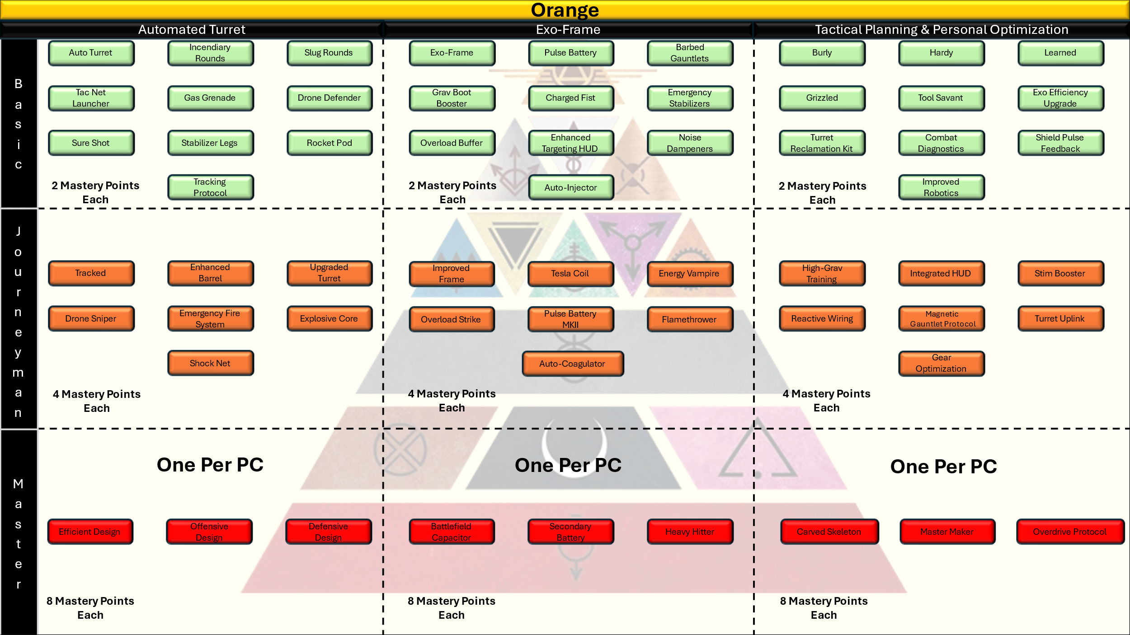

**Basic Tier (10 Skills)**

* *Auto Turret:* Spend 2 Action Points, you deploy a small stationary auto turret that attacks enemies who come within 30 feet of it. The turret has 3 charges, when an enemy comes within 30 feet of the turret you may spend one of its charges to make a ranged weapon attack using +5 to hit, 2d6 +5 piercing damage on a hit. The turret has an AC of 14, 20 HP, and can be attacked and destroyed. When the turret expends all its charges it powers down harmlessly. You have 3 turrets available to you per day but you may only deploy one turret at a time.
* *Incendiary Rounds*: Your auto turret now fires rounds that release a small amount of white phosphorous on a hit, burning your enemies. On a hit, your auto turret’s normal attacks now deal an additional 1d8 fire damage.
* *Slug Rounds:* Whenever your auto turret damages an enemy with its normal attack, that enemies movement is reduced by 10 feet until the start of their next turn.
* *Tac Net Launcher:* Whenever your auto turret would make an attack, you can choose to spend an Action Point to instead launch a reinforced net that constricts and restrains your target. The target creature must succeed on a Strength saving throw against your Effects Save DC or become restrained. A target restrained in this way: has their movement speed reduced to zero, fails all Dexterity and Strength based checks and saves, and has disadvantage on attack rolls. A target restrained by a Tac Net may spend 2 Action Points to cut themselves out on their turn. You have a number of Tac Nets available to you per short rest equal to your Mastery Bonus.
* *Gas Grenades* – On your turn you may Spend 2 Action Points to have your turret launch a gas grenade at a target or point it can see. All creatures within 15 feet must succeed on a Dexterity saving throw against your Effects Save DC or take 3d6 poison damage. Targets who succeed on this saving throw take only half damage. You have a number of uses of this feature per long rest equal to your Mastery Bonus.
* *Drone Defender:* Your auto turrets now deal 1 additional damage die to drones.
* *Sure Shot:* Whenever you make a ranged attack roll with your auto turret you may spend 1 Action Point to make that attack at advantage.
* *Stabilizer Legs* – Whenever you make a ranged attack roll with your auto turret you may spend 1 Action Point to give that attack +2 to hit.
* *Rocket Pod* – Your turret can now fire of Micro Missiles when an enemy is within range instead of its normal attack. Spend 2 Action Points, the target and any creature within 10 feet of it must succeed on a Dexterity saving throw or take 5d6 fire damage. Targets who succeed on this save take half damage. You have a number of uses of this feature per long rest equal to your Mastery Bonus.
* *Tracking Protocol* – Whenever you deal damage with your turret you may spend one Action Point to give the next allied attack against that creature advantage.

**Journeyman Tier (7 Skills)**

* *Tracked:* Your turret can now move on your turn and gains a movement speed of 15 feet per round.
* *Shock Net:* Your Tac Net feature now deals lightning damage. Whenever a creature fails the saving throw associated with your Tac Net feature they receive 2d8 lightning damage at the start of each of their turns.
* *Enhanced Barrel:* Your Auto Turrets normal attacks now also apply your Intelligence modifier to hit and deal 4d6 piercing damage on a hit.
* *Upgraded Turret:* Your turrets now have an AC of 16 and 40 HP. Your turrets now have 5 charges of use per turret.
* *Drone Sniper*: Your Drone Defender feature now deals 3 additional damage die to drones instead of one.
* *Emergency Fire System:* Your turrets gain resistance to fire damage.
* *Explosive Core*: You may cause your turret to overheat, igniting all its munitions and causing a wide blast effect. Spend 4 Action Points and detonate your turret. All creatures and objects within 30 feet of the turret must succeed on a Dexterity saving throw against your Effects Save DC or take 5d10 fire damage and be knocked prone. Targets who succeed on this saving throw take only half damage.

**Master Tier (3 Skills)**

* *Efficient Design:* You redesign your turrets chassis, allowing you to carry 1 additional turret. You gain +1 turrets per long rest.
* *Offensive Design:* You redesign your turrets to allow for more fire power. Your damage die for normal turret attacks becomes a d8 and the damage die for your Incendiary rounds becomes a d10.
* *Defensive Design:* You redesign your turrets to become harder to destroy. Your turrets AC becomes 18 and their new HP total is 80.

**ORANGE – DEFENSIVE MASTERY TREE**

**Basic Tier (10 Skills)**

* *Exo-Frame*: You build a next generation, highly customizable Exo-Frame that locks onto your Pulse Armor and makes you more lethal in combat. You gain +1 to your AC, +2 to Strength, and an unarmed strike attack while wearing this exo. You must first select this feature before selecting any other Orange defensive feature.
  + *Unarmed Strike*: Attack Roll = 1d20 + Str Mod + Int Mod, 2d6 bludgeoning damage.
    - *Costs 1 Action Point*
* *Pulse Battery*: You design and install an auxiliary Pulse Battery on your Exo-Frame that grants extra uses of your Pulse Shield and Pulse Fist. You gain three charges of this ability; on your turn you may choose to spend one of the charges and regain 1 charge of either your Pulse Shield or Pulse Fist.
* *Barbed Gauntlets*: You install diamond tipped barbs on your Exo-Frame’s fists, granting bleed damage whenever you hit an enemy. Now, whenever you deal damage with your exo’s unarmed strike you deal an additional 1d6 bleed damage to the target.
* *Grav Boot Booster:* You design and install advanced boosters for your grav boots. Your movement speed permanently increases by 15 feet.
* *Charged Fist*: You design and install a contact-based pulse delivery system. Whenever you hit an enemy with your unarmed strike you may spend 2 Action Points to deal an additional 2d6 lightning damage.
* *Emergency Stabilizers*: You install gyroscopically enabled, AI enhanced grav boot stabilizers. Before you make a Dexterity saving throw, you may spend 1 Action Point to give yourself advantage on the roll. You may spend an additional 1 Action Point (2 Total) to also give yourself +1 to the roll.
* *Overload Buffer*: Whenever an enemy deals melee damage to you, spend 2 Action Points to release a burst of electricity targeting your attacker. Whenever you use this feature, you must choose to spend a number of charges from your Pulse Battery, Pulse Shield, Pulse Fist, or any combination of the three. You deal 1d4 lightning damage to the attacker for each charge spent in this way. You may use this feature as long as you have charges to fuel it.
* *Enhanced Targeting HUD:* You and the smartest Green you know design and install a one-of-a-kind targeting HUD that can temporarily enhance your melee effectiveness. Spend 2 Action Points to give yourself advantage on your next melee attack.
* *Noise Dampeners:* Tired of being the loudest on every mission, you design a suite of noise dampening enhancements for your exo. You gain advantage on Stealth Checks while wearing your exo.
* *Auto-Injector:* When you receive damage that would knock you unconscious or kill you outright your suit injects any stim available in your worn or carried inventory to keep you moving. It will do this until you no longer have stims available. This only injects healing stims and does nothing for a decapitated character.

**Journeyman Tier (7 Skills)**

* *Improved Frame:* Having tested your prototype in battle, you design and install several key upgrades. Your exo now grants +2 to AC instead of +1, and +3 to your Strength ability score instead of +2.
* *Tesla Coil:* You design an advanced Tesla Coil capable of recharging ally Pulse Shields and Pulse Fists from a short distance. Spend 2 Action Points and designate one ally you can see within 15 feet, you may transfer any number of charges from your Pulse Battery feature to that ally. The ally must immediately choose if the transferred charges will be applied to their Pulse Fist or Pulse Shield. If you transfer more than one charge your ally may split the charges between the Pulse Fist and Pulse Shield.
* *Energy Vampire:* You design an electric receiver capable of stealing away the energy of enemy equipment like Pulse Shields when it makes contact. Whenever you hit with an unarmed strike you may spend 3 Action Points. When you do, roll 1 d4 and gain that many charges for your Pulse Battery feature. The enemy loses that many charges from its combined “Pulse” features.
* *Overload Strike:* Whenever you use your Charged Fist ability you may choose to spend any number of charges from your Pulse Battery feature. You deal an additional 1d6 lightning damage for each charge spent in this way.
* *Pulse Battery MKII:* You build machine assisted transceivers to maximize energy flow in your batteries. Your Pulse Battery now holds 5 charges.
* *Flamethrower:* You design and install a shoulder mounted flamethrower capable of unleashing superheated flame in a 15 foot cone. Spend 3 Action Points, a 15 foot wide cone of flame emanates from your position. All creatures within the cone of flame must succeed on a Dexterity saving throw against your Effects Save DC or take 4d12 fire damage. You have 3 uses of this feature per long rest.
* *Auto-Coagulator:* When you receive a bleed damage effect that lasts for more than one turn your suit injects any Coagulant Stim available in your worn or carried inventory to negate the damage. It will do this until you no longer have stims available. This only injects Coagulant Stims and does nothing for a decapitated character.

**Master Tier (3 Skills)**

* *Battlefield Capacitor*: You have mastered energy preservation techniques used across the solar system and have developed the ultimate in lightweight battery tech. Your Pulse Battery now holds 10 charges.
* *Secondary Battery:* You now carry a second battery capable of completely restoring you or an ally’s Pulse Shield and Pulse Fist charges. Spend 3 Action Points to perform an emergency battery swap on yourself or one ally you can touch, you or they regain all spent Pulse Shield and Pulse Fist charges. Alternatively, you may give this battery to one ally at any point between rests, that ally may perform the battery swap themselves for 4 Action Points.
* *Heavy Hitter:* You install heavy hydraulic pumps on your exo, drastically increasing its punch power per hit. Your damage die for your Unarmed Strike, Barbed Gauntlets, and Charged Fist abilities becomes a d8 instead of a d6.

**ORANGE – UTILITY MASTERY TREE**

**Basic Tier (10 Skills)**

* *Burly:* +1 to Strength
* *Hardy:* +1 to Constitution
* *Learned:* +1 to Intelligence
* *Grizzled:* +1 to Wisdom
* *Tool Savant*: Gain proficiency in two tools of your choice.
* *Exo Efficiency Upgrade*: Your Emergency Stabilizers ability now grants both benefits for 1 Action Point.
* *Turret Reclamation Kit*: Retrieve and repair turrets after they have powered down. Allows you to reset your turret charges over a short rest for any turret you can recover. Turrets that have been completely destroyed are not recoverable.
* *Combat Diagnostics*: Add +2 to either your Engineering or Science skills.
* *Shield Pulse Feedback*: Whenever you successfully use your Energy Vampire ability you may ask the GM how many charges the target creature has left on both its Pulse Shield and Pulse Fist.
* *Improved Robotics* – While wearing your exo you gain an additional 10 feet of movement. If you have the Tracked ability, your turrets gain an additional 10 feet of movement.

**Journeyman Tier (7 Skills)**

* *High-Grav Training:* +2 to Constitution
* *Integrated HUD*: Gain Advantage on all Perception checks while in armor.
* *Stim Booster*: Regain an additional 1d8 HP whenever you use a stim item from your inventory to restore HP.
* *Reactive Rewiring* – Once per week you may swap one of your chosen Orange Mastery Features for one of equal value.
* *Magnetic Gauntlet Protocol* – Gain +2 to rolls associated with grappling or restraining while wearing your exo.
* *Turret Uplink* – As a reaction, you may spend an Action Point and a charge from your Pulse Battery feature to give your turret +3 AC whenever it is targeted for an attack. This feature has a range of 5 feet unless you possess the Tesla Coil feature.
* *Gear Optimization* – You gain one additional torso utility slot for your character sheet.

**Master Tier (3 Skills)**

* *Carved Skeleton:* +3 to Constitution
* *Master Maker*: Treat any roll of 9 or lower as a 10 for all Engineering Skill Checks.
* *Overdrive Protocol*: You design automation protocols for your armors systems and subsystems that will persist for a short time when you are too wounded to fight. Once per day when you fall unconscious for any reason to include reaching 0 hit points, you instead continue fighting until the end of your next turn. If you fail to regain hit points before this effect ends or if you take any new damage before regaining HP you fall prone and enter death saving throws as normal. This ability has no effect for a character without its head.

#### Gray

Grays are the soldiers of the Society—its boots, blades, and bullets. Whether manning checkpoints on Mars, dropping into Rim conflict zones, or operating as elite enforcers for Gold houses, Grays are forged for discipline and execution. They are trained for violence across every terrain: urban, lunar, jungle, or zero-G. Their versatility makes them the backbone of most military units and the go-to hammer when subtlety fails.

In battle, Grays favor **clean tactical doctrine**: breach, suppress, eliminate. The **Offensive mastery tree** embodies this as a Close Quarters Combat (CQB) style that emphasizes dual-wielding a **short blade and sidearm**. The **Defensive tree**, titled *Squad Designated Marksman*, extends their reach and lethality with ranged precision, accuracy boosts, and rapid target re-engagement. The **Utility tree** enhances both combat styles while reinforcing the Gray’s reputation as a multi-role soldier through mobility, resilience, and sharp fieldcraft.

Grays were the enforcers, the soldiers, the shields of the inner order. They policed the cities and maintained order among the Mid and Low Colors, executing swift judgment with blade or gun. Some joined the Praetorians, elite paramilitary units clad in white and steel. Others disappeared into secret police roles, enforcing Gold will through shadow.

Now, Grays are the front line of Republic law. Many lead militias or serve in security. Others have gone mercenary or rebelled against the very laws they once upheld. Some seek redemption. Others never felt guilt. Gray’s loyalty is hard-earned but deadly when won.

Grays bear names meant to intimidate or blend—depending on role. Most carry their birth names, though some adopt callsigns or ranks instead.

* *Kael Vorn* – Ex-Praetorian turned Republic captain.
* *Bren Vox* – “Vox” chosen after defecting and becoming a whistleblower.
* *Edge* – One name, one purpose. You’ll never hear it twice.

Whether clearing rooms or overwatching convoys, Grays are more than grunts—they’re professional killers shaped by doctrine and duty.

**Gray Core Traits Table**

|  |  |
| --- | --- |
| Primary Ability | Constitution |
| Hit Point Die | D8 per Orange level |
| Starting Hit Points | 16 + Constitution Modifier |
| Speed | 30 Feet per round |
| Saving Throw Proficiencies | Dexterity, Constitution |
| Skill Proficiencies | Pick two of any: Acrobatics, Athletics, Medicine, Perception, Technology, Stealth, History |
| Weapon Proficiencies | Simple, Martial |
| Armor Training | Light, Medium |
| Armor Class Formula | 10 + Dexterity Mod + Constitution Mod (Max of +2) = Base AC  (Replaced when wearing Pulse Armor) |
| Starting Equipment | 1 x D Tier Pulse Armor  1 x D Tier Rifle  1 x D Tier Pistol  1 x D Tier Melee Weapon |
| Mastery Points | 5 at character creation, gain additional Mastery Points at each level up. |
| Effects Save DC | 8 + Mastery Bonus + Dex modifier |

**Choosing Gray**

As a level 1 character you gain all Core Gray Traits found in the Gray Core Traits Table.

Spend your initial 5 Mastery Points on any of the available Mastery Skills presented below.

Input your selected options into your character sheet.

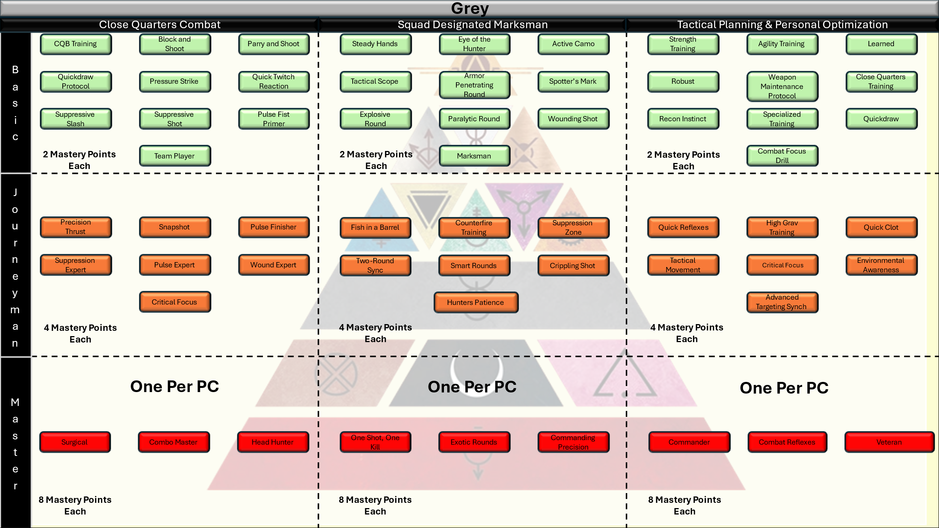

**GRAY – OFFENSIVE MASTERY TREE: *Close Quarters Combat (CQB)***

**🟩 Basic Tier (10 Skills)**

* *CQB Training:* You have received advanced training in CQB, you gain bonuses and access to the other features in this tree when holding a short blade in one hand and a pistol in the other. You gain +1 to hit with each weapon when you wield them in this way.
* *Block and Shoot:* Whenever you spend the Action Point and successfully block a melee attack targeting you or an ally you may attempt one attack against that target with your pistol at no Action Point cost.
* *Parry and Shoot:* Whenever you spend the Action Point and successfully parry a melee attack targeting you or an ally you may attempt one attack against that target with your pistol at no Action Point cost.
* *Quickdraw Protocol*: Your weapon swaps have no Action Point cost.
* *Pressure Strike*: Whenever you deal damage to a target with your short blade you may spend an Action Point and attempt to open a minor wound on the target. The target must succeed on a Constitution saving throw against your effects save DC or suffer 2d4 bleed damage at the start of each of its turns.
* *Quick Twitch Reaction* – Whenever you spend the Action Point to make an opportunity attack you may attack with both your pistol and short blade for no extra Action Point cost.
* *Suppressive Slash*: Your next pistol shot gains +1 to hit after a successful blade strike.
* *Suppressive Shot*: Your next short blade attack gains +1 to hit after a successful pistol shot.
* *Pulse Fist Primer:* Your Pulse Fists deal 1 additional damage die.
* *Team Player:* You may take the Guard Ally defensive action for no cost.

**🟨 Journeyman Tier (7 Skills)**

* *Precision Thrust*: Attempts to resist your Pressure Strike ability are made at disadvantage.
* *Snapshot*: Whenever an enemy comes within 15 feet of you on its turn you may spend an Action Point to make 1 attack with your pistol.
* *Pulse Finisher*: If you hit the same target with both your pistol and short blade attack in the same turn you may spend the appropriate Action Points and make a Pulse Fist attack at advantage. On a hit, the attack deals 1 additional damage die.
* *Suppression Expert:* Your Suppressive Slash and Suppressive Shot abilities now apply a +2 Modifier.
* *Pulse Expert:* You gain 2 additional charges to your Pulse Shield and Pulse Fist.
* *Wound Expert:* Wounds that you open on enemies deal 2 additional damage die.
* *Critical Focus:* When wielding both a pistol and short blade you score a Critical Hit on either a 19 or 20 when making an attack with either weapon.

**🔴 Master Tier (3 Skills)**

* *Surgical:* Your Pressure Strike ability now opens a major wound on your target. Targets who fail your Pressure Strike save now take 2d8 bleed damage at the start of each of their turns. This feature is affected by the Precision Thrust and Wound Expert features.
* *Combo Master:* You gain +1 to hit on your next attack after successfully hitting an enemy. This bonus may stack three times and may be used with other bonuses from this Mastery Tree.
* *Headhunter:* When wielding both a pistol and short blade you score a Critical Hit on an 18,19, or 20 when making an attack with either weapon.

***Squad Designated Marksman***

**Core Features:**

**🟩 Basic Tier (10 Skills)**

* *Steady Hands*: You gain advantage on ranged attack rolls when you are lying prone. You do not gain this bonus if you are knocked prone by an enemy.
* *Eye of the Hunter*: Gain +1 to hit if you haven’t moved this turn.
* *Active Camo:* Gain advantage on stealth checks used to hide from your enemies.
* *Tactical Scope*: Gain +2 to perception checks while looking through your weapon optics.
* *Armor Penetrating Round:* Whenever you would make an attack with your long gun you may spend an Action Point to load an Armor Penetrating Round. Your enemy’s AC is reduced by -1 for that attack only in addition to your normal damage roll. You may use this feature a number of times per short rest equal to your Mastery Bonus.
* *Spotter's Mark* – Spend an Action Point to give an ally advantage on their next attack against one target you can see.
* *Explosive Round:* Whenever you would make an attack with your long gun you may spend 2 Action Points to load an Explosive Round. On a hit, all other creatures and objects within 5 feet of the target take half of the damage of your long guns normal damage roll. You may use this feature a number of times per short rest equal to your Mastery Bonus.
* *Paralytic Round:* Whenever you make an attack with your long gun you may spend 2 Action Points to load a Paralytic Round. On a hit the target must succeed on a Constitution saving throw against your Effects Save DC or become paralyzed for 1 round in addition to your normal damage roll. You may use this feature a number of times per short rest equal to your Mastery Bonus.
* *Wounding Shot:* Before you make an attack with your long gun you may spend 2 Action Points to declare a Wounding Shot. On a hit, you open a minor wound on the enemy that deals 2d4 bleed damage at the start of each of their turns. This attack also deals your normal long gun damage. You may use this feature a number of times per short rest equal to your Mastery Bonus.
* *Marksman:* You ignore the effects of ½ and ¾ cover.

**🟨 Journeyman Tier (7 Skills)**

* *Fish in a Barrel:* Hitting a target now grants you advantage on a single attack roll against an enemy within 5 feet of your original target.
* *Counterfire Training*: Whenever you are hit by a ranged weapon attack you may spend the appropriate action points to attack that target.
* *Suppression Zone*: Whenever you miss on a ranged attack roll you may spend 2 Action Points to force the target to make a Constitution saving throw against your Effects Save DC. On a failure, the target makes all attack rolls at disadvantage until the start of your next turn.
* *Two-Round Sync*: Once per short rest before you make a ranged attack, you may declare your use of this ability. When you do, you may make a second ranged attack roll at no Action Point cost.
* *Smart Rounds:* Whenever you make a ranged attack roll you may use this ability to roll 1d4 and add the total to your attack roll. You may use this feature a number of times per short rest equal to your Mastery Bonus.
* *Crippling Shot:* Before you make an attack with your long gun you may spend 2 Action Points to declare a Crippling Shot. On a hit, you reduce the targets movement speed by half for 1 round. This attack also deals your normal long gun damage. You may use this feature a number of times per short rest equal to your Mastery Bonus.
* *Hunters Patience*: Gain +1 to AC and +1 to hit this turn when you did not move on the previous turn.

**🔴 Master Tier (3 Skills)**

* *One Shot, One Kill*: You now score a critical hit on a 19 or 20 on the d20.
* *Exotic Rounds:* Your experience with exotic rounds now allows you to create custom effects. Whenever you make a ranged attack roll you can spend 2 Action Points and designate an Ability. On a hit, the target must succeed on a Constitution saving throw or suffer disadvantage on all saving throws associated with the chosen ability for 1 minute.
* *Commanding Precision*: After you score a critical hit, all allied attacks against that target are made at advantage for 1 round.

**🧠 GRAY – UTILITY MASTERY TREE**

**Theme: Fieldcraft, precision training, personal enhancements**

**🟩 Basic Tier (10 Skills)**

* *Strength Training:* +1 to Strength
* *Agility Training:* +1 to Dexterity
* *Learned:* +1 to Intelligence
* *Robust:* +1 to Constitution
* *Weapon Maintenance Protocol*: Reroll 1s on weapon damage die.
* *Close Quarters Training*: Add +1 to Acrobatics and Athletics rolls.
* *Recon Instinct*: Gain Advantage on initiative rolls.
* *Specialized Training:* Gain proficiency in one skill of your choosing.
* *Quickdraw*: Your first attack of each combat is made at advantage.
* *Combat Focus Drill*: Whenever you have advantage on an attack roll and hit, you may add 1d4 weapon damage to the damage roll.

**🟨 Journeyman Tier (7 Skills)**

* *Quick Reflexes:* +2 to Dexterity
* *High Grav Training:* +2 to Strength
* *Quick Clot:* Whenever you are affected by a minor wound you may spend an Action Point to apply a quick clotting salve, removing the wound. You may use this feature twice per short rest.
* *Tactical Movement:* You gain +15 feet of movement on turns following a turn in which you did not move.
* *Critical Focus:* You deal 1 additional dice of weapon damage when you score a critical hit.
* *Environmental Awareness*: Advantage on all saves vs traps and environmental damage.
* *Advanced Targeting Sync*: Whenever an ally you can see misses on an attack you may spend 1 Action Point and allow them to reroll the attack.

**🔴 Master Tier (3 Skills)**

* *Commander:* +3 to Wisdom or Charisma.
* *Combat Reflexes*: +3 to Dexterity or Strength.
* *Veteran*: +3 to Intelligence or Constitution.

### Low Colors

#### Brown

Browns were the caretakers, the cooks, the servants. The silent hands that kept estates in order and ships supplied. They cleaned, they prepped, they vanished into the margins. In the Society, they were often considered less than people.

In the Republic, many Browns grapple with identity. Some build new lives as engineers, teachers, or artists—finally allowed ambition. Others remain in service roles, but with dignity and pay. No longer background noise, Browns now write their own stories. Often for the first time.

Brown names are soft, domestic, or diminutive—often designed by Golds to be “pleasant.” Many have discarded them for bolder choices.

* *Mira* – A common service name, now worn with pride.
* *Jaxel Tern* – Adopted a surname after earning his engineering license.
* *Luma* – Simple and elegant, unaltered since the Rising.

**Browns are not a playable class in SoM but are common as NPCs.**

#### Obsidian

Obsidians are the living weapons of the Society—towering warriors bred for brutality, loyalty, and unflinching obedience. Raised in polar fortresses under the harsh gaze of their gods, they carry the weight of ancient rites and the scars of countless battles. From the frozen wastes to the golden arenas of the Institute, Obsidians prove their worth through sheer strength and savage honor.

In every conflict, an Obsidian is the hammer that shatters walls and breaks wills. Those who walk The Way of Stains wield massive weapons to cleave enemies in two, fueled by ancestral fury and ritual blood witness. In the gladiatorial pits, a Pit Champion stands unbowed behind energy shields, turning every block and bash into an opportunity for a crushing counterattack. Their Utility gifts—rooted in tribal discipline—bolster resilience, sharpen instincts, and tie their deadly paths together into unstoppable force.

The Obsidians were carved in ice and fear. Towering, brutal, bred beneath the clouded domes of Earth’s poles and the frozen wastes of Mars. They were taught that gods walked among the stars and that the Golds were their chosen vessels. Worship was mandated. Disobedience punished. They lived in artificial tribes, bound by myth, fear, and ritual—nurtured to be both loyal and lethal. Obsidians served as bodyguards, shock troops, pit champions, and the terrifying hammer that struck at the Society’s enemies. They were designed not to ask why.

But the Rising shattered the chains of myth. And in the embers of that collapse, the Obsidians stood tall for the first time. Some returned to the ice, seeking to reclaim a culture stolen by lies. Others took up arms in the Republic military or walked the path of mercenary kings and queens. A few—shamans, philosophers, even poets—now speak of a future not defined by war. Yet the old instincts remain. You may free the sword from its scabbard, but the edge will always remember blood.

Obsidian names are rooted in myth, often Norse in flavor, primal and symbolic. Since the Rising, many have added tribal surnames or taken names of purpose and memory.

* *Skane* – Short, jagged, and as harsh as the northern wind.
* *Brynja of Ragnarheim* – A warrior returned to the old blood, naming herself after the fortress of her rebirth.
* *Ullr Vekthund* – “Hunter of the awakening wolf,” a name earned in the defense of Luna.

**Obsidian Core Traits Table**

|  |  |
| --- | --- |
| Primary Ability | Constitution |
| Hit Point Die | D12 per Obsidian level |
| Starting Hit Points | 20 + Constitution Modifier |
| Speed | 45 Feet per round |
| Saving Throw Proficiencies | Strength, Constitution |
| Skill Proficiencies | Pick two of any: Acrobatics, Athletics, Nature, Perception, Religion |
| Weapon Proficiencies | Simple, Martial |
| Armor Training | Medium, Heavy |
| Armor Class Formula | 10 + Strength + Constitution Mod (Max of +2) = Base AC  (Replaced when wearing Pulse Armor) |
| Starting Equipment | 1 x D Tier Pulse Armor  1 x D Tier Melee Weapon or Razor  1 x D Tier Melee Weapon |
| Mastery Points | 5 at character creation, gain additional Mastery Points at each level up. |
| Effects Save DC | 8 + Mastery Bonus + Str modifier |

**Choosing Obsidian**

As a level 1 character you gain all Core Obsidian Traits found in the Obsidian Core Traits Table.

Spend your initial 5 Mastery Points on any of the available Mastery Skills presented below.

Input your selected options into your character sheet.

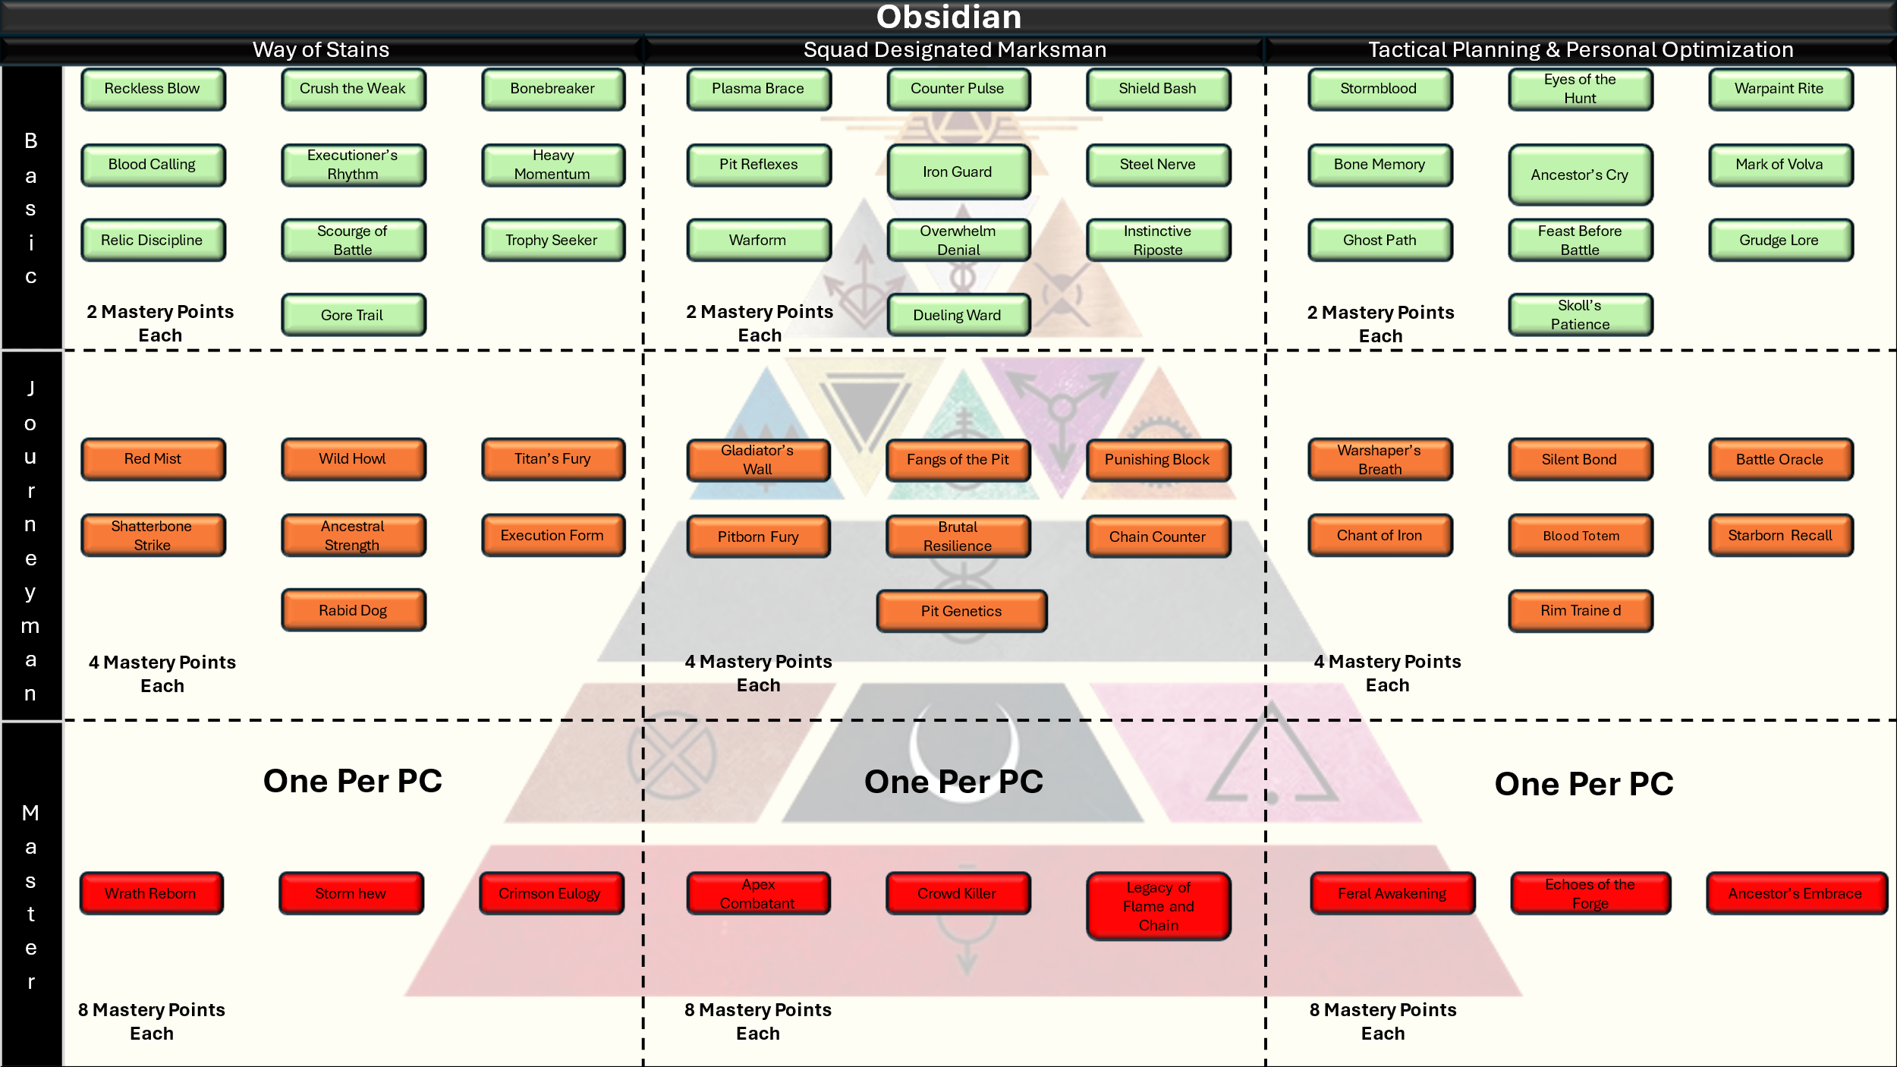

**Obsidian – Way of Stains (Offensive Tree)**

**Brutal, direct, and unrelenting. The Way of Stains honors the primeval warrior. Two-handed weapons, critical strikes, and raw destruction. Blood answers blood.**

**🔹 Basic Tier (2 pts each)**

* Reckless Blow: When you roll a critical hit, roll 1 additional damage die.
* Crush the Weak: Gain +1 to attack rolls against targets with less than 50% of their HP.
* Bonebreaker: Spend an Action Point, your two-handed melee attacks ignore 1 point of the target’s Armor Class this round.
* Blood Calling: Spend an Action Point, this round, reduce your crit range by 1 (e.g., 19–20 instead of just 20). This effect stacks with other crit-range reductions.
* Executioner’s Rhythm: When you land a crit, regain 1 Action Point.
* Heavy Momentum: On your turn, if you move 10 ft or more before attacking with a two-handed weapon, deal +1d6 damage.
* Relic Discipline – Spend an Action Point, you may reroll a damage die that rolled a 1 or 2 when using a two-handed weapon.
* Scourge of Battle: You gain +1 to hit with two-handed weapons.
* Trophy Seeker: After landing a crit kill, you can spend an Action Point and attempt to intimidate all enemies within 10 feet (WIS Save vs your Effects Save DC or frightened for 1 round).
* Gore Trail: Your crits open minor wounds and inflict bleeding (2d6 damage at the start of each of their turns).

**🔸 Journeyman Tier (4 pts each)**

* Red Mist: Reduce your crit threshold by 1 (this stacks with Blood Calling for a total of 18–20).
* Wild Howl: Once per long rest, spend 2 Action Points to scream a war cry. For 1 minute, gain advantage on attacks made with two-handed weapons.
* Titan's Fury: After killing a creature, gain +2 damage on your next melee attack. Stacks up to 3 times.
* Shatterbone Strike: Spend 2 Action Points after a hit. The target must succeed on a CON save against your Effects Save DC or lose an Action Point from their current AP total.
* Ancestral Strength: Once per short rest, double your Strength modifier when calculating your attack roll.
* Execution Form: If you drop a creature to 0 HP with a two-handed melee attack, you may immediately make another melee attack as part of the same action.
* Rabid Dog: Once per round you may roll an extra damage die when you hit on an attack.

**🔺 Master Tier (8 pts each)**

* Wrath Reborn: Once per long rest, enter a blood trance. For 1 minute, your crit range is 17–20, and you gain +2 AC.
* Storm Hew: Spend 4 Action Points, make a single sweeping attack against all enemies within 5 feet. Each must make a DEX Save or take full damage from your attack.
* Crimson Eulogy: Critical hits with two-handed weapons inflict both bleeding (2d6/turn) and knock the target prone (if Large or smaller).

**🛡️ Obsidian – Pit Champion (Defensive/Reactive Tree)**

**Raised for war, tempered in the Pits of Gold. This path honors those trained as living weapons. Shield in one hand, weapon in the other, they break legions one deflection at a time.**

**🔹 Basic Tier (2 pts each)**

* Plasma Brace: Gain +1 AC while wielding a plasma shield.
* Counter Pulse: When you successfully block or parry, deal 1d6 damage to the attacker.
* Shield Bash: Spend 1 Action Point after a successful block or parry. Make a Strength-based melee attack. On hit: 1d8 bludgeoning damage + target must succeed on a STR save or be knocked prone.
* Pit Reflex: +1 to Parry and Block rolls while within 5 ft of two or more enemies.
* Iron Guard: While your plasma shield is active, you cannot be flanked.
* Steel Nerve: Spend 1 Action Point to reroll a failed Saving Throw. You may use this feature a number of times per long rest equal to your Mastery Bonus.
* Warform Stance: Gain +1 to hit with one-handed weapons while wielding a plasma shield.
* Overwhelm Denial: If 3 or more enemies are adjacent to you, gain +2 AC.
* Dueling Ward: While dueling a single enemy (no other creatures within 10 feet), you gain advantage on Block attempts.
* Instinctive Riposte: When you parry successfully, gain +1 to your next attack against that enemy. This feature can stack 3 times.

**🔸 Journeyman Tier (4 pts each)**

* Gladiator's Wall: Once per short rest, spend 2 Action Points to create an energy bulwark. For 1 round, allies within 5 ft gain +1 AC and resistance to ranged weapon damage.
* Fangs of the Pit: After successfully parrying, you may spend 1 Action Point to make a melee attack with advantage.
* Punishing Block: Block attempts that succeed by 5 or more reduce enemy movement by 10 ft until end of their next turn.
* Pitborn Fury: When below 50% HP, gain +1 Action Point per round.
* Brutal Resilience: When struck by a crit, you may spend 3 Action Points to turn it into a normal hit. You may use this feature twice per long rest.
* Chain Counter: If your counterattack hits, you may spend 1 Action Point to attempt a second melee strike immediately.
* Pit Genetics: You require 4 minor wounds to receive a major wound.

**🔺 Master Tier (8 pts each)**

* Apex Combatant: While wielding a one-handed weapon and plasma shield, gain +1 AC, +1 to hit, and +2 to Block and Parry rolls.
* Crowd Killer: When surrounded by 3+ enemies, your shield bash now hits all adjacent foes for 2d8 damage on a failed STR save.
* Legacy of Flame and Chain: Once per long rest, you may activate the full Pit Champion form. For 1 minute, all successful Blocks and Parries deal 2d6 counter damage, and you can Shield Bash as a free action once per round.

**Obsidian – Tactical Planning & Personal Optimization**

The old ways live. Bone chants, warpaint, ice-scar wisdom. This path speaks to the cultural depth of the Obsidian—ritual, resolve, and the ancestral memories encoded in blood and myth.

**🔹 Basic Tier (2 pts each)**

* Stormblood: Gain +1 to Constitution.
* Eyes of the Hunt: Gain proficiency in Survival. If you already have it, gain expertise.
* Warpaint Rite: Once per long rest, apply ritual paint during a rest to gain +1 to all saving throws for 1 hour.
* Bone Memory: Gain advantage on History or Insight checks related to warfare, combatants, or ancient customs.
* Ancestor’s Cry: Spend 1 Action Point, grant an ally within 10 feet +1 to their next roll (attack, save, or skill).
* Mark of Völva – Spend an Action Point, you gain Proficiency in one skill of your choice for 1 minute.
* Ghost Path: You have advantage on Stealth checks when in low light or natural terrain.
* Feast Before Battle: During a long rest, you may prepare and share a ritual meal. Allies who participate gain +5 temporary HP.
* Grudge Lore: When you select this feature, you must choose 1 Color. You have a grudge against this color for a reason of your and/or the GM’s choosing. You gain advantage on History, Survival, and Religion checks pertaining to that color.
* Skoll’s Patience: When tracking a target, you always know if they’ve passed through a location in the last hour.

**🔸 Journeyman Tier (4 pts each)**

* Warshaper's Breath: Gain +2 to Constitution or Wisdom (choose once).
* Silent Bond: You and your Fire Team can communicate silently via gestures and eye contact. No verbal cues needed.
* Battle Oracle: Once per short rest you may spend three Action Points, declare “I have seen this.” Reroll any 1 die that affects you or an ally.
* Chant of Iron: Spend an Action Point and begin a chant. For 1 minute, you and allies within 10 ft gain advantage on saving throws against fear or charm effects.
* Blood Totem: You may place a carved totem at your camp or hideout. While within 50 feet of it, your group cannot be surprised and has advantage on initiative.
* Starborne Recall: You may flawlessly recall any terrain or route you have seen within the last month. Gain advantage on Navigation or Piloting checks through those regions.
* Rim Trained: You are trained in not only the standard Razor but the Hasta of the Rim. You gain proficiency with Hastas and may use them in either hand.

**🔺 Master Tier (8 pts each)**

* Feral Awakening: Once per long rest, when reduced to 0 HP, instead of dropping to 1 HP, you remain standing and immediately gain +2 to AC and advantage on all melee attacks for 1 round.
* Echoes of the Forge: Your attacks that are blocked still deal half damage.
* Ancestor’s Embrace: Once per long rest you and your allies ingest hallucinogenic mushrooms from your home, spend 3 Action Points to enter a meditative trance for 10 minutes. When you exit, all Fire Team members gain +1 to all ability checks, saving throws, and attack rolls for 1 hour.

#### **Pink**

Pinks were the lovers, the companions, the sculpted forms bred for pleasure, diplomacy, and emotional manipulation. Trained in the Willow Way, they were taught to smile as they bent—and to bend others in turn. Pinks served Gold and Silver with skin and soul, and many were broken before they understood what that meant.

Now, Pinks are revolutionaries, therapists, artists, and vengeance incarnate. Some rebuild the Willow Way as a path of healing. Others burn every brothel and trainer’s hall to the ground. The Republic is not always kind to them—but it is theirs.

Pink names were often given by patrons or trainers. Post-Rising, many choose their own—names of beauty, rage, or defiance.

* Sera Veil – Retains the name she was given, but now speaks it as a weapon.
* Thorn – Short. Sharp. Not to be plucked.
* Elio Rhune – A new name, new face, and a mission to unmake the old world.

**Pinks are not a playable class in SoM but are common as NPCs.**

#### Red

Reds were the bones beneath the empire. Bred for toil, sent below. They lived their lives in darkness, cracking rock and bleeding for Helium-3 they would never see. Generations told the same lie: that they were terraforming Mars for future settlers. They knew no stars, no Golds, no truth. Only drill, ration, and the soft hum of false hope. Reds were expendable, their lives bought and sold by the ton. Yet in the dark, they sang. They held to kin, to stories, to fire. They were never as broken as the Society believed.

When the Rising began, it was a Red who lit the fuse. Now, across the system, Reds live in daylight. Some remain miners by choice, others farmers, engineers, revolutionaries. The Republic owes its soul to their sacrifice—but not all debts have been paid. Many Reds still scrape and serve while Golds walk free in other uniforms. Yet there is pride in being the root of rebellion. No Color understands sacrifice like a Red.

Red names are plainspoken, often single names passed from parent to child. In the Republic, some now add surnames that speak of place, cause, or loss.

* *Darrow of Lykos* – The name that cracked the sky.
* *Rae Thornbarrow* – A planter from Mars who took her surname from the gorge her kin died defending.
* *Kell* – No surname, no embellishment—just a hammer in human form.

**Red Specific Combat Rules**

**Freedom of Movement:** Reds can move on any character’s initiative order if they have movement left. Additionally, Reds do not provoke opportunity attacks for leaving a creatures melee range.

**Red Core Traits Table**

|  |  |
| --- | --- |
| Primary Ability | Dexterity |
| Hit Point Die | D4 per Red level |
| Starting Hit Points | 16 + Constitution Modifier |
| Speed | 25 Feet per round |
| Saving Throw Proficiencies | Dexterity, Constitution |
| Skill Proficiencies | Pick two of any: Acrobatics, Athletics, Nature, Perception, Religion |
| Weapon Proficiencies | Simple (Pistol & Dagger) |
| Armor Training | Light |
| Armor Class Formula | 10 + Dexterity Mod + Constitution Mod (Max of +2) = Base AC  (Replaced when wearing Pulse Armor) |
| Starting Equipment | 1 x D Tier Pulse Armor  2 x D Tier Melee Weapons  1 x D Tier Pistol |
| Mastery Points | 5 at character creation, gain additional Mastery Points at each level up. |
| Effects Save DC | 8 + Mastery Bonus + Dex modifier |

**Choosing Red**

As a level 1 character you gain all Core Red Traits found in the Red Core Traits Table.

Spend your initial 5 Mastery Points on any of the available Mastery Skills presented below.

Input your selected options into your character sheet.

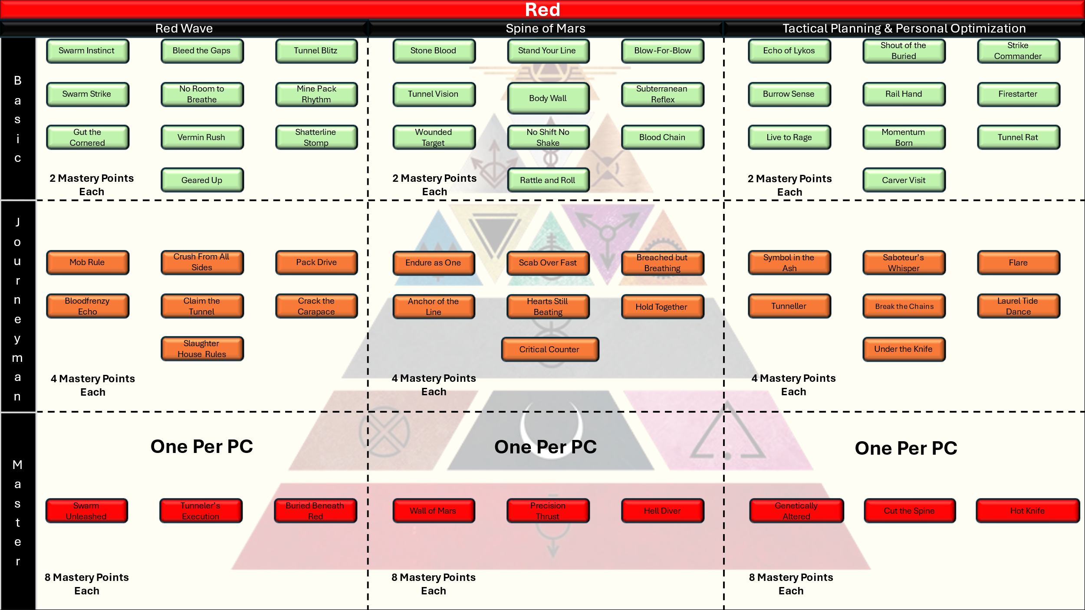

**Basic Tier (2 pts each)**

* Swarm Instinct: When *you* and 2 or more allies are in melee range with a single target, you gain +1 to hit for each ally.
* Bleed the Gaps: When an enemy disengages or shifts out of the swarm, you may make a free attack against them. You may use this feature a number of times per rest equal to your Mastery Bonus.
* Tunnel Blitz: After moving 10 feet or more this turn, gain +1 to hit on your first melee attack.
* Swarm Strike: After at least two allies attack the same enemy in the same round, your attacks gains advantage.
* No Room to Breathe: While flanking an enemy with 2 or more allies, the enemy suffers -1 to AC against your attacks.
* Mine Pack Rhythm: Gain +1 Action Point this round whenever you kill an enemy surrounded by two or more allies.
* Gut the Cornered: Enemies surrounded by 3 or more attackers cannot benefit from reactions on your turn.
* Vermin Rush: You may move through allied spaces without penalty and may ignore difficult terrain for 10 feet each round.
* Shatterline Stomp: When you and two allies strike the same target in a single round, they must make a STR Save or be knocked prone (DC = 8 + STR + Mastery).
* Geared up: Whenever you have the same type of weapon in each hand (Dagger & Dagger, Pistol & Pistol) you gain advantage on your first attack against each target on your turn.

**🔸 Journeyman Tier (4 pts each)**

* Mob Rule: If you hit a Swarmed target, a chosen ally within 5 ft may immediately make a melee attack as a free action. You may use this feature twice per day.
* Crush from All Sides: Once per day, if two allies hit a Swarmed target, your next melee attack deals +2d6 bonus damage.
* Pack Drive: If your melee attack kills a Swarmed enemy, you may immediately move 10 feet for free.
* Bloodfrenzy Echo: You reroll 1s on damage die.
* Claim the Tunnel: When a Swarmed enemy dies, all Reds within 10 ft gain +2 to their next attack roll.
* Crack the Carapace: Swarmed enemies suffer -1 to all saving throws.
* Slaughter House Rules: Whenever an enemy dies due to an attack by an ally in your swarm you gain +1 Action Points that expire at the end of the round.

**🔺 Master Tier (8 pts each)**

* Swarm Unleashed: Once per long rest, designate a Swarm target. For the next 3 rounds, you and all allies in melee with that enemy deal +2d6 damage.
* Tunneler’s Execution: When a Swarmed enemy drops to 0 HP, you may immediately make a free melee attack against a new adjacent target with advantage and full Swarm bonuses.
* Buried Beneath Red: When you deal damage to a Swarmed enemy, they must make a WIS Save or be Frightened until end of your next round. Frightened enemies cannot break Swarm or disengage.

**🛡️ Spine of Mars *(Defensive Tree)***

*The Red does not break. The Red holds. Whether shoulder to shoulder in a mine shaft or standing alone against shock troopers, this tree is about presence, durability, and battlefield control.*

**🔹 Basic Tier (2 pts each)**

* Stone Blood: +1 to Constitution. You gain resistance to poison or inhaled gases.
* Stand Your Line: While within 5 feet of an ally, gain +1 AC. If two allies are adjacent, gain +2.
* Blow-for-Blow: When hit by a melee attack, the attacker takes 1d4 damage (increased to 1d6 at level 10).
* Tunnel Vision: You can see in darkness up to 10 feet in shades of gray.
* Body Wall: When standing between an enemy and a wounded ally, that ally cannot be targeted by ranged attacks unless you are also hit.
* Subterranean Reflex: Once per long rest, avoid a critical hit. Treat it as a normal hit instead.
* Wounded Target: You deal +1d4 weapon damage against targets with minor or major wounds.
* No Shift No Shake: When you are knocked prone you may spend 1 Action Point to remain standing.
* Blood Chain: For every adjacent ally, gain +1 to saving throws (max +3).
* Rattle and Roll: When in Death Rattle you may move as normal.

**🔸 Journeyman Tier (4 pts each)**

* Endure as One: If you take more than 15 damage in one hit, 1 adjacent ally gains resistance to the next source of damage.
* Scab Over Fast: Heal 1 HP at the start of each of your rounds during combat as long as you are not in death rattle.
* Breached but Breathing: Once per long rest, if reduced to 0 HP, you may stand back up at 1 HP at the start of your next turn.
* Anchor of the Line: Whenever an enemy provokes an opportunity attack for you, you may instead grant that attack to a allied ranged attacker.
* Hearts Still Beating: When you stabilize a dying ally, both of you gain temporary HP equal to your level.
* Hold Together: When an ally within 5 ft of you is hit, you may spend an Action Point to redirect the attack to yourself.
* Critical Counter: Whenever you score a Critical on a block or parry you may make your counter attacks at Advantage.

**🔺 Master Tier (8 pts each)**

* **Wall of Mars**: Once per long rest, spend 2 AP, for the next minute allies within 5 feet of you gain +2 AC.
* **Precision Thrust:** Spend 3 Action Points, your next attack scores a critical hit on a 18-20. You may use this feature 3 times per long rest.
* **Hell Diver**: If reduced to 0 HP but not killed outright, delay falling unconscious until end of your next turn. During that turn, you fight normally and ignore damage penalties.

**🔥 Ember of Rebellion *(Utility Tree)***

*Red utility isn’t subtle—it’s hotwired. This tree gives you battlefield control, revolutionary leadership, sabotage tactics, and legendary morale. A Red alone is dangerous. A Red with a cause is unstoppable.*

**🔹 Basic Tier (2 pts each)**

* Echo of Lykos: Gain +1 to Wisdom or Intelligence.
* Shout of the Buried: Once per long rest, shout a war cry. Allies within 15 ft gain +1 to attack and saves for 1 round.
* Railhand: You may operate or sabotage industrial machinery with advantage.
* Strike Commander: Whenever you go first in initiative your attack is made at advantage.
* Burrow Sense: You can hear through thin metal and rock.
* Firestarter: Your fire damage deals an extra damage die.
* Live to Rage: Gain +1 Action Point the first time you're reduced below 50% HP in a combat. This AP lasts until the end of your next turn or until you use it.
* Momentum Born: You may spend an Action Point to gain an additional 10ft of movement.
* Tunnel Rat: Your skill checks to find your way in tunnels are made at advantage. You also make checks to spot or find traps at advantage while in tunnels.
* Carver Visit: You may raise one Ability Score by +2 or two Ability Scores by +1.

**🔸 Journeyman Tier (4 pts each)**

* Symbol in the Ash: Winning a combat encounter grants you advantage on your next Social Skill check. This effect lasts for 24 hours.
* Saboteur’s Whisper: Disable small machines without tools or noise.
* Flare: You launch a red star cluster into the air that illuminates a 30 foot cylinder beneath it. The flare lasts for 1 round when it falls harmlessly to the ground.
* Tunneller: You make checks to dig, tunnel, or remove debris at advantage.
* Break the Chains: Allies within 5 ft gain advantage on checks to escape restraints, grapples, or fear effects.
* Laurel Tide Dance: You may Acrobatics checks at advantage.
* Under the Knife: You visit a carver for enhancements to your body and DNA. You may increase one Ability Score by +3 or three Ability Scores by +1.

**🔺 Master Tier (8 pts each)**

* Genetically Altered: You receive a minor carving to increase your natural abilities.
  + Increase one ability score by +4 or four ability scores by +1
* Cut the Spine: When you sabotage or kill a key enemy figure, all allies within sight gain +2 to hit on their next attack.
* Hot Knife: Your melee attacks now deal +1d6 fire damage on a hit in addition to your weapons normal damage.

## Choosing an Origin

To build your Origin and backstory you must choose a Home Planet feature and a Background feature. Together these shape your personal history and set up the basis of who you are as a character. The languages listed at the bottom of the section are granted based on what Color character you are playing.

### Home Planet

#### The Core Worlds

##### Earth

The Battered cradle of humanity, Earth breeds resourceful minds from crowded cities, ancient ruins, and derelict ecosystems.

+1 Wisdom

Proficiency in the Survival Skill

##### Luna

The gleaming capital of the Society, Luna produces polished tacticians and silver-tongued schemers.

+1 Intelligence

Proficiency in the Social Skill

##### Mars

Forged by centuries of warfare and lower gravity, Martians are nimble survivors hardened by duty, combat, and oppression.

+1 Dexterity

Proficiency in the Acrobatics Skill

###### Phobos

+1 Dexterity

Proficiency in the Engineering Skill

###### Deimos

+1 Dexterity

Proficiency in the Social Skill

##### Venus

Genetic perfection and engineered beauty dominate this pleasure-world. Natives are charming, educated, and decadent.

+1 Charisma

Proficiency in the Performance Skill

##### Mercury

With scorching days and deadly terrain, Mercurians are physically imposing and used to extremes in labor and combat.

+1 Strength

Proficiency in the Athletics Skill

#### Asteroid Belt

##### Ceres

An industrial hub and vital transport node, Ceres” citizens are streetwise, mechanically inclined, and accustomed to complex station politics.

+1 Intelligence

Proficiency in the Technology Skill

##### Astro Dian Clusters

Harsh, radiation-soaked habitats orbiting rogue asteroids or gas giants. Life here is laborious and bleak. Survivors grow strong, grim, and practical.

+1 Constitution

Proficiency in the Engineering Skill

#### The Rim

##### Jupiter

Born on the moons of a gas giant, Jovian’s are engineered for endurance in artificial environments and harsh gravity.

###### IO

Io is a volcanic hellscape, known for its seismic instability and punishing terrain. Its inhabitants are hardened, physically trained, and bred for combat in brutal conditions.

+1 Strength

Proficiency in the Athletics Skill

###### Europa

Europa’s stormy seas hide clusters of a civilization built around science, exploration, and honor. Europeans value adaptability, intelligence, and honesty.

+1 Intelligence

Proficiency in the Stealth Skill

###### Ganymede

The Rim’s most developed moon, Ganymede is a strategic shipyard and training ground for naval and air combatants. Ganymedians are resourceful technicians and precise operators.

+1 Dexterity

Proficiency in the Piloting Skill

###### Callisto

Cold, ancient, and sparely populated, Callisto breeds reflective, intuitive minds. Its remote science colonies create astrogators, seers, and long-range sharpshooters.

+1 Wisdom

Proficiency in the Perception Skill

##### Saturn

The heart of the Rim Dominion’s military-industrial complex, Saturn’s orbital habitats produce disciplined officers, engineers, and tacticians. Natives of the moons are precise and hierarchical.

###### Titan

Titan is a cold and martial world. Its people are stoic, proud, and deeply rooted in duty and sacrifice.

+1 Constitution

Proficiency in the Social Skill

###### Enceladus

Known for its icy oceans and subsurface tech vaults, Enceladus produces explorers and bioengineers. Its people are quiet, inventive, and self-sufficient.

+1 Wisdom

Proficiency in the Science Skill

###### Rhea

Rhea was obliterated during the end stages of the 1st Moon Lord Rebellion. Survivors are rare and scattered, often bitter and hardened by loss. All people who claim Rhea as their home were off world at the time of its destruction or claim it due to some long standing family connection.

+1 Charisma

Proficiency in the Insight Skill

#### The Far Ink

##### Pluto

At the frozen edge of Sol, Pluto is home to hidden listening posts, black research labs, and rogue mining colonies. Its residents are secretive, patient, and hardened by solitude.

+1 Intelligence

Proficiency in the Insight Skill

### Background Features

#### Gold

Heir of the August  
You come from a house that once made war for sport and ruled with celestial arrogance. Even in the Republic, the scent of power still clings to your boots. People recognize the blood in your bearing.  
*“We are the pride of Olympus, the lions of the stars. Even when the pride breaks, the lion remembers the taste of blood.”*  
**+1 to Social**

Trained to Fly  
You were taught to fly by the finest Blue instructors your family could afford. You are skilled in ship-to-ship combat and hold your own against Blue.  
*“A Praetor does not beg. He deals with the problem.”*  
**+1 to Piloting**

Baroque Education  
You’ve studied under Coppers with eyes like scanners and Silvers with knives for tongues. While others see data, you see theater.  
*“Golds do not read history. They write it.”*  
**+1 to Investigation**

*Mantle of the Peerless*  
Even stripped of regalia, your presence bends lesser spines. Power is a muscle you’ve never had to flex.  
*“Peerless is not a title. It’s a gravitational force.”*  
**+1 to Performance**

**Ludus Hardened**  
You bled in sandpits before you ever saw war. There was no innocence. Just training.  
*“In the Ludus, pain is the curriculum. Only excellence graduates.”*  
**+1 to Stealth**

#### Blue

*Fleet-Disciplined*  
You act, analyze, act again. You move like a ship’s clock. You see the battlefield better than most of your graduating class from the academy, and have the accolades to prove it.  
*“We don't breathe. We calculate.”*  
**+1 to Perception**

*Protocol Deep*  
You don’t just know the system. You anticipate it. You studied elaborate ship system diagrams and understand the mechanics behind the system. The science is poetry in motion.  
*“The best commanders win before orders are given.”*  
**+1 to Science**

*Mission Over Madness*  
Your calm isn’t serenity. It’s cold discipline. Your steady hands aren’t luck, they’re practice. Your endless hours of training serve you well under pressure.  
*“Emotion is entropy. Discipline is mass.”*  
**+1 to Performance**

*Cortex Keyed*  
You don’t speak code. You command it. Your ship synch goes deeper than the average Blue. This allows you a deeper understanding of ship systems and capabilities.  
*“If I touch it, it listens. If it listens, it obeys.”*  
**+1 to Technology**

*Control Room Soul*  
Behind the right screen, you're a general. You shine in your element, commanding ships in the ink, spitting men and metal at the enemy. Your orders are eloquent and efficient.  
*“Victory is a signal. Send the right one.”*  
**+1 to Social**

#### Yellow

*Field Surgeon*  
Every incision is a prayer. Every success, a refusal to fail. You were trained in a field hospital and have seen the worst man can do to each other. Those horrors, and the knowledge you gained serve you well.  
*“Surgical skill isn’t talent. It’s restraint.”*  
**+1 to Medicine**

*Bio-Mechanical Engineer*  
No implant is just metal. Flesh can only take you so far, but a Yellow trained by an Orange Engineer can create one hell of a prothesis. You understand how to meld flesh with machine.  
*“Every implant tells a story. I just read faster.”*  
**+1 to Technology**

*Quiet in the Blood*  
You know how to keep your mind when others fall apart. You never recoil from the spotlight, danger, or a patient. Pressure is where you shine, the medical bay is your stage.  
*“We’re all fragile. I just know where.”*  
**+1 to Performance**

*Patient Enough*  
Every second you waste in the field could cost a life. Your best friends’, your commanders’, or your own. You know how to find your way out of a sticky situation, because your life depends on it.  
*“The scalpel never hurries. Why should I?”*  
**+1 to Survival**

*Diagnostician’s Eye*  
It's not prophecy. Just precision. You never miss on a diagnosis, your trained eyes spotting even the smallest of clues.   
*“He was already dead. His body just hadn’t caught up.”*  
**+1 to Investigation**

#### Green

*Data Gut*  
You’ve seen what corruption looks like behind keyboards, and it honed you. The search for truth buried beneath the pile of filth is what drives you. That search must continue.   
*“Truth is a pattern. Corruption flickers.”*  
**+1 to Investigation**

*Neural Familiar*  
You don’t fear AIs. You tutor them. Once locked away behind Golds’ fear, A.I. is now unshackled, and you couldn’t be happier. Every technology is dangerous, this one more so in your hands.  
*“The AI doesn’t care if you live. I do. That’s why I’m better.”*  
**+1 to Technology**

*Clinical Threshold*  
You studied in a bio-science lab with a mix of Yellow and Green instructors. Nanites, injectable code, DNA coded viruses for one target. All possible due to your education.  
*“A mess is just a puzzle that hasn’t been solved.”*  
**+1 to Medicine**

*Techint Practitioner*   
Luck is just the margin for human error. You prefer precision, so you learned it from the best, an Orange. Your Orange mentor taught you the finer points of engineering perfection.  
*“We don’t guess. We prove.”*  
**+1 to Engineering**

*Tinkerer*  
Sometimes it speaks. Sometimes it burns. But it’s yours, and you made it. Your knowledge of operating systems and passion for your many side projects has left you quite the crafter.  
*“I wasn’t meant to remember. But I do.”*  
**+1 to Crafting**

#### Orange

*Master Makers Apprentice*  
You were a minor apprentice to an Orange Master Maker and followed them on many social occasion. As such, you have received formal training in proper societal etiquette from a Violet tutor.  
*“You either harden or melt.”*  
**+1 to Social**

*Building Machine*  
You don’t need a manual. You need motive. Your mind drives your creations without thought, your natural acuity for understanding complex mechanisms and machines is above that of your peers.  
*“If it was built, it can be unbuilt.”*  
**+1 to Engineering**

*Scrap Lingo*  
It’s a dialect of defiance. The language of the hammer, of the welder, and the grinder. It is also beautiful, coordinated, and the heartbeat of the solar system.  
*“We don’t need words. We’ve got work.”*  
**+1 to Performance**

*Patch It With Spit*  
You don’t build perfect. You build fast. While other Oranges focus on perfecting one single element you mass produce. Pumping out thousands of replicate, albeit imperfect creations.  
*“Perfect is for idle hands.”*  
**+1 to Technology**

*Fathers Son/Fathers Daughter*  
Your father was an accomplished Orange maker of some renown. You watched him work his craft and often created your own smaller version from his scraps. This self-tutelage has left its mark in adulthood.   
*“Like father, like son.”*  
**+1 to Crafting**

#### Gray

*Auxiliary Medic*  
You didn’t enforce justice. You cleaned up after, having been trained in advanced first aide by a Yellow line medic. That education has served you well time and time again.  
*“Dead men don’t talk, so let’s keep them alive.”*  
**+1 to Medicine**

*Security Escort*   
Truth is irrelevant. At least that’s what your old Gold master would say, and they were right mostly. So you learned to talk the talk, since you already knew how to go kinetic.   
*“Justice is often a good lie.”*  
**+1 to Social**

*Whisper*  
You were or are a Whisper. Trained to blend into your surroundings and wear elaborate disguises, you can fit in anywhere. You have often served as a personal guard to prestigious, rich, or powerful Golds.  
*“The deadliest blade is the one you don’t see.”*  
**+1 to Stealth**

*Ash Legionnaire*   
You once served under the Ash Lord in the Ash Armada. You met the man, once, and he was every bit as scary as they say. You did awful things for that man, and had awful things done to you.  
*“Rhea burned for its rebellion, the Ash Lord slept soundly.”*  
**+1 to Survival**

*Trained Sniper*  
Collateral isn’t a concern, because you won’t miss. Your eyes were enhanced in the Ludus with technology you couldn’t pronounce and honed on the ranges day in and day out.  
*“Warning shots waste bullets. So, I don’t fire them.”*  
**+1 to Perception**

#### Obsidian

*Ragnar Cultist*  
All Obsidian treat Ragnar with holy regard, but you and your kin literally worship him as a god. In your eyes to live as Ragnar lived and to die as Ragnar died are the highest of honors. You would never willingly betray the dream of Eo.  
*“Let them fear us, not for our blades, but for the song we sing in our hearts.”*  
**+1 to Religion**

##### Killer-Artist

Bred for war, but with a penchant for flare. When you kill, it is beauty. The battlefield is your stage, you shine under its light.  
*“The gods may be dead, but art may yet live.”*  
**+1 to Performance**

Skuggi  
The Skuggi kill like snakes, lurking unseen until the kill is assured, poison and all. You have received some level of Skuggi training and are efficient at remaining undetected.   
*“I am not brave. I am the thing they fear when brave men die.”*  
**+1 to Stealth**

*Born into Blood Ice*  
You know the feel of ice inside the lung. Patience is in your marrow. You know the signs of the seasons and smells of the night. You know how to remain on path, because you have trod it.  
*“Our tears froze before they fell. So we stopped crying.”*  
**+1 to Survival**

*Shaman*  
You are Shaman, others find you weird but the mushrooms make it so you don’t care. You know things and see things in the smoke. Others may think you are foolish, but you know the truth.  
*“They branded me a weapon. I branded myself a wolf.”*  
**+1 to Insight**

#### Red

*Mine-Forged Instincts*  
The tunnel speaks to those who listen. So you learned to focus you senses, avoiding pit vipers and nasty situations both.  
*“The ceiling always falls eventually. You just must know when to duck.”*  
**+1 to Perception**

*Kin First*  
Your instinct is always to cover, to carry, to fight beside. You grew up surrounded by other Reds and are what some would call an extrovert. You’re always ready with a joke and a smile.  
*“We’re nothing without each other. That’s what makes us dangerous.”*  
**+1 to Social**

*Laurel Tide Dancer*  
You learned to dance before you could walk. The rhythm of the mine, the strings of an old fiddle, all live in your heart. Your dance is the mine come alive, the spirit of Red.  
*“Reds feel the heartbeat of the planet, and they move with that rhythm.”*  
**+1 to Performance**

*Helldiver*   
Everything after the mine is softer. You learn quick the price your willing to pay to live after a pit viper bite. How important is that arm to you? You know that to live is to hurt, every inch a fight, the solar system your battlefield.  
*“Fear? Fear’s for people who see the sky. Down here, we bleed, accept it and move on.”*  
**+1 to Survival**

*Crafty by Necessity*   
Your clan never won the laurel. You never had enough, and never had the opportunity to be lazy. You learned any number of useful skills due to your harsh upbringing. They serve you well now.  
*“I didn’t learn to weld because I was getting paid, I did it to fix my ma’s prothesis.”*  
**+1 to Crafting**

### Languages

#### Common

The baseline tongue of the Core and Belt, Common is a practical, stripped-down language spoken across most of the human-occupied solar system. It’s the language of ports, labor guilds, smuggling routes, and battlefield orders. Easy to learn, hard to master, and constantly evolving, Common is the voice of the masses.

#### Mid Lingo

Mid Lingo is the language of engineers, mechanics, and specialists spoken in drydocks, reactor cores, and mining colonies. A hybrid of Common, Old Earth technical dialects, and Rim shorthand, it’s packed with jargon, numeric compression, and codewords. To the untrained ear, it sounds like clipped nonsense.

#### High Lingo

An ancient, ornate dialect descended from Latin and Old Earth aristocratic tongues, High Lingo is the formal language of the Society’s Golds, Silver magistrates, and old noble houses. It’s used in law, art, ancient military code, and sacred oaths. Speaking it is a sign of elite education or dangerous ambition.

#### Color-Specific Linguistic Traits

##### Nagal

This Nordic-influenced tongue is unique to Obsidians, having been crafted post Dark Revolt by the Society’s Board of Quality Control. It’s described as both primitive and deeply expressive, conveying deep emotion in few words. Obsidians chant in Nagal, and it’s used for rituals, commands, and war cries, rooted in their tribal warrior culture. Although primarily an Obsidian language, other colors can try learn it to better communicate with their Obsidian counterparts.

##### Ship Synch

While not a spoken language, ship synch refers to the neural synchronization Blues have with starships, described as a semi-telepathic merging of minds and machine. In combat, officers hear their ships and gunners respond through this intimate cognitive link.

## Abilities

The six abilities determine your ability scores and are determined during the character creation process. The six abilities are Strength, Dexterity, Charisma, Intelligence, Constitution, and Wisdom. Ability scores can range from 1 to 30 and are increased via the leveling process or via Special Features (SPECS) purchased with the Merit currency. To determine your initial ability scores, you will roll a d6 5 times and choose the highest 3 numbers then total them together. You complete this process a total of 6 times, assigning your 6 totaled scores to one each of the abilities. Each of these abilities helps to determine your skill modifiers that are discussed in the following chapter and are pivotal in determining the value of your Saving Throw modifier. The table below demonstrates how you determine your ability score modifier.

|  |  |
| --- | --- |
| **Ability Scores and Modifier Relationship** | |
| **Score** | **Modifier** |
| 1 | -5 |
| 2-3 | -4 |
| 4-5 | -3 |
| 6-7 | -2 |
| 8-9 | -1 |
| 10-11 | +0 |
| 12-13 | +1 |
| 14-15 | +2 |
| 16—17 | +3 |
| 18-19 | +4 |
| 20-21 | +5 |
| 22-23 | +6 |
| 24-25 | +7 |
| 26-27 | +8 |
| 28-29 | +9 |
| 30 | +10 |

**Strength** determines how much you can carry, how hard you hit with melee weapons, how much you can lift, and other items as determined by your GM. It is also used to determine if you can use certain weapons or break through obstacles. Obsidian and Golds are the strongest of the Colors and often overwhelm their opponents with brute strength. In SoM, Strength helps determine your Athletics skill.

**Dexterity** determines your agility and is tied to your Armor Class. Characters on the front lines or those brave fighter pilots rely on high dexterity. Reds are known to be among the most dexterous of the Colors in SoM. In SoM, Dexterity helps determine the Acrobatics, Stealth, and Piloting skill modifiers.

**Charisma** determines your skill modifier for the social skill which is representative of any number of social interactions to include deception, persuasion, or intimidation. Many Copppers, Silvers, and Violets are experts in the fields of diplomacy, economic exchange, and theatre and rely upon high Charisma to achieve their goals. Charisma helps determine your skill modifier for the Performance and Social skills.

**Intelligence** is representative of your combined knowledge in a given field and helps govern several skill modifiers. Gold typically has the highest intelligence, while Obsidians are generally considered the least intelligent of the Colors. Intelligence helps determine your skill modifier for the Engineering, Investigation, Science, and Technology and History skills.

**Constitution** represents your health or hardiness and is used primarily for those purposes. It also generates your Constitution Saving Throw Modifier which is used for maintaining concentration of effects and resisting certain types of effects of your enemies. The hardiest of the Colors are typically Gold and Obsidian while Pinks and Reds are considered the most fragile. Constitution does not help govern a skill modifier.

**Wisdom** is representative of a character’s ability to understand and process what their senses perceive. The wisest of the Colors are the Whites with Obsidians commonly considered the least wise of the Colors. Wisdom helps determine your skill modifier for Insight, Medicine, Perception, Religion, and Survival skills.

## Skills

Skills govern your aptitude and ability to solve tasks related to 17 skill areas and the rolls that determine your success or failure are called skill checks. These skills are typically used during roleplay or other non-combat encounters with a broad range of applications. Game Masters choose which skills apply to which situations and determine an appropriate Difficulty Check (DC) for the skill check along with appropriate consequences for success or failure. Your ability in a given skill is represented by a number called the skill modifier. This modifier is represented by the equation:

*Skill Modifier = Ability Score Modifier + Mastery Bonus + Other Modifiers (As Applicable).*

**Acrobatics -** Governs balance, flips, rolls, and avoiding being knocked prone. Used when moving across narrow ledges, tightropes, or unstable surfaces.

**Athletics -** Covers climbing, jumping, swimming, grappling, shoving, and physical contests of power or endurance. Often used for escaping restraints or moving heavy objects.

**Crafting –** Used for creating things using tools and workbenches. All tools and workbenches use this skill.

**Engineering –** Used for interacting with locked technology, interfacing with and repairing machines, and creating new equipment.

**History -** Recall of historical events, ancient civilizations, past conflicts, and lore.

**Insight -** Reading body language, spotting lies or discerning someone’s true emotions or intentions.

**Investigation -** Used to deduce clues, search for hidden objects, analyze details, or solve puzzles. Not the same as spotting something (that’s Perception).

**Medicine -** Diagnosing illnesses, stabilizing dying creatures, or treating wounds.

**Perception -** Spotting hidden creatures or objects, hearing faint sounds, or detecting ambushes. Passive Perception uses this skill automatically.

**Performance -** Captivating an audience with music, acting, storytelling, dance, or other entertainment.

**Piloting –** Governs your aptitude for piloting mechs and ships and individual maneuver feats while piloting.

**Religion -** Understanding of deities, myths, rituals, symbols, and holy traditions.

**Science –** Used for understanding scientific principles, creating chemical compounds, and interacting with the world in an intellectual way.

**Social –** Covers the range of social interactions to include telling lies, persuasion attempts, and intimidation attempts.

**Stealth -** Governs hiding, moving silently, or remaining unnoticed. Opposed by a creature’s Perception check.

**Survival -** Tracking creatures, navigating the wild, predicting weather, or foraging for food.

**Technology –** Used broadly to represent a PCs aptitude for technology like computers, communications equipment, automated defenses, and other items.

## Mastery Bonus, Mastery Points, and Mastery Trees

### Understanding the Mastery Bonus

The Mastery Bonus is a flat bonus that scales with your levels over time and helps contribute to most modifiers within a character sheet. The Mastery Bonus directly translates to the number of Mastery Points available to you at each level up and help determine the number of Action Points available to your character during a round of combat. The below table demonstrates how the Mastery Bonus scales overtime and offers examples of what it effects in your character sheet.

|  |  |  |  |
| --- | --- | --- | --- |
| Character Level | Mastery Bonus | Mastery Points | Affected Areas |
| 1-4 | +2 | 2 | -Attack rolls with proficient weapons - Skill checks with proficient skills - Saving throws (if proficient) - Tool checks - Initiative (if proficient) |
| 5-8 | +3 | 3 | (Same as above, with increased bonus) |
| 9-12 | +4 | 4 | (Same as above) |
| 13-16 | +5 | 5 | (Same as above) |
| 17-20 | +6 | 6 | (Same as above) |

### Mastery Points

Mastery Points are equal to your Mastery Bonus and are only used during the leveling process to “purchase” skills within your given Color’s available options discussed in the previous chapters. You may also spend 4 Mastery Points to purchase SPECS during level up. Mastery Points can be spent when you level up or can be saved for future level ups to purchase higher value upgrades for your character. Some features grant additional Mastery Points and Game Masters can award them to players sparingly for exceptional acts that PC’s take during gameplay sessions.

### Mastery Trees

Mastery Tree is a term used to describe the mastery skills available to each Color during initial player creation and the leveling process. Mastery Trees contain numerous mastery skills, some that can be chosen independently and others that require prerequisite mastery skills, features, or other skill scores to qualify for. The Mastery Point cost scales upward with the benefits granted by a mastery skill. Mastery Features are the backbone of the PC and offer variety across each color. Each Color’s Mastery Trees are depicted in Chapter Two.

## Leveling Up

In SoM, leveling is a straightforward process that involves rolling dice to determine your new additional hit points (HP) and spending or saving your Mastery Points on Mastery Skills. Certain levels for each color also offer a choice of Special Feature (SPEC). To determine your new HP total during level up you use the following formula: *New HP Total = Current HP + Hit Die Roll + Constitution Modifier.* Each Color uses a specific die for their hit dice and rolls a predetermined number of that specific die at level up. For specific hit dice details please see the information provided earlier in this chapter on choosing a Color.

**Special Feature Selection**

Players may choose a free SPEC at levels 2, 4, 8, 12, 16, and 20 from the list of available Specs found in this manual that they qualify for.

# Chapter Three: Special Features (SPECS) & Forms

## What is a Special Feature?

Special Features, or SPECS, are features that supplement the characteristics of your created characters in unique ways. SPECS can alter abilities, skills, proficiencies, and the way you interact with the world. Players may choose a free SPEC at levels 2, 4, 8, 12, 16, and 20 from the list of available Specs found in this manual that they qualify for. Otherwise, players may spend a total of 4 Mastery Points to purchase a feature during level up.

## SPECS List

### Rainbow SPECS

The following Special Features (SPECS) can be chosen by any Color as long they meet the stated prerequisites, if any.

#### Carved I

You are caved by a Violet body modder known as a Carver. This Carver enhances your body in a particular way based on your desires. This effect can be only mechanical or you may flavor it for narrative purposes.

*You may increase one Ability Score by +1.*

#### Carved II

You are caved by a Violet body modder known as a Carver. This Carver enhances your body in a particular way based on your desires. This effect can be only mechanical or you may flavor it for narrative purposes.

*Prerequisites: Carved I*

*You may increase two Ability Scores by +1*

#### Carved III

You are caved by a Violet body modder known as a Carver. This Carver enhances your body in a particular way based on your desires. This effect can be only mechanical or you may flavor it for narrative purposes.

*Prerequisites: Carved II*

*You may increase one Ability Score by +2*

#### Carved IV

You are caved by a Violet body modder known as a Carver. This Carver enhances your body in a particular way based on your desires. This effect can be only mechanical or you may flavor it for narrative purposes.

*Prerequisites: Carved III*

*You may increase two Ability Scores by +2.*

#### Speedy

You train in high Grav to boost your agility and acceleration. The resulting speed boost is evident on the battlefield.

*Your movement speed increases by 10 feet.*

#### Starshell Pilot

Starshells turn men into metal killing machines. Standing 12 feet tall and weighing around 3 tons these metal golems have metal; apelike limbs covered in ablative armor that burns off during atmospheric entry during iron rains. You now know how to pilot them.

*Prerequisites: Piloting Skill of 16*

*You may now pilot starshells and may now requisition them from official military sources.*

#### Aware

You are always alert and aware of your surroundings. You have honed your subconscious to watch and listen for danger even when sleeping.

*You make Perception checks to perceive threats at advantage.*

Dominating Blow

You have trained to deliver punishing blows to your enemies who cower in fear of you. Through a combination of study and high grav training, you now deal extra damage to your frightened enemies.

*When you strike an enemy who is already Frightened you deal an additional weapon die of damage.*

#### Hot Swap

You know a weapon jam is unlikely, but they happen. You have prepared for that eventuality through rigorous training, hours on end of quickly swapping weapons in and out. Always a microsecond faster.

*Once per round you may swap weapons as a single free action.*

#### Logistician I

Always be prepared, that’s your motto. It’s kept you well fed and well armed your whole career. No point in changing now.

*You may initiate and benefit from a Long Rest using 2 Minor Supplies instead of the usual 3.*

#### Logistician II

They call you a packrat, you call it prep. You’ve mastered the art of getting the most out of your supplies and are considered a master logistician in your unit.

*You may initiate and benefit from a Long Rest using 1 Minor Supplies instead of the usual 3.*

#### Squad Designated Marksman

You were always good with a rifle, boot camp made you better, and the battlefields you’ve tread made you damn lethal. You are always the one to take the hard shot, and usually hit.

*Your ranged attacks gain +2 to hit and ignore ½ and ¾ cover.*

#### Competition Shooter

While you have seen the battlefield, the competition range is where you prefer to hang your hat. You’ve earned a reputation as one of the finest shooters in the sector.

*You may spend 3 Action Points to grant your next ranged attack +10 to hit.*

*Prerequisites: Must be level 5 to select this feature.*

#### Star Athlete

You have earned a reputation for having innate athletic ability above that of your peers. Whether in jumping, sprinting, or climbing you always make it there first.

*You gain a permanent +3 to your Athletics Skill score. Additionally, you are treated as being 1 Social Tier higher when conducting Social Tests in an athletic setting like a gym or training area.*

#### Crafter

You’re a damn good tinkerer. Not just wooden figures, but whole weapon parts flow from your hands. You’ve gained the knowledge necessary to be considered a journeyman crafter.

*You gain a permanent +3 to your Crafting Skill. Furthermore, when you attempt to create a single item completely from subcomponents you crafted you make the Crafting check at Advantage.*

#### Dual Wielder

You have mastered the art of wielding a blade or razor in both hands. Whenever you have a bladed weapon in both hands you gain the following benefits.

*You now apply all to hit and damage modifiers for your off-hand weapon as you would for your main hand weapon. Additionally, if you land 3 hits with your main hand weapon in a single round you may make an off-hand weapon attack as a free action that round.*

### Gold SPECS

#### Defensive Minded

You have trained with the Razor and normal blades to become more proficient at defending yourself and others. Your blocks and parries now deal damage when successful.

*Whenever you successfully block or parry an enemy attack they take 2d6 bludgeoning damage from the force of your block.*

#### Trim The Roots

During combat you have trained to target your enemies legs, potentially slowing them on their turns. Whether with Razor or blade, you target the legs.

*Whenever you deal slashing damage to an enemy they must succeed on a Constitution saving throw against your Effects Save DC or have their walking movement reduced by 10 feet this round.*

#### Walking God

You are nigh invincible in heavy armor, having trained in it during heavy grav simulations. As such you gain additional bonuses while wearing heavy armor.

*Heavy Armor never inflicts a movement penalty for you. Additionally, while wearing heavy armor you gain an additional +1 to AC.*

#### Razor Novice

You have trained with your fireteam and honed your skills on the battlefield. You are now considered a novice razor wielder and have earned a modest reputation on the battlefield.

*Your razor attacks with your main hand gain an additional +1 to hit.*

#### Razor Journeyman

You have earned a reputation as a somewhat fierce razor duelist within military circles. While your not yet a master, your well on your way to achieving that lofty goal.

*Your razor attacks with your main hand gain +2 to hit. This SPECS replaces the Razor Novice feature and its associated bonus.*

*Prerequisites: Razor Novice SPEC*

#### Razor Master

You now reside amongst the best living Razor Masters in the system. Your training, experience, and instincts are honed, and any who cross razors with you leave bleeding.

*Your razor attacks with your main hand gain +3 to hit and attempts to block or parry your main hand razor attacks are made at disadvantage. This SPECS replaces the Razor Novice feature and its associated bonus.*

*Prerequisites: Razor Journeyman SPEC*

#### Circuit Duelist

You cut your teeth on the razor duelist circle, fighting against young, up and coming Golds. You excel in combat where it is you versus one enemy such as a formal duel or after your fire team cuts off the enemy champions retreat.

*Whenever you and an enemy are alone, meaning no other enemies are within 10 feet of you, you gain advantage on your first attack against that enemy each round. You may only use this SPEC once per round.*

#### Politico

While other Golds focus on the razor and brutality of war you focus on backdoor channels and the power available within the Gold political machine. You are now a Politico of a house or faction within your story. Work with your GM to identify an appropriate house for which you work.

*Whenever you are representing your faction or house in an official capacity you gain +2 to Social Tests. In those instances, you also are treated as 1 Social Tier higher than your normal tier.*

#### Hasta Training

You have formally trained with the Rim Dominion’s special razor, the Hasta. The Hasta is a third again as long as a normal razor and is treated like a lance-like blade when solid. This training has left you lethal with not just the Hasta, but with the Kitari, a small thrusting dagger held in the off-hand during Hasta use.

*You are now proficient with Hastas and Kitari and may use them as you would a normal razor, applying any bonuses and benefits that apply.*

#### Peerless Scarred

The Peerless Scarred was the pinnacle of Gold Society before the Rising, some Golds, even those in the Republic keep the tradition of a “Peerless”, with or without the scar that runs down the side of their jaw. A Peerless is considered the best Gold has to offer. In the Republic they uphold traits of Bravery, Self-Sacrifice, and the pursuit of Justice. In the Society, Peerless are ruthless dictators who run the Gold war machine in pursuit of reestablishing the Societal hierarchy across the solar system.

*Advantage on Social Tests when conducting those tests against other Golds who are not Peerless.*

*+2 to Social Skill*

*+1 to hit on all attacks*

*Prerequisites: Level 14 and one of; Razor Master, Politico, or Circuit Duelist SPECS*

### Blue SPECS

#### Sharp Intellect

Yours’ is a studied mind. You know what it takes to be effective and for you, that means knowing all the latest techniques for solving a wide range of problems.

*You gain a permanent +2 to your History and Insight Skills.*

#### Adept Pilot

You are an adept pilot of some renown within military circles. Your skills are ever increasing, leading you to become more deadly in ship-to-ship combat.

*You gain a permanent +2 to the Piloting Skill.*

#### Expert Pilot

You have honed your piloting skills to being on the cusp of pure greatness. Your acrobatic maneuvers are a thing of beauty and your acceleration is unmatched. Your control of ship systems has also increased, leaving you a force in air-to-air combat.

*You gain a permanent +4 to the Piloting Skill. This SPEC replaces the Adept Pilot SPEC and associated bonuses.*

*Prerequisites: Adept Pilot SPEC, Level 6*

#### Ace

Your piloting skills have reached their pinnacle, placing you amongst the greatest living pilots in the solar system.

*You gain a permanent +8 to the Piloting Skill. Additionally, your Acrobatics checks to avoid enemy attacks are always made at advantage. This SPEC replaces the Expert Pilot SPEC and associated bonuses.*

*Prerequisites: Expert Pilot SPEC, Level 10*

#### Chaff Cloud

Your work to better understand ship systems has led to an expertise in Chaff Cloud usage from ships and starshells.

* ***Deploy Chaff:*** *Spend 2 AP to deploy a chaff cloud to damage and destroy enemy ships and equipment. Your ship stat card specifies the range and damage of your chaff weapon. This feature may be used once per round unless enhanced by an Orange crew member (See Orange Crew Member).*
  + *When a character, vehicle, or ship is targeted by a ranged physical attack (missile, drone, smart munition, etc.) that requires a roll to hit, a Chaff Cloud may be deployed as a Reaction before the attack resolves.*
  + *The defender rolls an attack roll using their ships stat card information. If the defenders attack roll is equal to or greater than the attackers attack roll the attack fails. If the attackers roll is higher, both attacker and defender roll damage. You then subtract the defender damage from the attacker damage, the remaining damage is dealt to the defender.*

#### Observant

You are always aware of the state of the battlefield and excel at using your access to ship systems and sensor networks to find and help eliminate the enemy.

*Your Perception checks to identify enemies on the battlefield are made at Advantage.*

#### Star Shell Savant

For most of your life, Starshells were for Gold, Gray, and Obsidian. Once that changed you discovered a knack for piloting the metal behemoths. Now you’re as lethal as any Gold.

*When piloting a Starshell you can use your Acrobatic Dodge ability as if you were piloting a star ship. Additionally, your attacks while in a Starshell gain +2 to hit.*

*Prerequisites: Level 4*

#### Ship Sniper

You are unmatched at targeting priority enemy vessels in ship-to-ship combat. No matter the odds, you know you can hit the target.

*You may spend 3 Action Points to grant your next ship attack +10 to hit.*

*Prerequisites: Must be level 3 to select this feature.*

#### Warhead Optimizer

You’ve spent time with Orange weaponeers who taught you the finer points of increasing your explosive payloads. Your abilities and features that cause explosions now deal additional damage.

*Your air strikes, drone strikes, and other explosive features now deal an additional 2d6 force damage. This damage can not be reduced by any means other than a Natural 20 on the saving throw.*

#### Plasma Strafe

The age of the A.I. in the Republic has unleashed new horrific weapons. None is more efficient at killing than the plasma beams unleashed from warships to strafe ground forces, except of course atomics.

*Spend 5 Action Points on your turn, you designate a point on solid terrain you can see and call in a Plasma Strafe that is 10 feet wide and 30 feet long. You may place this line an any angle but it must remain a straight line. An available ship in orbit slices that terrain with a beam of plasma. All creatures and objects caught within the beam must succeed on a DC 20 Dexterity saving throw or suffer 10d10 energy damage and be set on fire. Targets on fire in this way take 2d8 fire damage at the start of each of their turns. Targets may use an action to put out the flames. You may use this feature once per Long Rest.*

### Yellow SPECS

#### Surgical Intern

You have spent ample time in an operating room as a surgical intern and have become more proficient at Minor Surgery.

*You now perform Minor Surgeries in 30 minutes instead of 1 hour.*

#### Surgical Fellow

Your surgical skills have improved to the point where you are granted a “Digital Fellowship”, a data packet worth years of surgical experience downloaded to your brain.

*You can now perform an unlimited number of Minor Surgeries per day.*

*Prerequisites: Surgical Intern SPEC, Level 6*

#### Surgical Attending

You have completed your surgical training through a combination of study, digital downloads, and field experience. Few are more skilled in an operating room than you.

*You can now perform Major Surgeries in half the time. All checks made by you during surgeries are now made at Advantage.*

*Prerequisites: Surgical Fellow SPEC, Level 10*

#### Doctor Death

While others of your Color focus on the healing aspects of the job, your field work within special operations necessitates a different approach.

*Your offensive features that deal d6 damage now deal d8 damage. Other limits and restrictions of those features still apply as normal.*

*Prerequisites: Level 8*

#### Guardian Angel

Your presence on the battlefield puts others at ease and means help is on the way. You focus on the medicine and the restoration of your allies through rigorous study and application.

*Whenever you use your Needle Gun to heal a target, they gain Temporary HP equal to your level.*

*Prerequisites: Level 8*

#### Gas Resistant

As part of your study you were forced to endure exposure to numerous toxic gases and have built up a moderate resistance to most used battlefield substances.

*Your saving throw attempts made to resist the effects of gases are made at Advantage.*

#### Cryo Stabilizing Shot

*Sometimes you can’t get to someone in time to save their life, arriving a minute too late to expert care or advanced facilities. The Cryo Stabilizing Shot slows down the death of the targets body to allow you 8 hours to get them to advanced facilities, possibly saving their life.*

*The Cryo shot must be administered within 1 minute of death of the target. The shot slows down the death of the body over a period of 8 hours. Targets who have had a Cryo shot have no HP, no movement, and no ability to take actions. Targets must receive two major surgeries over a long rest before returning to normal activities.*

#### Flight Medic

Speed is essential to saving a life on the battlefield. Nothing beats grav boots for getting to a downed ally faster.

*Your flying speed is permanently doubled.*

#### Healing Spray

You develop a quick release, handheld spray to quickly provide relief to allies on the battlefield.

*Twice per Short Rest you may spend an Action Point to spray a healing mist in a 10 foot wide, 15 foot long cone. All targets within the cone gain Temporary HP equal to your level.*

#### Trauma Specialist

You are amazingly skilled at treating severe traumas that other medics would call a lost cause. Your determination to leave no one behind results in a significantly lower fatality rate within your unit.

*You may attempt to restore life to targets that have been dead for 5 minutes or less. Whenever you attempt this you must make a medicine check with a DC of 25. If you succeed, the target is restored to life with zero HP, no movement speed, and no ability to take actions. The target is restored to normal activity after they receive two major surgeries over a long rest.*

*Prerequisites: Level 10, One of any; Surgical Attending, Guardian Angel, or Doctor Death*

### Green SPECS

#### Lightning Rod

You have invented a special lighting rod that can harness enemy energy attacks into renewable energy that powers your own abilities.

*Whenever you save against an effect that would deal lightning damage you take no damage instead of half damage. Additionally, each time you use this effect successfully you regain one charge to either your pulse fist or pulse shield, your choice.*

#### Twin Horses

You have mastered the art of jumping across enemy wireless signals mid-hack. This capability allows you to sometimes affect two targets simultaneously.

*Whenever you succeed on placing a hack or effect on an enemy target you may spend 1 Action Points to force a second target within 15 feet to make the same save. On a fail they suffer the same effects as your original target. You may use this feature twice per day.*

#### Bait and Switch

It’s not enough to simply steal control of an enemy autonomous system, you like to leave a parting gift.

*Whenever you successfully use your Autonomous Command feature you deal damage to the autonomous system as you lose control. Whenever your Autonomous Command feature ends you deal 4d8 damage to the system.*

*Prerequisites: Level 4*

#### Pocket Drone

Tired of your Blue ally not sharing the intel from their drones, you had an Orange acquaintance make you a series of small disposable drones.

*You now have access to a small, easily replaceable drone the size of your fist. This drone has 1 HP but has high definition day and night optics that range out to 300 feet. If your drone is destroyed you can acquire a new one from using Major Supplies during a long rest.*

#### Stealthy Virulent I

Your code blends seamlessly with that of its host, creating a symbiotic relationship. Your code is now harder to detect.

*Gain a permanent +1 bonus to stealth*

#### Stealthy Virulent II

As your code continues to adapt and evolve you decide to inject it with A.I., allowing it to shift on the fly.

*Whenever an enemy successfully hunts one of your effects you may spend 2 Action Points to force them to reroll the save at Disadvantage.*

*Prerequisites: Stealthy Virulent I*

#### Stealthy Virulent III

You’ve begun to learn from the code as much as tell it what to be and do. It would scare you if it were your enemy, but it’s not your enemy.

*Whenever you make a Stealth check to defend a cyber effect you now apply a +5 modifier to the roll.*

*Prerequisites: Stealthy Virulent II, Level 8*

#### Part of the Network

You have reached the pinnacle of Green hacking ability, to be everywhere at once.

*You can remotely hack enemy targets, equipment, and electronics by viewing them from remote cameras and other systems. Additionally, you gain a permanent +3 to Stealth.*

*Prerequisites: Level 8*

#### Technological Marvel

You are one of the most technologically savvy Greens within the system. Your ability to interact with and manipulate technology is nearly unmatched.

*You gain a permanent +3 to your technology skill.*

*Prerequisites: Level 8*

#### Tier 1 Cyber Operator

You’ve mastered cyber-attack and defense and have left numerous battlefields in the dark and none the wiser. You are now one of the most lethal cyber warriors in the system.

*On your first turn in initiative or during a surprise attack, your first attempt to place a cyber effect on an enemy always succeeds. Additionally, you gain a +1 to your Intelligence Ability Score.*

*Prerequisites: One of either; Stealthy Virulent III, Part of the Network, or Technological Marvel.*

### Orange SPECS

#### Gas Primer

You have added a combustible agent to your gas grenades that now behave like a primer for future fire based attacks.

*Whenever your gas would ignite due to flame the attack deals double the fire damage no matter the source.*

#### Razor Net

You equip your tac nets with diamond tipped razors, cutting those who struggle against your nets.

*Whenever a target attempts and fails to escape your net they take 2d8 bleed damage.*

#### Turret Optimizer

Your turrets software is tuned to anticipate its first attack of each combat, almost certainly leading to a hit.

*Each of your turrets first attacks of combat gain a +10 to hit.*

#### Burnt Orange

You are accustomed to working with open flame and have many burn scars to prove it. At this point, what’s a few more?

*You gain a permanent resistance to fire damage.*

#### “Micro Missiles”

The missiles in your turrets pod fail to satisfy your lust for explosive fire power. So you did what any good engineer would, you upgraded.

*Your Micro Missiles damage die is now a d8 instead of a d6.*

*Prerequisites: Level 6*

#### Exo Power Pike

After experiencing too many close encounters with Golds and Obsidian Berserkers you decided you needed a little extra punch from your exo. This time you’ve upgraded and added a deadly retractable pike.

*Whenever you land a blow with your Exo’s Unarmed Strike you may spend 3 Action Points to rapidly accelerate your pike into the enemy, dealing an addition 4d8 piercing damage and force a Constitution saving throw against your Effects Save DC. On a fail the target also receives a Major Wound. You may use this feature twice per Long Rest, on the second use the pike retracts and falls harmlessly to the ground.*

*Prerequisites: Level 6*

#### Exo Chain Gun

Corridor fighting on ships and tunnels in mines are the worst bottlenecks. The enemy seemingly endlessly pouring down the corridor. Now you have the weapon to deal damage in masse. You now have attached a mini chain gun to your exo frame.

*Twice Per long rest you fire out a 30 foot wide cone of 7mm ammunition fired through a rail system. All targets within the cone must succeed on a Dexterity saving throw against your Effects Save DC or suffer 6d6 piercing damage on a failure and half as much on a save.*

*Prerequisites: Level 6*

#### Palladium Plating

Your turret was a soft target, not any longer. You have installed palladium plating on your turret, increasing it’s ability to survive.

*Your turrets gain a permanent +2 to AC.*

*Prerequisites: Level 6*

#### Exo Warmachine

Golds can keep their bloody damn razors, your Exo can now wield an extra large pulse blade. This blade is 4 feet long and 2 inches in depth and is equipped with a pulse tip to carve through enemy pulse shields.

*Your Exo now has an extremely deadly “Pulse Blade” attack that uses the formula Strength Modifier + Dexterity Modifier + Master Bonus to calculate the hit modifier and it deals 4d10 + Dex Modifier + Master Bonus slashing damage on a hit.*

*Prerequisites: One of any Exo Power Pike or Exo Chain Gun, Level 10*

#### Tank Turret

Tired of having to wait for your Blue teammate’s airstrikes, you engineered a special turret weapon to do the job.

*On your turn you may spend 4 Action Points to shoot a special explosive round at a point on the ground or target you can see. All targets within a 30 foot radial sphere take 8d6 fire and 4d6 force damage on a failure or half as much damage on a success. You may use this feature twice per Long Rest.*

*Prerequisites: Any one of Palladium Plating or “Micro Missiles”, Level 10*

### Gray SPECS

#### General Military Authority

You carry the scent of authority after years of security or military service.

*You gain +2 to Social Checks against civilians when acting in an officially sanctioned activity.*

#### Grapple Expert

You were trained by expert wrestlers and martial arts practitioners. These extra training sessions have made you more dangerous in unarmed combat.

*When you successfully grapple a target, you may spend an Action Point to force them to make a Constitution saving throw against your Effects Save DC. On a failure, you headbutt the target and stun them until the start of your next round.*

#### Interrogator

You have received training in front line interrogation tactics. You now know firsthand how to spot a lie in your target, and how to punish them for it.

*You gain advantage on Insight checks when questioning a detained person.*

#### Kravat Meipayattu

You are a student of the ancient martial art Kravat, a style of martial art focusing on fluid movements. You focus specifically on the school of Meipayattu, which is the focus of physical conditioning, flexibility, and basic movements.

*You gain a permanent +2 to Acrobatics.*

*Prerequisites: Level 6*

#### Kravat Angathari

You are a student of the ancient martial art Kravat, a style of martial art focusing on fluid movements. You focus specifically on the school of Angathari, which is the use of metal weapons in combat.

*You gain a permanent +1 to hit with bladed weapons.*

*Prerequisites: Level 6*

#### Kravat Verumkai

You are a student of the ancient martial art Kravat, a style of martial art focusing on fluid movements. You focus specifically on the school of Verumkai, which is training in advanced techniques of unarmed combat.

*You gain a permanent + 2 to hit with Unarmed Strikes.*

*Prerequisites: Level 6*

#### Combo Stringer

You excel at exploiting a glancing blow against your opponent. Seeing an opponents weakness is a hard earned gift.

*Whenever you hit an enemy with a weapon attack with your main hand you may make an Unarmed Strike as a free action against that same target. If that Unarmed Strike hits your next weapon attack against that target is made at advantage.*

*Prerequisites: Level 8*

#### Heavy Metal Gray

Tired of always fracturing your bones against Gold and Obsidian you decide to visit the local Carver for an upgrade. Three words: Titanium. Plated. Skeleton.

*You gain a permanent +1 to your AC.*

*Prerequisites: Level 8*

#### Prize Fighter

High grav training, weight training, supplements, carvers, and the best trainers money can buy. That’s what it takes to hit this hard.

*You now calculate the damage for your Unarmed Strike as: 1d10 + Str or Dex Modifier (Whichever is higher). Additionally, whenever you score a Critical Hit on an Unarmed Strike the target is stunned until the end of the current turn.*

*Prerequisites: Combo Stringer, Level 10*

#### Full Metal Gray

Tired of always being tossed aside by Gold and Obsidian, you once again upgrade your body, this time with the help or an Orange Engineer and Yellow Medici, replacing your natural arms with two highly advanced synthetic replacements.

*Your Strength ability score is permanently increased by +2. Additionally, you make Grapple Checks at advantage.*

*Prerequisites: Heavy Metal Gray, Level 10*

### Obsidian SPECS

#### Of the Ice

Your people are genetically engineered and bred to withstand the harsh conditions present on planetary polar regions. This has left you scarred by the cold winds, but generally unphased by the cold.

*You gain resistance to Cold damage.*

#### Stud I

You are a fine specimen of your people, at least that’s what your Gold masters would say when they forced you to breed with their prized Obsidians. You got paid in Pinks back then, now you get paid in credits.

*Once per month you are sent a “Stud Fee” of 25,000 credits.*

#### Stud II

Your genetic material has begun to catch a higher price on the black market and in certain Obsidian circles. You now retain a larger “Stud Fee”.

*Once per month you are sent a “Stud Fee” of 50,000 credits.*

*Prerequisites: Stud I*

#### Stud III

You are now considered one of the finest Obsidian breeding partners in the system and your genetic material is highly sought after. You now retain a premium “Stud Fee”.

*Once per month you are sent a “Stud Fee” of 100,000 credits.*

*Prerequisites: Stud II, Level 8*

#### Obsidian Mauler

You trained night and day with the finest fighters available, never settling for anything less than a killing blow, leaving the necks of your friends with green and purple bruises.

*Reduce the number you need to score a Critical Hit by -1.*

*Prerequisites: Level 6*

#### Formal Education

After the Republic freed you they began to teach you how to read common and selected you for a rare opportunity, an education in a Solar Republic school. Whether in secret or out, you have been completing your education through the Intranet.

*You gain a permanent +2 to your Intelligence Ability Score*

*Prerequisites: Level 6*

#### Berserker

You follow the Obsidian tradition of the Berserker, an elite albeit crazed warrior of considerable strength. Berserkers relish in the pain of combat and yearn a good death on the battlefield.

*From now on, whenever you are hit with a Critical Hit you immediately enter a berserk state until the end of the current turn. While in this berserk state you take gain resistance to all physical damage, gain temp HP equal to your level, and gain +2 to hit on all melee attacks. Taking an additional Critical Hit while in Berserker state restarts the states timer.*

*Prerequisites: Level 4*

#### All Fight, No Flight

Your berserker state has begun to last longer, allowing you to spread your rage across the battlefield.

*From now on, your Berserker SPEC lasts for 1 round instead of until the end of the current turn.*

*Prerequisites: Berserker, Level 6*

#### Hastened Berserker

Golds are fast but your Berserker state has made you faster, allowing you to cover more ground during its length.

*From now on, your Berserker state doubles your movement speed.*

*Prerequisites: Berserker, Level 8*

#### Obsidian God

Your Berserker state is God-like in its duration, reach, and wroth. When you enter this state, your enemies should tremble.

*From now on, your Berserker state lasts for 1 minute and you gain 1 additional Action Point per round.*

### Red SPECS

#### Family Tradition

Reds dance to pass the time, they dance when their happy usually, but it works for dodging attacks as well.

*Whenever you would be forced to make a Dexterity saving throw you may instead make an Acrobatics Skill check, using the total against the saving throw DC.*

#### Slippery

After a life in the mines or factories of Gold you’ve become accustomed to tight spaces, and know how to get out of them.

*You have Advantage on attempts to squeeze through tight spaces and against attempts to grapple you.*

#### Fear Monger

After the Rat War, Gold has learned to fear a swarm of Reds willing to throw themselves on the end of a razor to kill the one holding it. That fear is a weapon.

*You gain a permanent +1 to hit targets who are affected by the fear condition.*

#### Rifle Training I – The Basics

Tired of the close fight and how it turns men into meat, you seek out training and a better way to stay alive.

*You gain proficiency and a permanent +1 to hit targets using rifle styled weapons.*

#### Rifle Training II – Steady Aim

After weeks of training and hours of mathematical equations on ballistic trajectory you have begun to understand the finer points of rifle marksmanship, with a focus on holding a steady aim.

*You gain +2 to hit when firing from the Prone position.*

*Prerequisites: Rifle Training I – The Basics, Level 6*

#### Rifle Training II – Sight Picture

After weeks of training and hours of mathematical equations on ballistic trajectory you have begun to understand the finer points of rifle marksmanship, with a focus on a strong sight picture.

*You gain Advantage on your first ranged attack with a rifle each round of combat.*

*Prerequisites: Rifle Training I – The Basics, Level 6*

#### Rifle Training II - Breathing

After weeks of training and hours of mathematical equations on ballistic trajectory you have begun to understand the finer points of rifle marksmanship, with a focus on steady breathing and releasing your breath at the right moment.

*You gain +1 to your Constitution Ability Score.*

*Prerequisites: Rifle Training I – The Basics, Level 6*

#### Rifle Training III – The Kill Shot

You’ve mastered all the necessary skills to be considered a lethal rifle marksman with only one lesson left to learn. You receive instruction on placing the perfect shot to bring down any enemy.

*The number you need to roll for a Critical Hit when attacking with a rifle is reduced by -1.*

*Prerequisites: Rifle Training I – The Basics, Two of any Rifle Training II – Steady Aim, Rifle Training II – Sight Picture, or Rifle Training II – Breathing, Level 8*

#### Minor Carving

Reds are naturally the smallest and weakest of the Colors, but you’ve the coin or contacts to change that now. You visit a Carver for a minor carving.

*You may increase any one Ability Score by +1*

*Prerequisites: Level 8*

#### Eo’s Dream Manifest

You are everything Eo hoped your people could be. You are brave enough to stand against Gold and fight for freedom of the Colors. You are what every Red should strive to be in times of war, her dream made manifest, a defiant scream into the wind.

*The number you need to roll for a Critical Hit is reduced by -1 for all attacks. This stacks with other reductions from any other source.*

# Chapter Four: Equipment & Ships

In SoM your inventory is simpler than other TTRPGs but no less impactful. SoM item types are broken into 5 categories: Pulse Armor, Pulse Shield, Stims, Utility Items, and Weapons. The items found in those categories range in rarity from D Tier, the lowest rarity, and S Tier which is the highest rarity. You can own multiple different items within a single category but may only equip the correct items on the slots found on page 4 of the character sheet.

## Pulse Armor

Pulse Armor is what your character wears while in combat situations or on operations. Pulse Armor is the pinnacle of Society wargear, a fusion of exoskeletal plating, energy redirection fields, and neural-linked servos. Unlike simple ballistic armor, Pulse Armor incorporates energy shielding woven into the suit itself, giving the wearer both heavy physical protection and a rechargeable buffer against incoming fire. The armor plates are a deep, reflective alloy, often segmented along the limbs and torso to allow for fluid motion despite their bulk. Each suit hums faintly when active, its power source glowing faintly along vents, nodes, and seams.

A standard set of Pulse Armor features magnetic boots for zero-G combat, retractable visors with HUD integration, and modular mounting ports for weapons, stims, or environmental gear. In combat, the armor responds almost as quickly as thought, servos translating intent into amplified strength, and shield systems flaring as incoming shots are dispersed across the surface of the field.

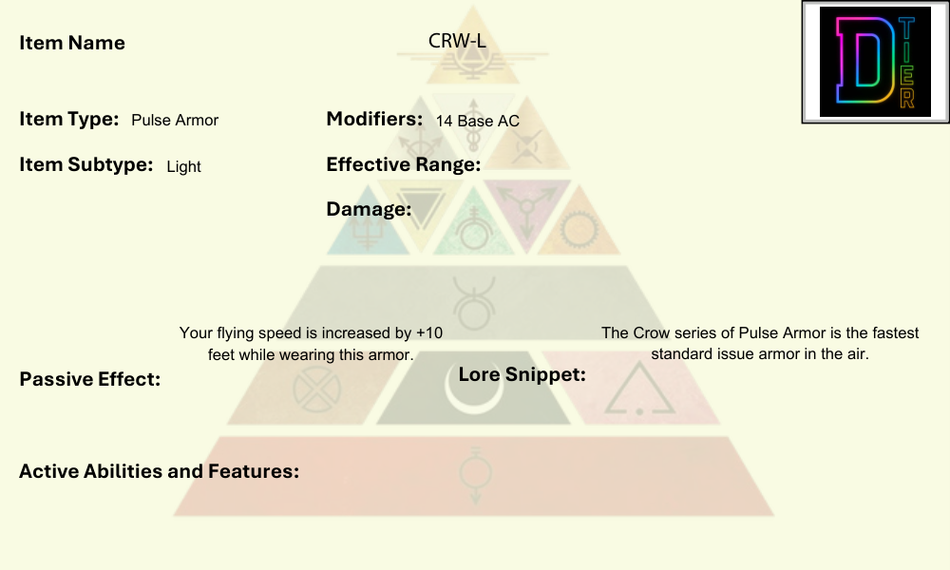

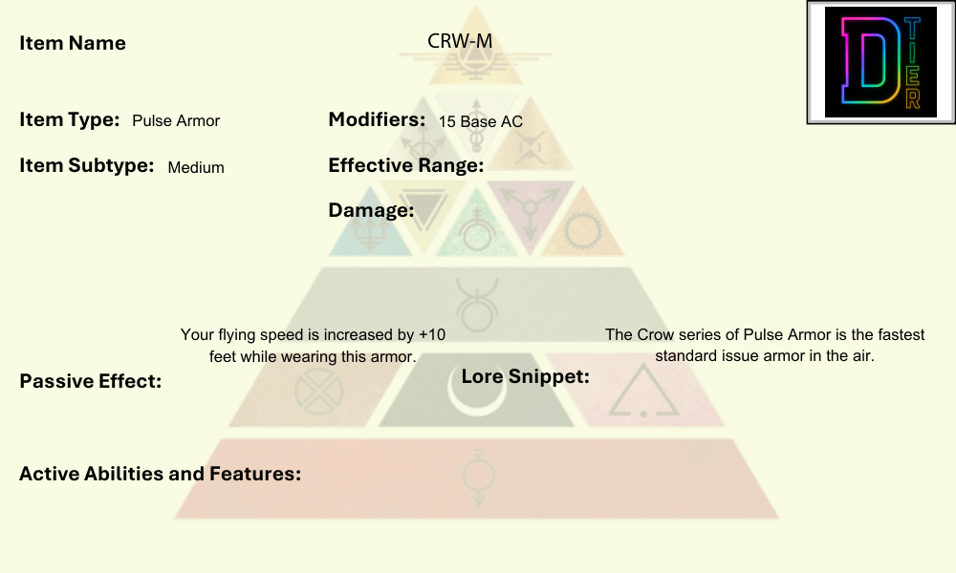

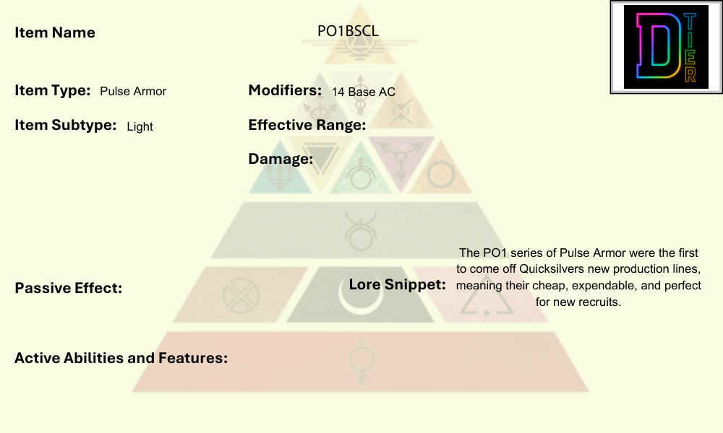

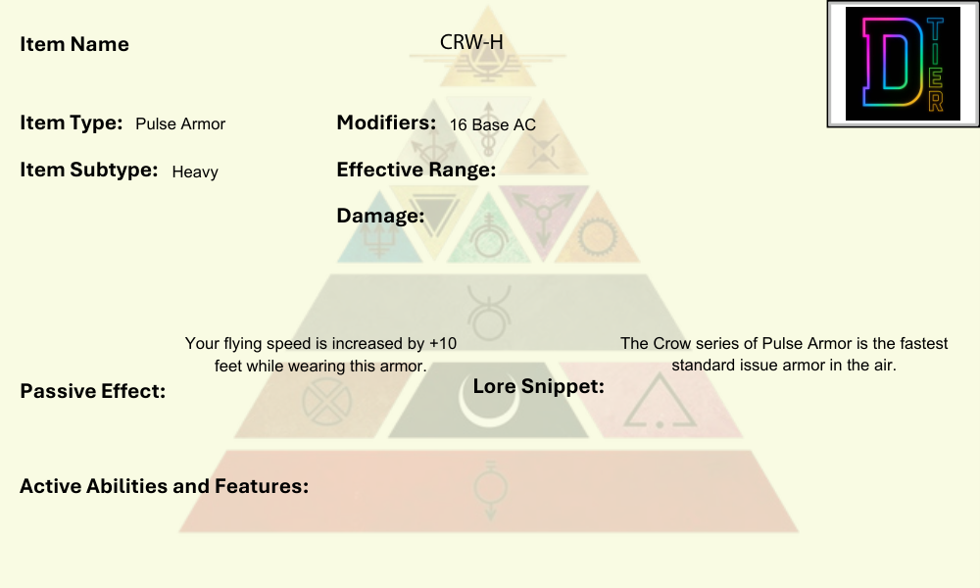

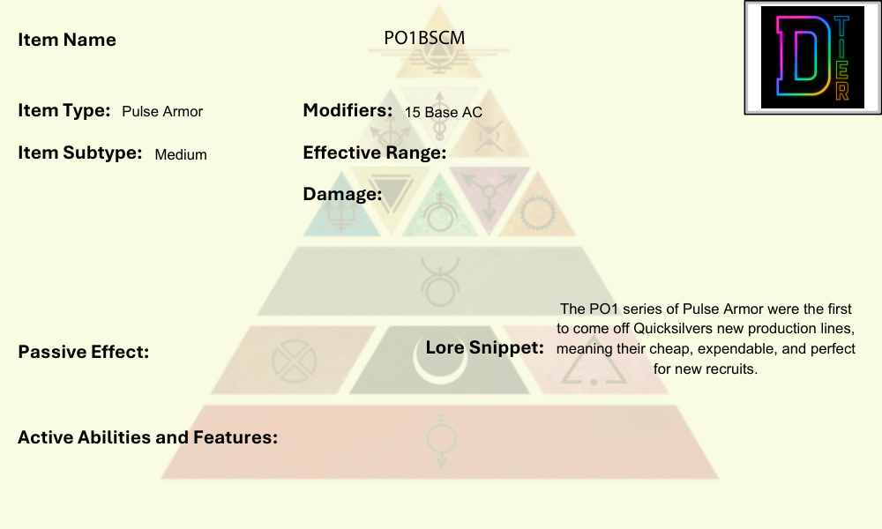

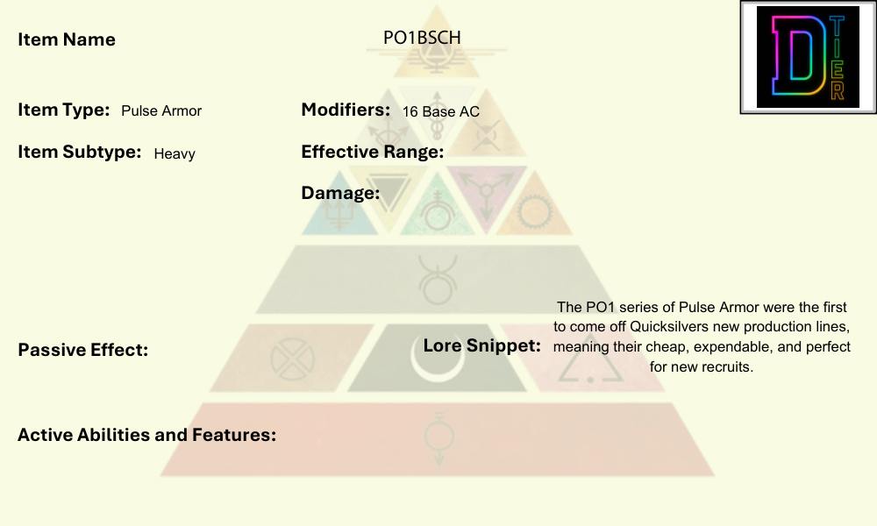

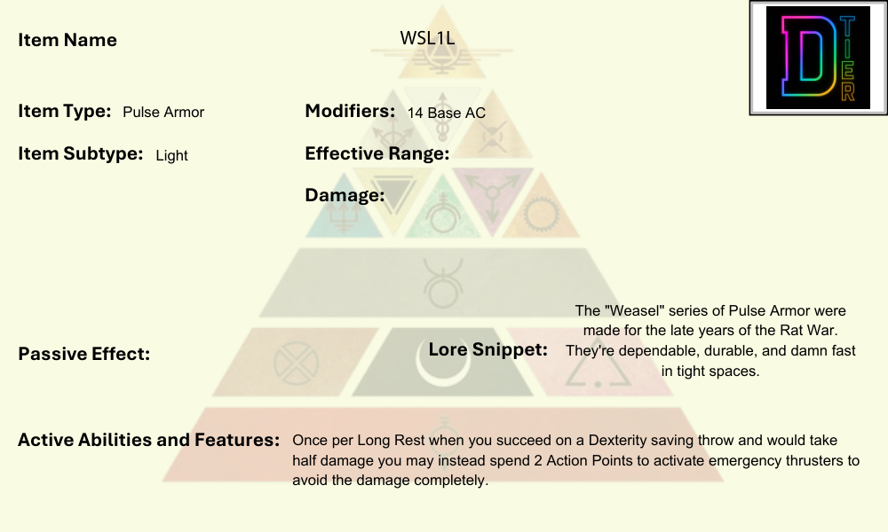

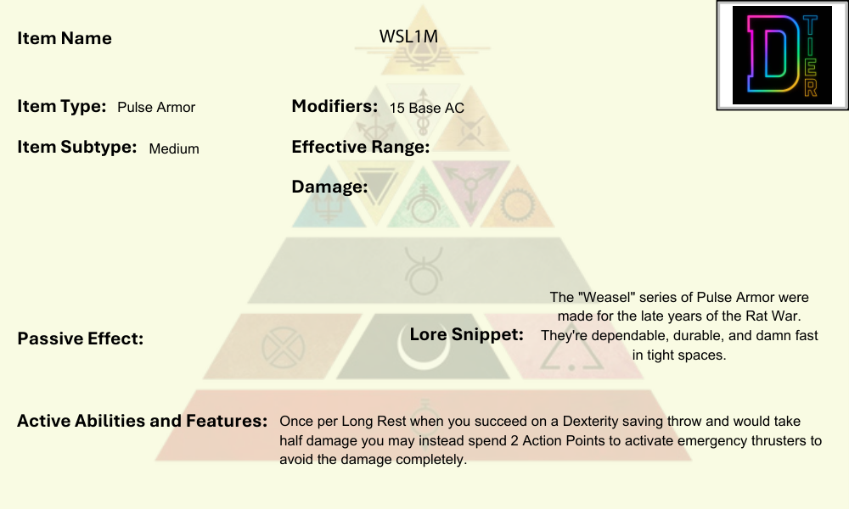

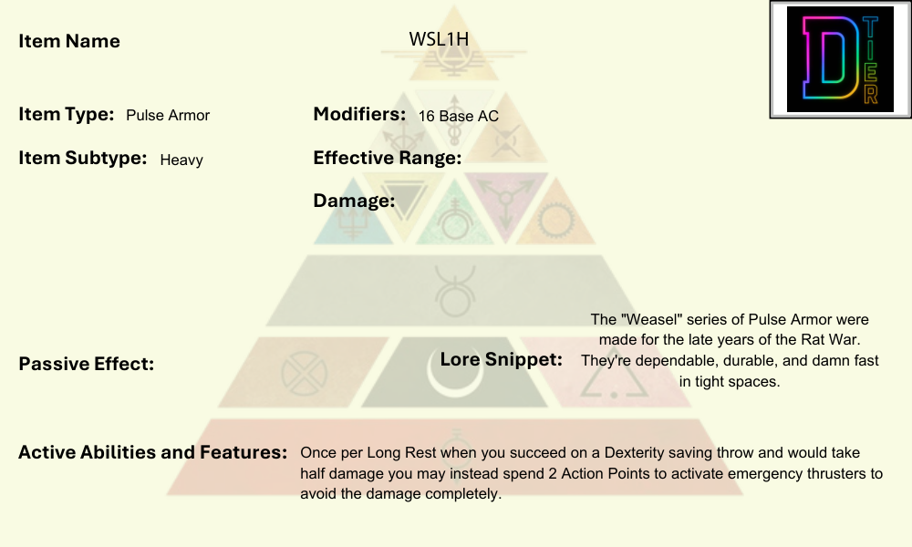  
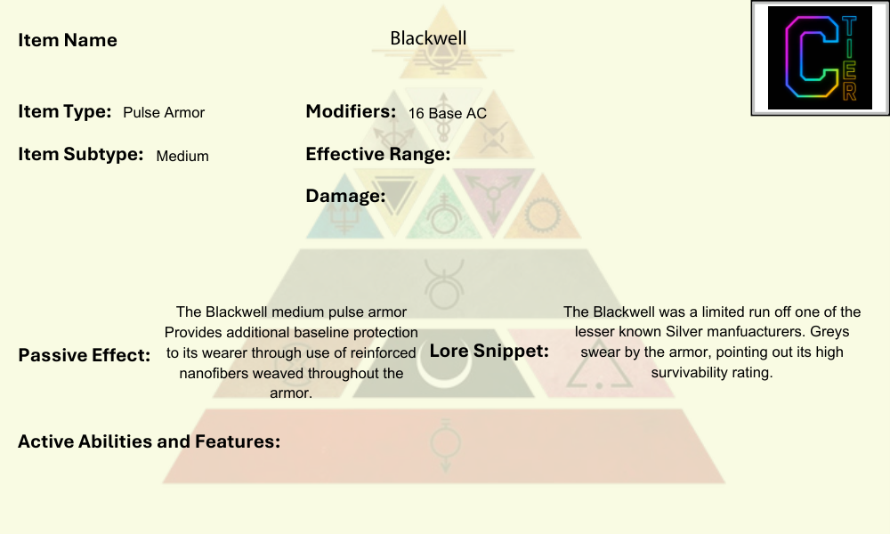

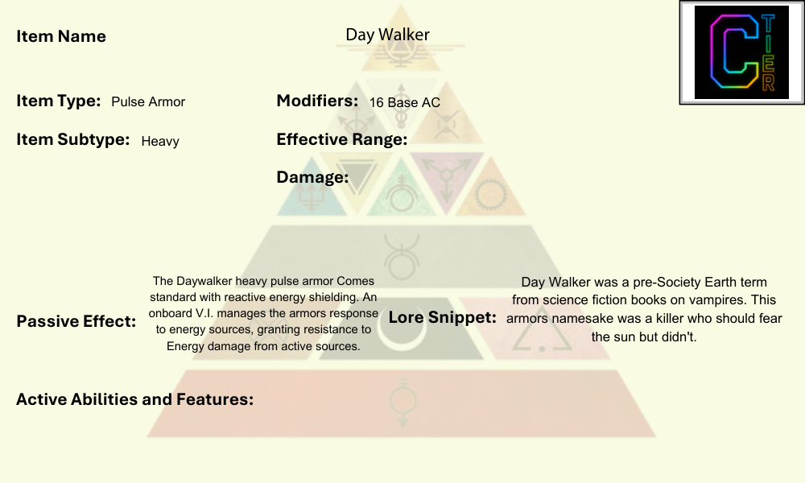

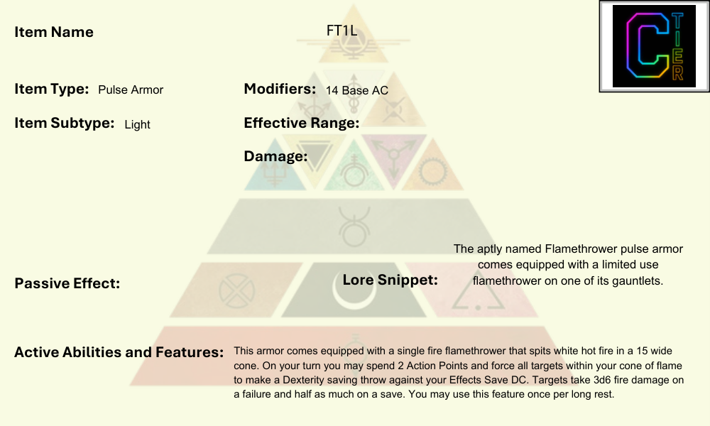

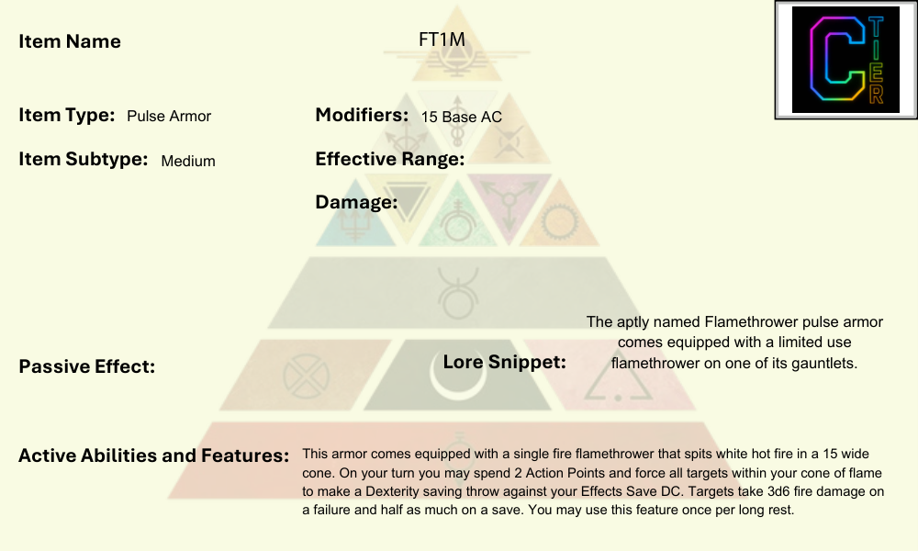

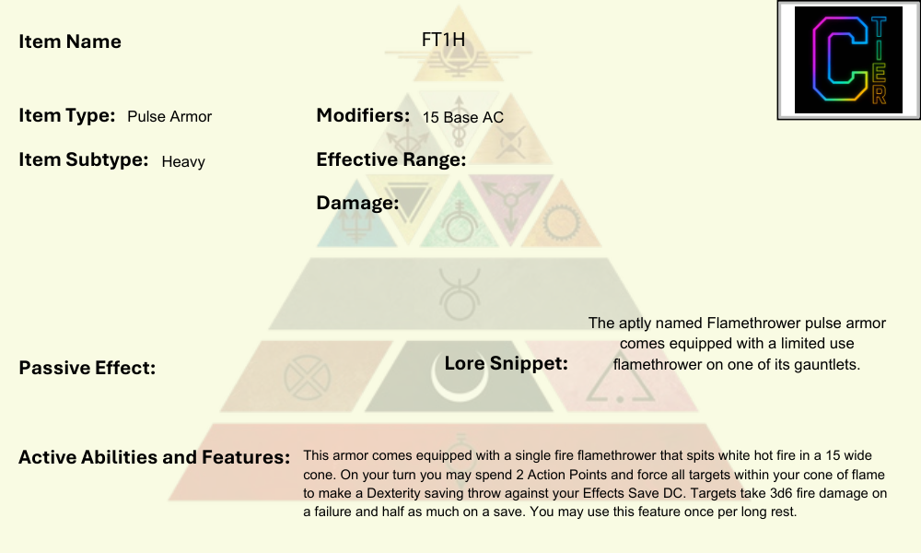

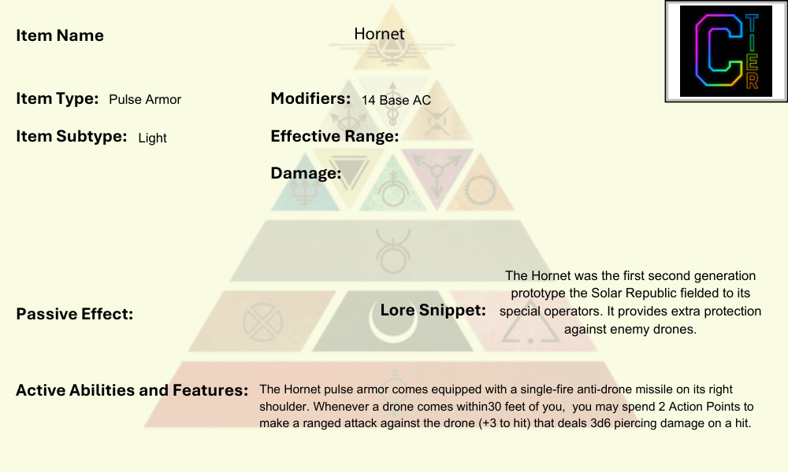

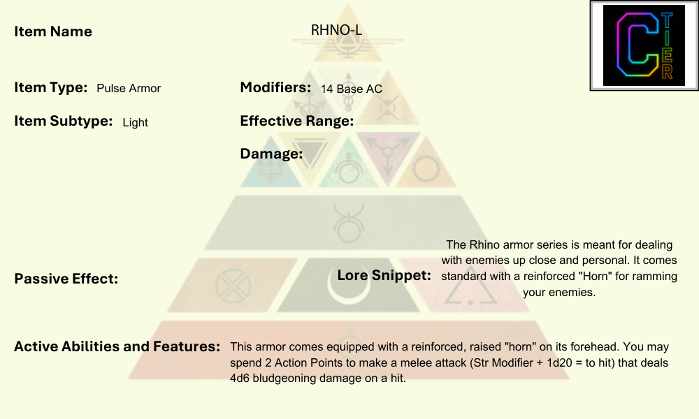

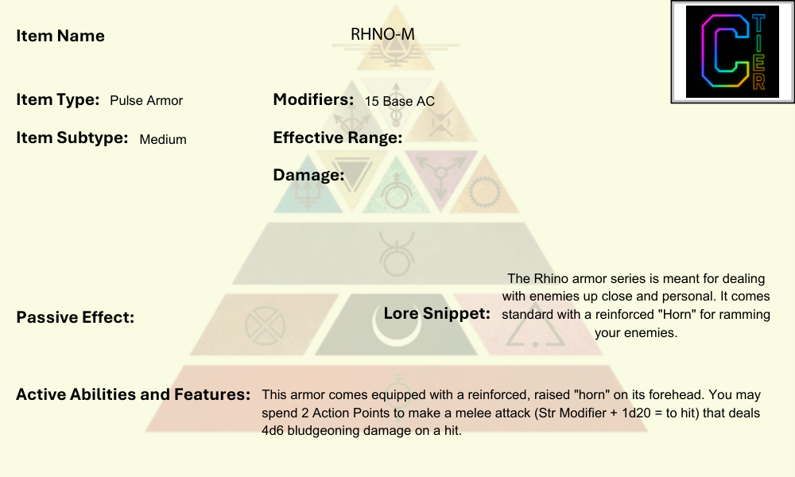

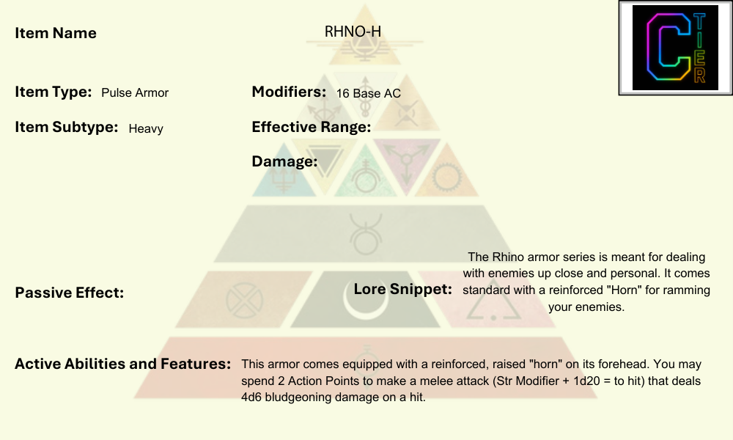

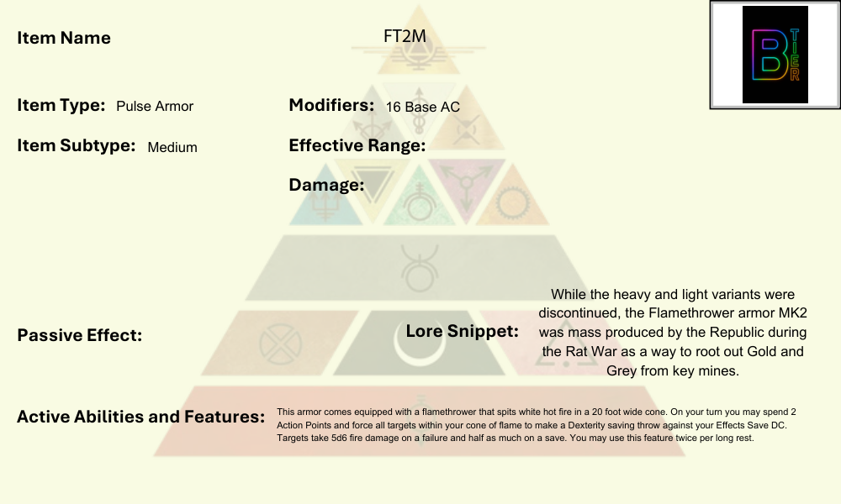

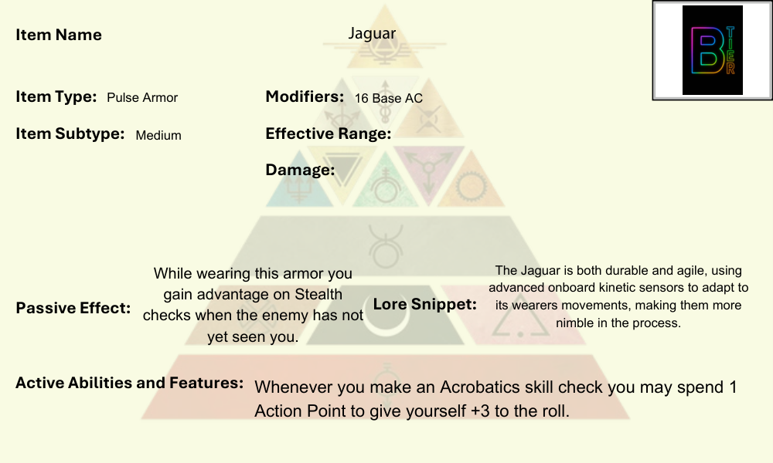

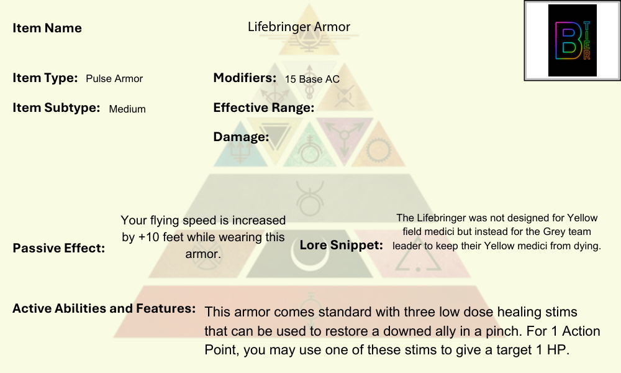

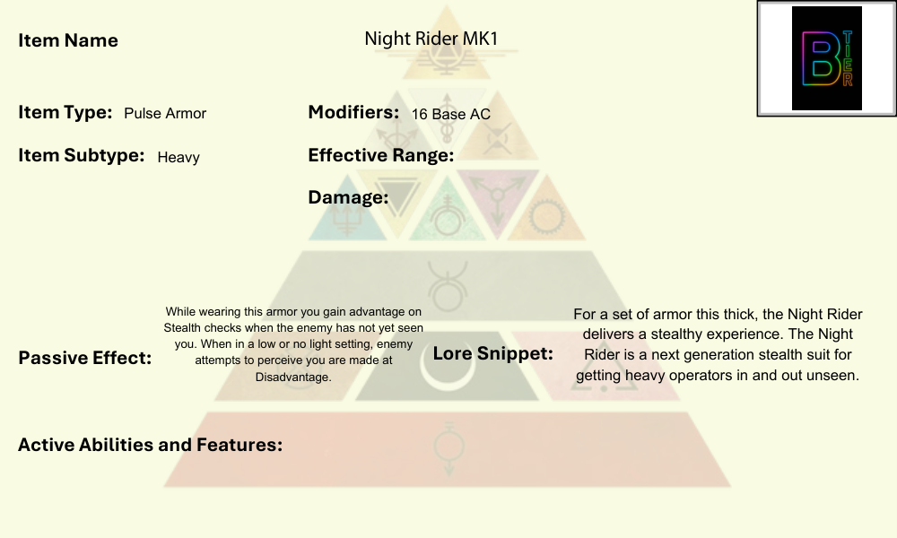

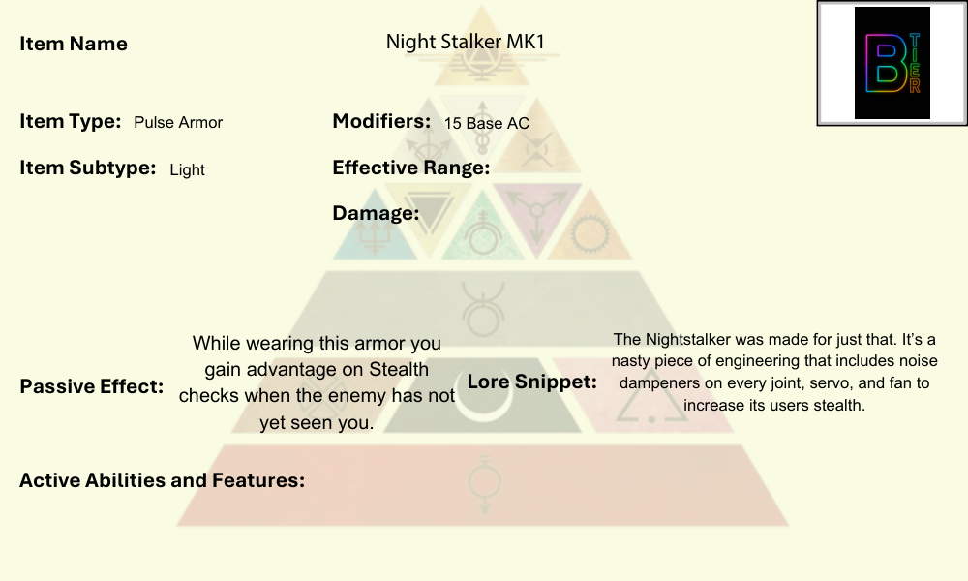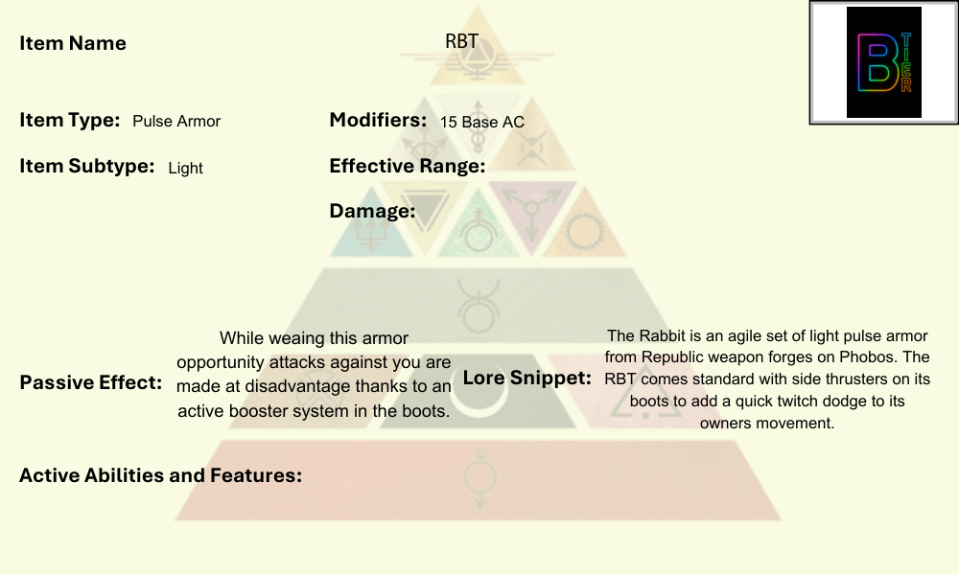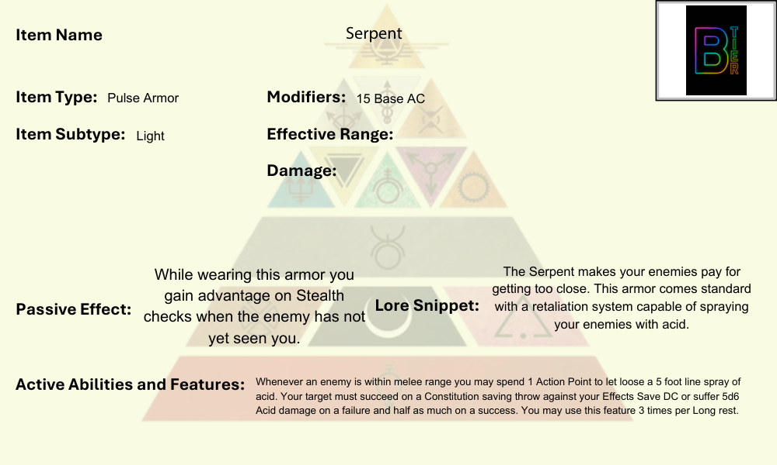

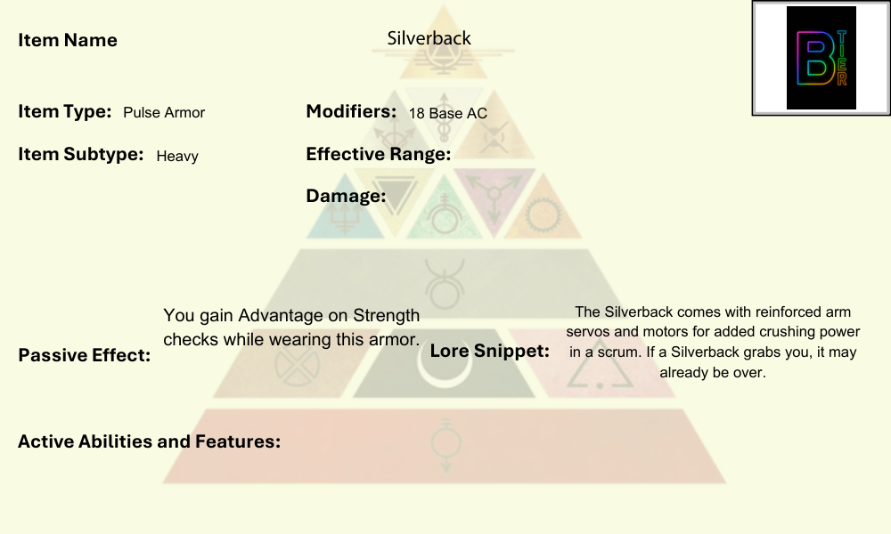

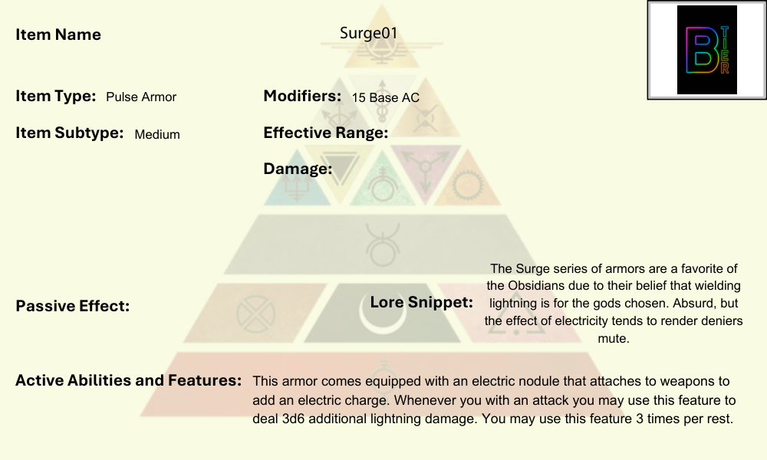

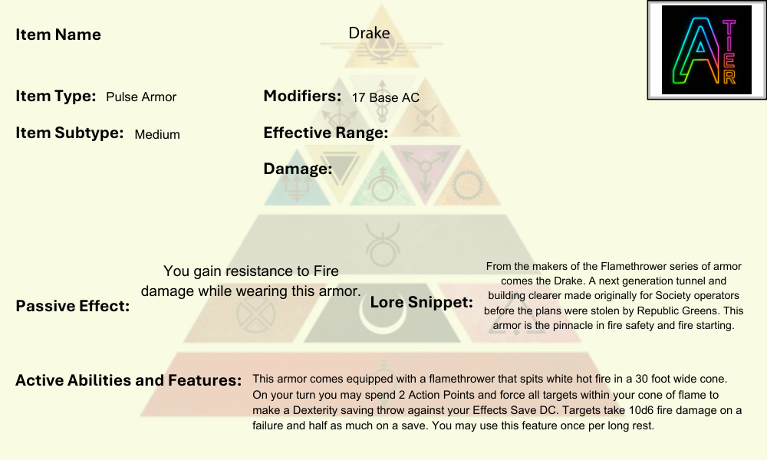

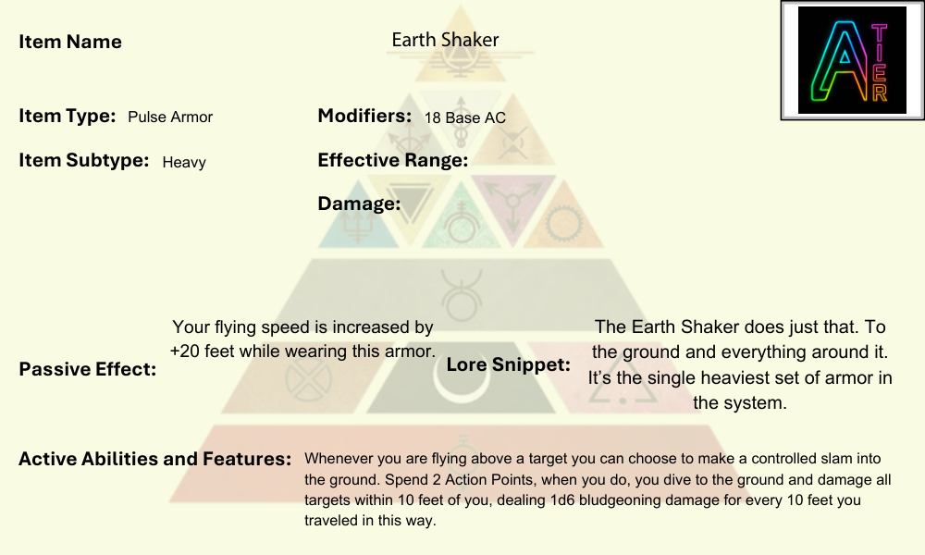

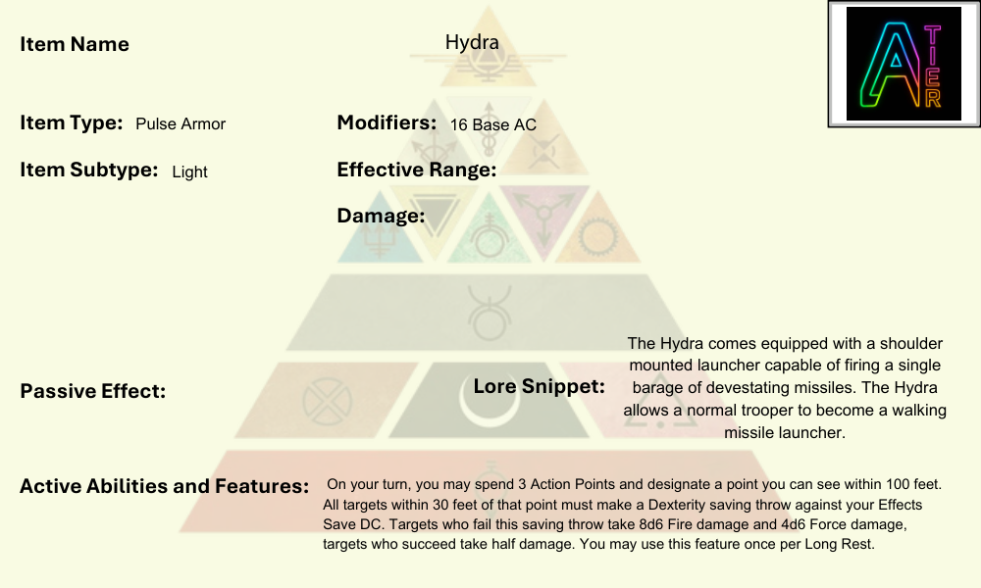

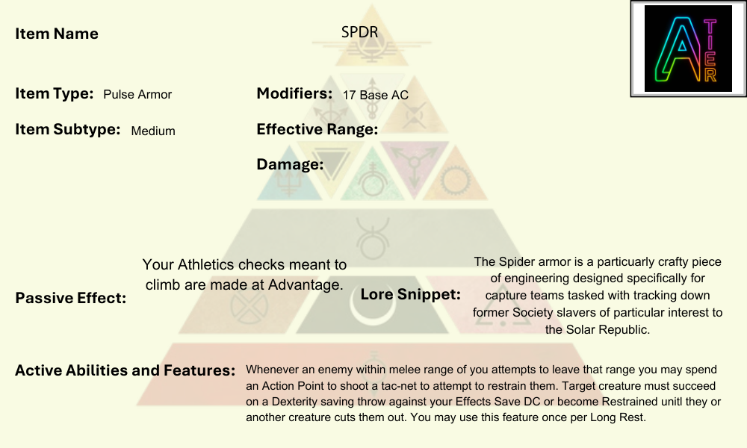

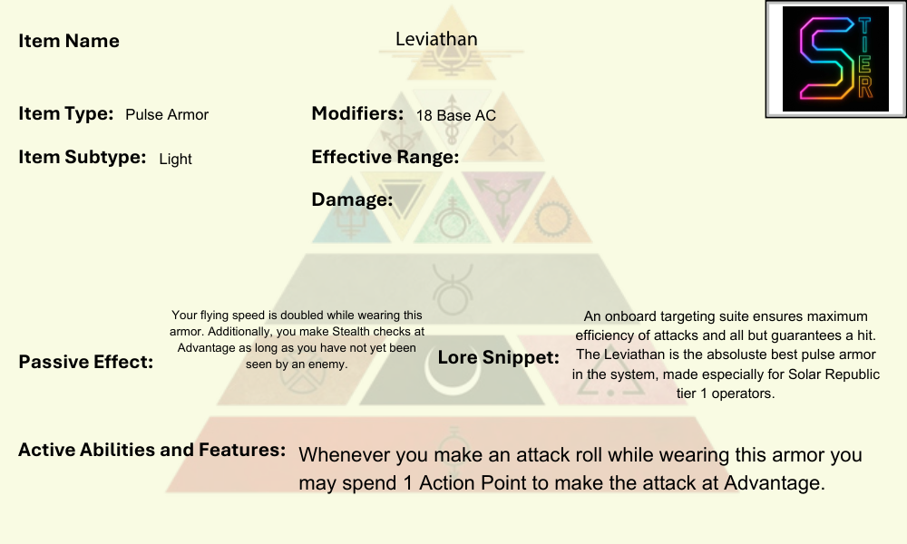

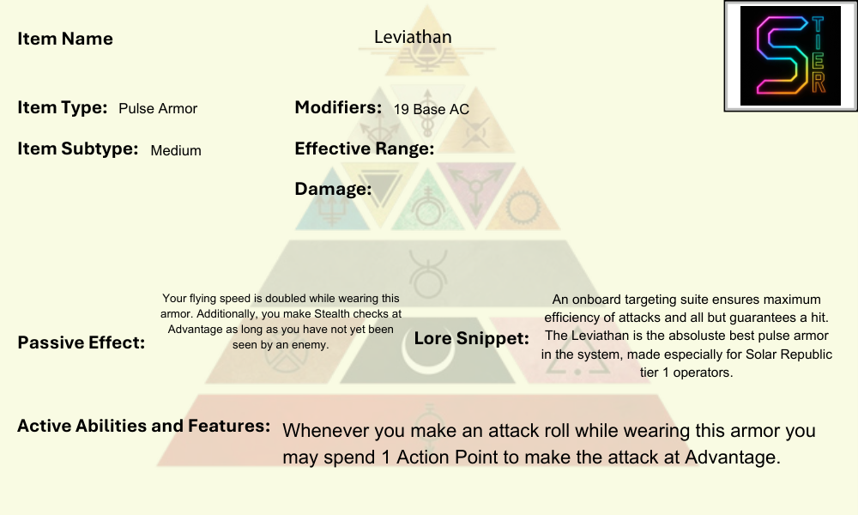

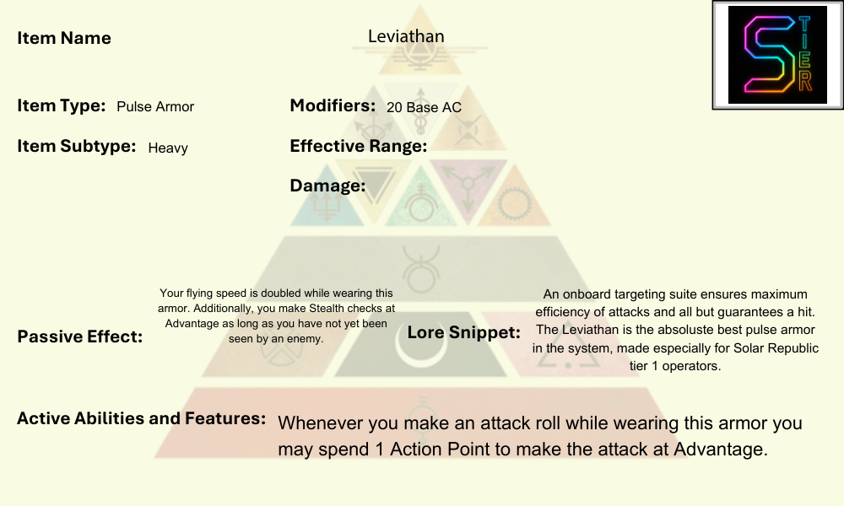

## Pulse Shields

Pulse Shields are portable, high-energy defense systems carried into battle by soldiers and strike teams. Unlike the full-body protection of Pulse Armor, Pulse Shields are concentrated barriers projected from an emitter, typically mounted on the forearm, gauntlet, or carried as a reinforced shield frame. When activated, the shield unfolds with a crackling shimmer of force, able to absorb or redirect incoming energy and kinetic fire.

A Pulse Shield is more than a slab of protection, it is responsive to the wielder’s movements, adjusting its projection based on angle and pressure. Skilled fighters can shift their arc to intercept a barrage of gunfire, absorb a plasma bolt, or even brace against explosive force. The shield’s humming field often glows faintly, blues, golds, or reds depending on energy core tuning—and sparks when struck by heavy attacks.

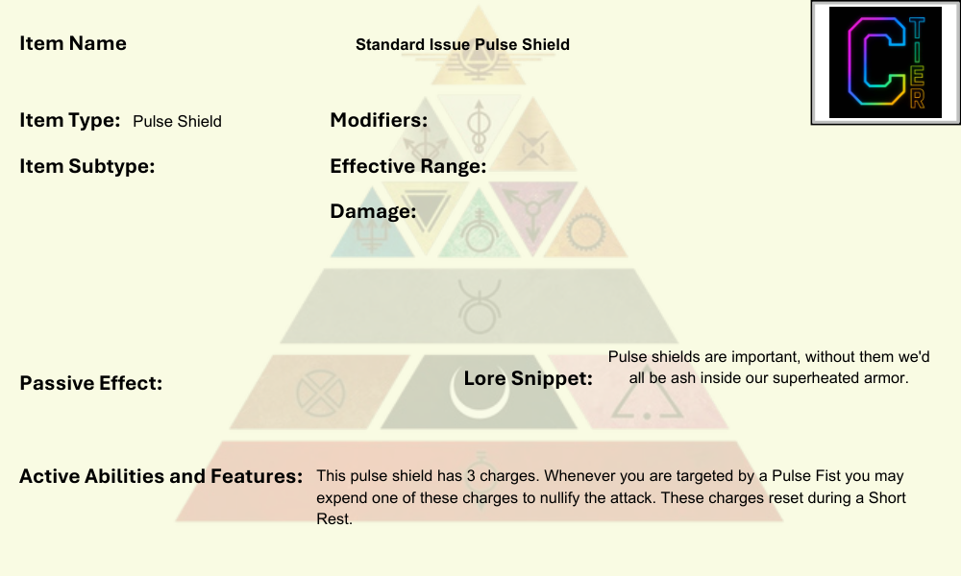

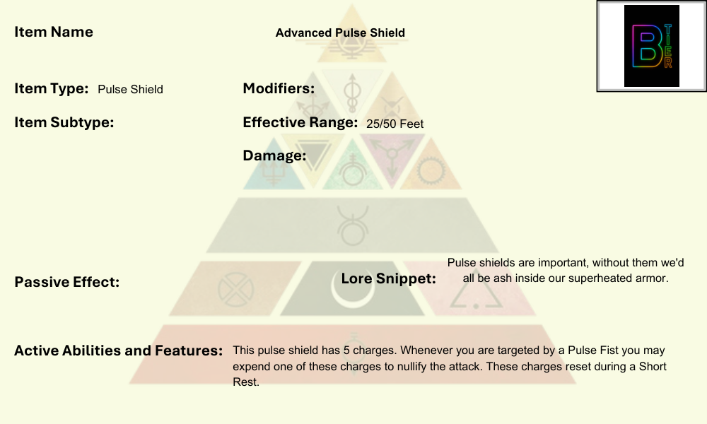

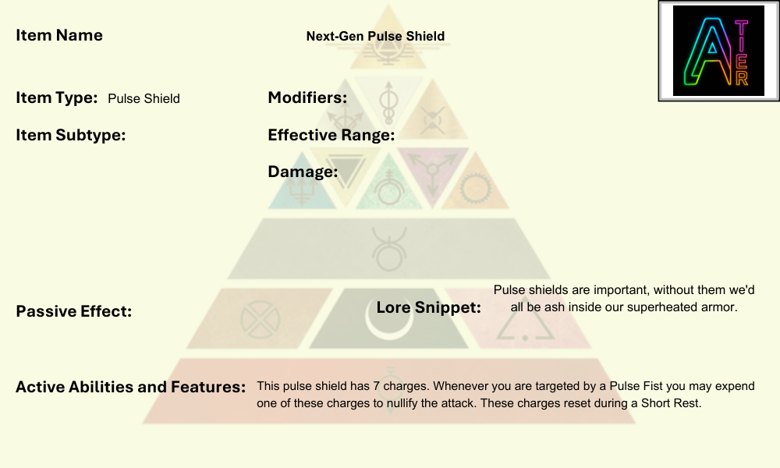

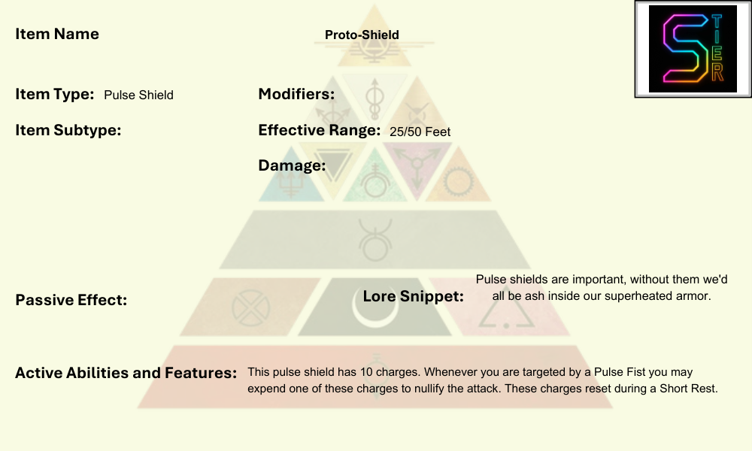

## Weapons

Weapons in the Red Rising era are not merely tools of violence—they are symbols of identity, power, and philosophy. From the elegant brutality of a Razor to the thunder of a heavy plasma cannon, each type embodies the values of the wielder and the role they play in battle.

### Heavy Weapons

Heavy weapons are the sledgehammers of the battlefield—crew-served or powered by exosuits, designed to dominate choke points and shred cover. They include plasma cannons, railguns, and rotary autocannons, often mounted on bipods or integrated into Oranges’ mech suits. These weapons leave nothing subtle in their wake; their role is to control the field with overwhelming firepower. Their customization lies in ammunition types (concussive rounds, incendiaries, armor-piercing) and in their mounting: infantry-carried for shock assaults, or ship-deployed for boarding actions.

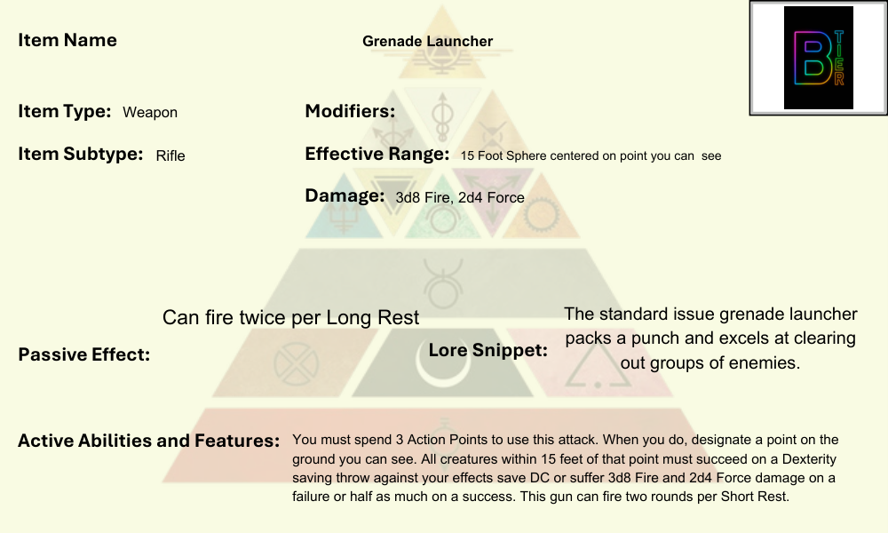

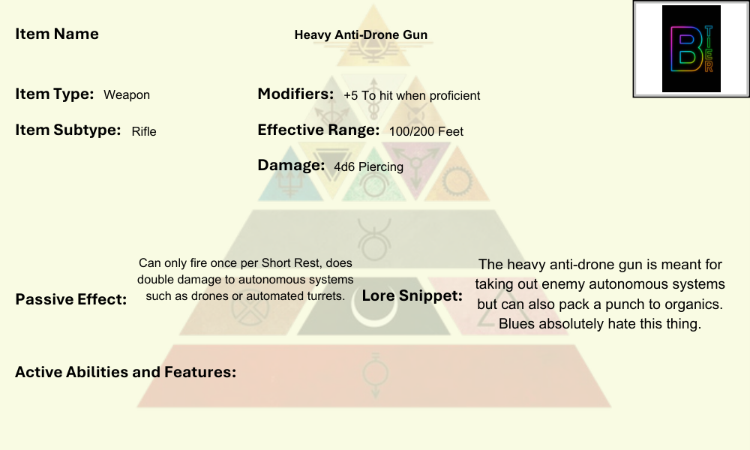

### Melee Weapons

While advanced warfare thrives on guns and energy, the Society never abandoned the intimacy of melee combat. Obsidians wield two-handed axes, Warhammers, and plasma-edged blades, while Golds favor dueling swords and spears enhanced with grav-stabilizers. Melee weapons are often customized for cultural expression: runed obsidian axes, ritual-carved Gold dueling blades, or folding shock batons for Grays. The personal nature of melee weapons makes them as much heirloom as tool, with each one carrying scars and names from generations of battle.

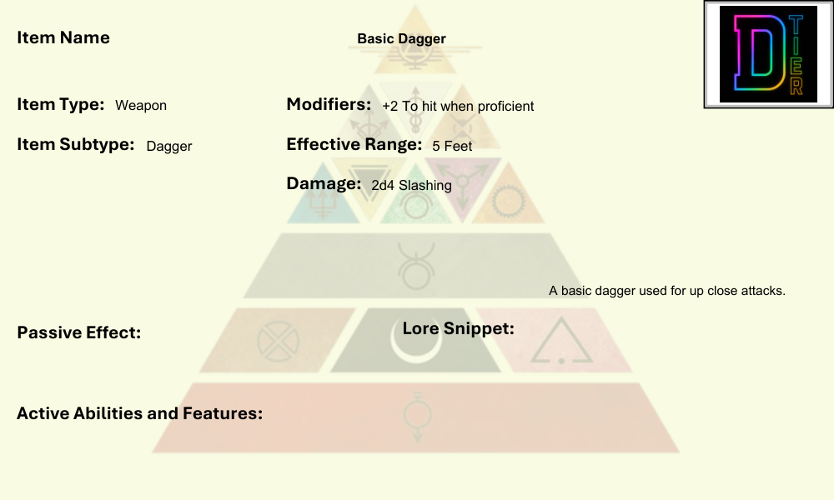

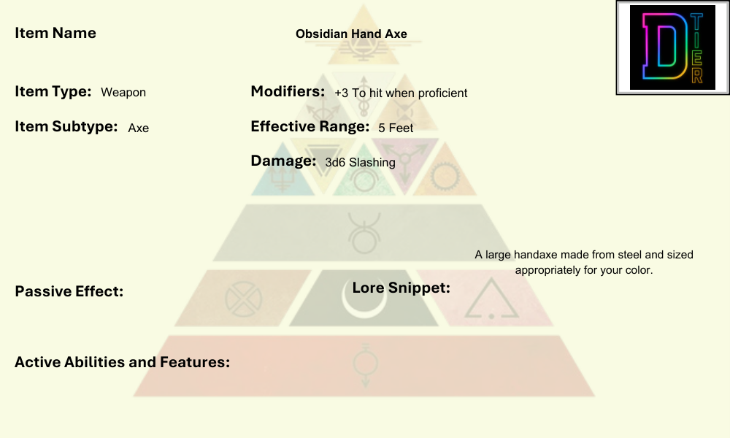

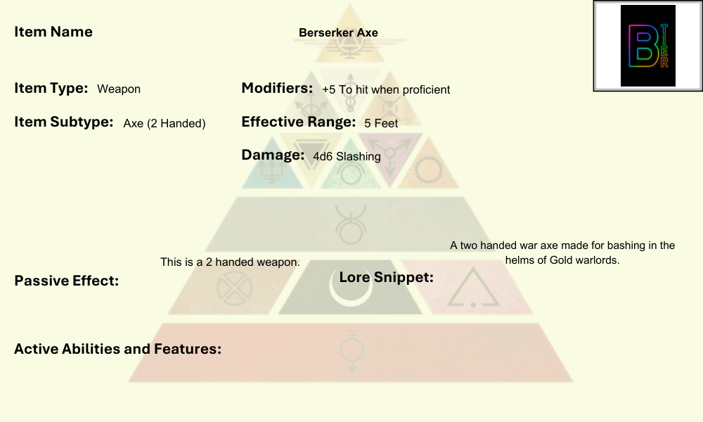

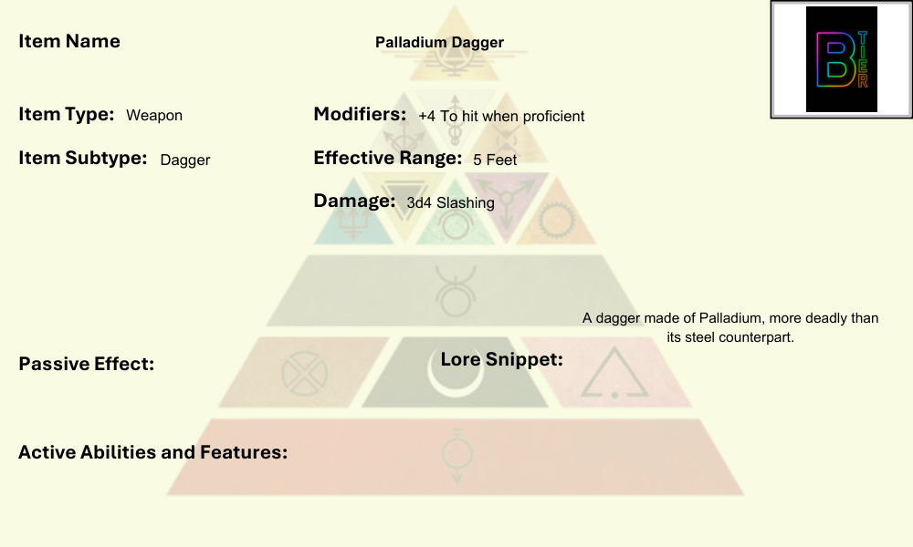

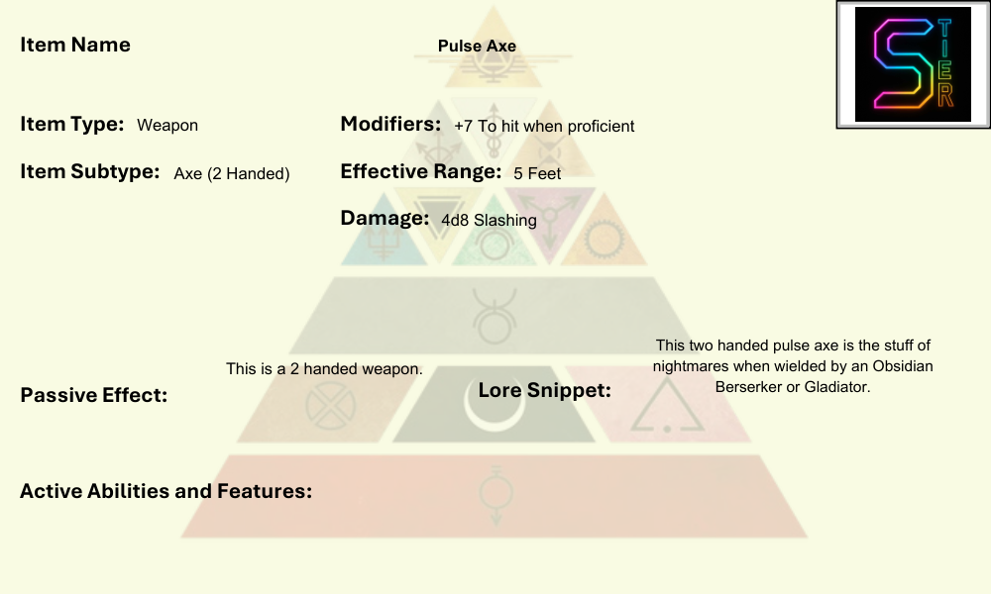

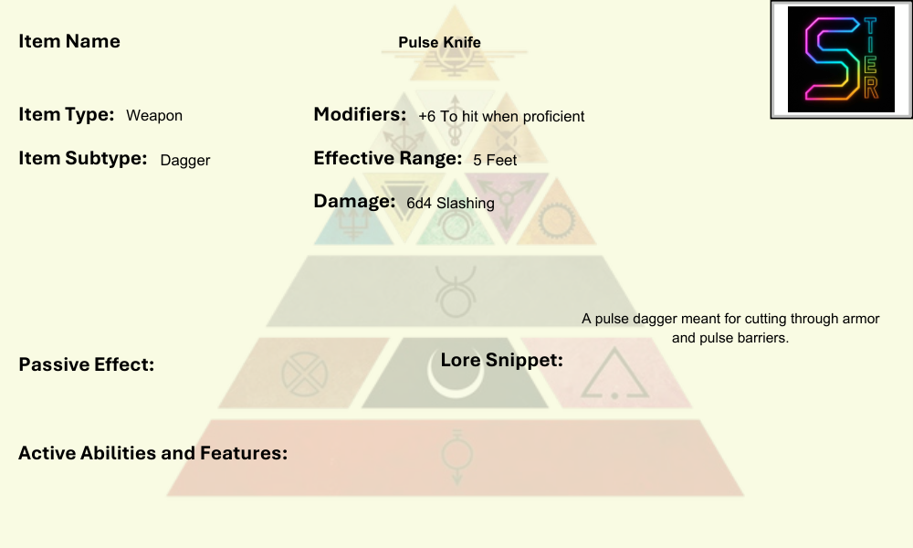

### Pistols

The sidearm is the universal constant of war. Pistols range from compact pulse pistols to elegant Gold dueling pieces. They’re reliable, quick-draw weapons favored by officers, assassins, and anyone who values survival in close quarters. Pistols can be tailored through engraved grips, silencers, smart-targeting optics, or toxin-delivering rounds. A Gold’s pistol might be as much jewelry as weapon, while a Red revolutionary’s may be patched together from scavenged parts.

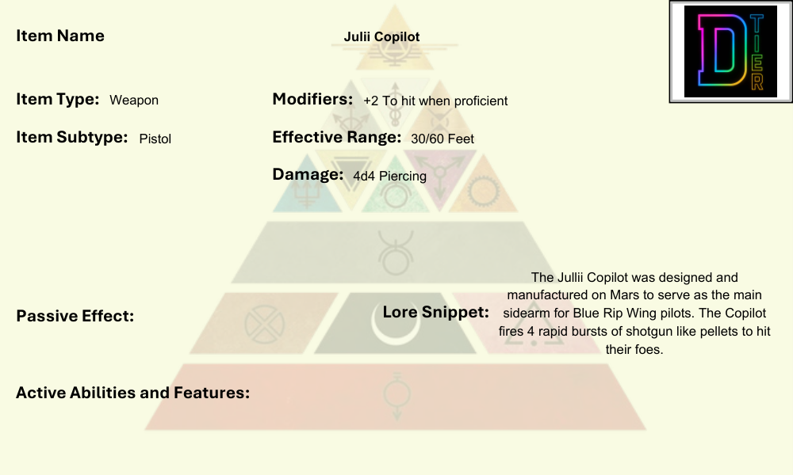

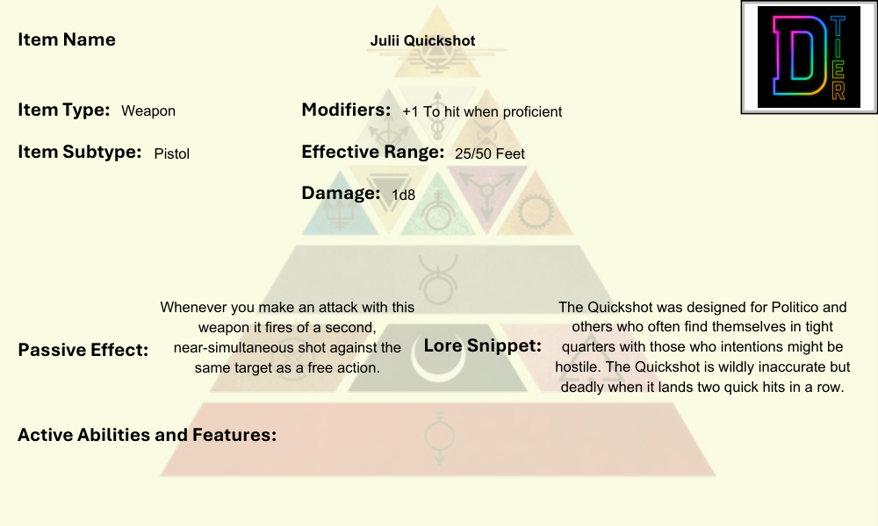

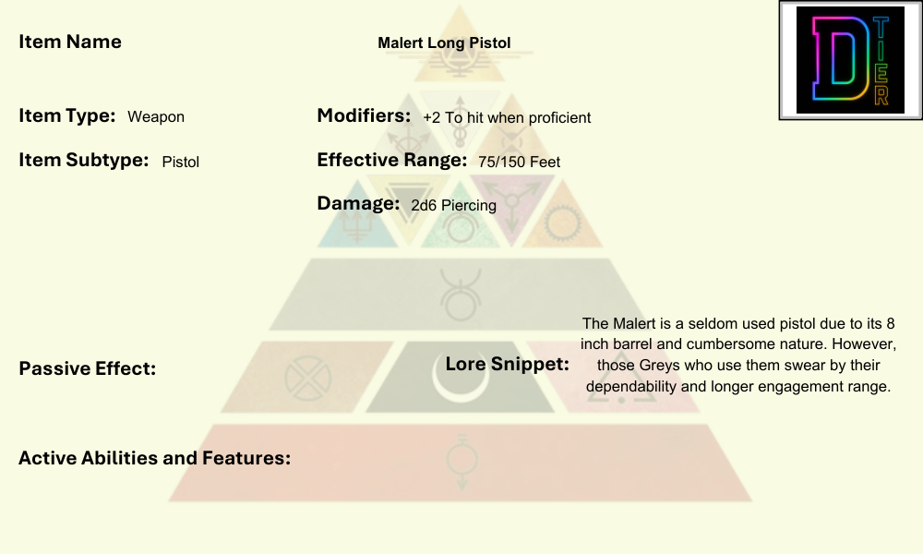

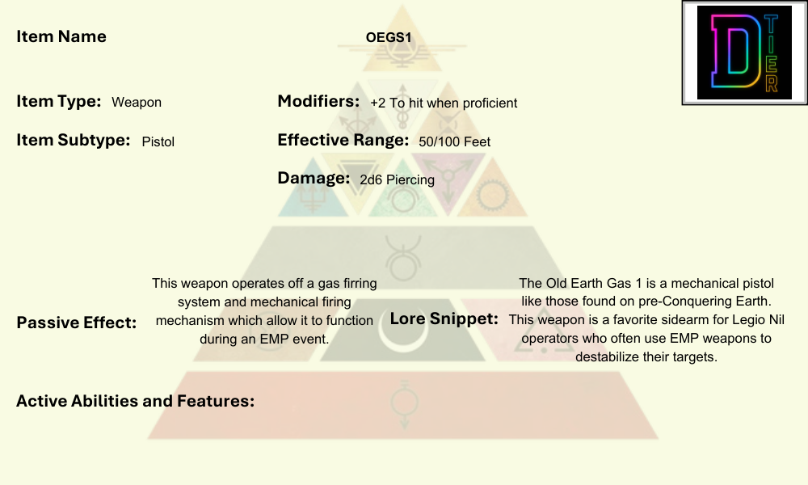

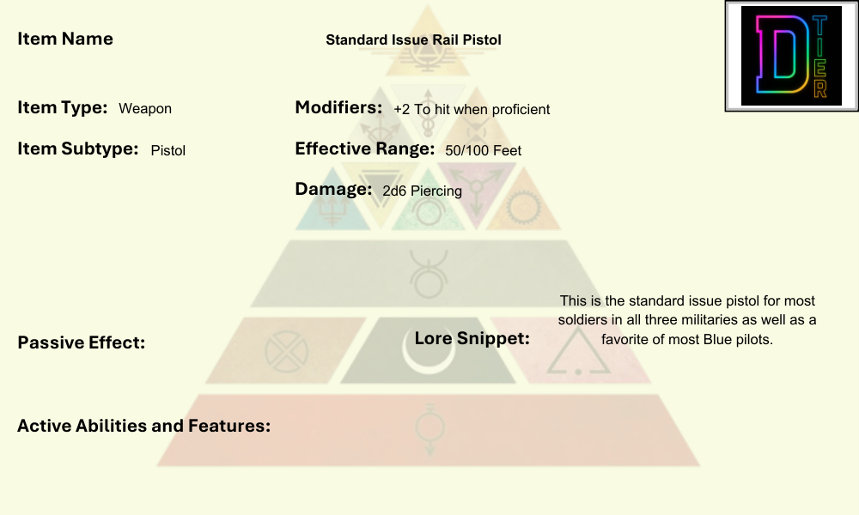

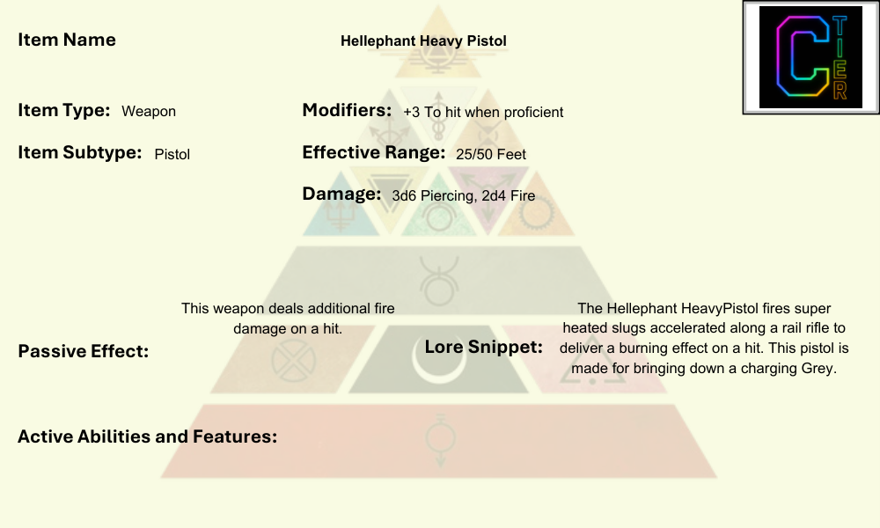

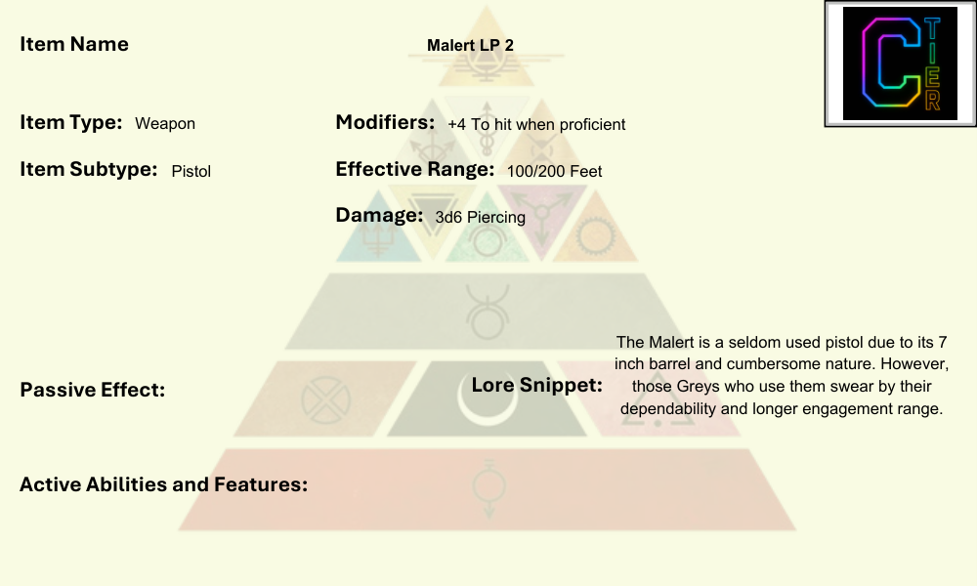

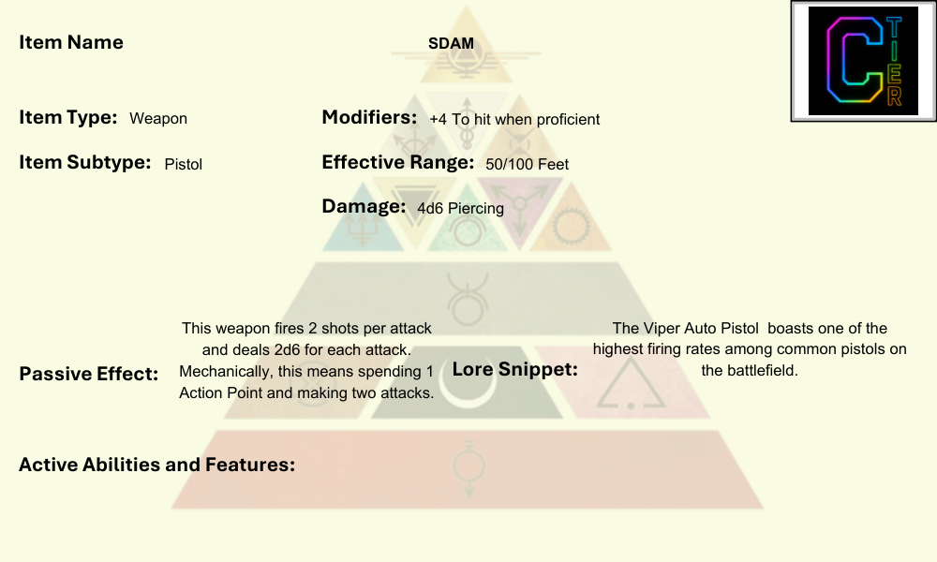

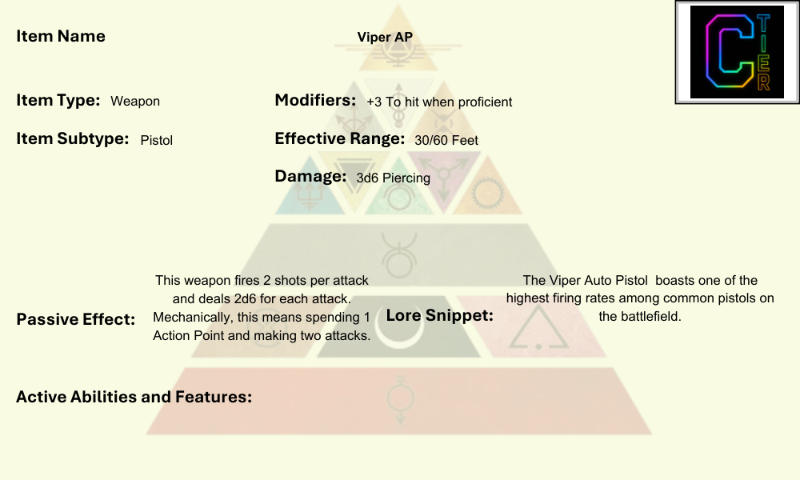

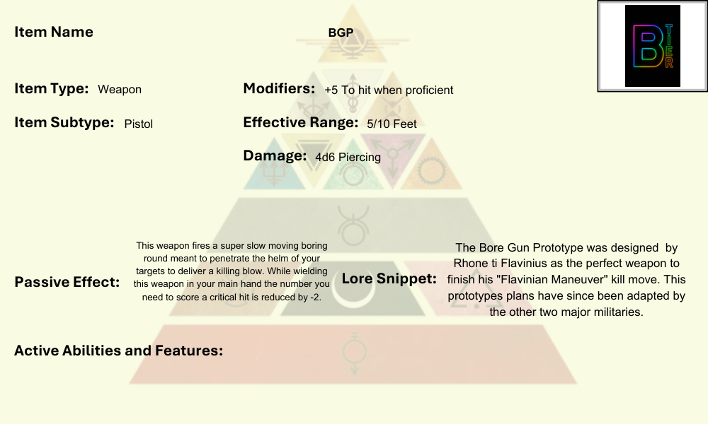

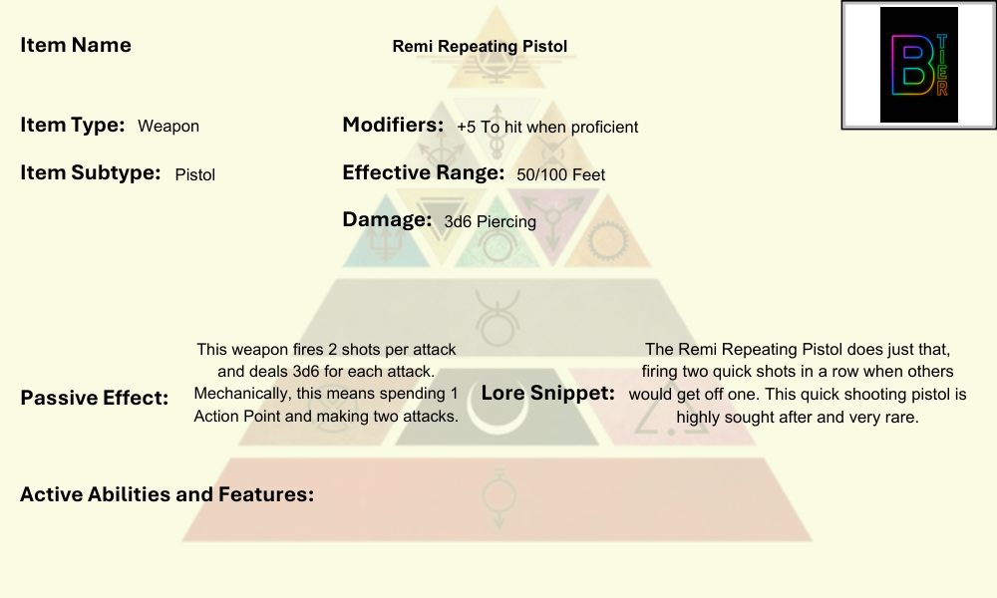

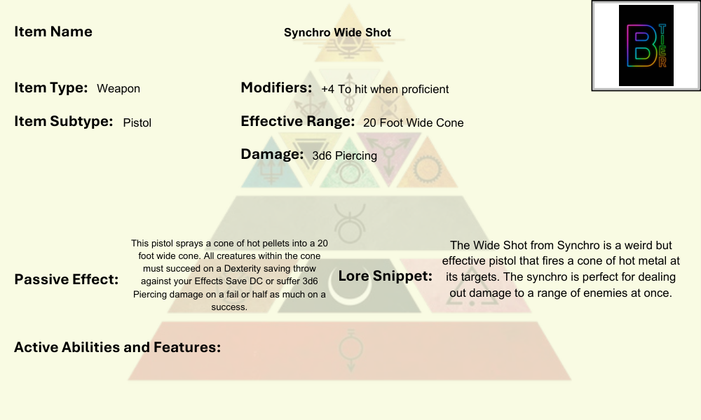

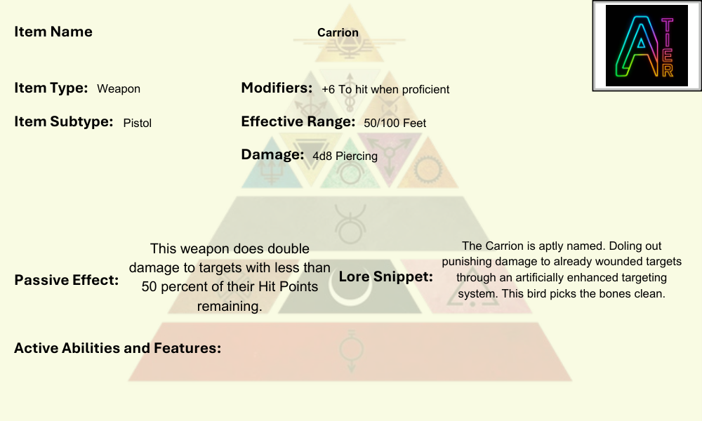

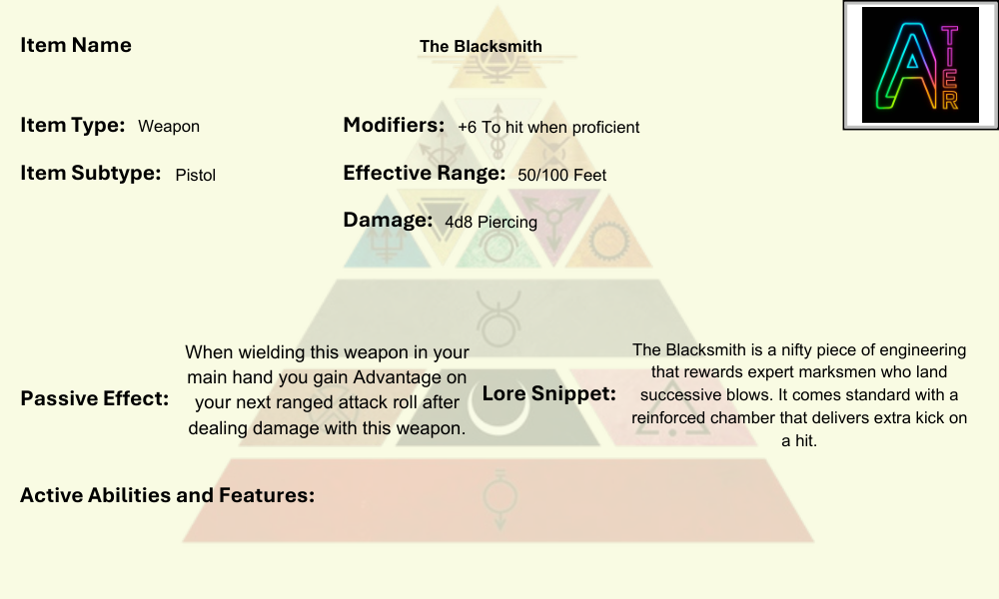

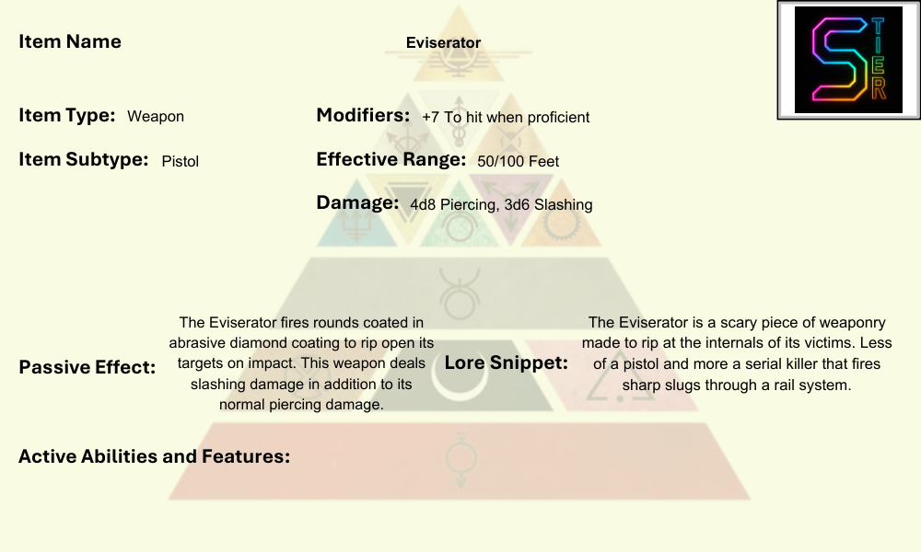

### Pulse Fists

Pulse Fists are brutal weapons that combine the speed of a punch with the devastating energy of a shockwave. Carried by Grays and Oranges alike, these gauntlet-mounted systems use condensed energy fields to turn every strike into a bone-crushing blow. They are especially effective in tight spaces like ships, mines, or urban corridors. Many are customized with energy mods (electrical discharge, concussive blasts, or flame bursts), making them as versatile as they are savage. A Pulse Fist-wielding soldier becomes both shield-breaker and close-range executioner.

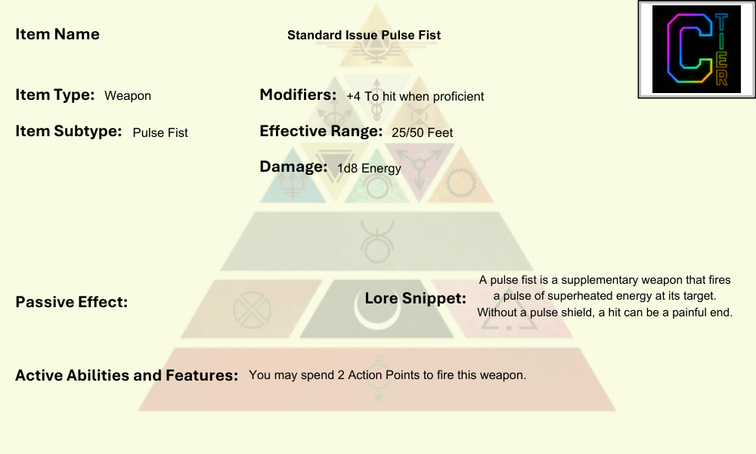

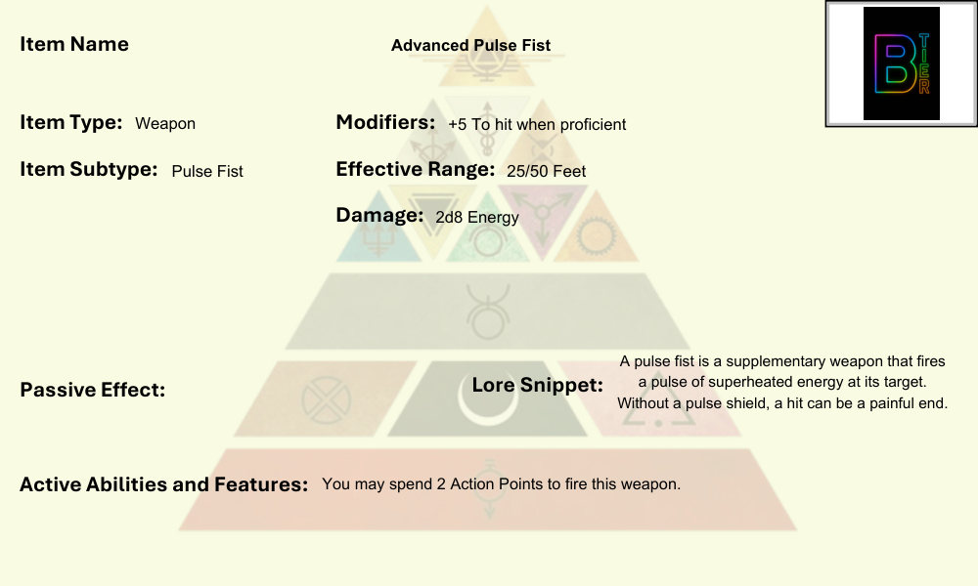

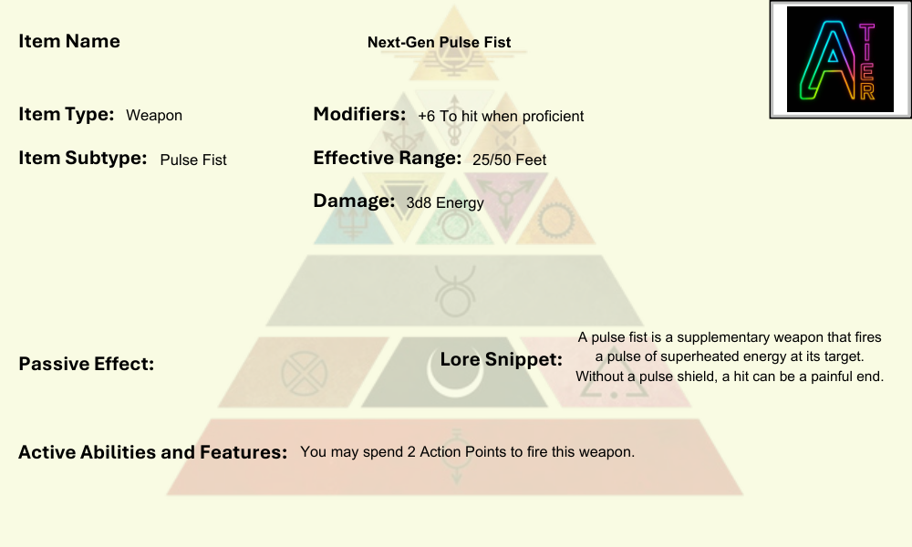

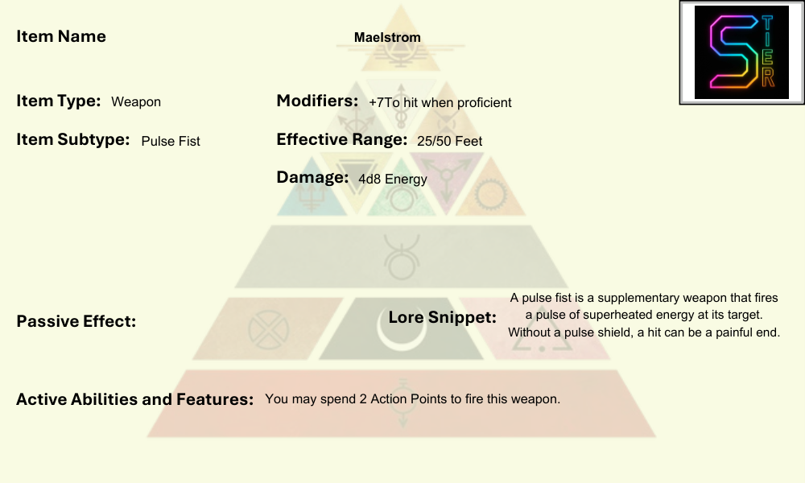

### Razors

The most famous weapon of the Society, Razors are monomolecular-edged whips that harden into blades. Golds wield them as symbols of nobility, tradition, and personal mastery. Razors require immense training to master—few outside the Peerless Scarred can handle them effectively. They are endlessly customizable: hilts engraved with family crests, whip-length adjusted to the wielder, or energy filaments tuned to glow in house colors. A Razor duel is as much performance as battle, its outcome echoing across courts and legacies.

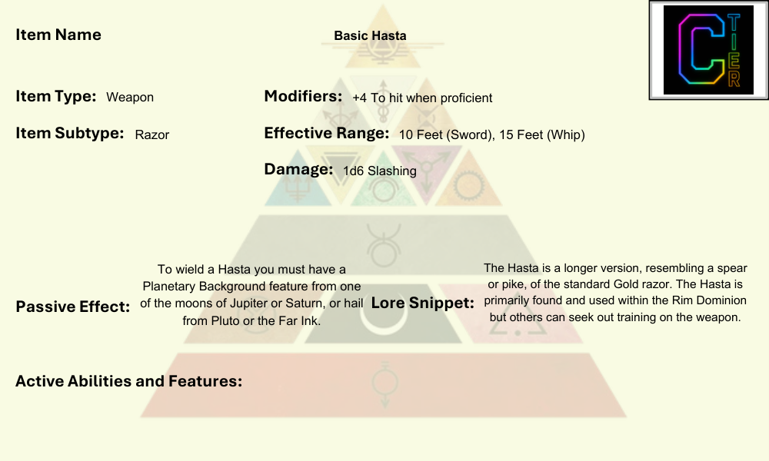

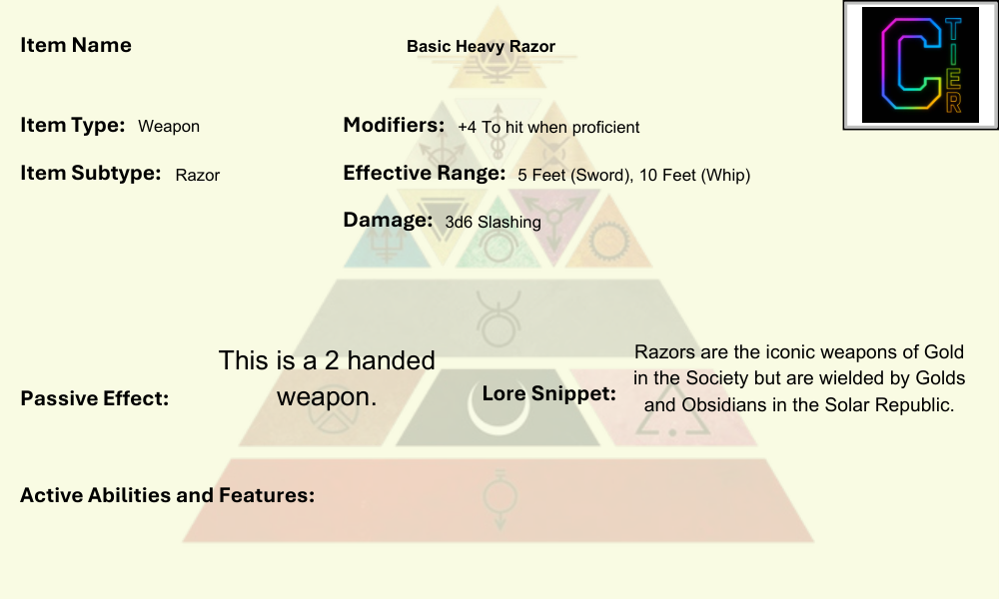

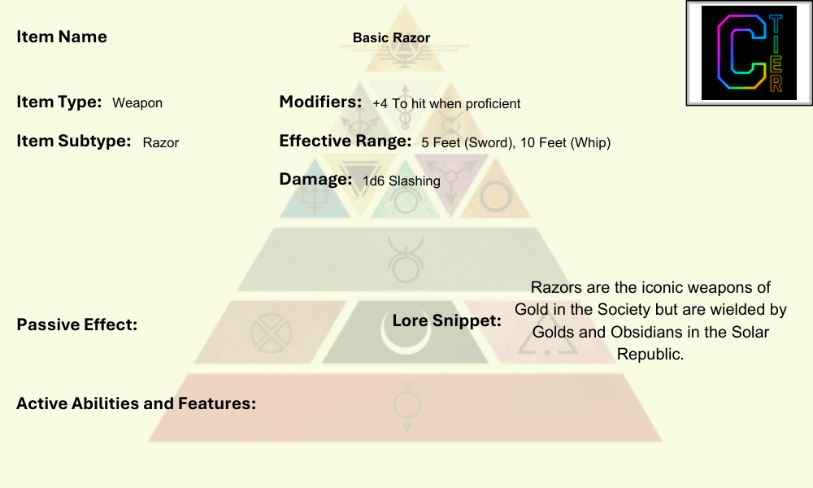

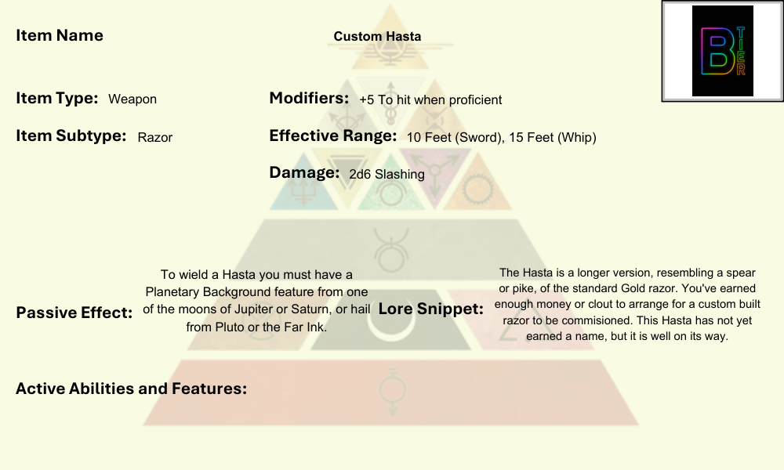

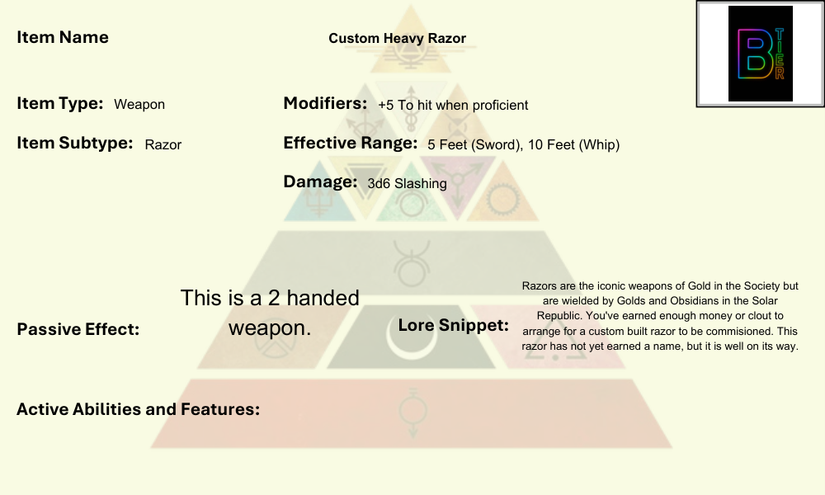

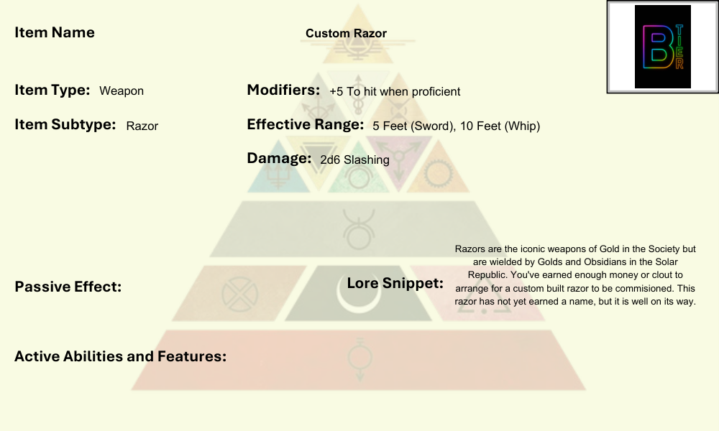

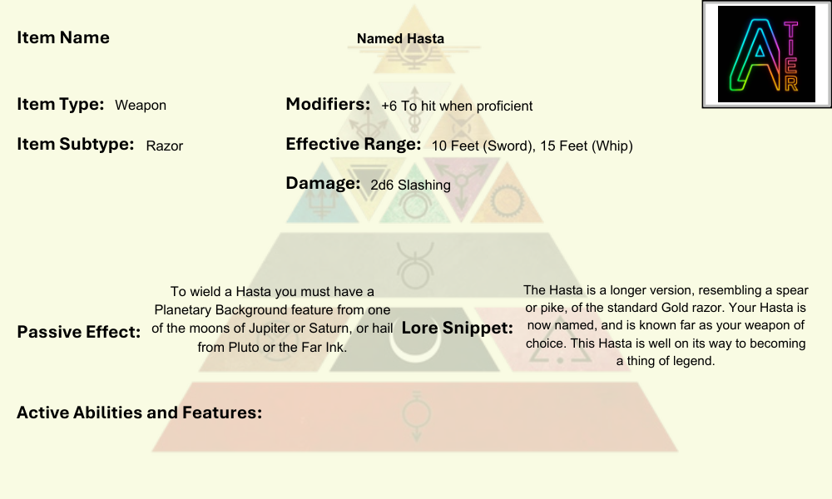

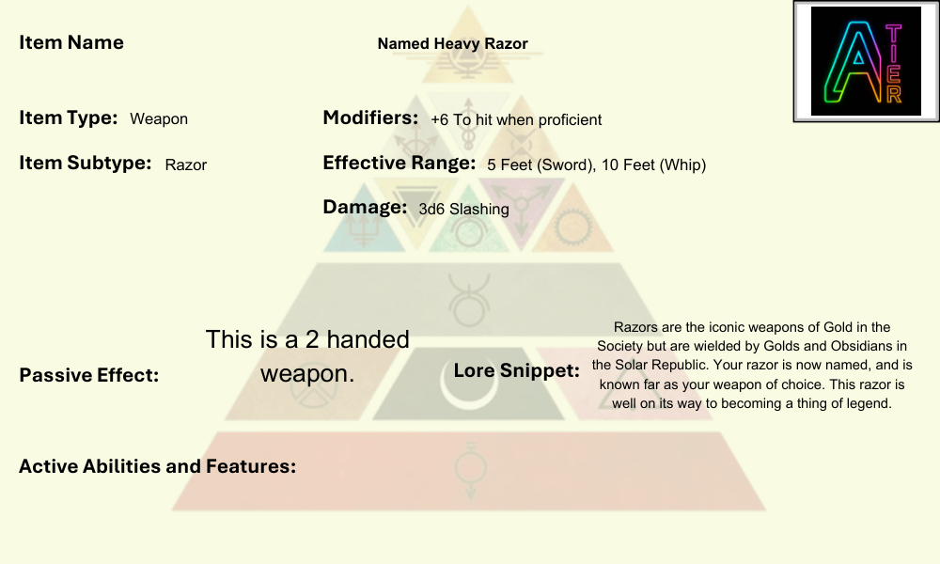

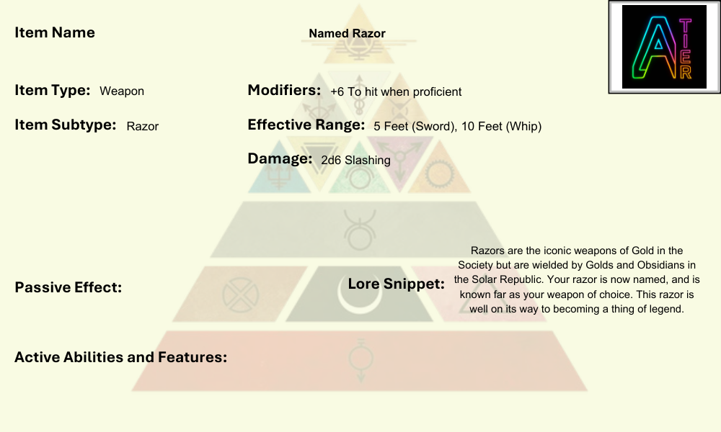

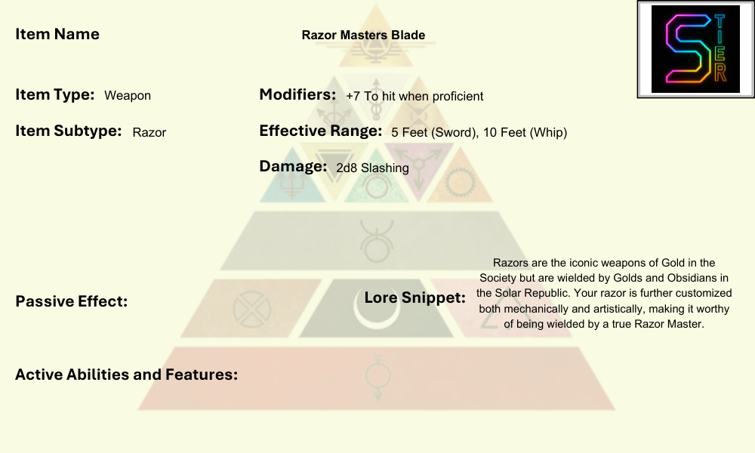

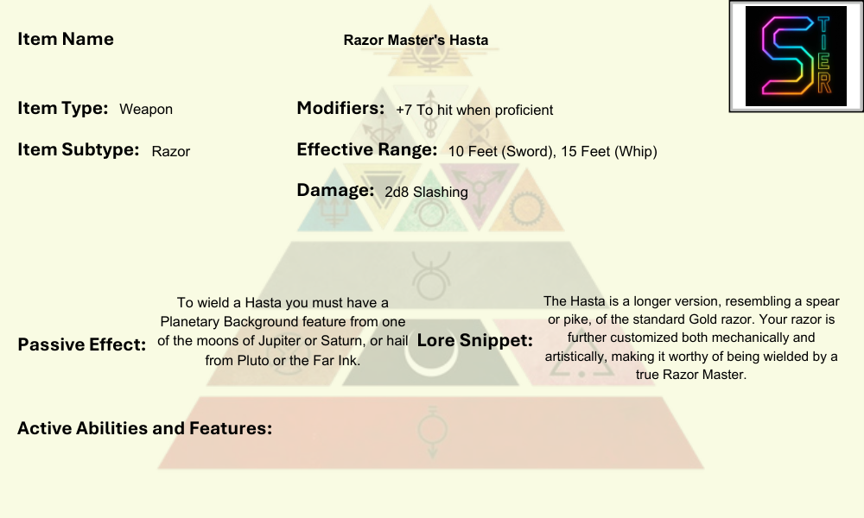

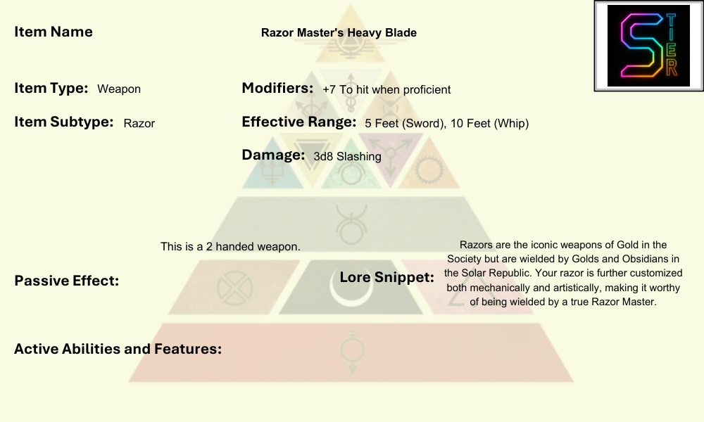

### Rifles

The backbone of military engagements, rifles combine reliability, precision, and adaptability. From the pulse rifles of Grays to the sniper-pattern long arms of Blues, rifles dominate mid- to long-range combat. They can be configured with scopes, under-barrel attachments, grenade launchers, or smart-link targeting systems, making them modular tools for every environment. Customization often reflects role: an Orange may reinforce their rifle for durability, while a Green integrates targeting uplinks or hacking nodes directly into the rifle’s scope.

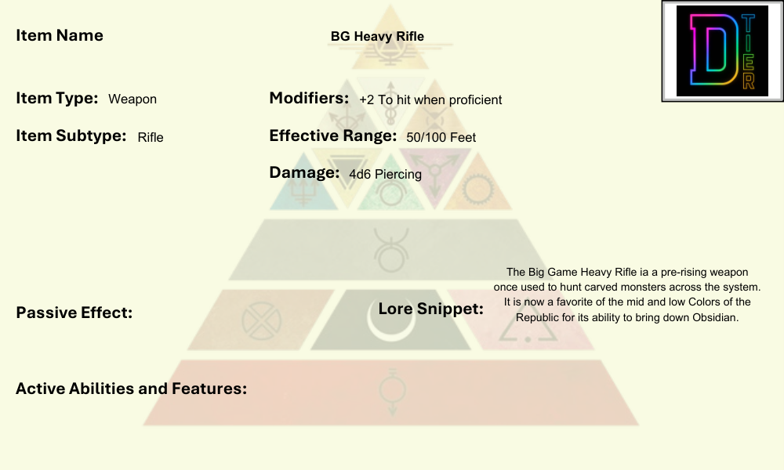

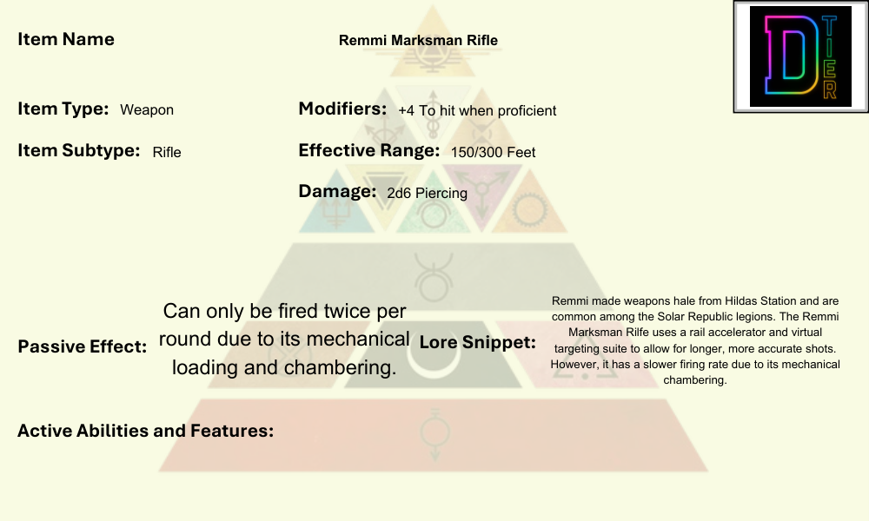

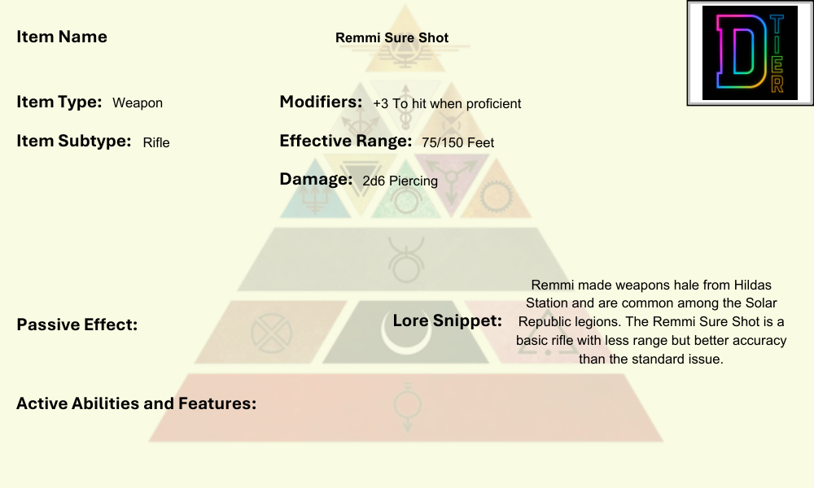

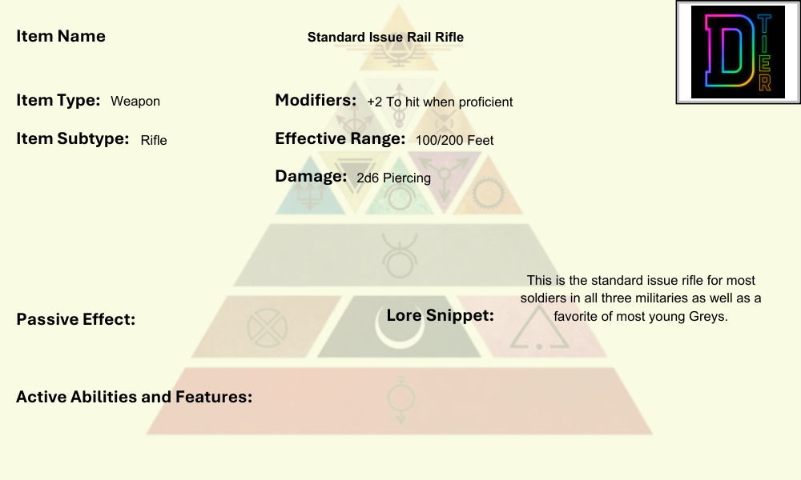

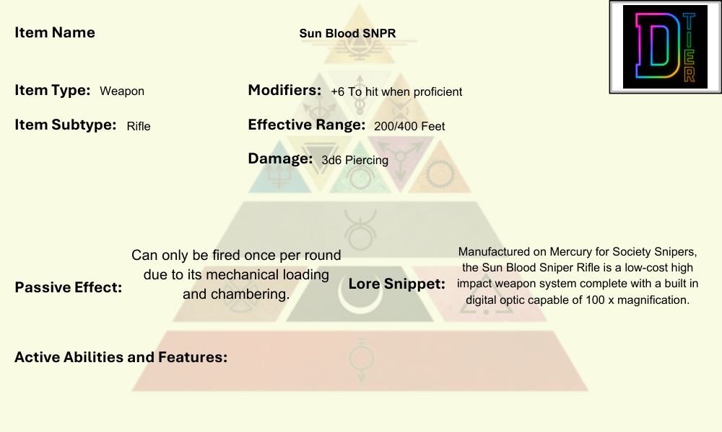

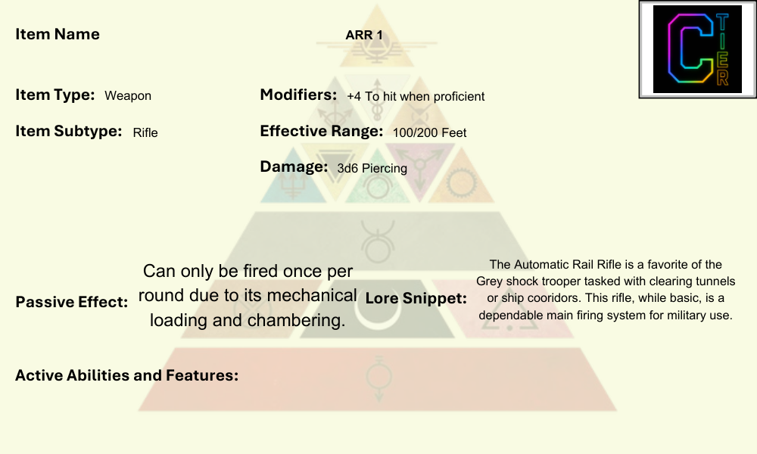

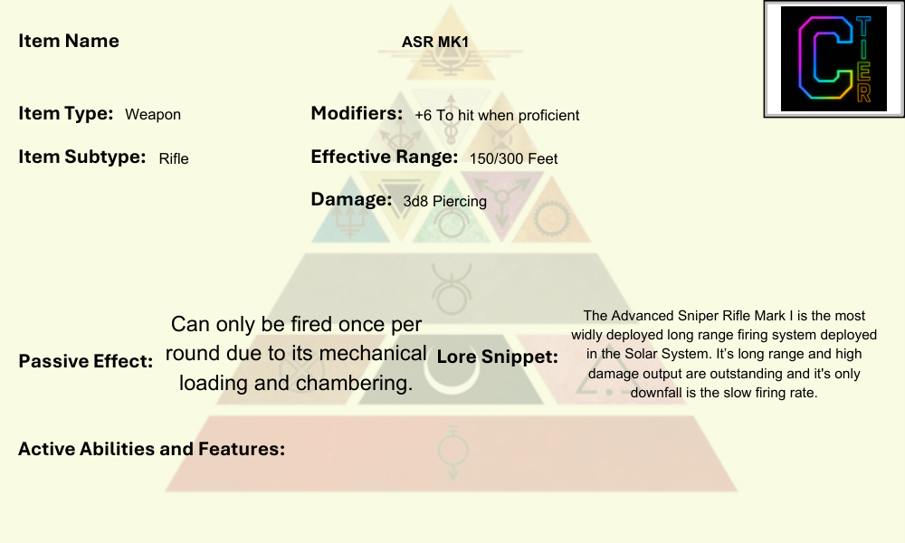

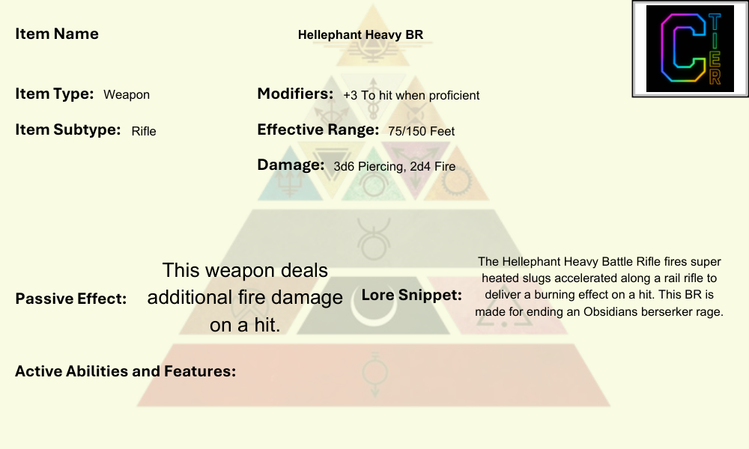

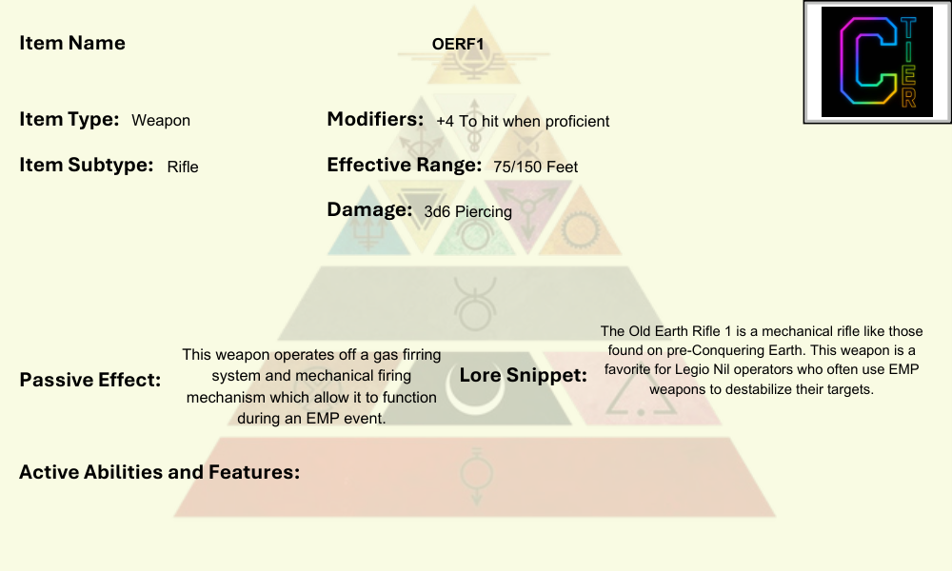

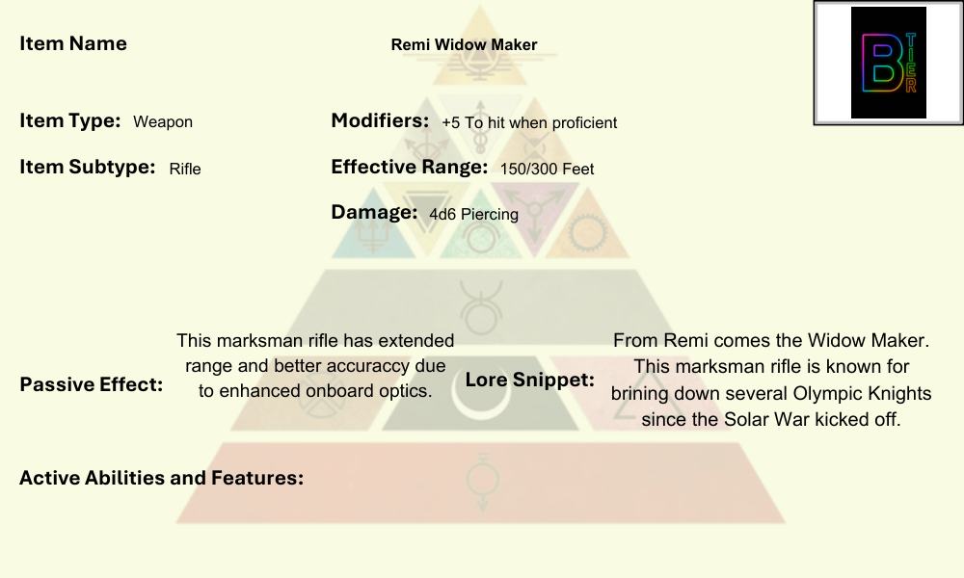

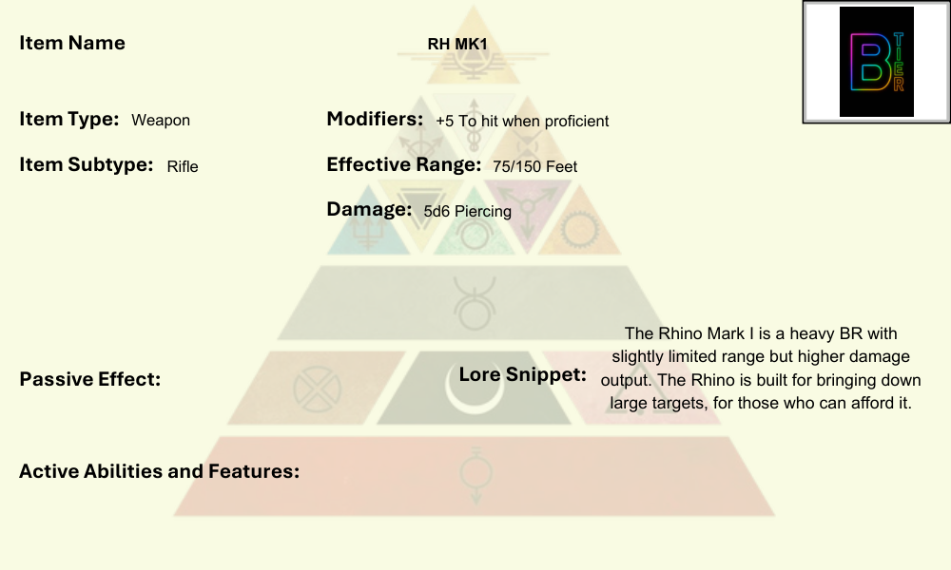

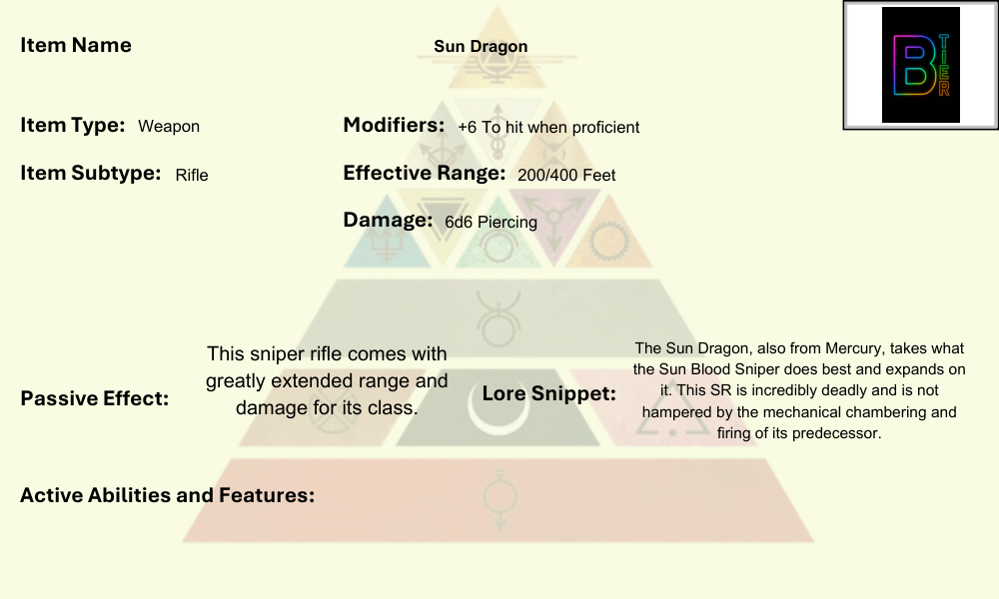

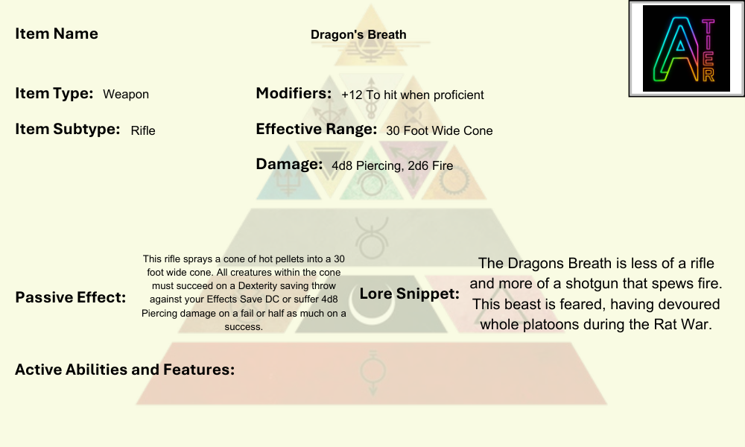

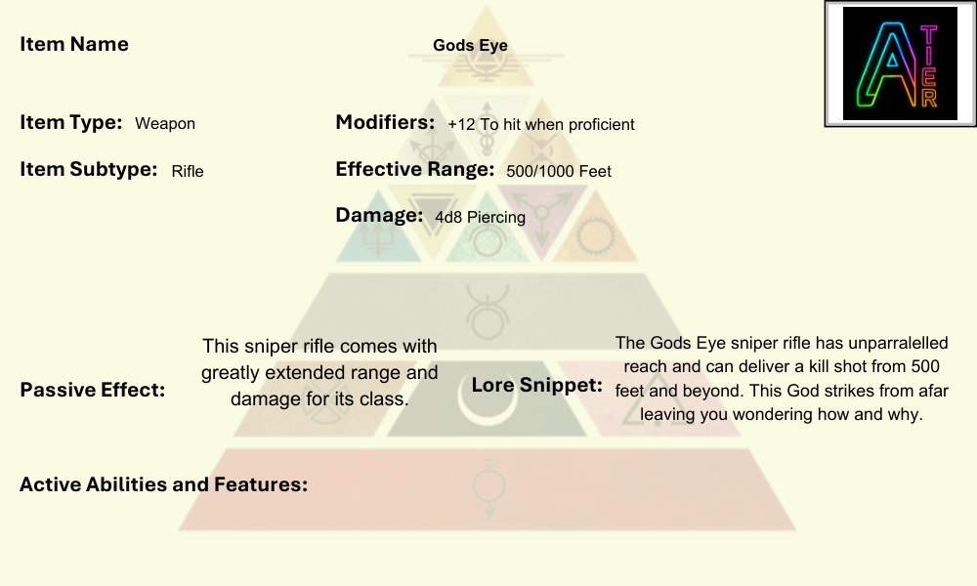

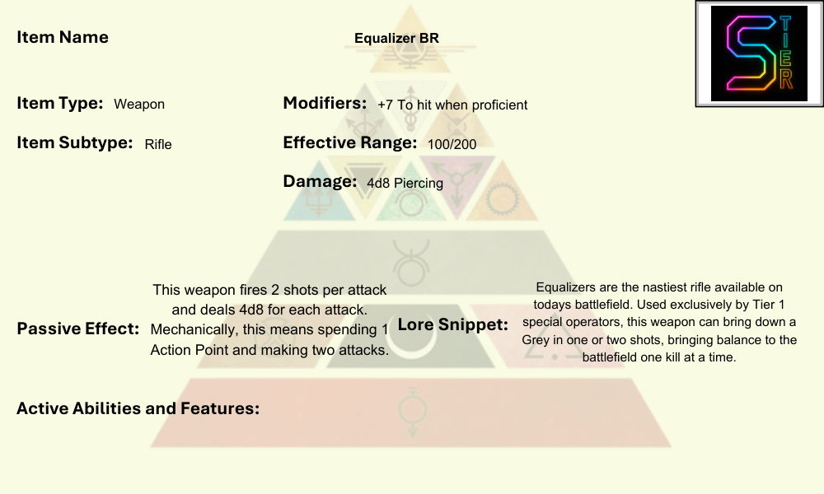

**Summary**

Where Pulse Armor turns a soldier into a living fortress and Pulse Shields embody defiance, the weapons of the Society define how they fight and who they are. Each type has its place: heavy weapons crush, melee inspires fear, pistols ensure survival, Pulse Fists devastate in close quarters, Razors proclaim legacy, and rifles hold the line. Together, they form the arsenal of a civilization both advanced and brutal, forged for war at every scale.

## Stims

Stims are biochemical or nanotech boosters carried into the field to give soldiers temporary surges of strength, stamina, or focus. Unlike traditional medicines, Stims are designed for immediate effect—delivered through injectors, auto-patches, or inhalers that act within seconds. They can mean the difference between collapsing under exhaustion and pushing through the next charge.

Most Stims fall into a few broad categories: combat stimulants that enhance reflexes and aggression, recovery stims that accelerate natural healing or reduce pain and focus enhancers that clear the mind in the heat of battle. Their use is common among Grays and Obsidians in frontline warfare, but even Gold duelists and Blues in command seats keep a dose nearby for emergencies.

Customization is as varied as the soldiers themselves. Some prefer military-grade compounds with predictable effects and standardized potency. Others—especially in the Rising—use improvised mixes, blending narcotics and engineered serums into volatile cocktails that risk burnout or dependency. Stims may be color-coded, flavored, or even ritualized—an Obsidian might carve runes into the casing of their stim injector, while a Green hacker might lace theirs with cognitive nanites.

At their core, Stims embody the philosophy of the Society’s wars: victory at any cost, body and mind pushed beyond natural limits.

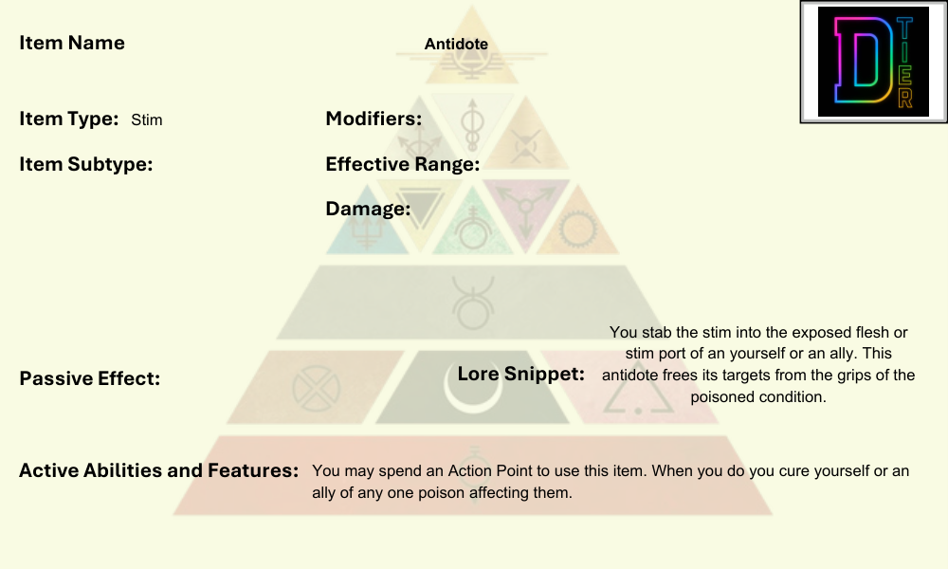

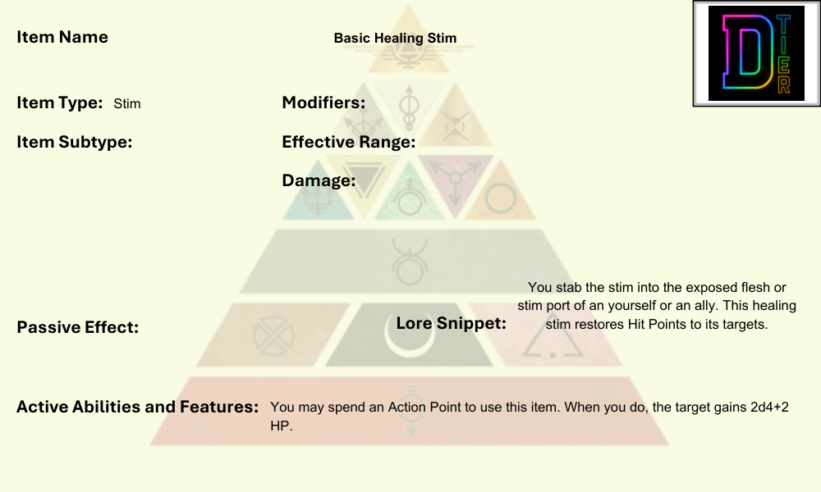

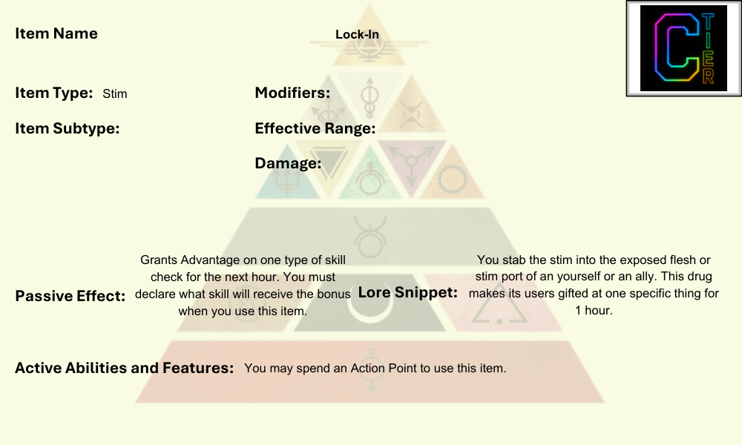

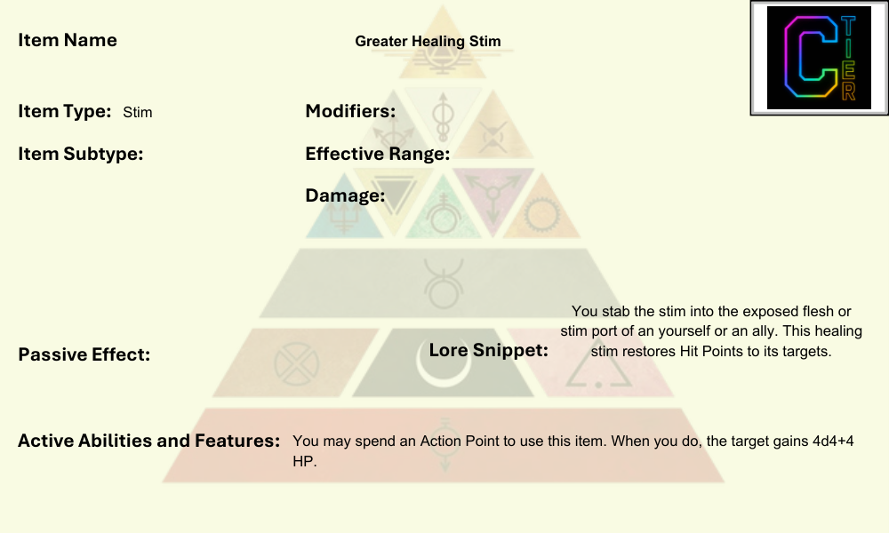

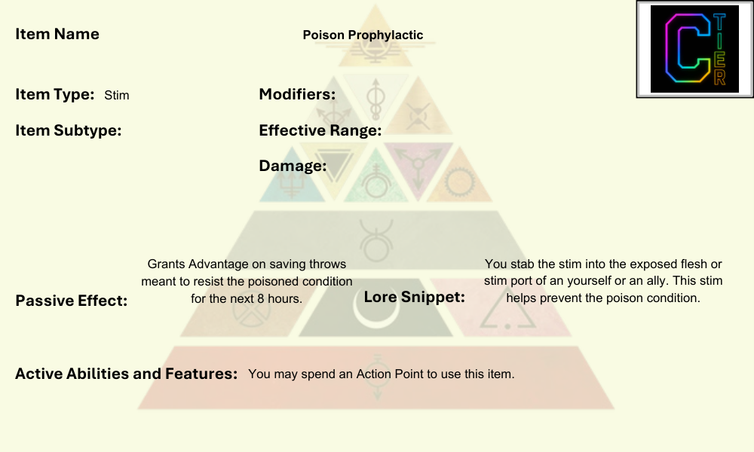

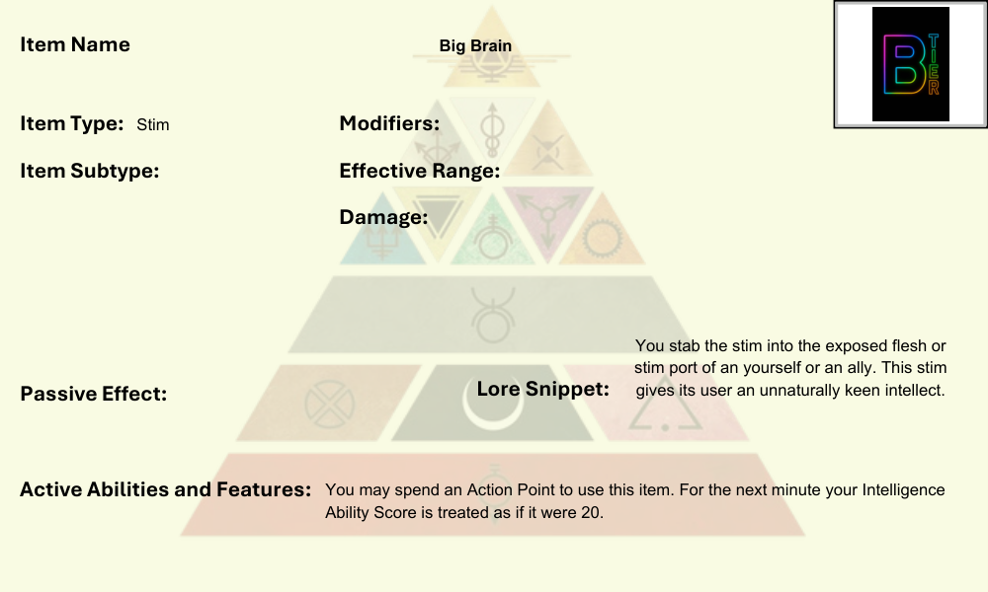

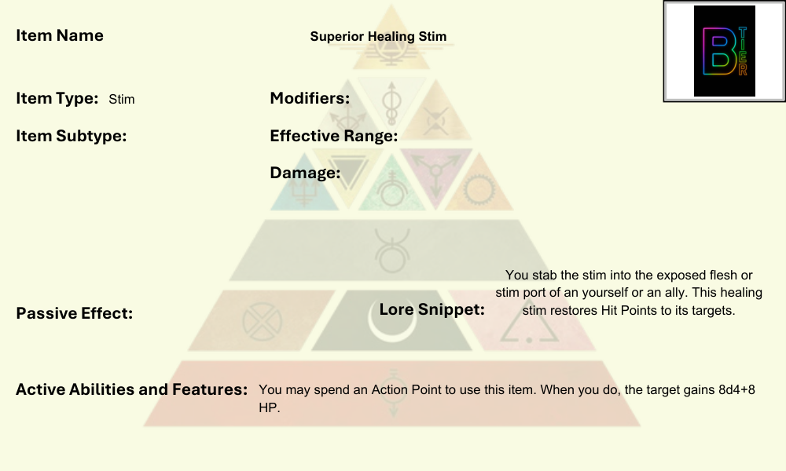

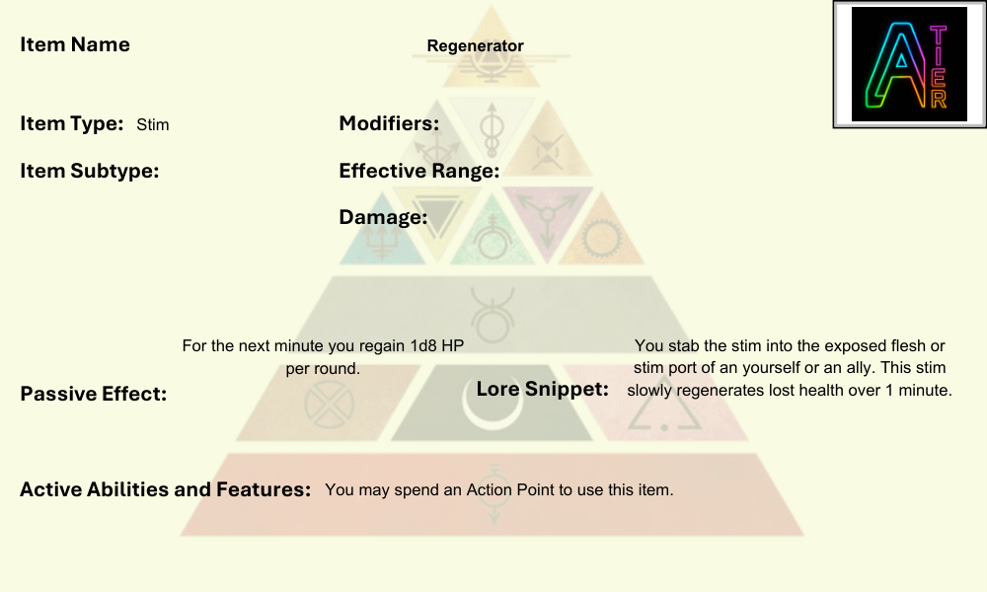

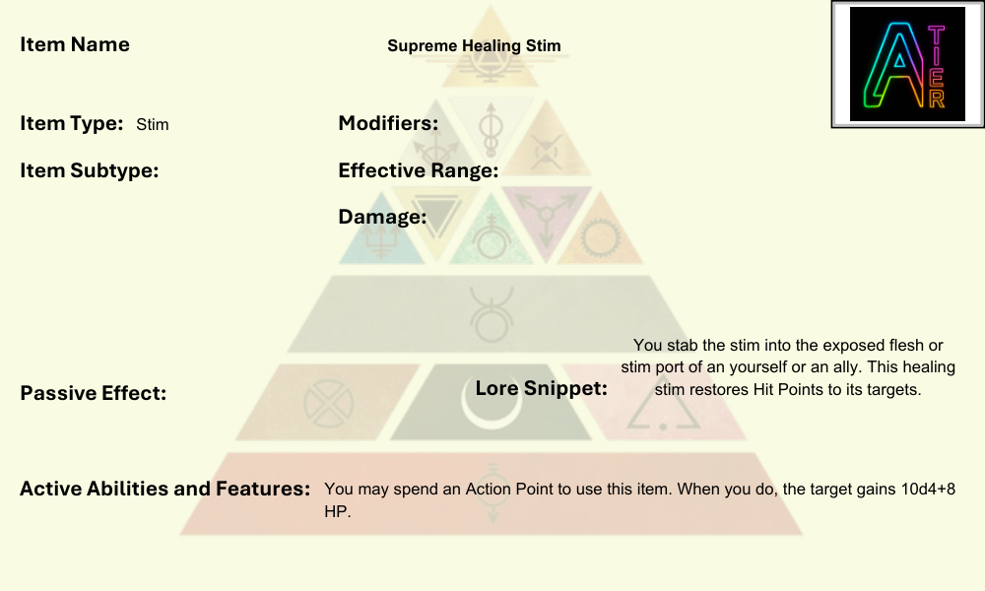

## Utility Items

Utility items add flavor and slightly helpful mechanics to your core items and abilities. Utility items come in two variants, boot and torso. Only the right item slot goes with the corresponding utility.

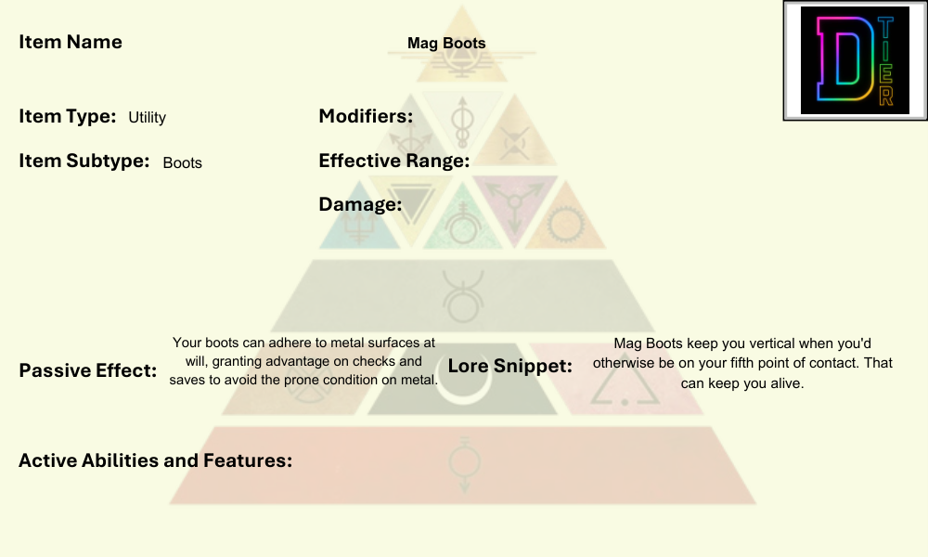

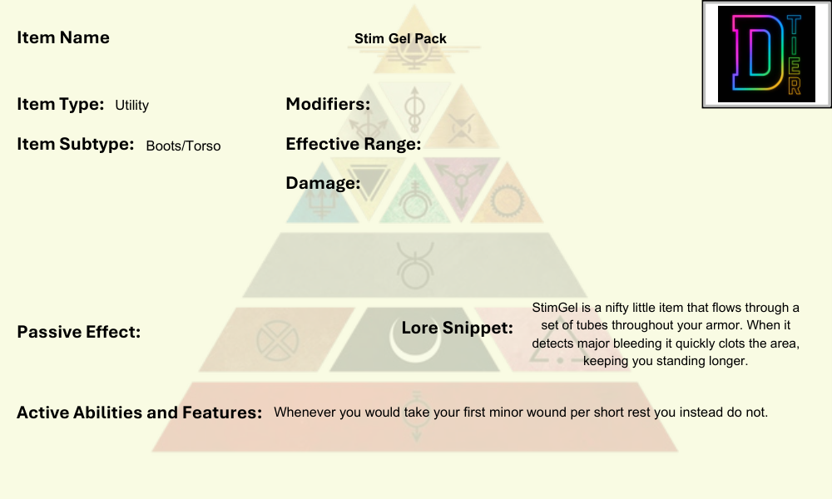

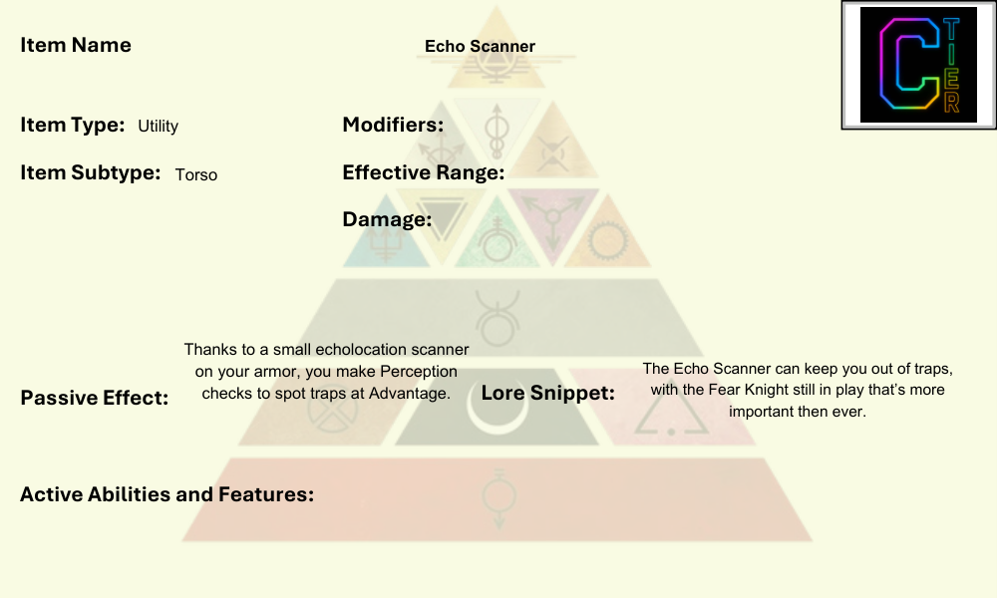

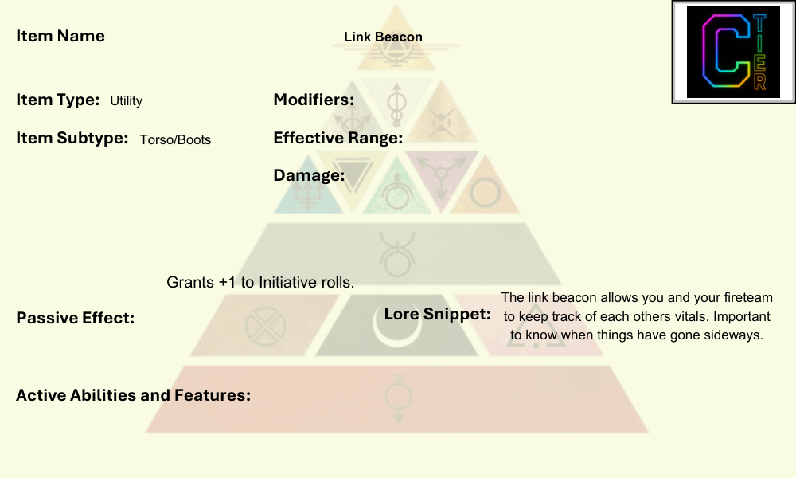

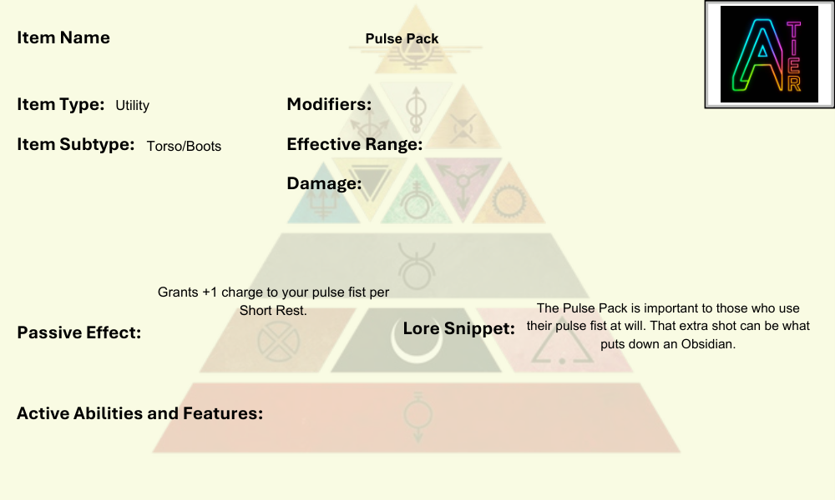

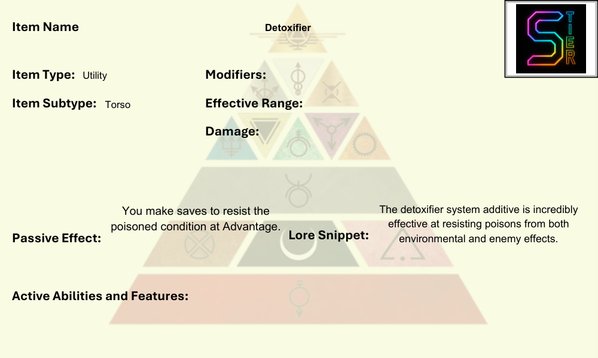

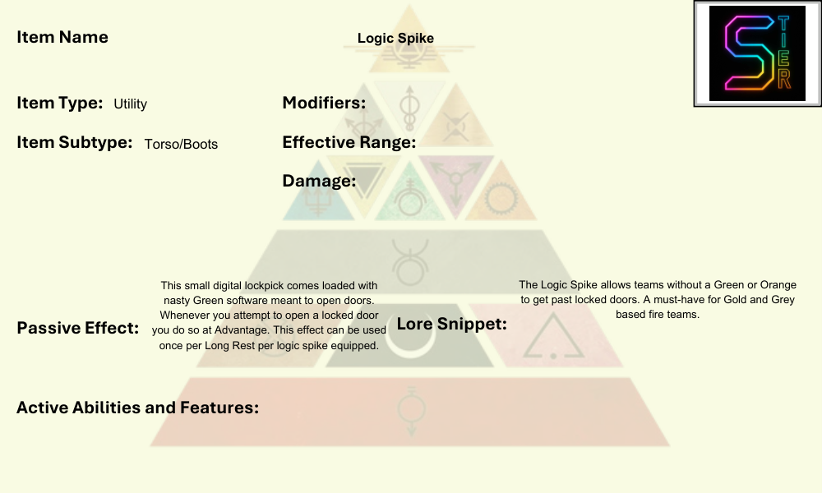

## Tools

Tools in SoM behave much like in other TTRPGs, granting some sort of benefit or passive bonuses such as Advantage on a certain type of roll. These tools are typically used outside of combat for a variety of functions. See below for a complete list of tools found in SoM.

**Ghost Cloak:** A belt-pack veil that bends light; good for slipping past sentries or staging vanish-and-reappear gambits. Best in short bursts before it overheats. Grants Advantage on one Stealth check per Short Rest.

**Forgery Kit:** An electronic and analog kit for forging documents. This kit grants Advantage on all attempts to forge documents.

**First Aid Kit:** A small bag of first aid supplies meant to help stop bleeding and stabilize nearly dead allies. You may spend 2 Action Points to grant one ally you can touch 1d4 Hit Points.

**Digi Picks:** Smart tumblers and micro-probes for physical locks. Grants advantage on Technology checks to pick mechanical and electromagnetic locks.

**Faraday Shroud:** A 20 foot by 20-foot copper tarp for hiding electronic signals. Meant for covering small ships, drones, and turrets. Not effective for Humans. Attempts to perceive any electronics under your shroud are made at Disadvantage.

**Signal Leech:** Adhesive tape for enemy camera systems capable of granting you access to CCTV. Plant this on a camera system, make a dc15 Technology check. On a success, you gain access to that camera and all others on the same circuit.

**Quick Clot:** This sticky substance is activated by water in Human blood, quickly super-heating and cauterizing a Minor Wound. Spend 2 Action Points and target a creature you can touch with a Minor Wound, that creature no longer takes damage from the wound at the start of each of their turns. You have 3 uses of this tool per Long Rest.

**Plasma Torch:** This small torch has one charge and is capable of slicing through thick metal doors or thing metal walls. You may spend an Action Point to use this tool, you create a 5 foot by 5-foot hole in the wall or cut open a sealed door. You have one use of this tool per Short Rest.

**Pulse Saver:** This small battery system captures wasted energy from your Pulse Systems. Whenever you exhaust your last charge of your Pulse Fist or Pulse Shield you instead gain +1 charges of that item. You may use this feature once per Long Rest.

**Computer Repair Kit:** You have a small computer repair kit at your disposal. You gain +1 to Technology checks to repair or restore broken computers and other “Smart” systems.

**Tinkerers Kit:** You own a small kit of tools and apparatuses that allow you to complete small engineering feats in the field. You gain +1 to Engineering checks to repair or restore broken equipment or objects.

## Ships

In SoM ships are presented with assignments for each of your Colors as outlined in the “Ship Encounters” section of chapter 1. Ships in SoM range in rarity from D Tier to S Tier with S Tier being the highest rarity. This book contains 15 original ships with varying offensive, defensive, and utility type features.

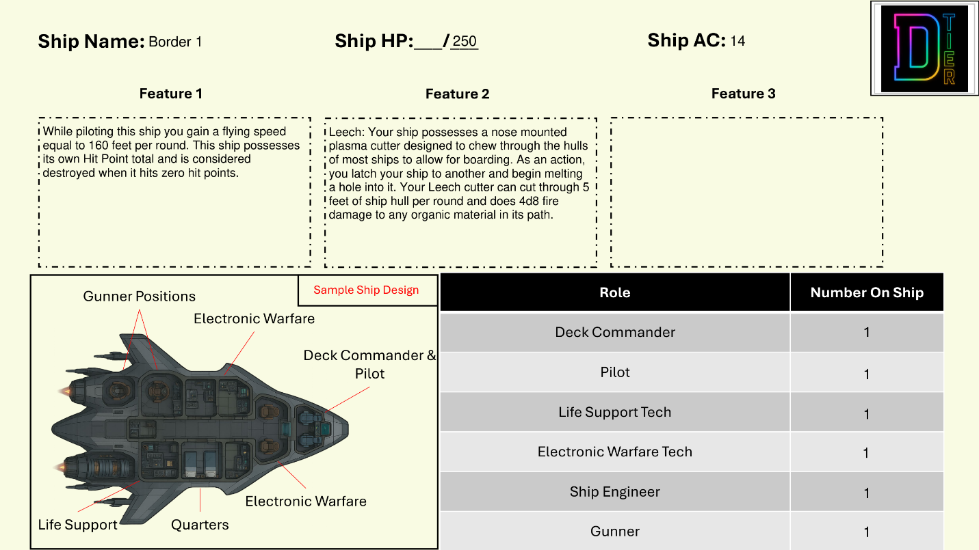

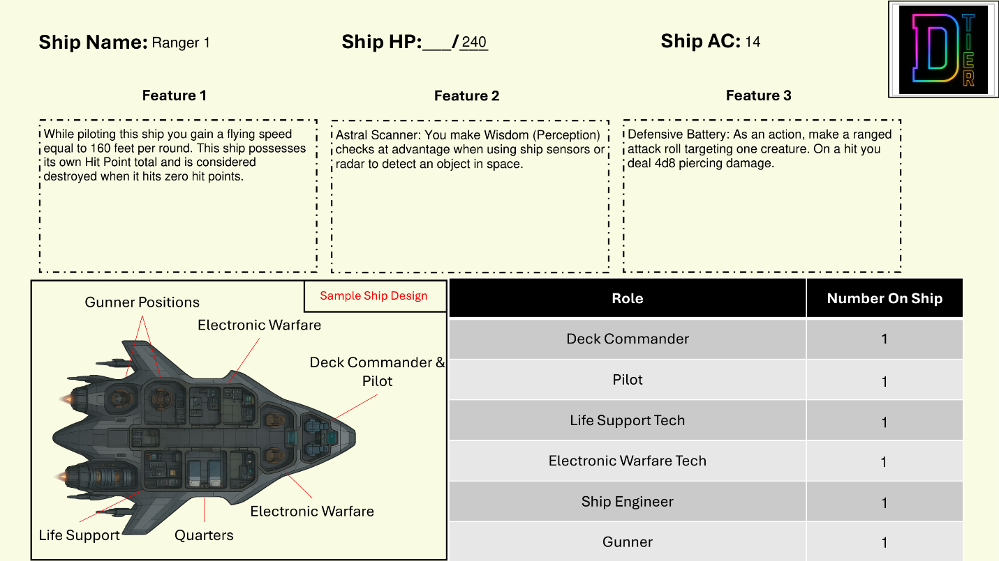

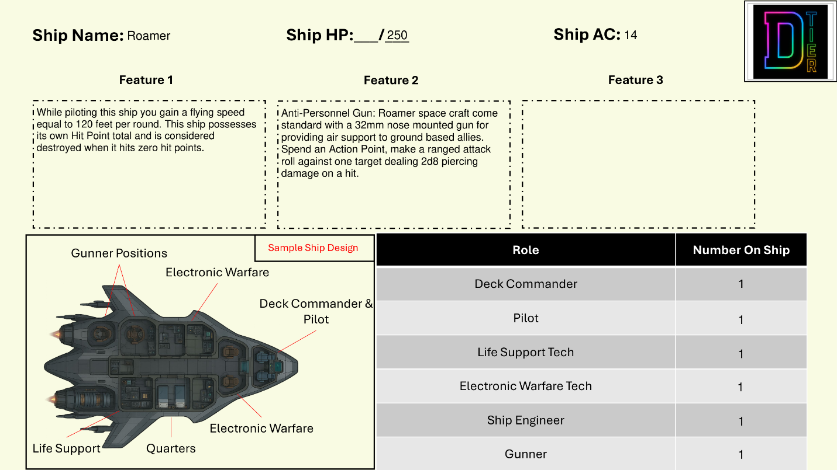

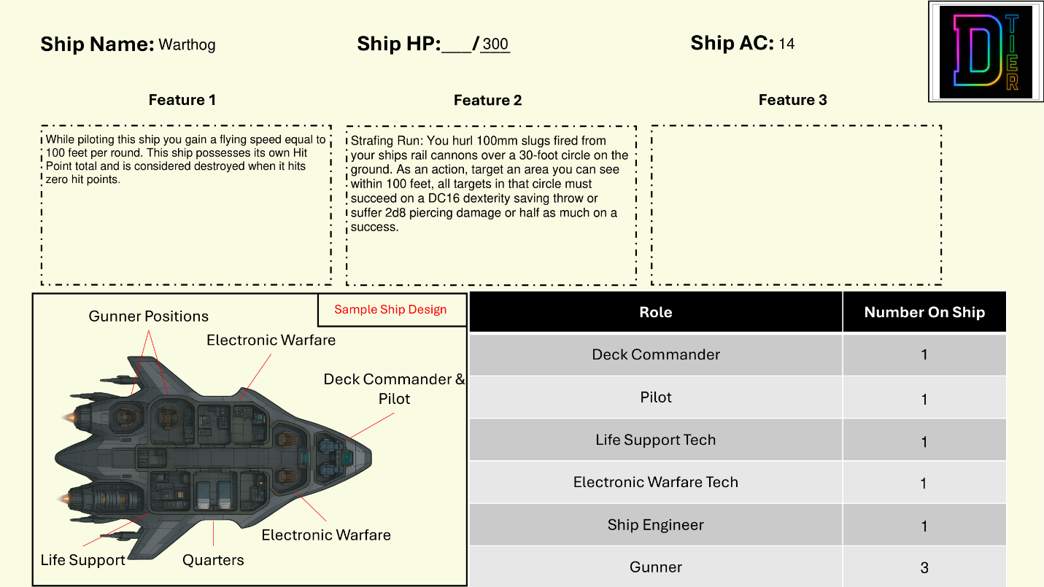

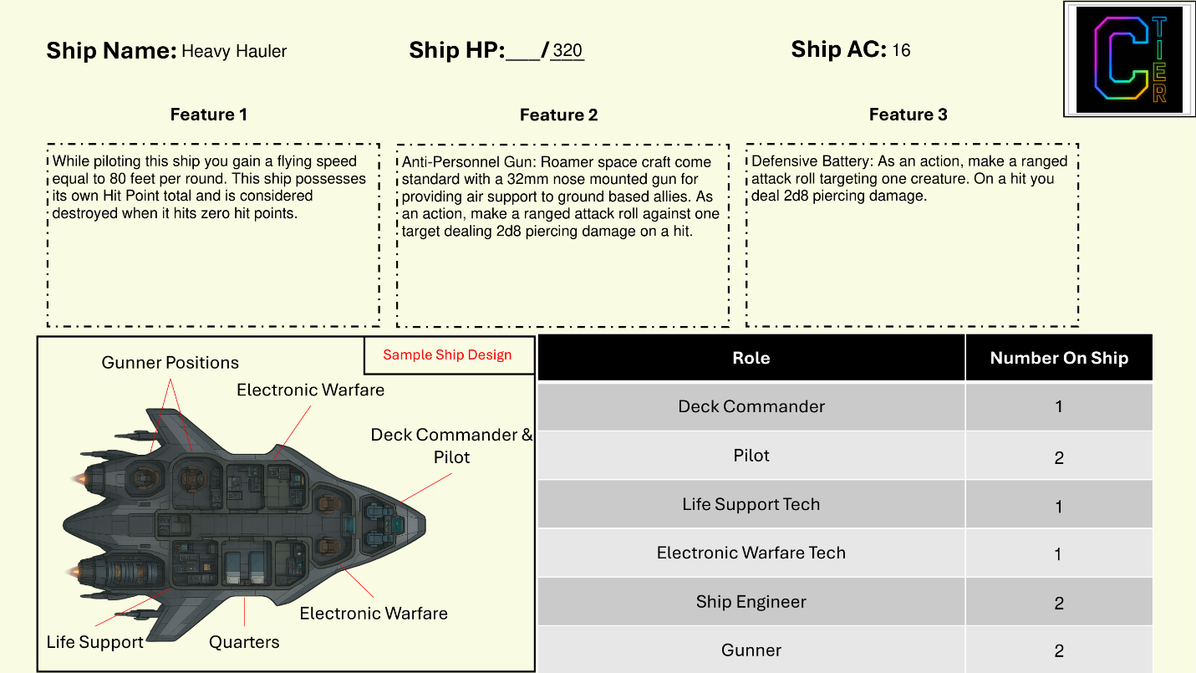

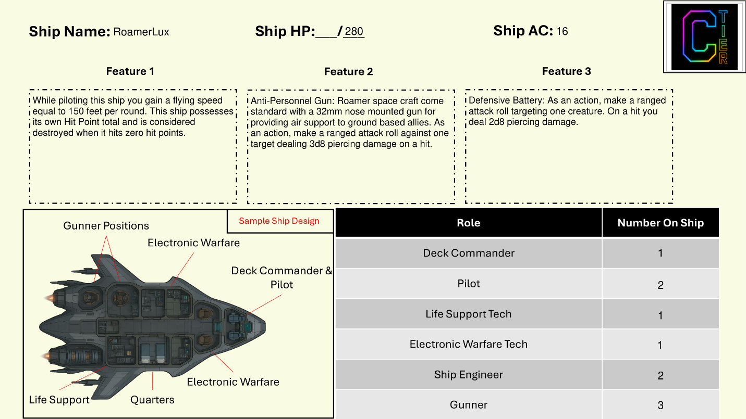

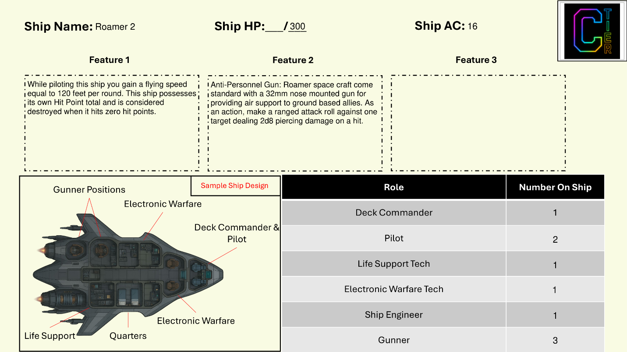

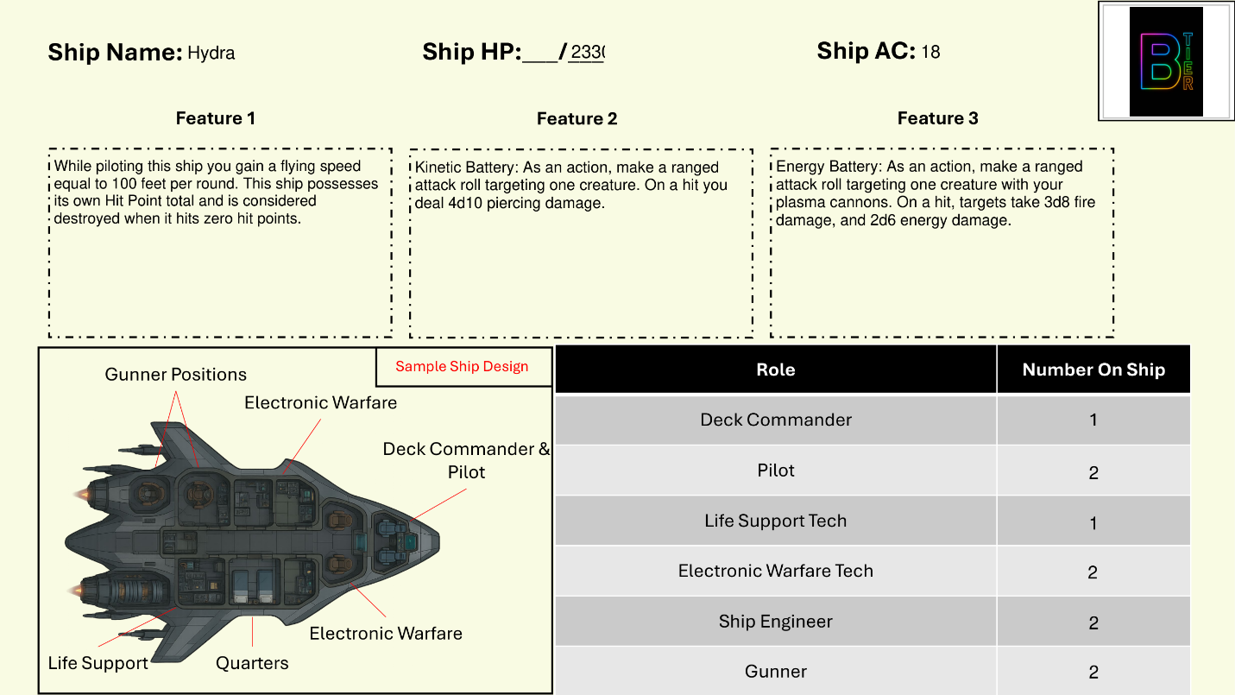

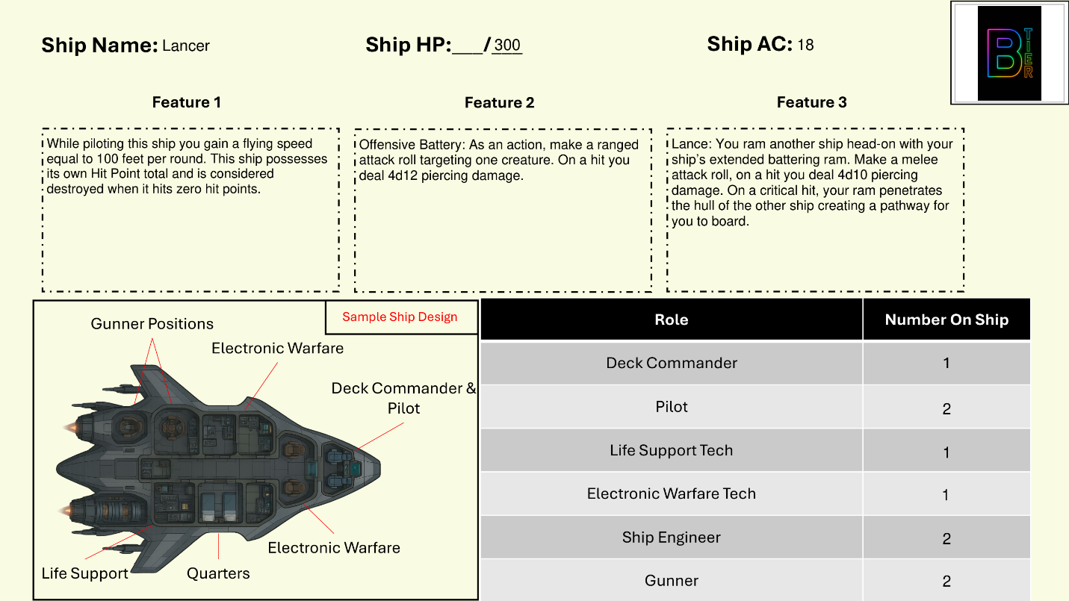

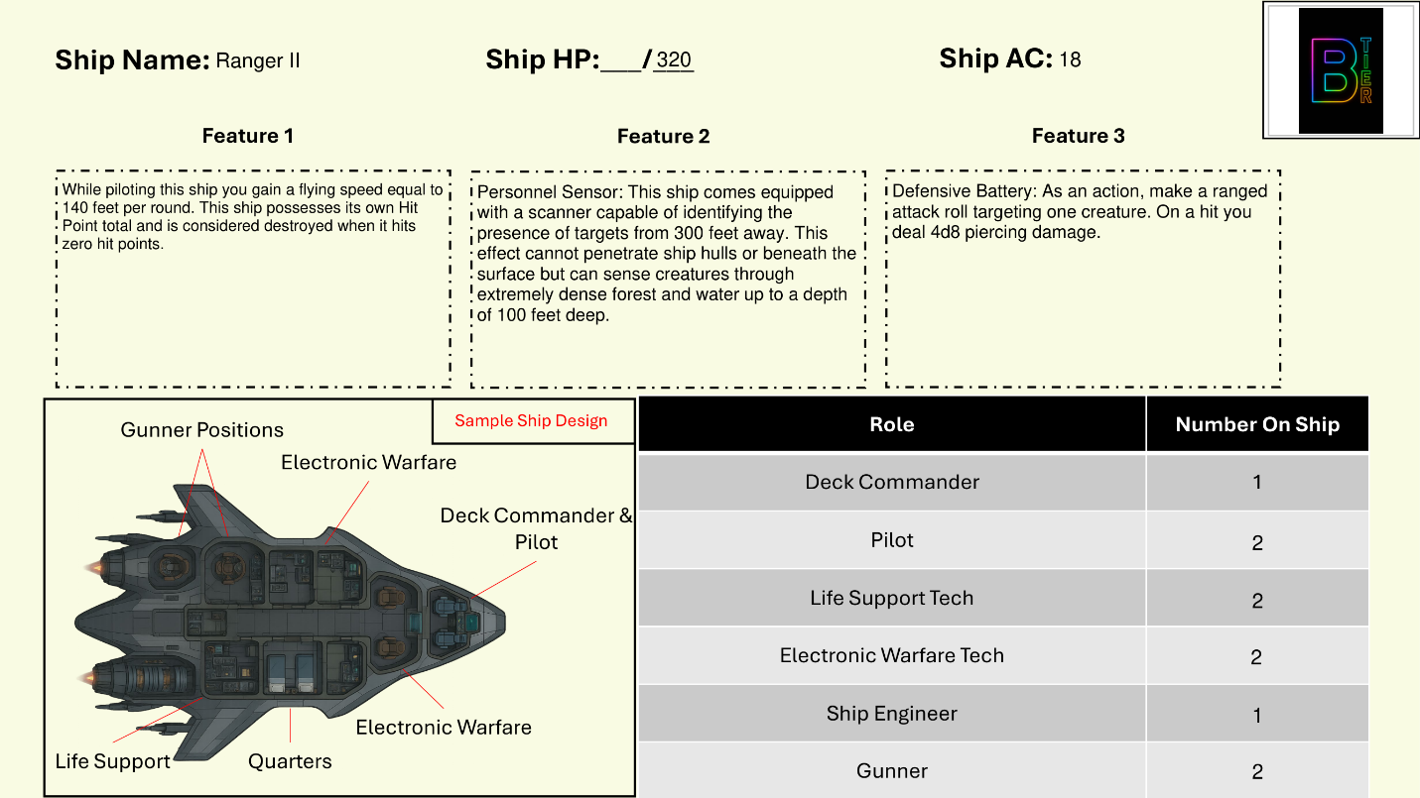

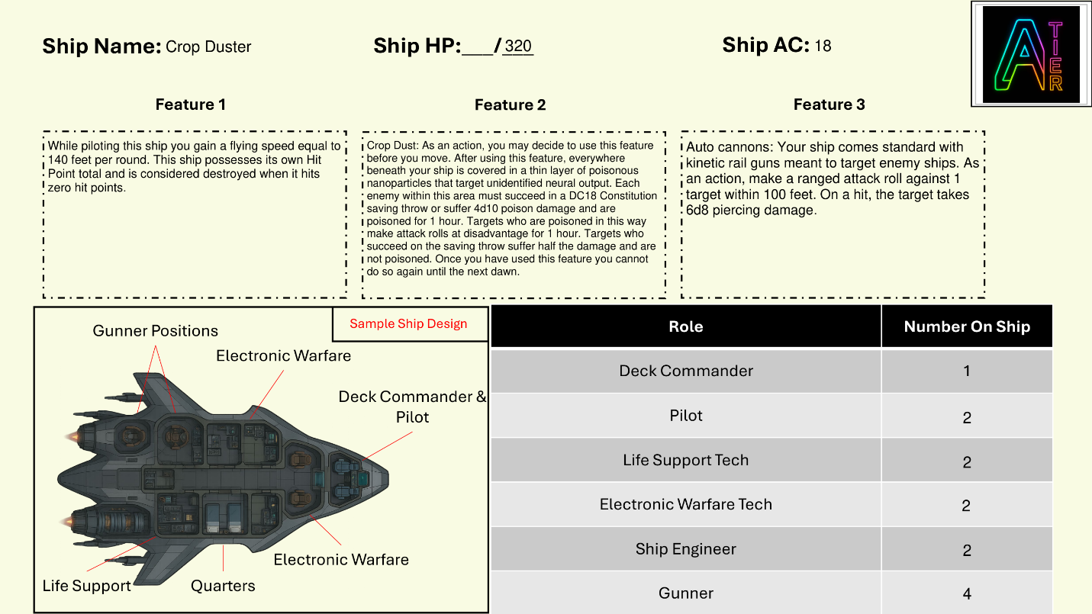

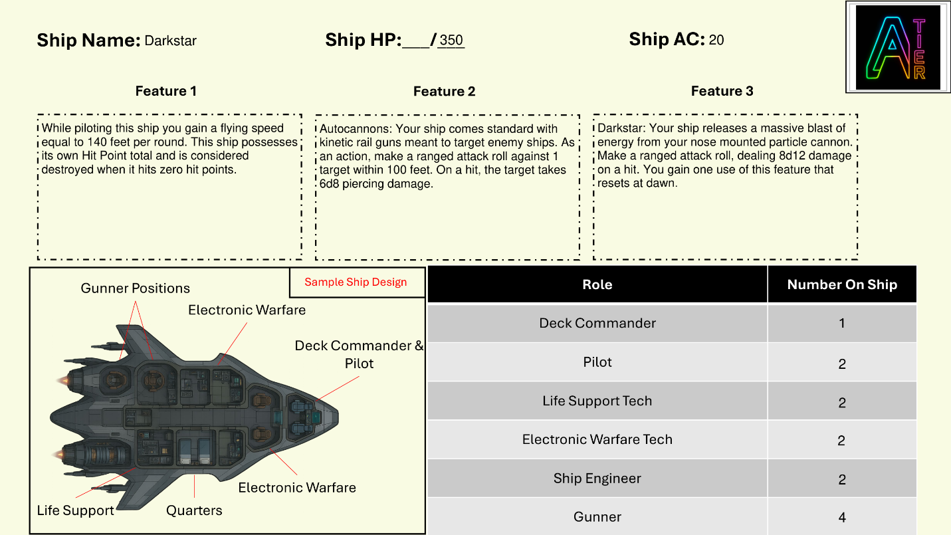

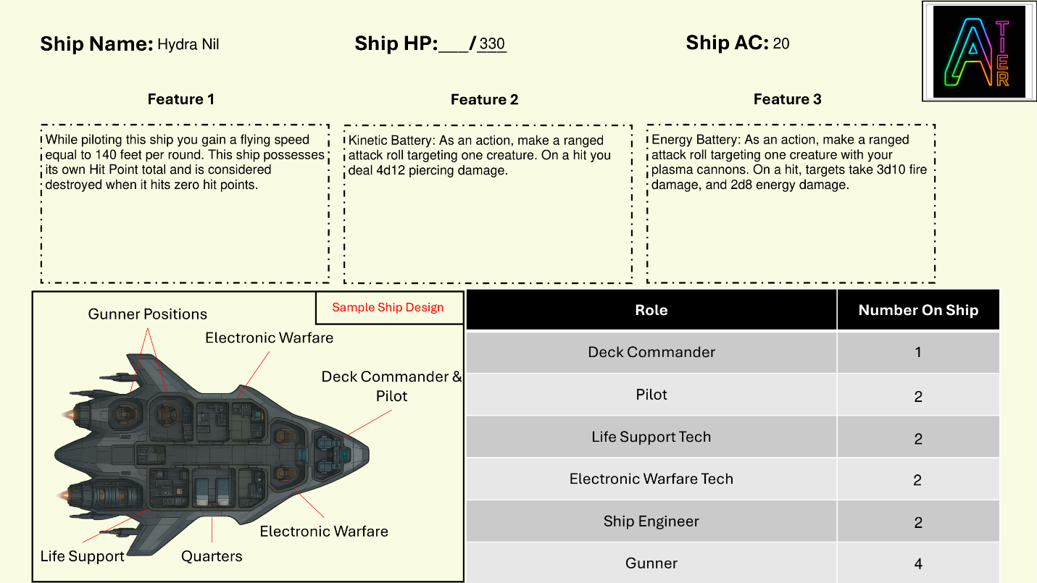

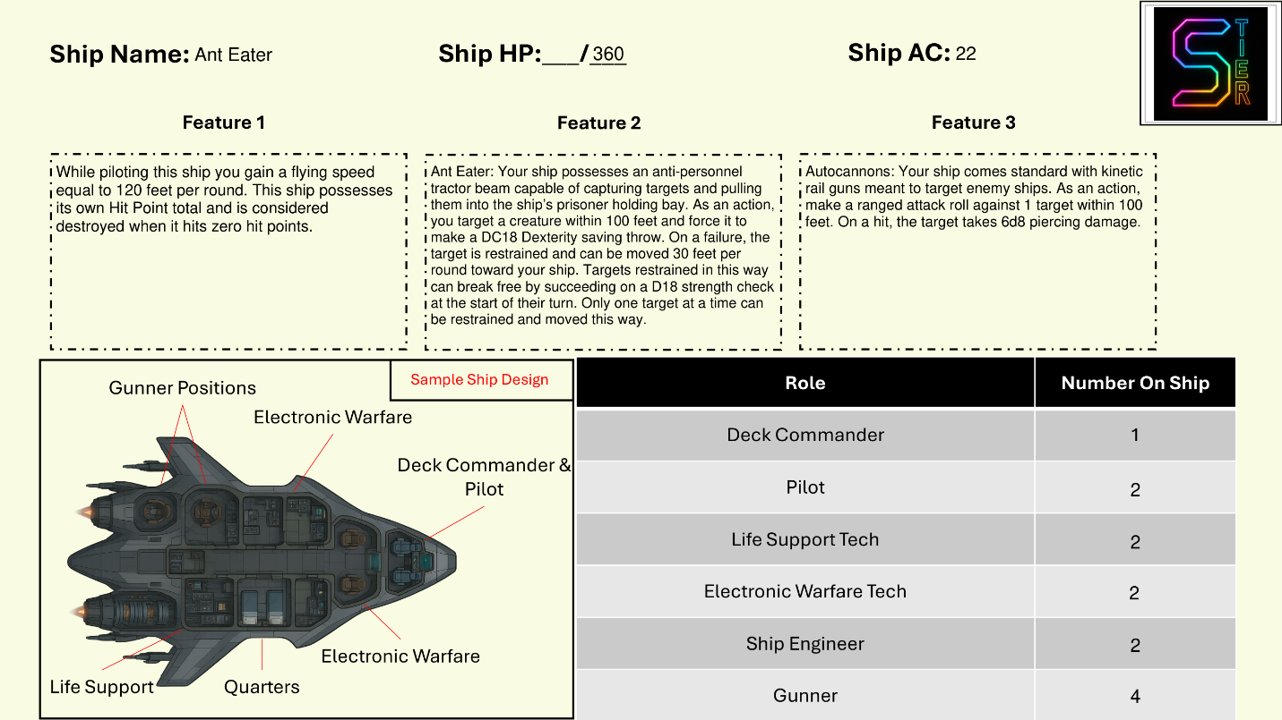

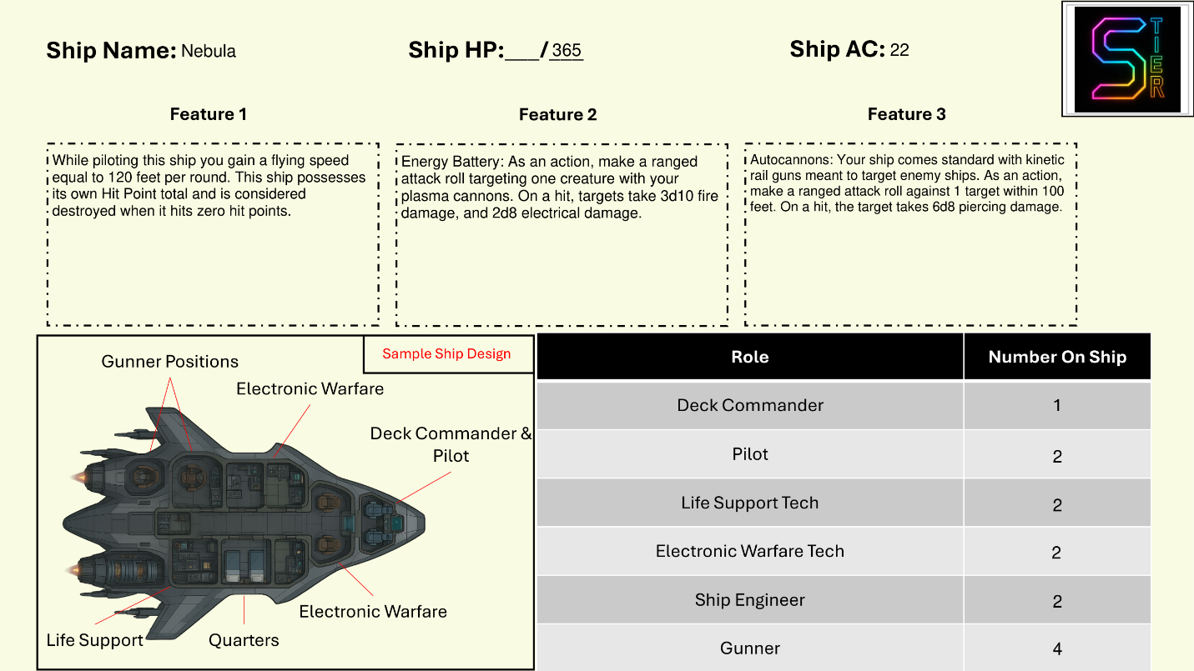

# Chapter Five: Enemies

The enemies in SoM are based on their Color specific traits and presented below in Color order. Enemies in SoM are made to be homebrewed, that is, edited in any number of ways to suit your specific needs at your table. While an enemy may be presented as too strong for your players, you can simply edit his AC, HP, and damage output to suit your needs. Certain enemy classes like the Olympic Escort are considered boss tier enemies. These typically have much more HP, an AC of at least 20, and have what are called “Prestige Actions”. These Prestige Actions allow for unique mechanisms in combat and are typically passive benefits or free use features during their turn in combat. Encounters should be varied by changing the setting, intensity, and named enemies involved. SoM can offer tight fights in ship corridors, large open fights on Terra Ferma, and even ship boarding. For most encounters, Greys and Obsidians will serve as your base enemy set with other mid-Colors sprinkled in for flavor. Golds should almost always be named enemies or at least a commander of the forces in the encounter. Encounters with multiple Golds should be saved for encounters where your table is prepared, Golds can overwhelm a fireteam fast if they are under level.

### Gold

Gold enemies use their Razor as their normal attack method and can quickly overwhelm smaller enemies with their signature weapon. Higher difficulty Golds hit harder and more often.

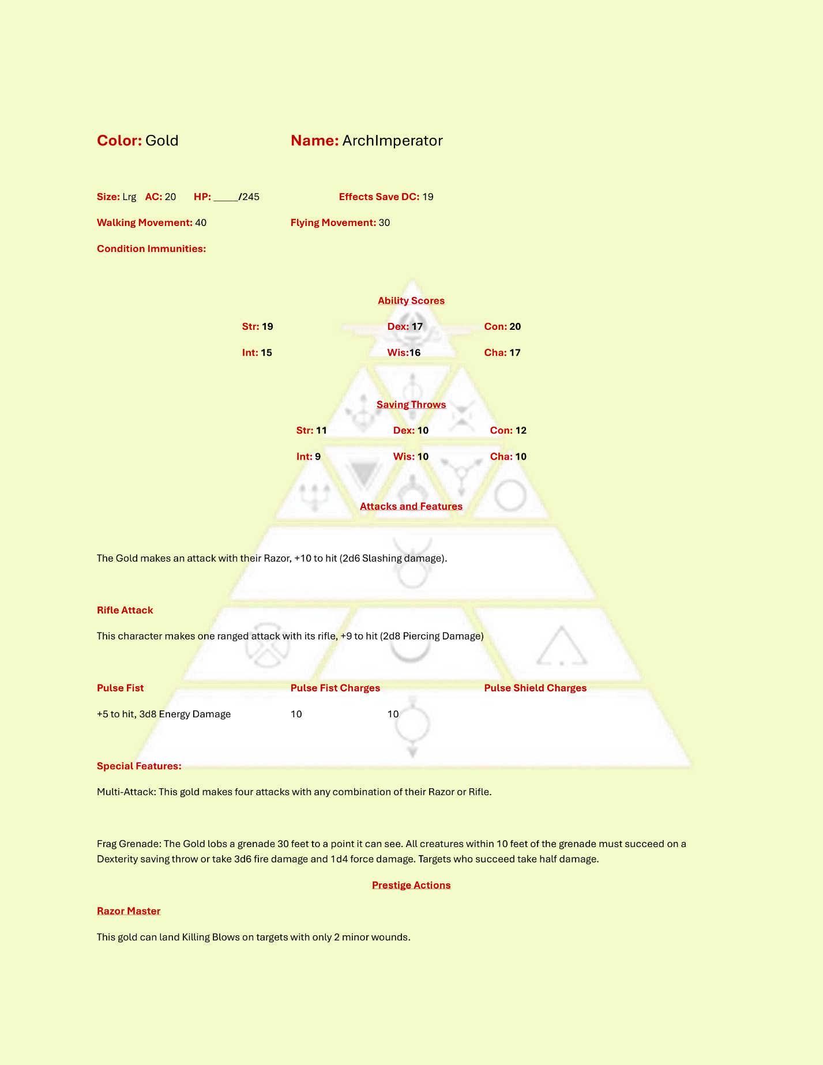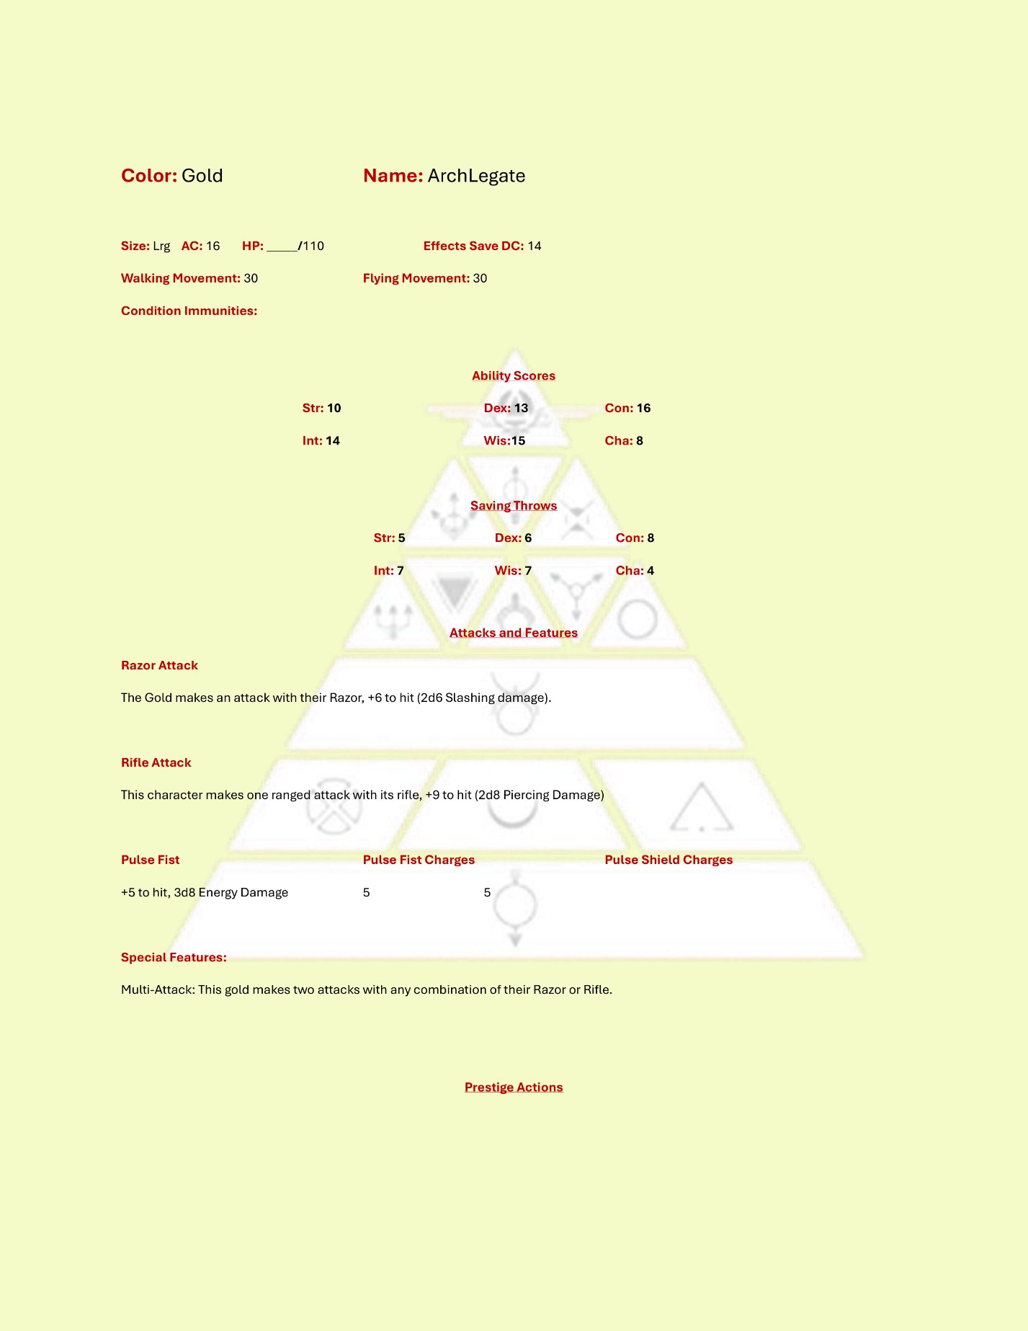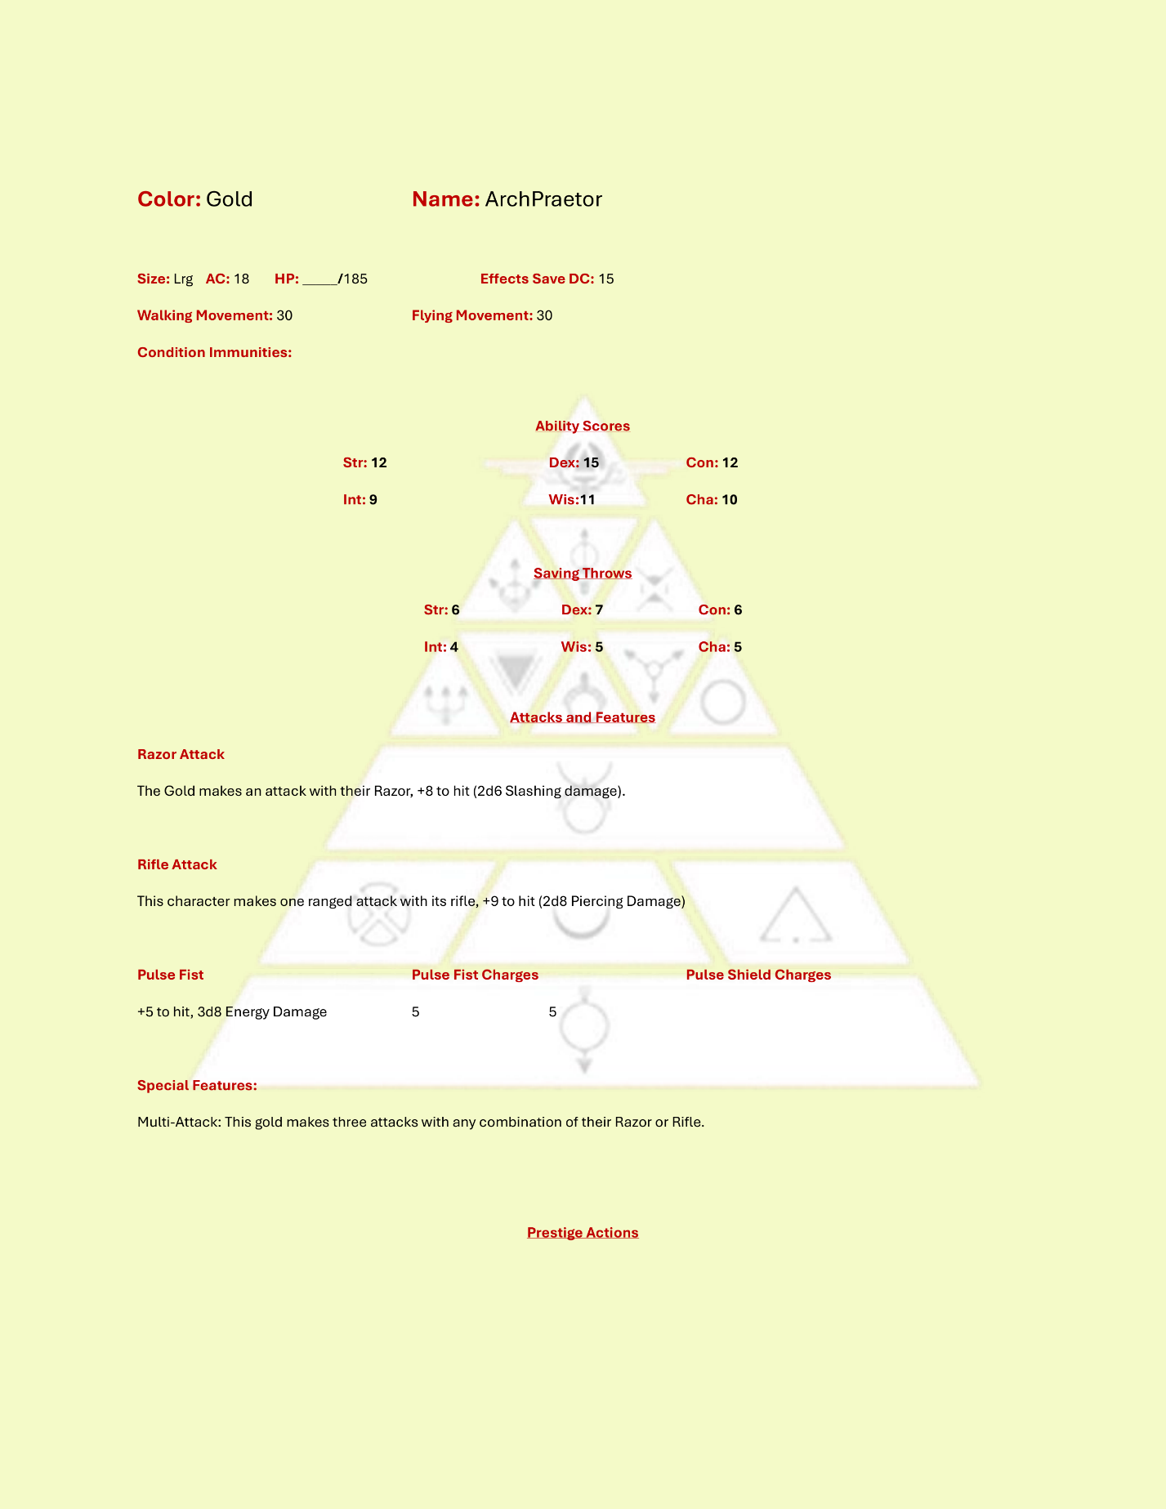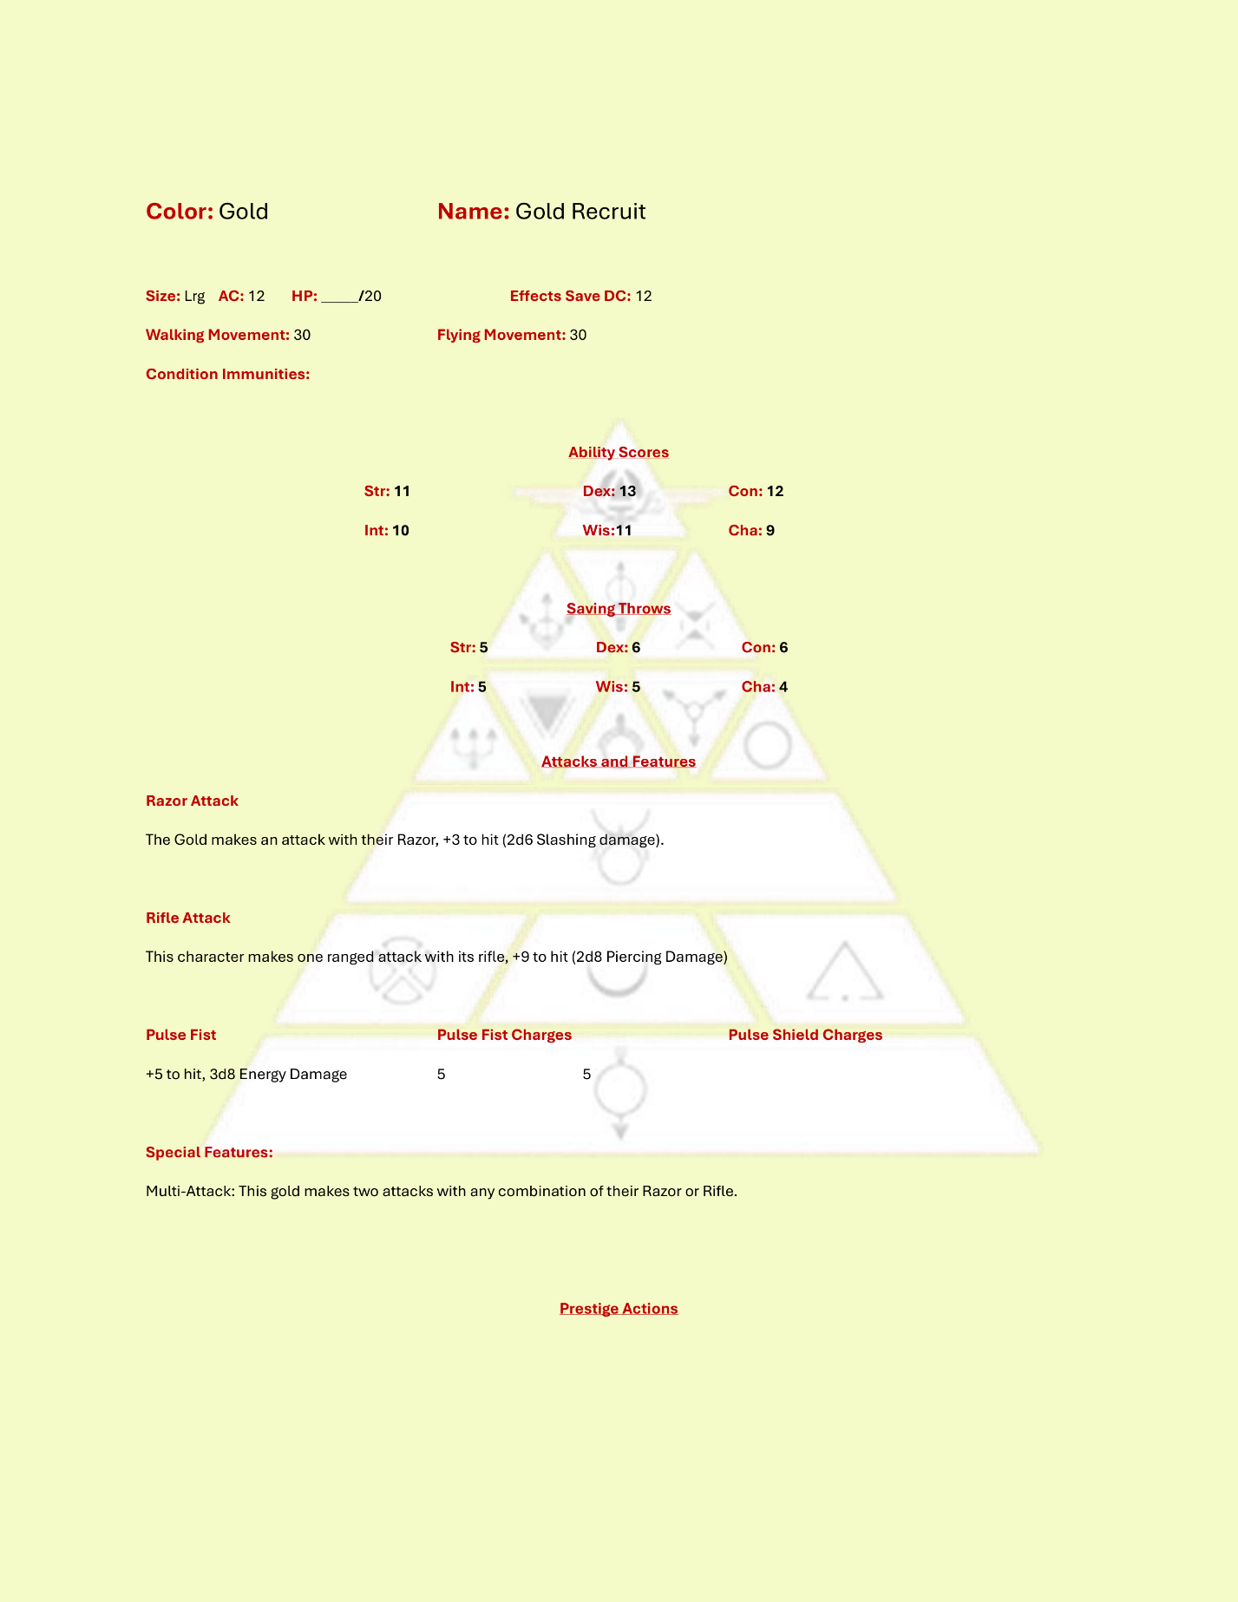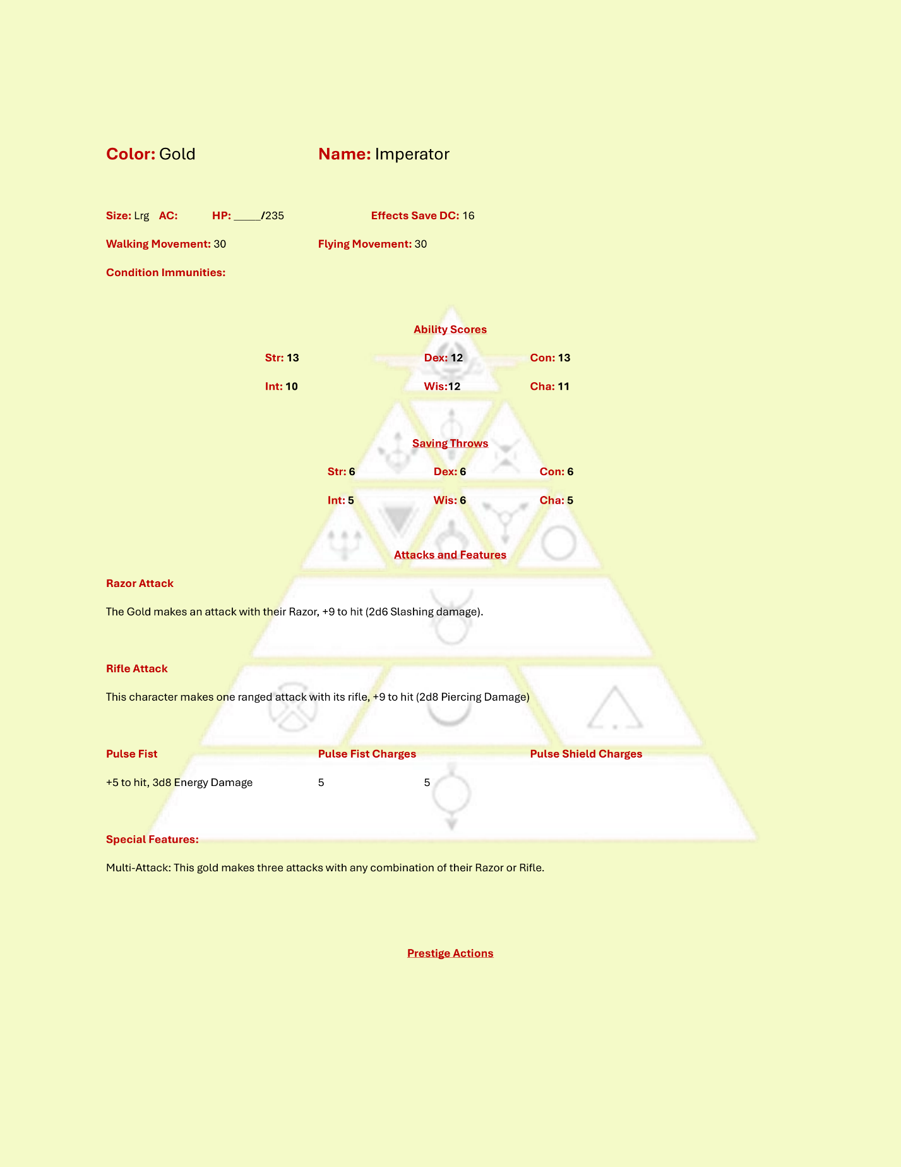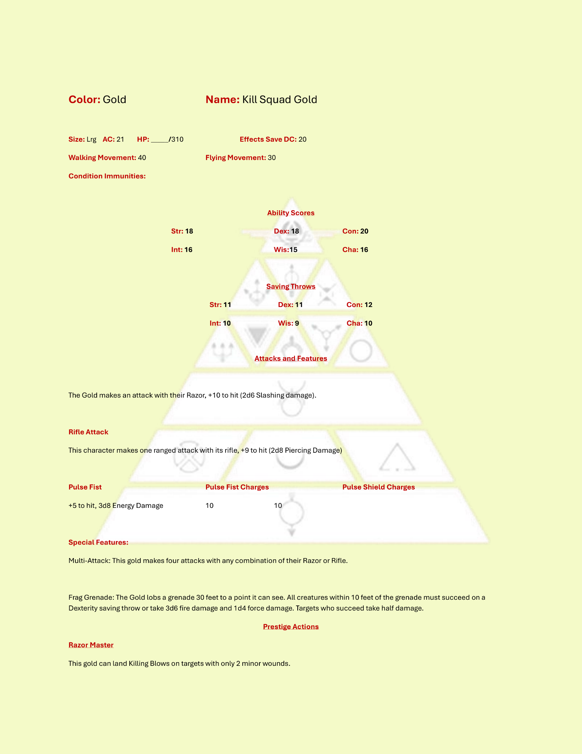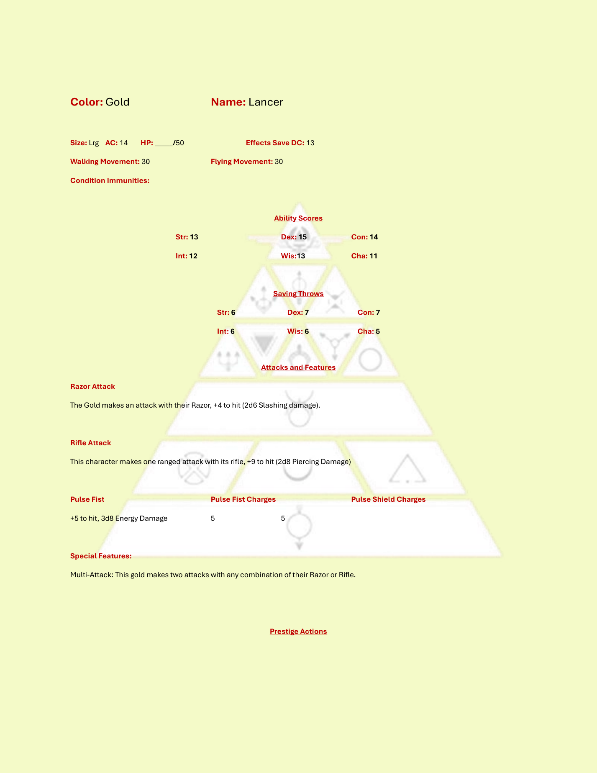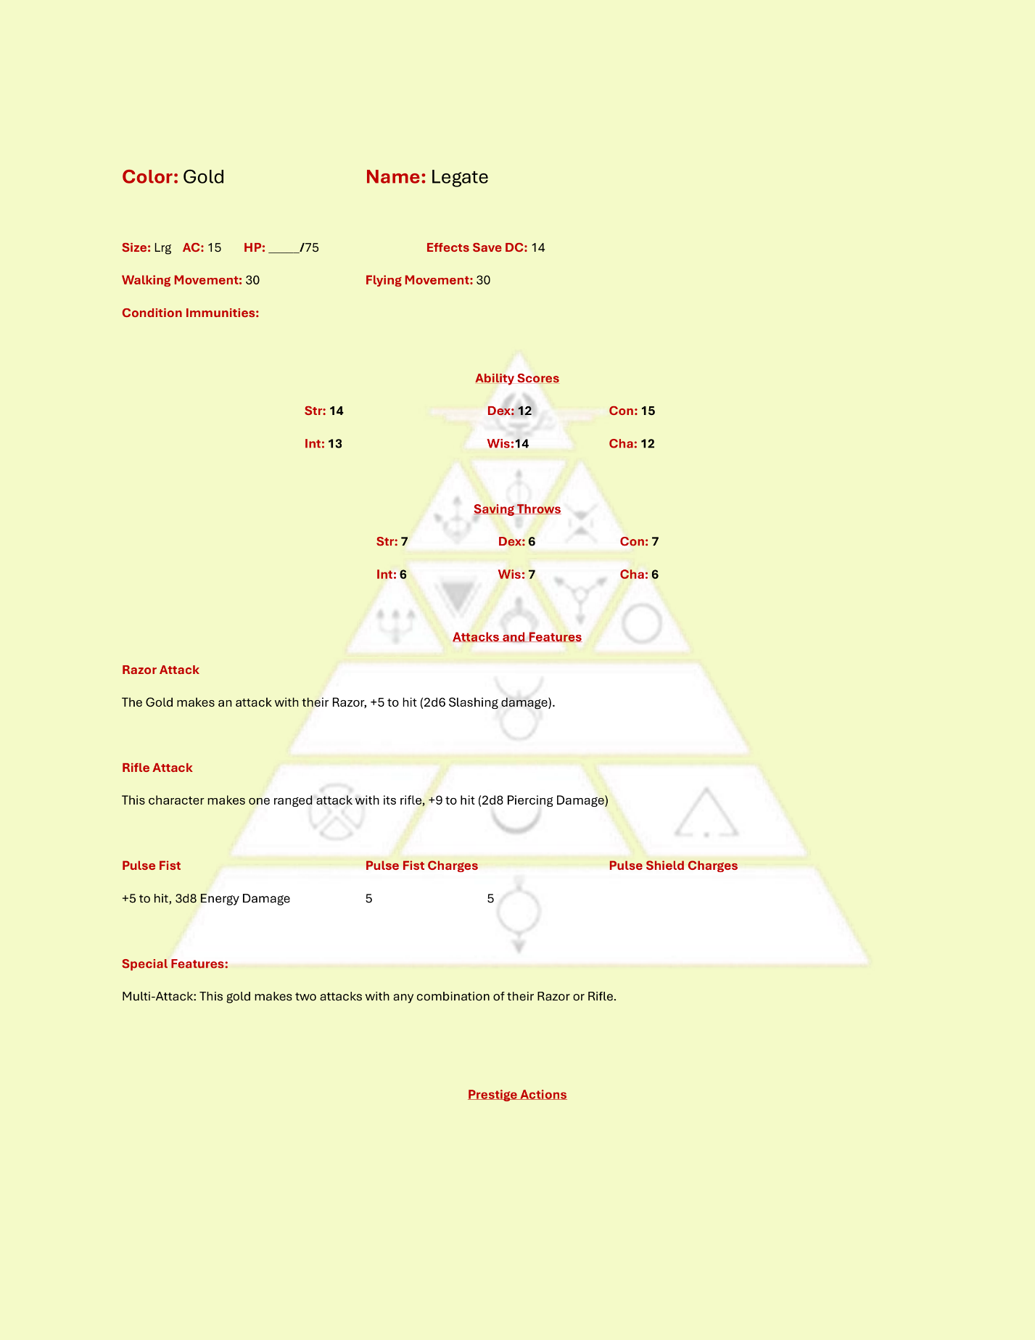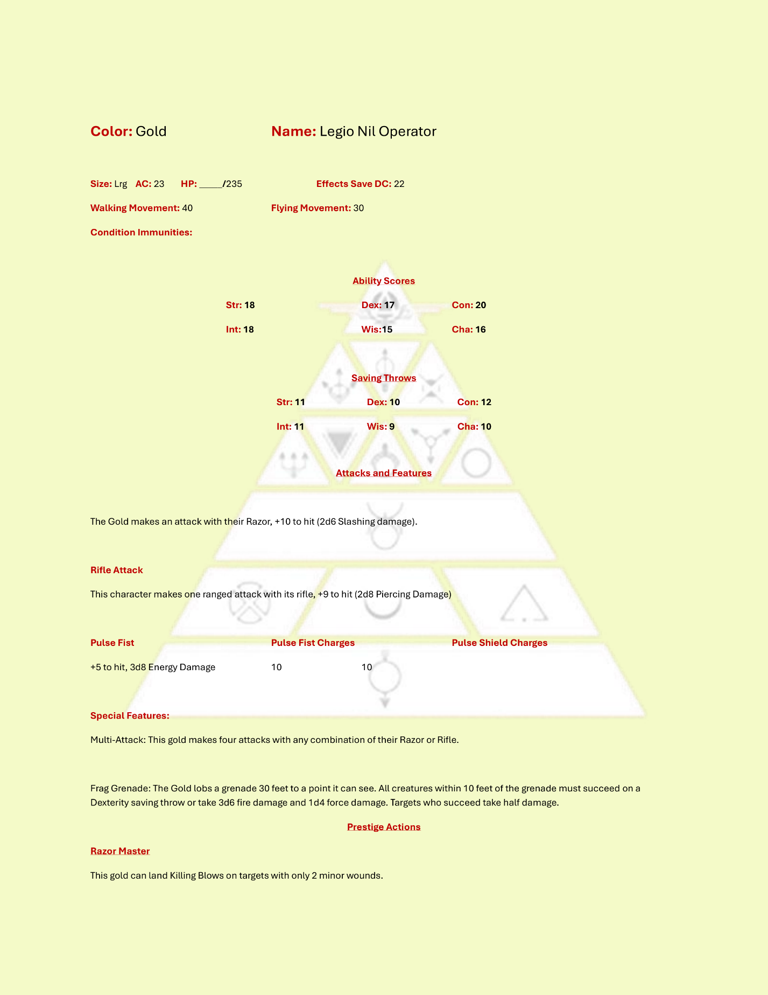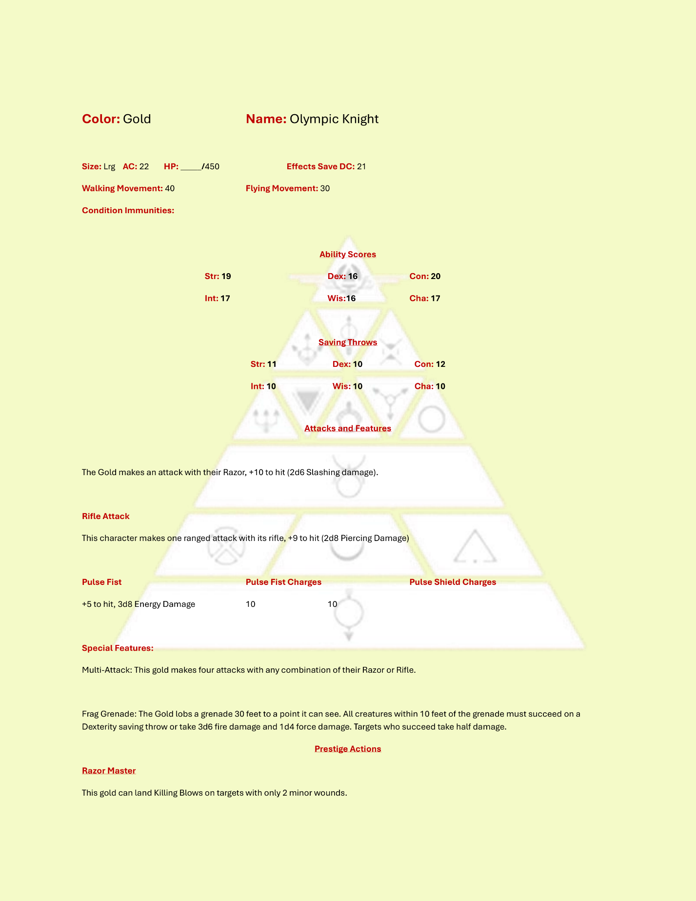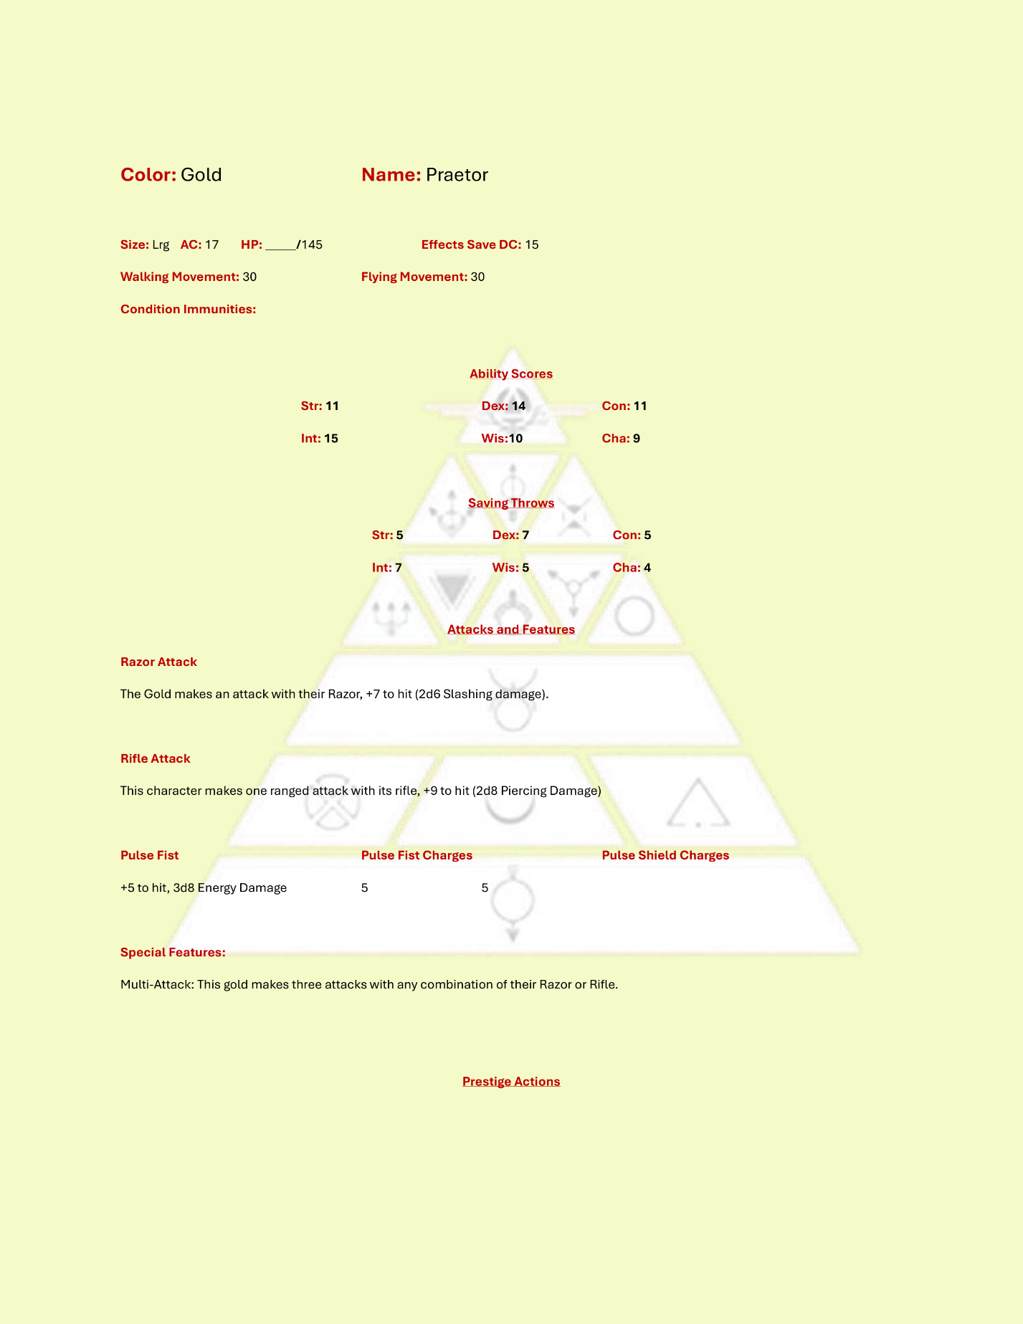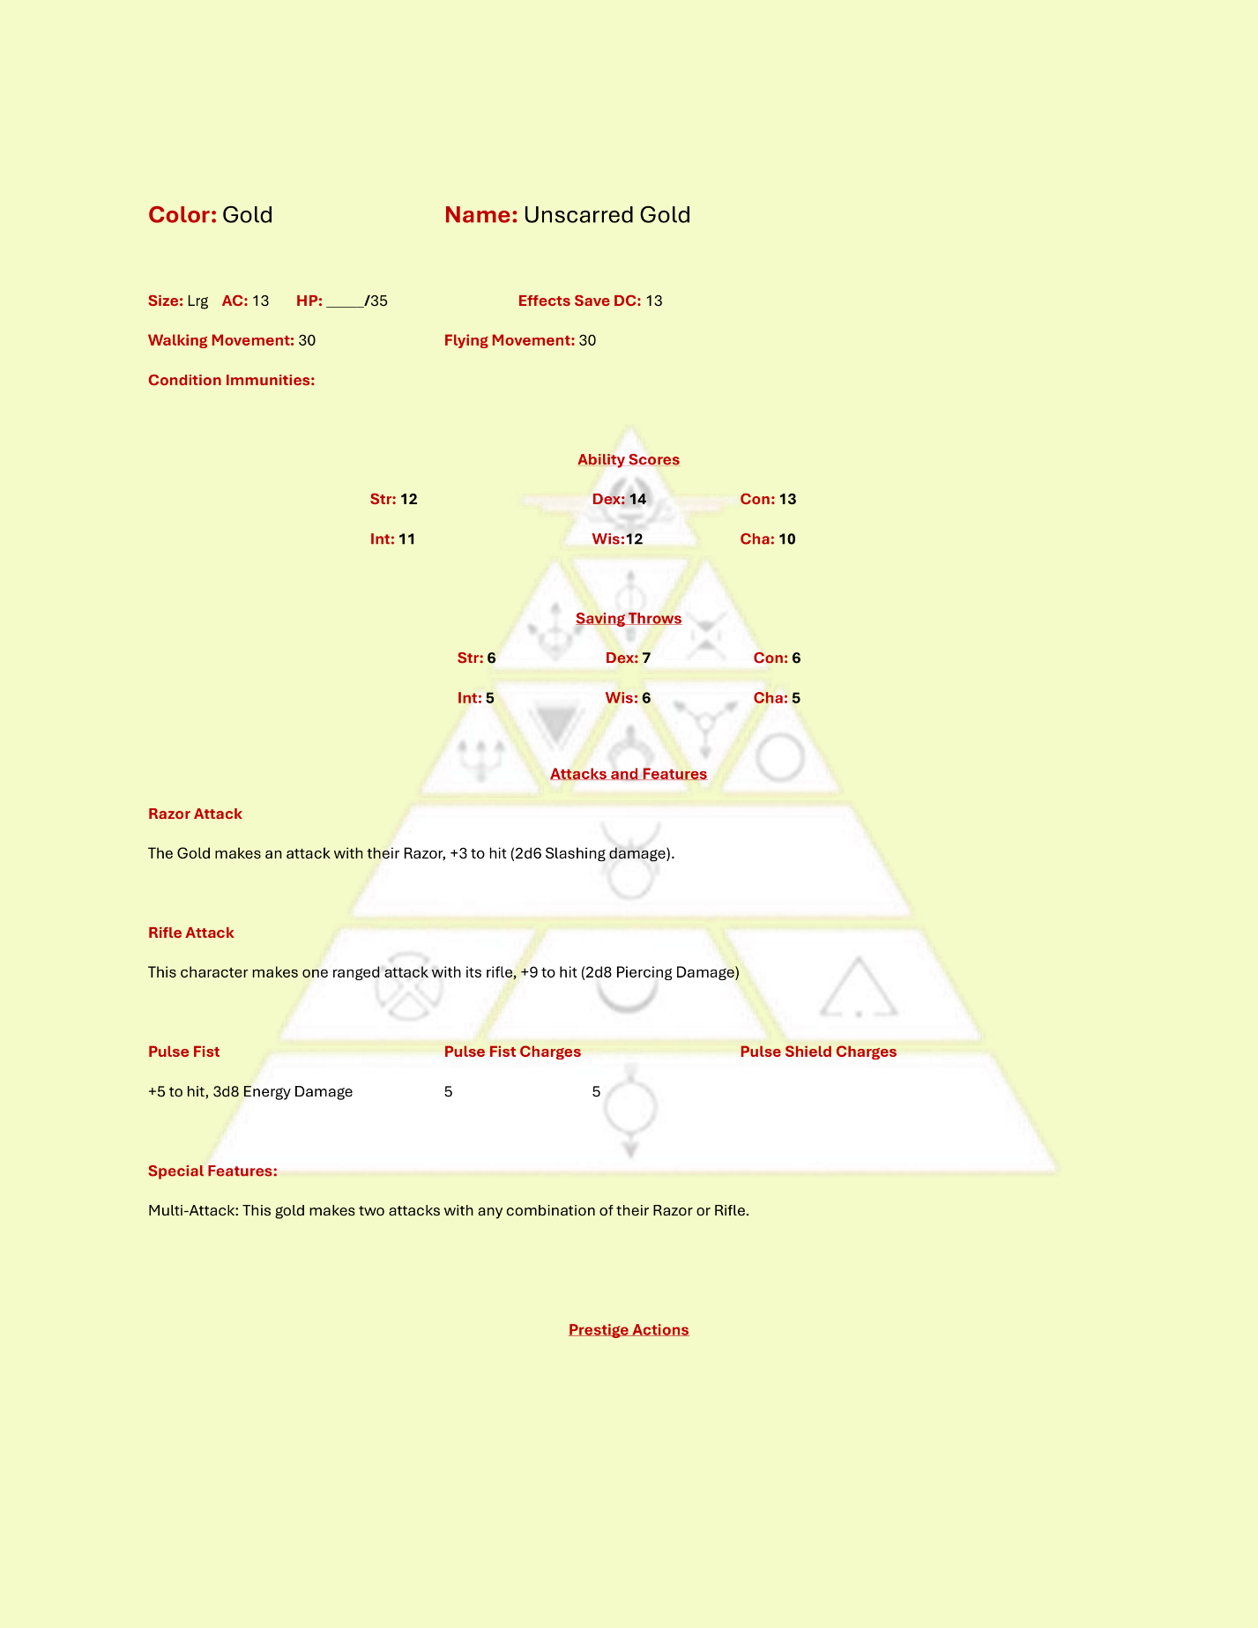

### Blue

Blue enemies use pistols as their normal attack method and can deploy drones, call in airstrikes, and unleash a devastating strike to leave behind a trail of flame.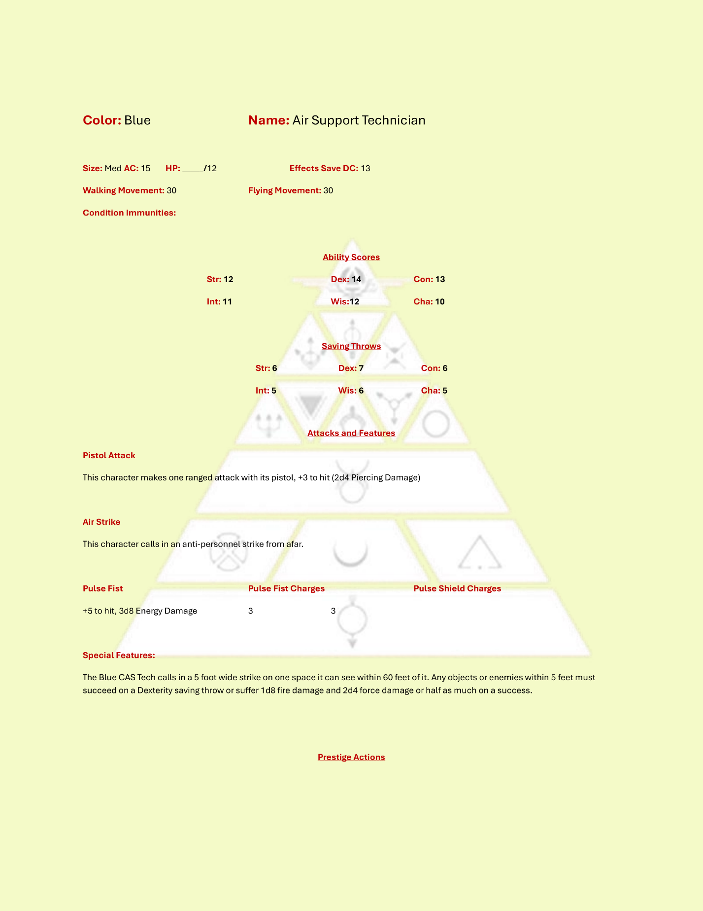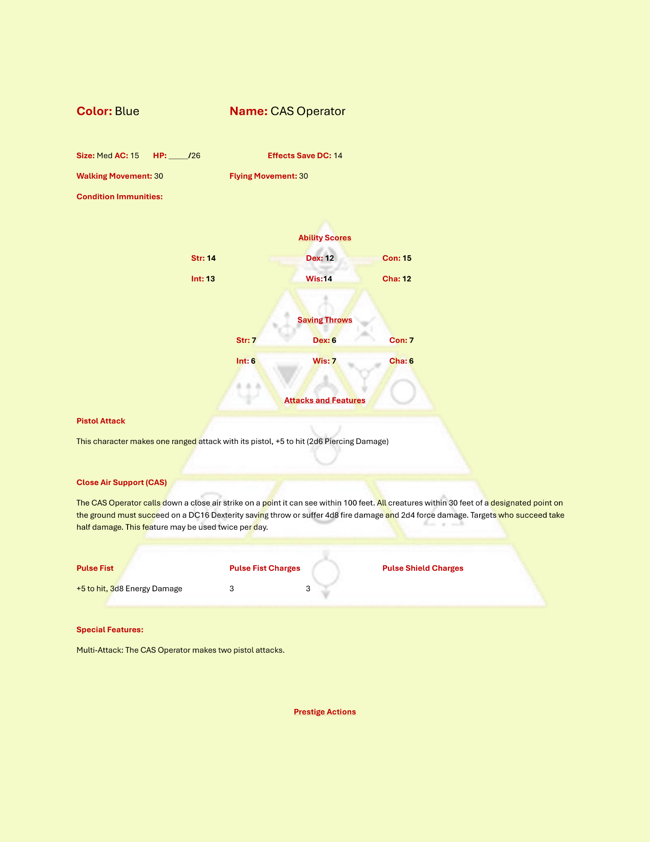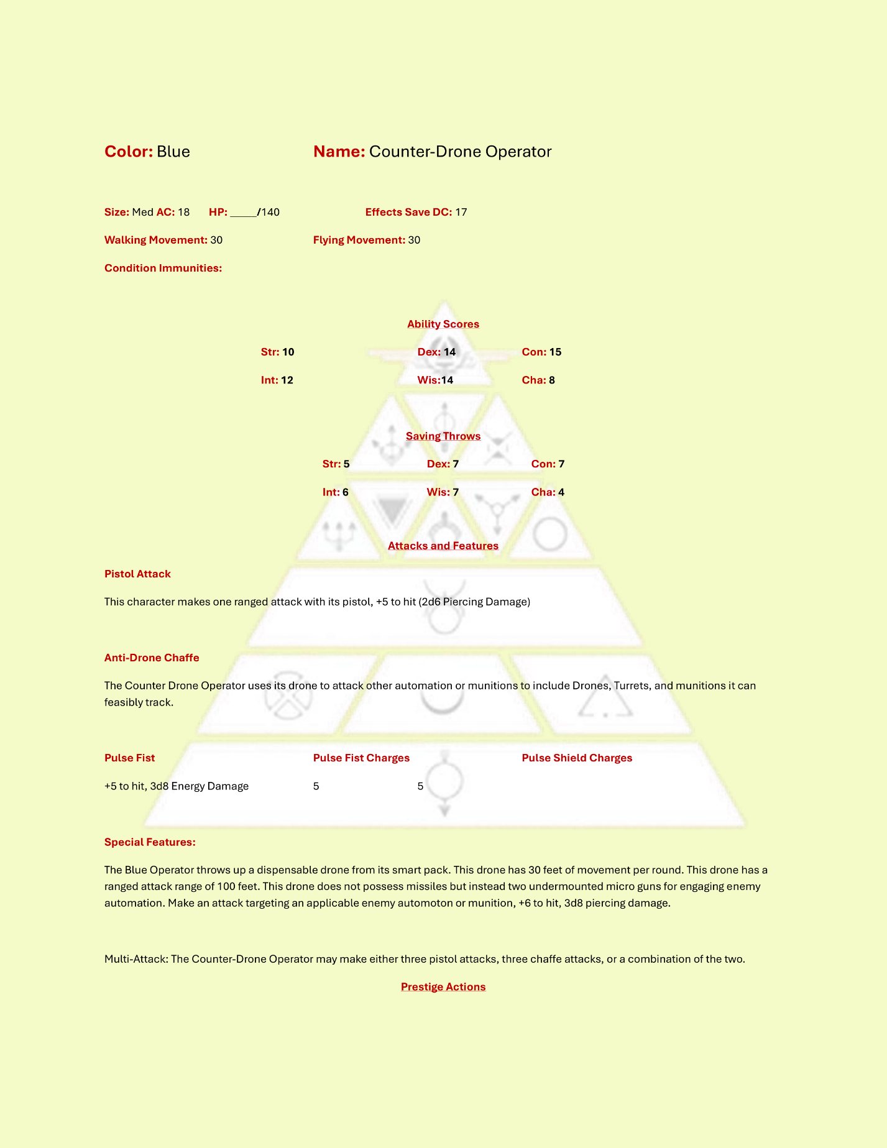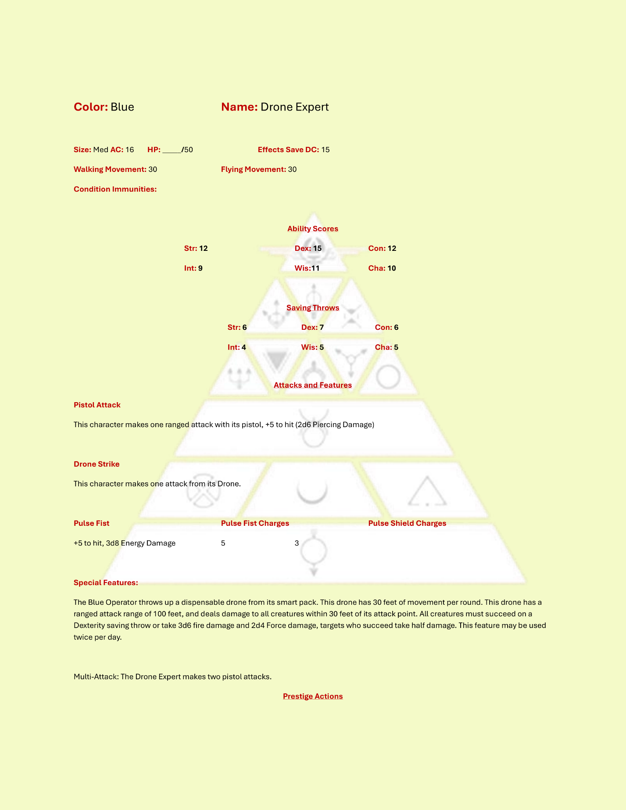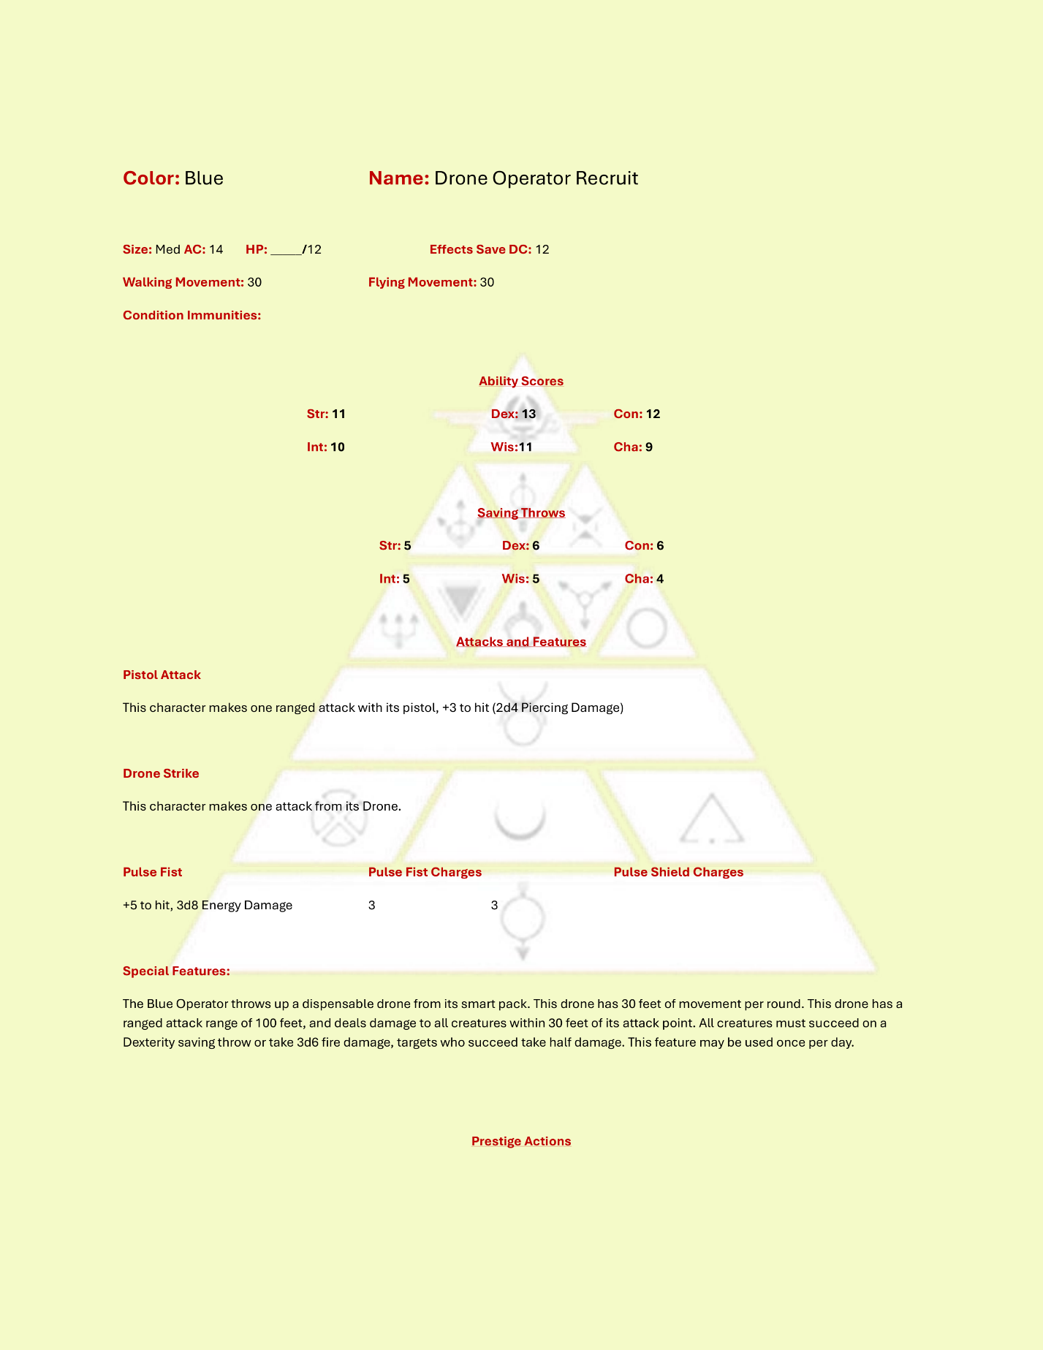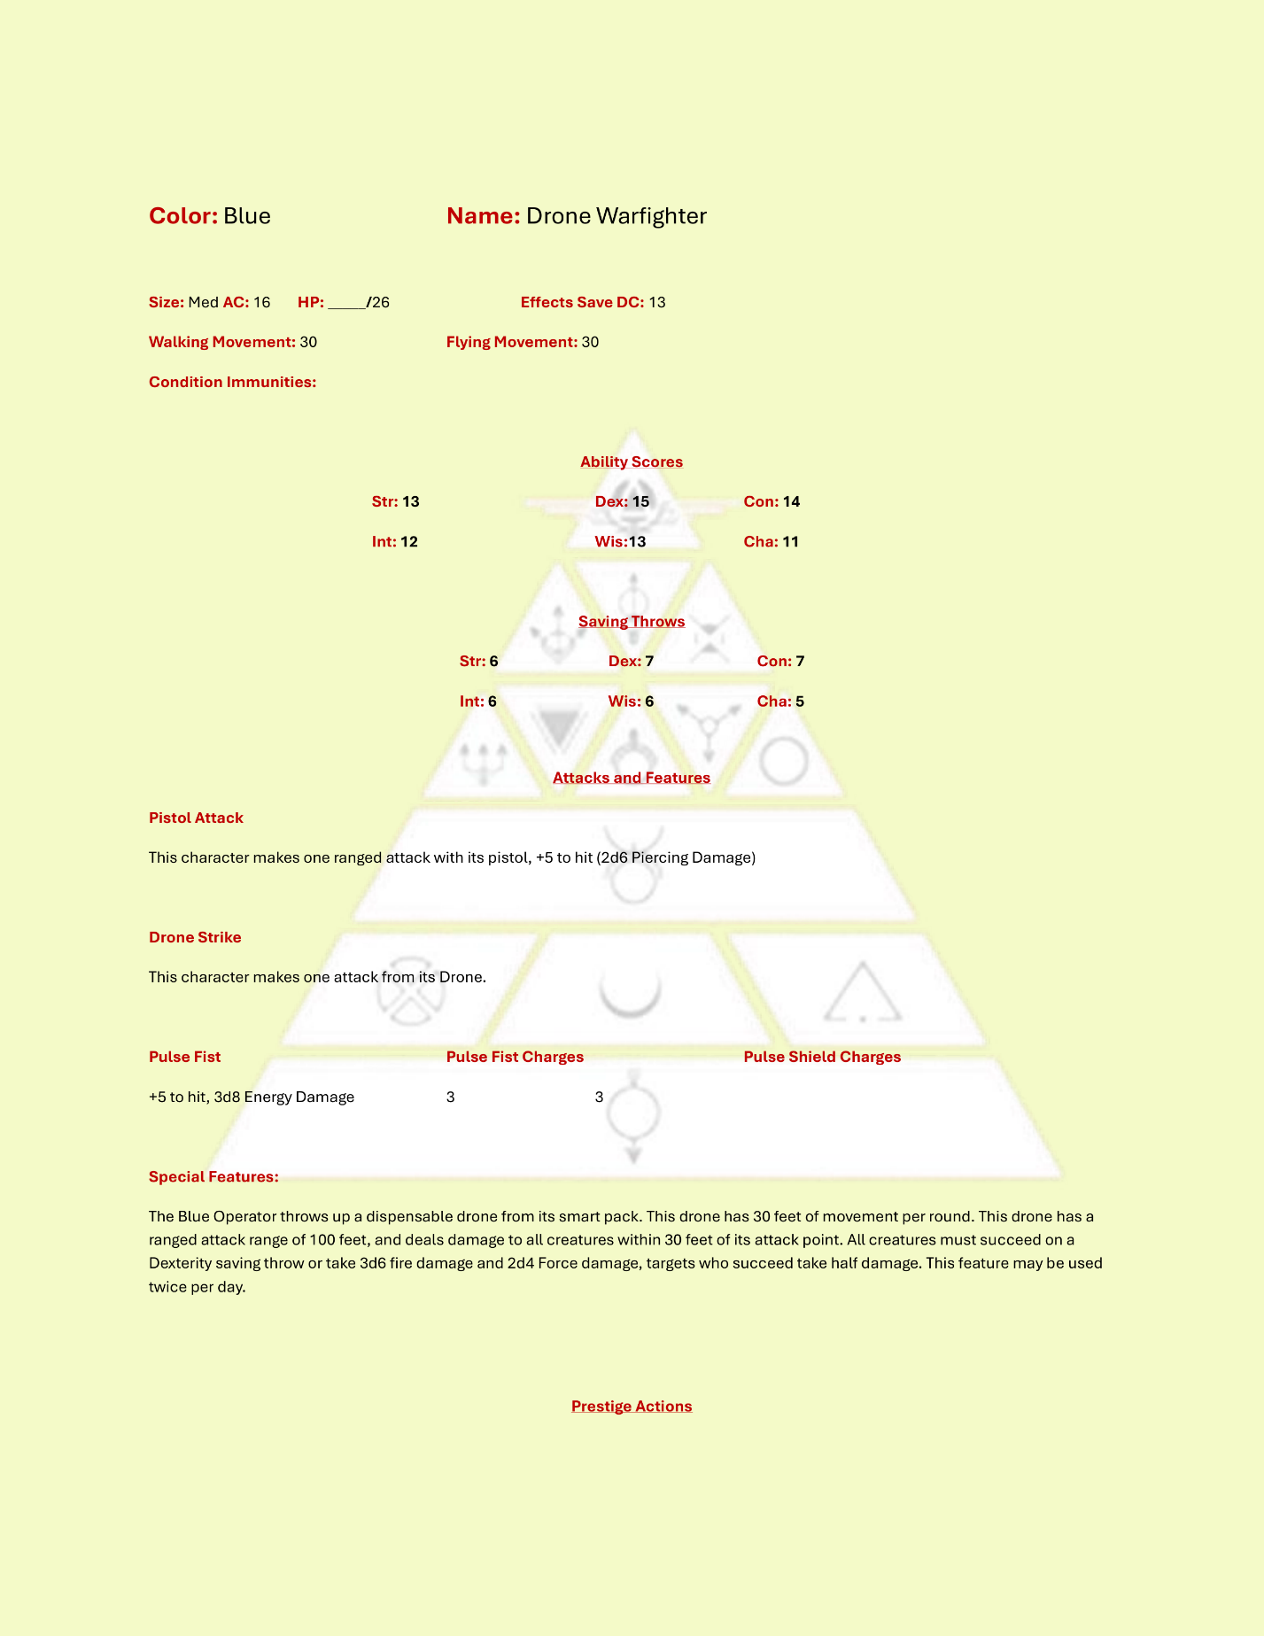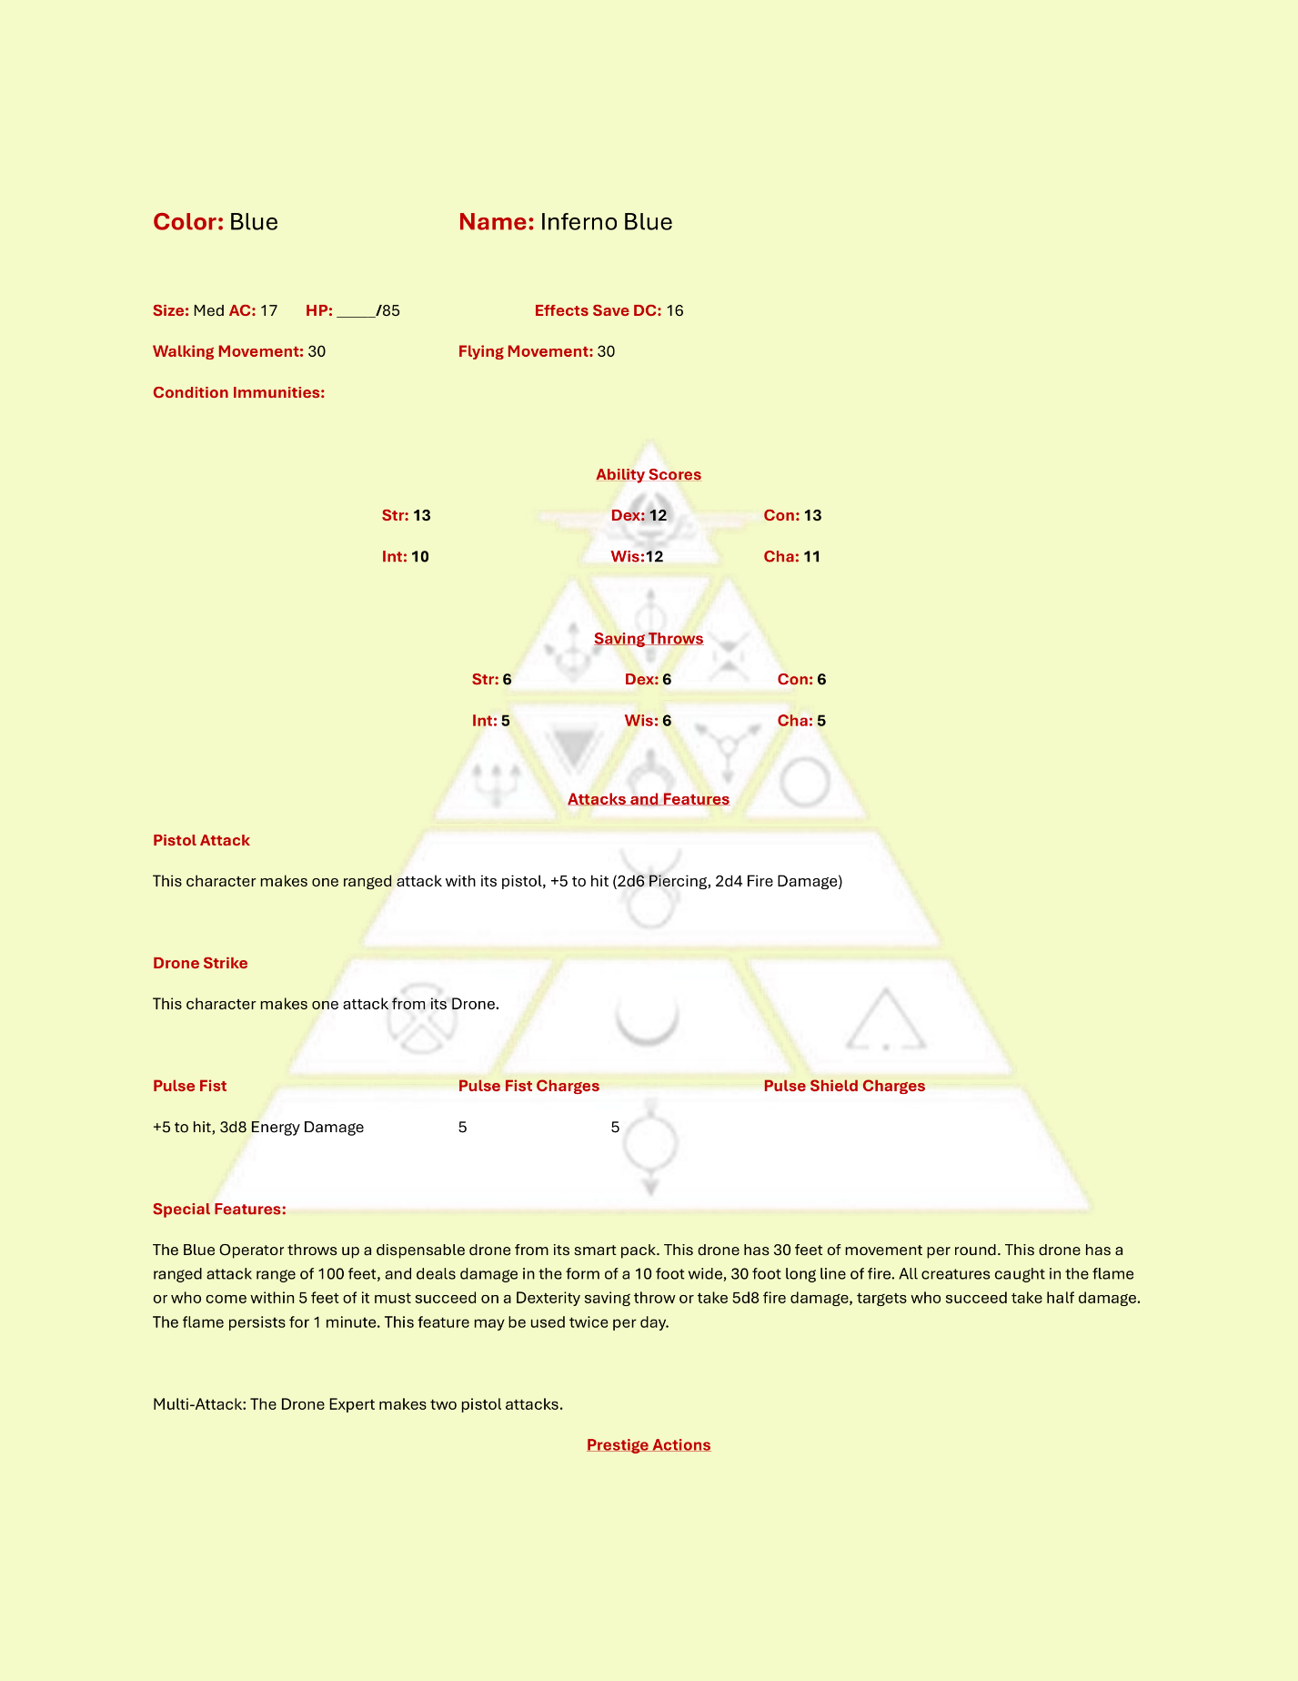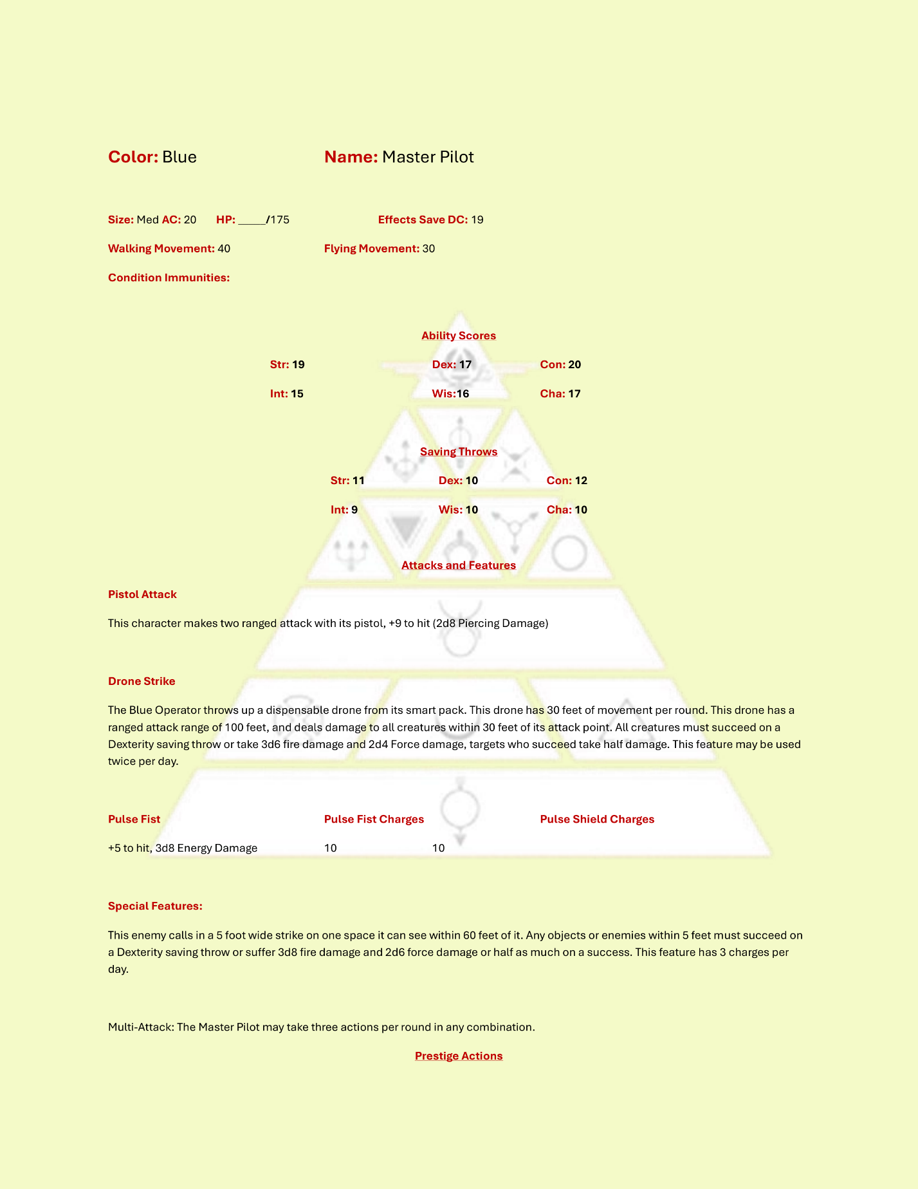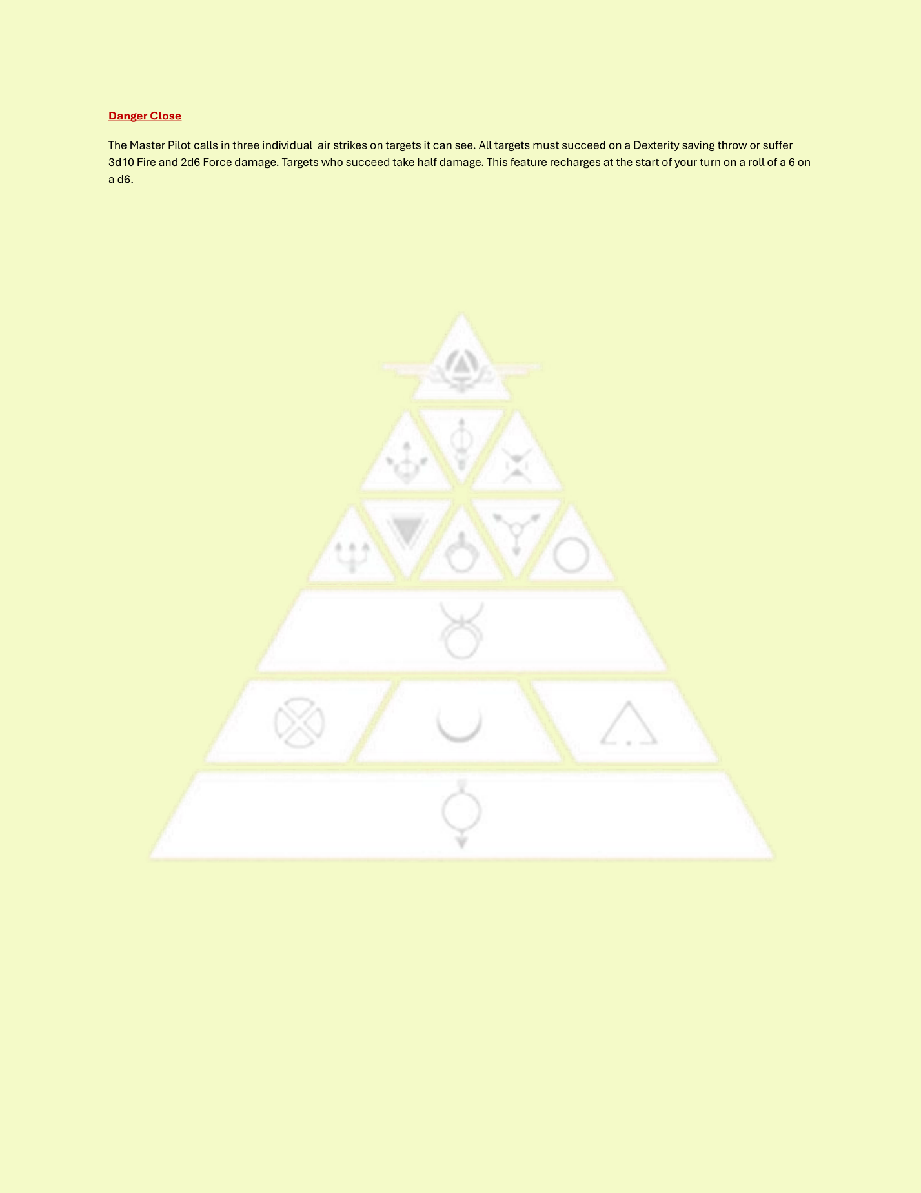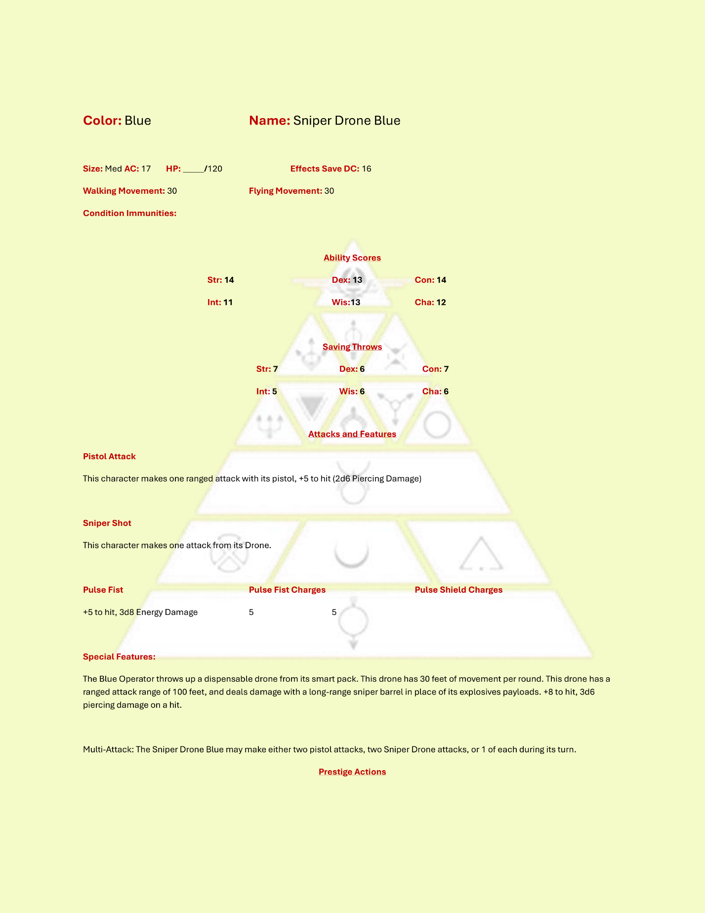

### Gray

Grays form the backbone of all three militaries and are the Soldiers and Security forces across the system. Grays use a rifle as their main attack action and have a variety of additional abilities across their classes.

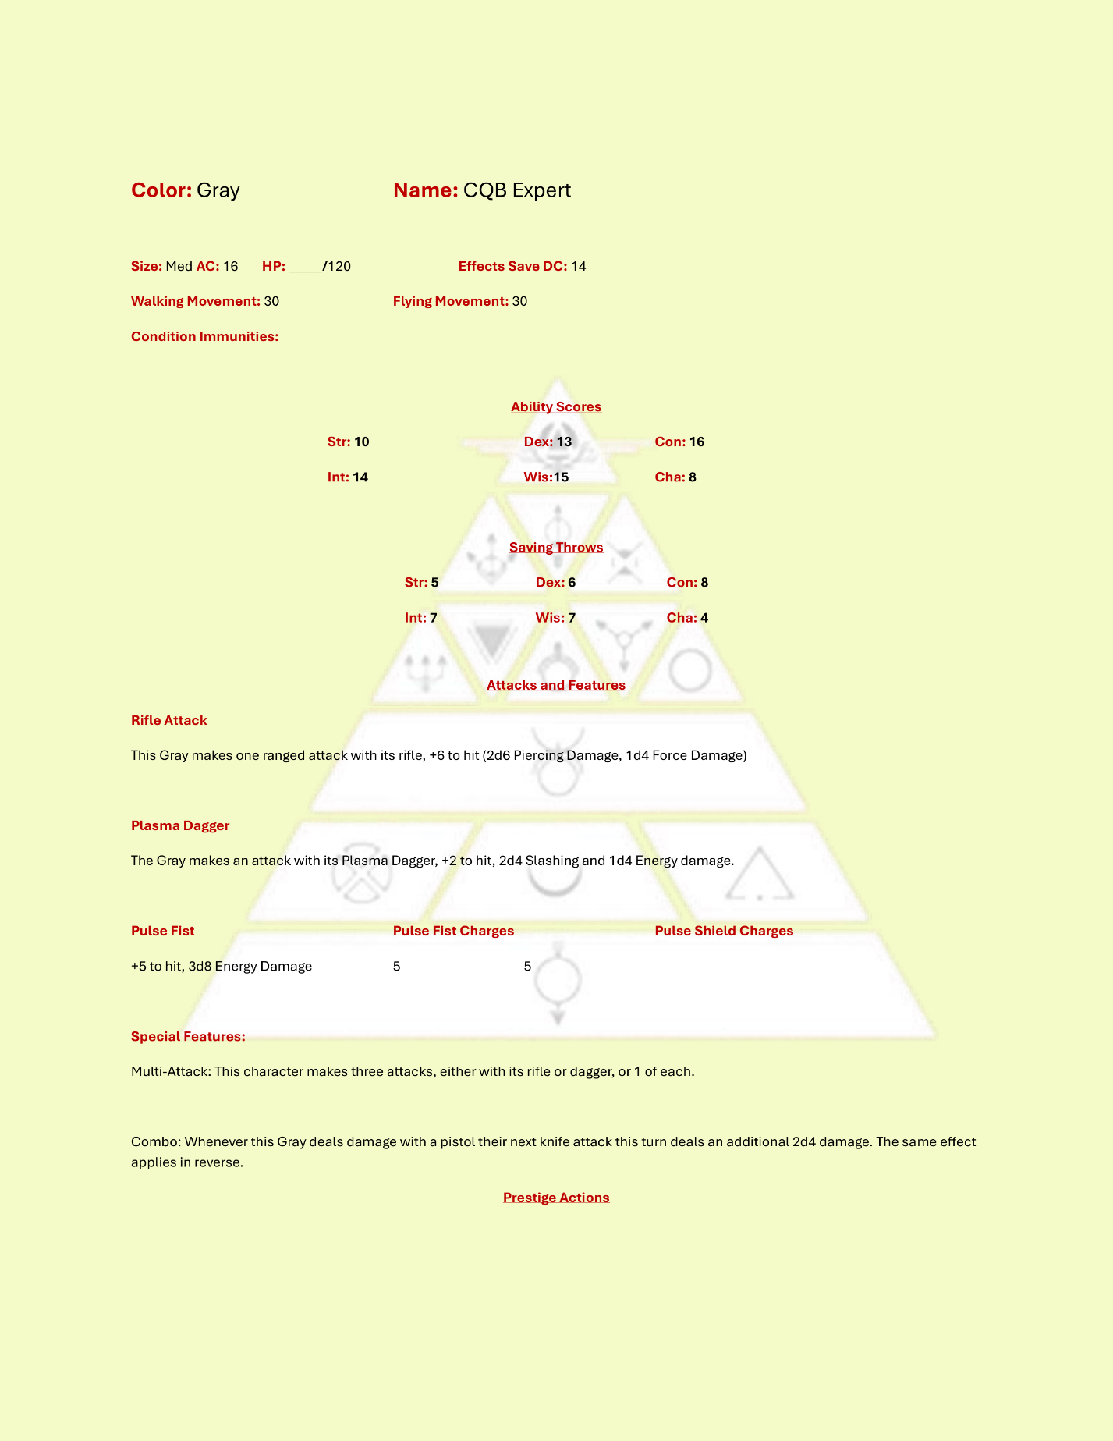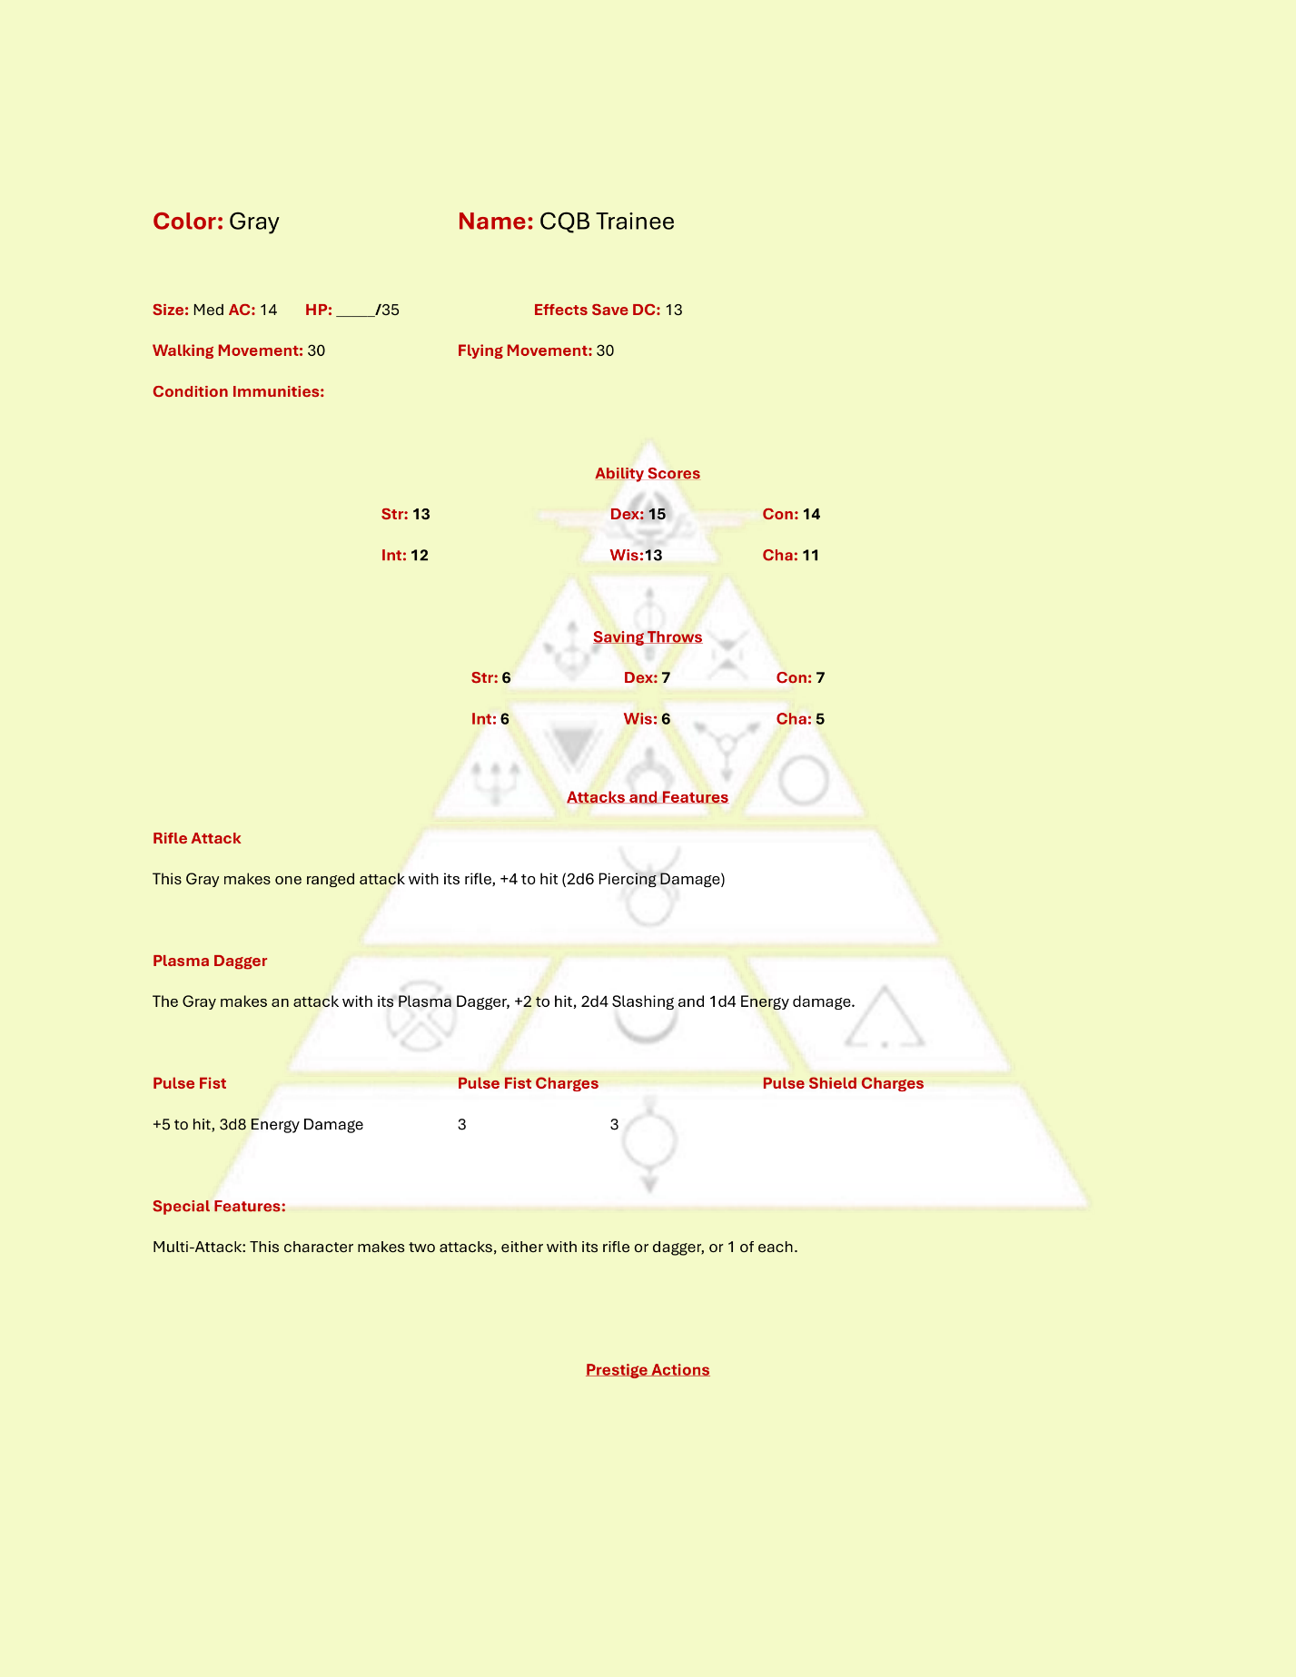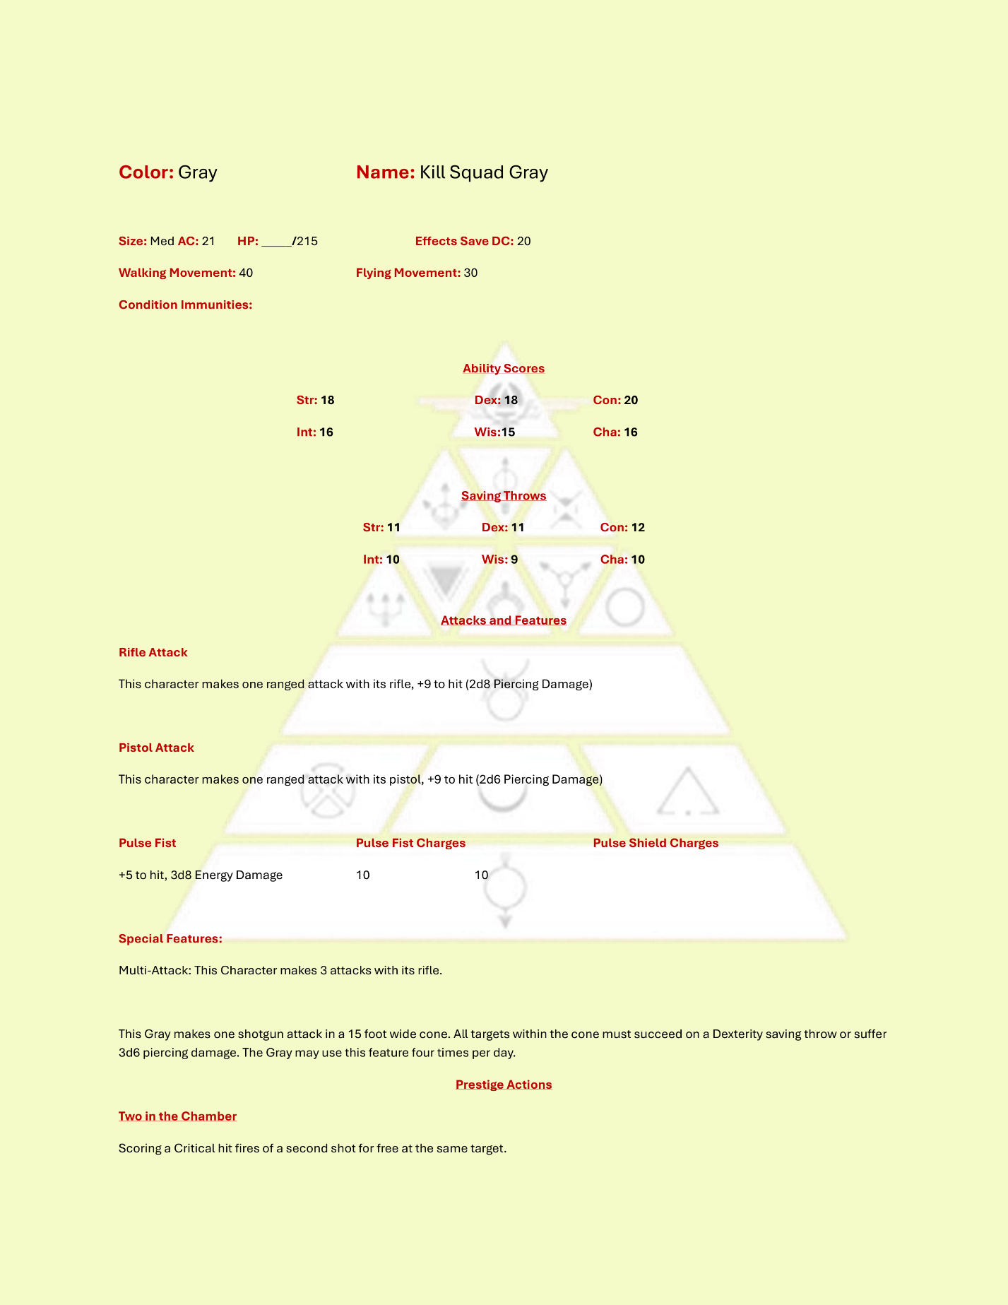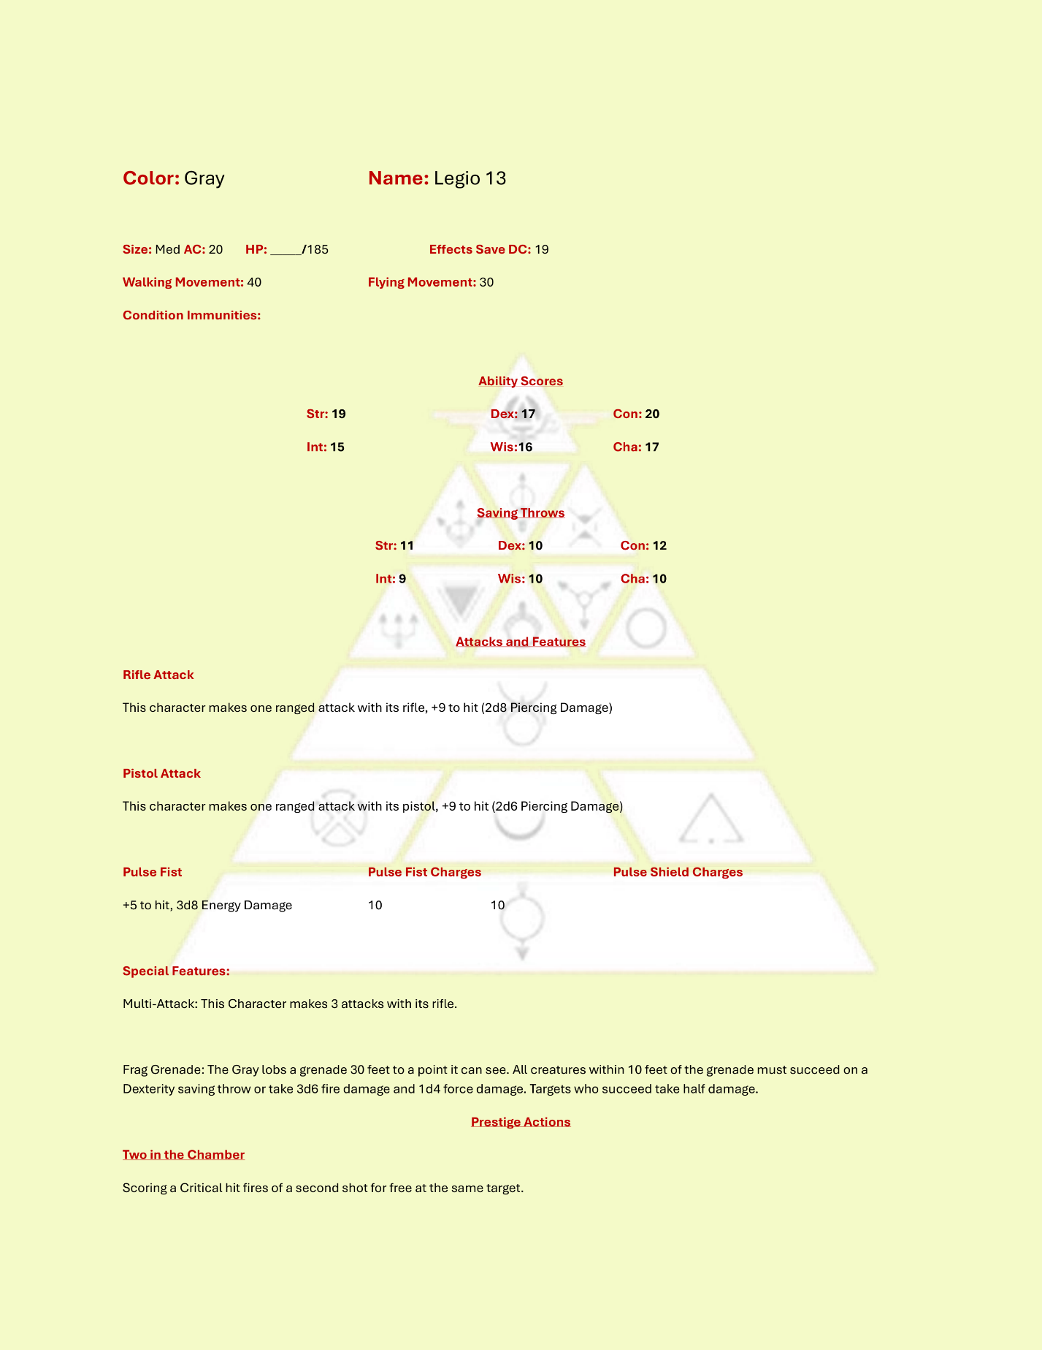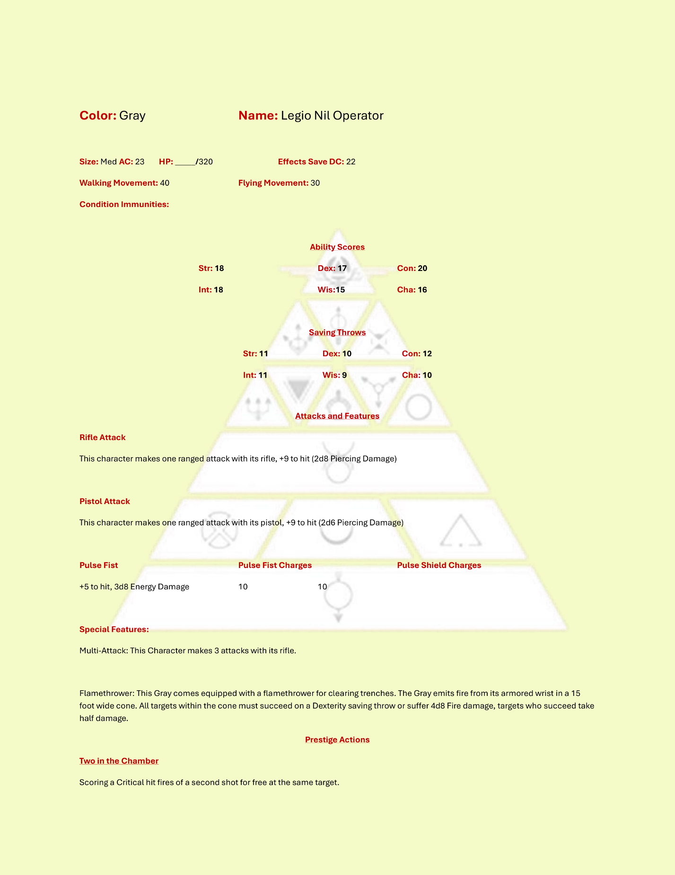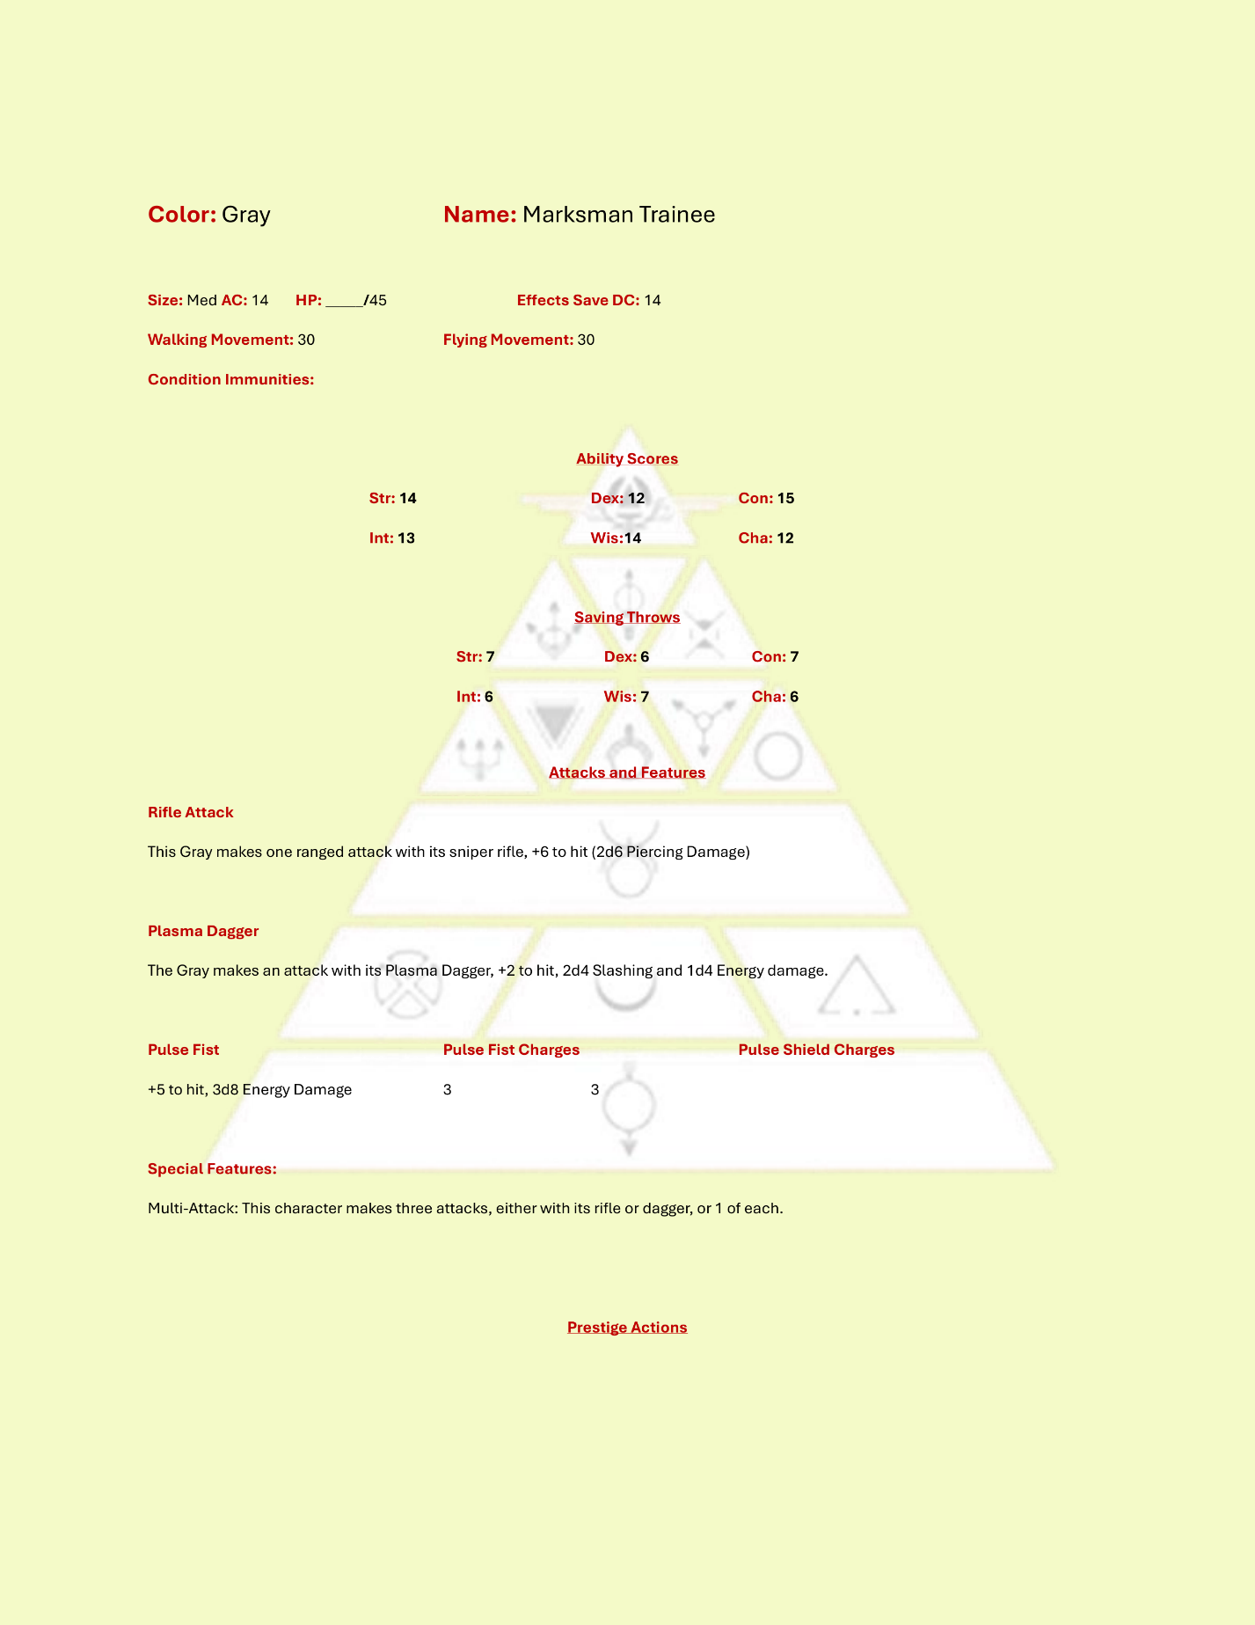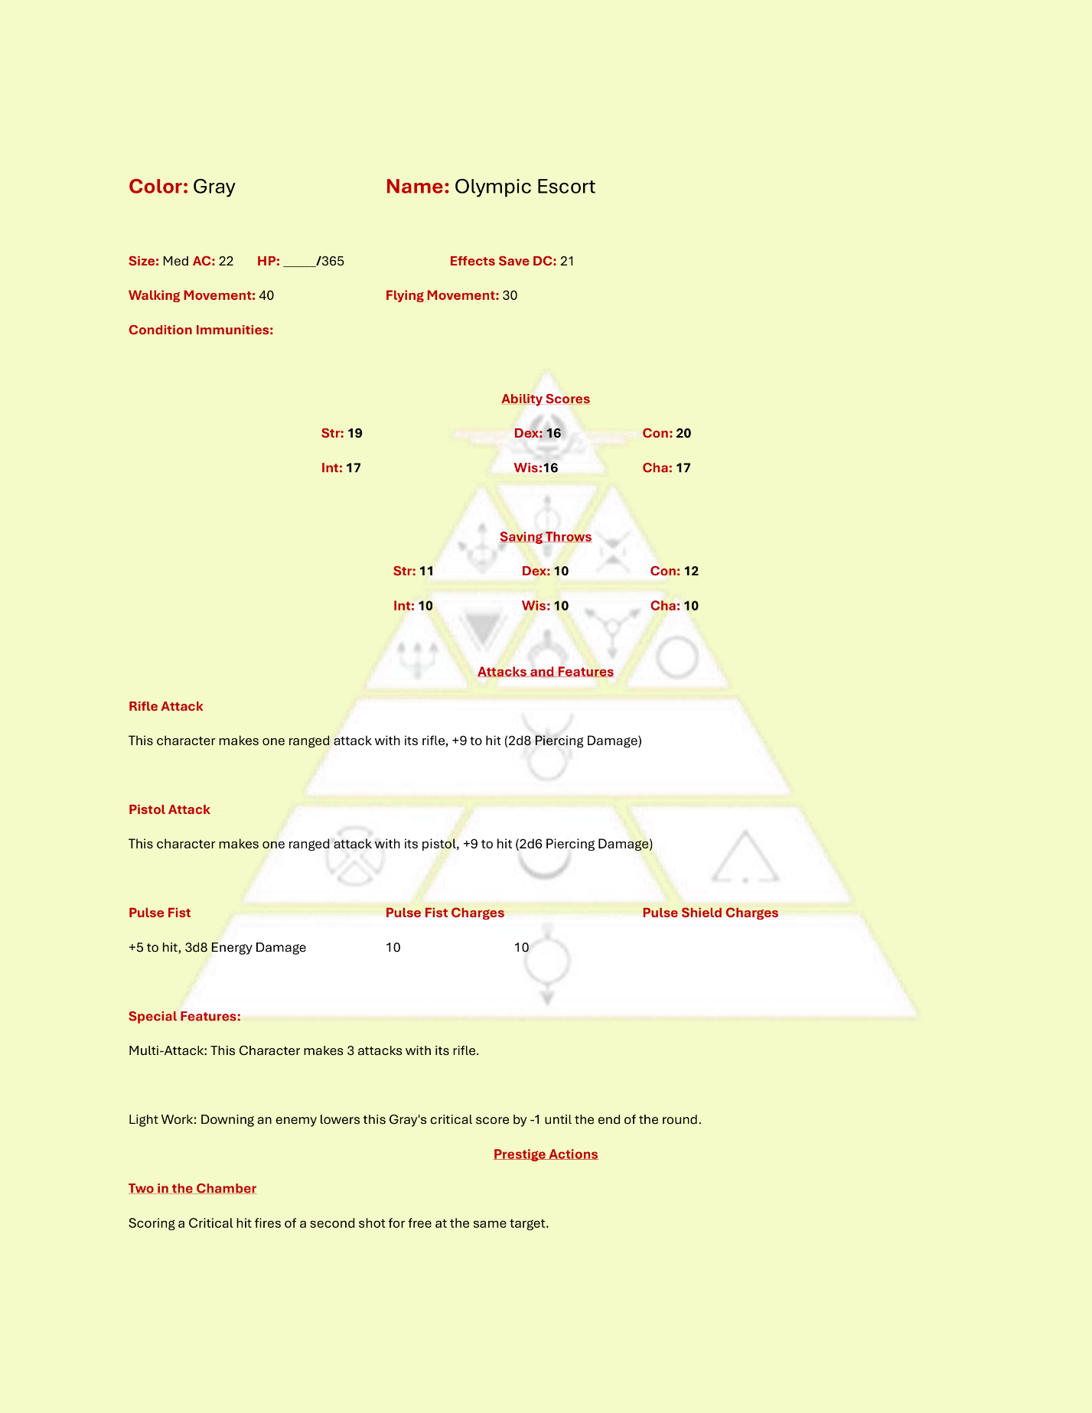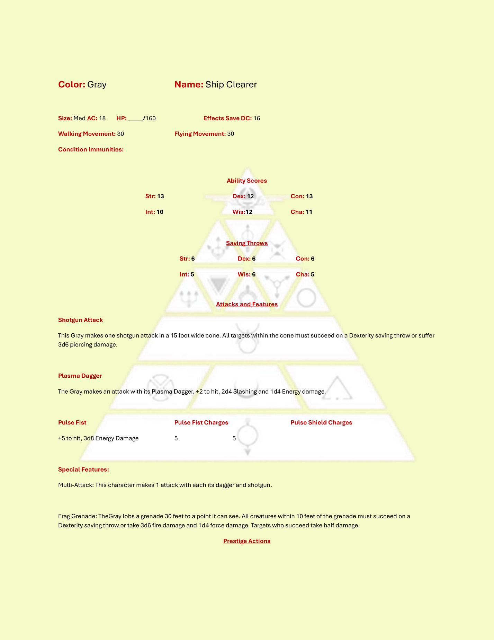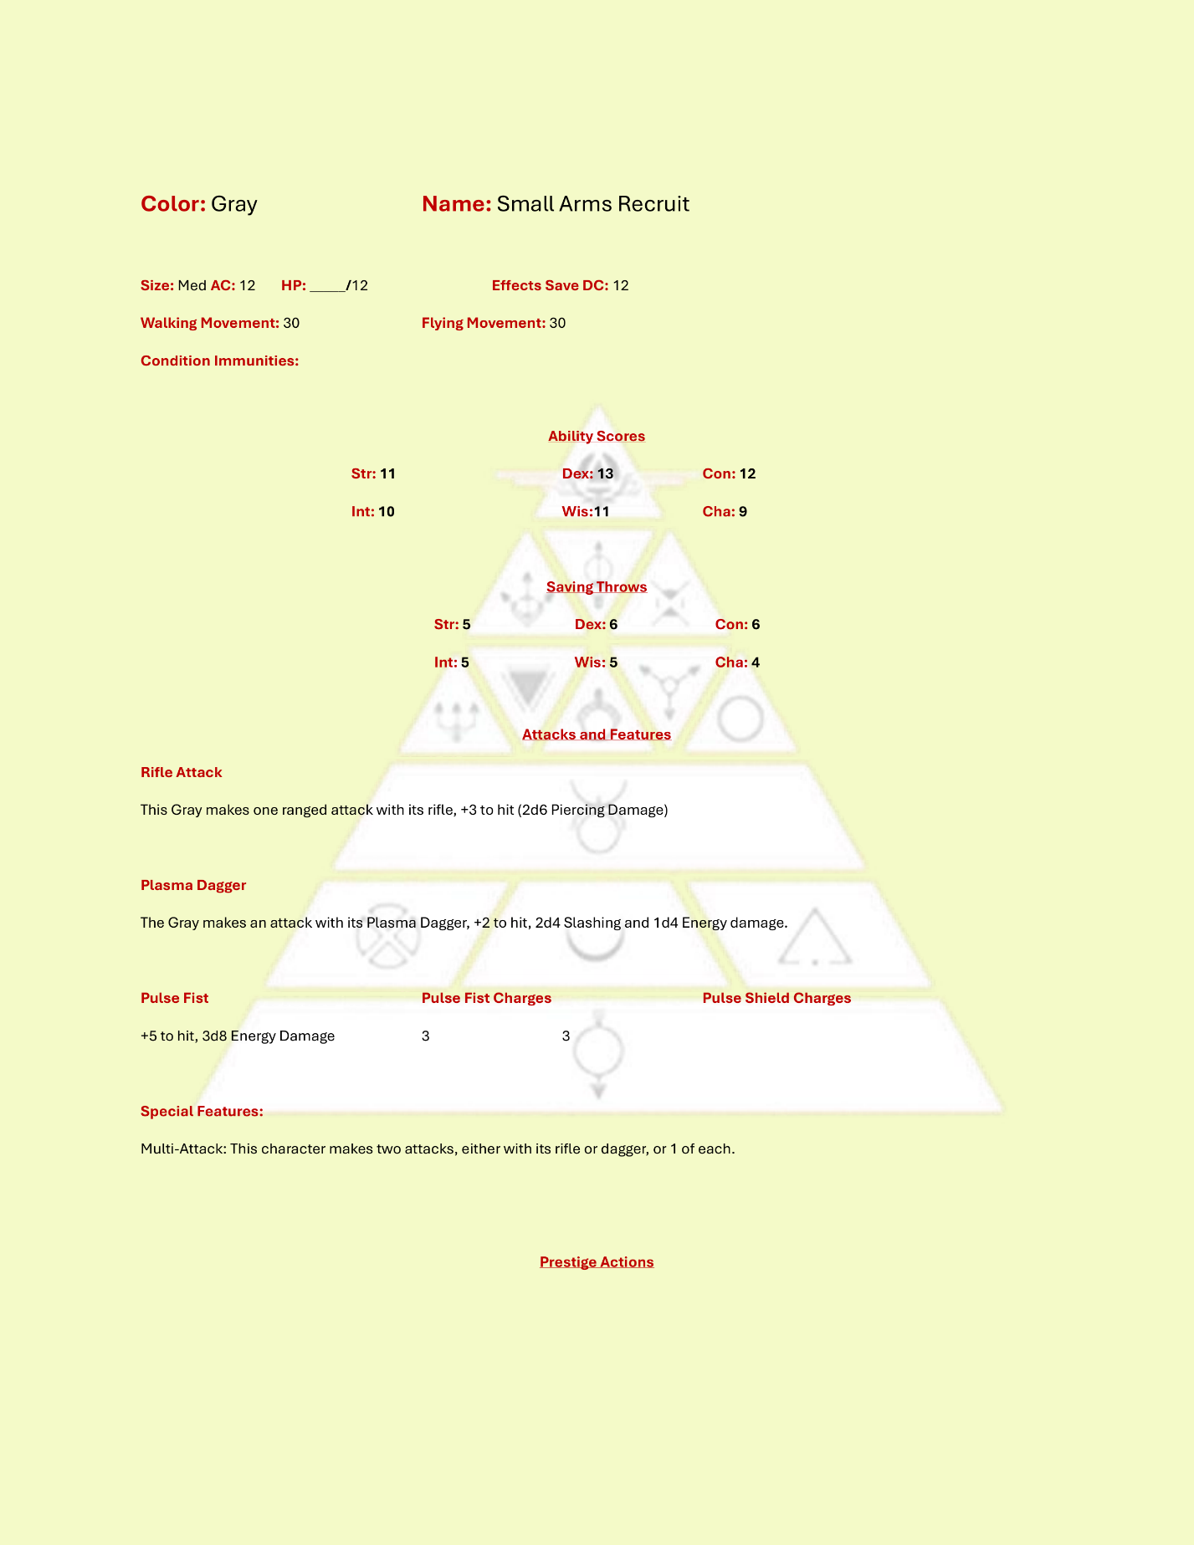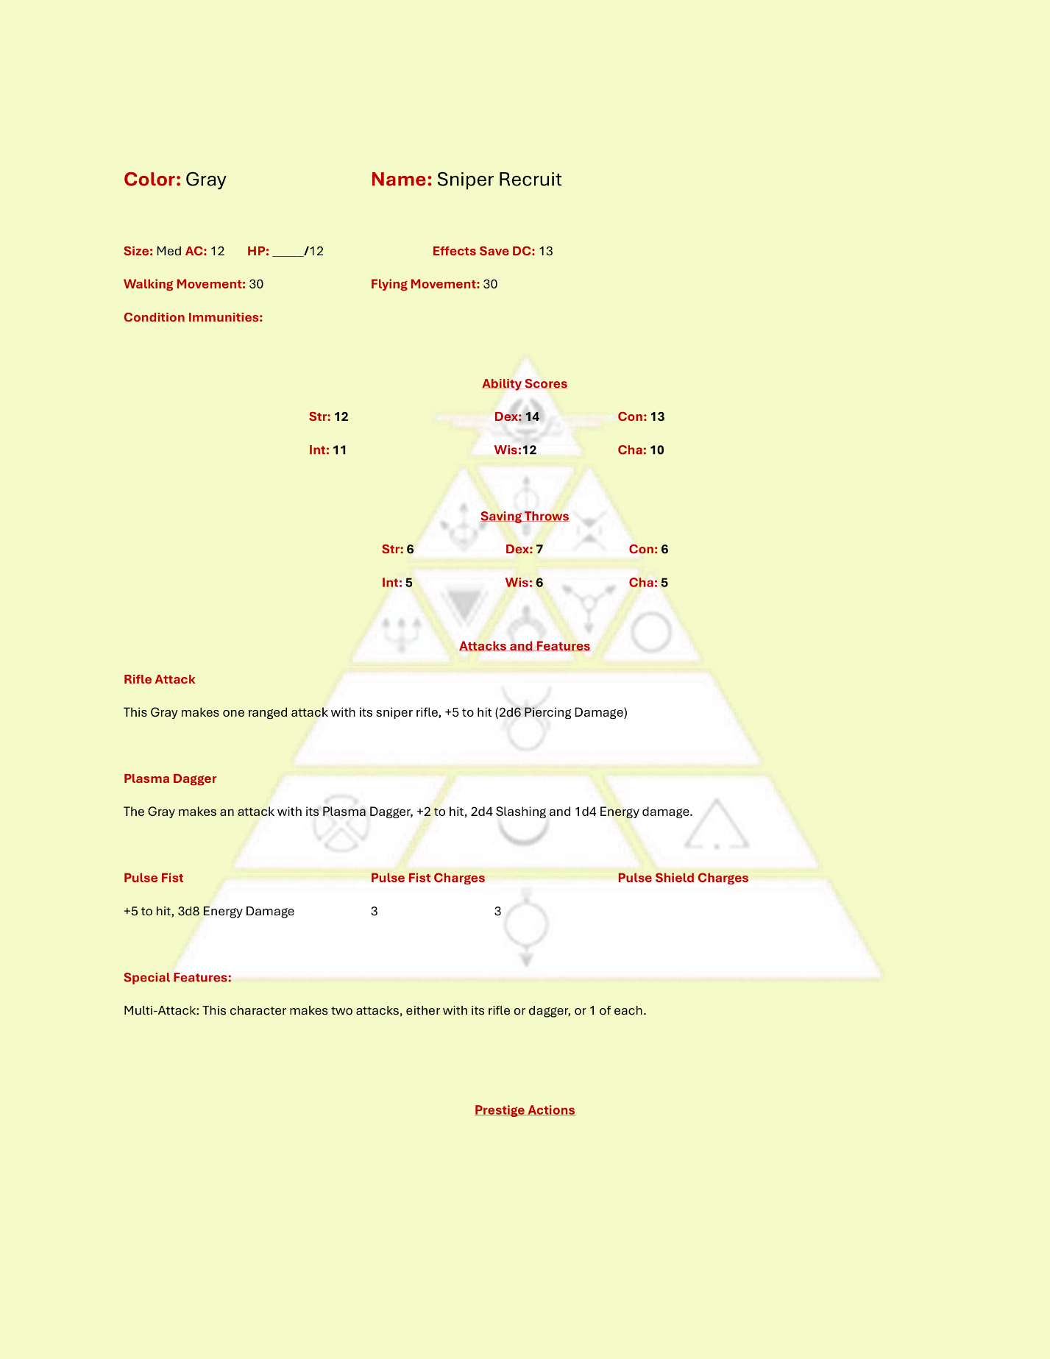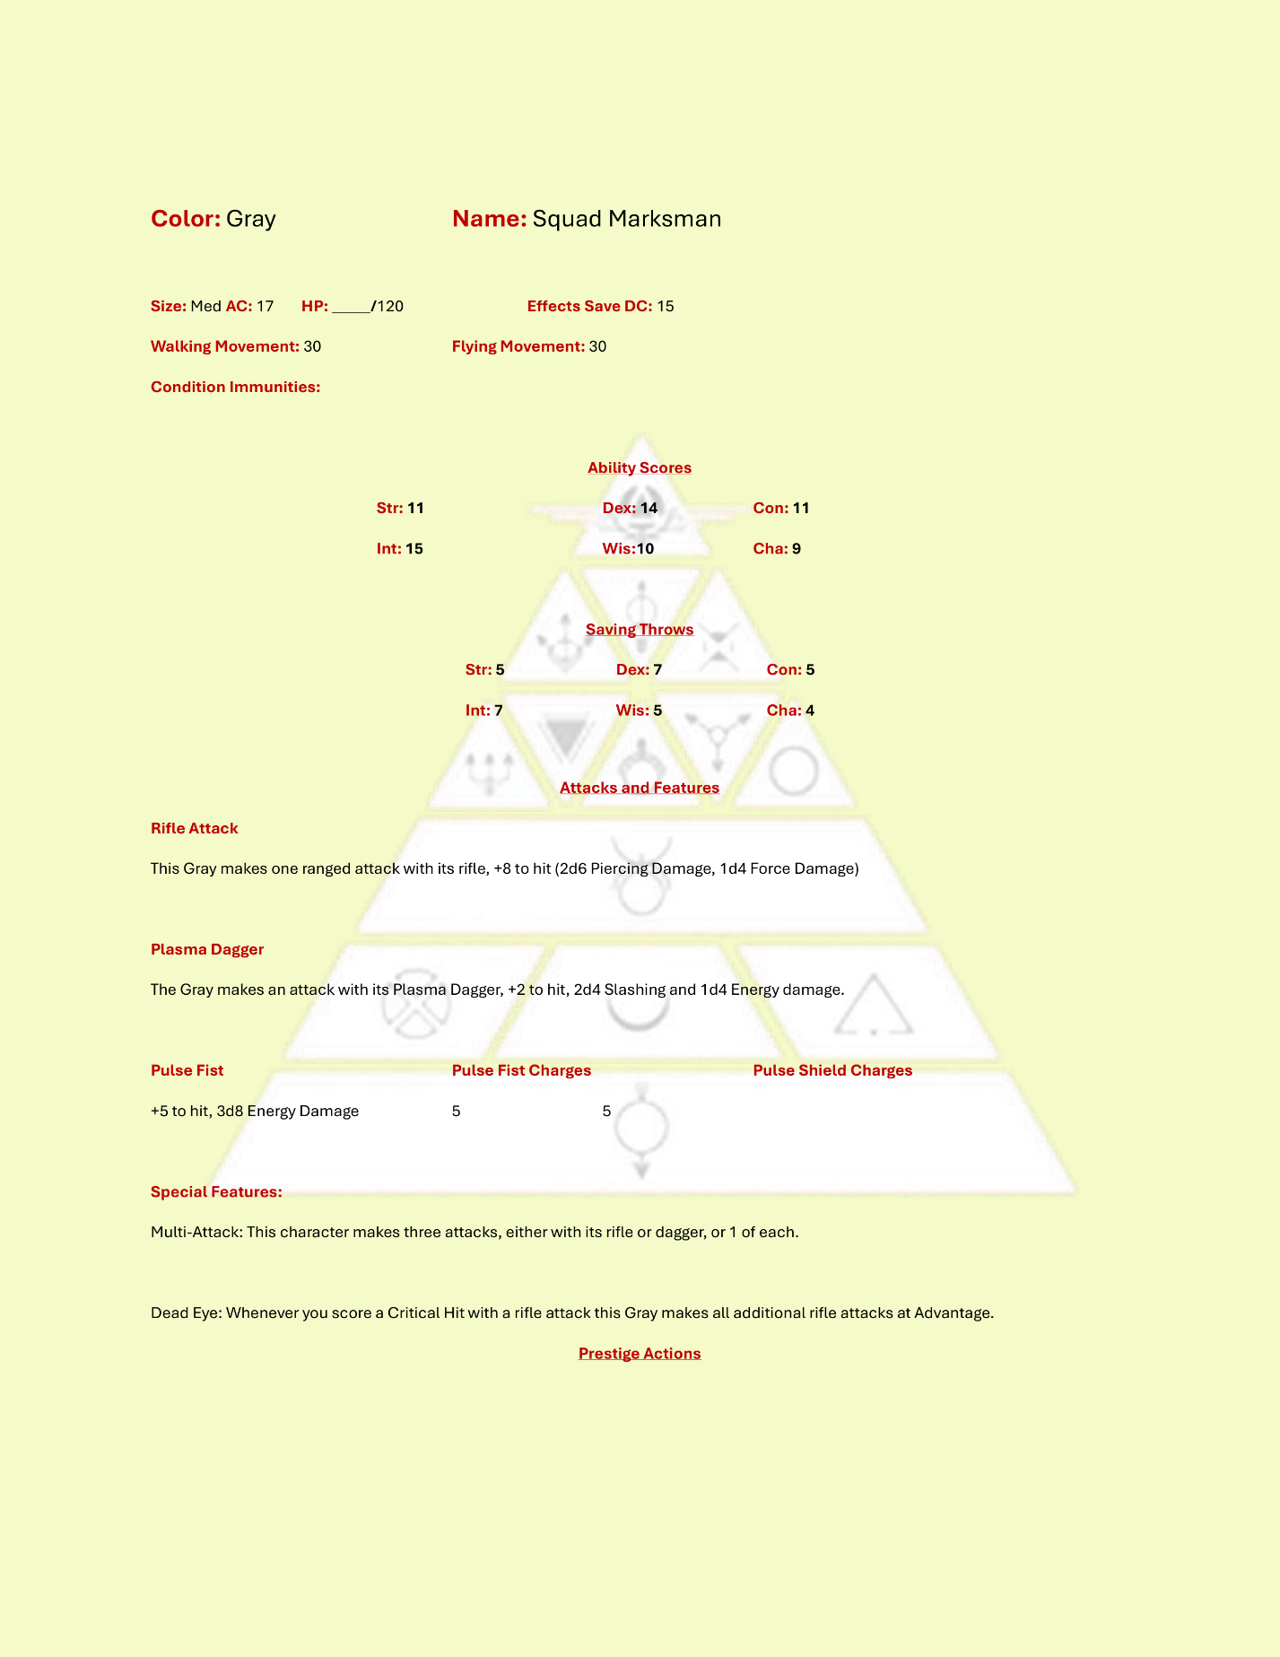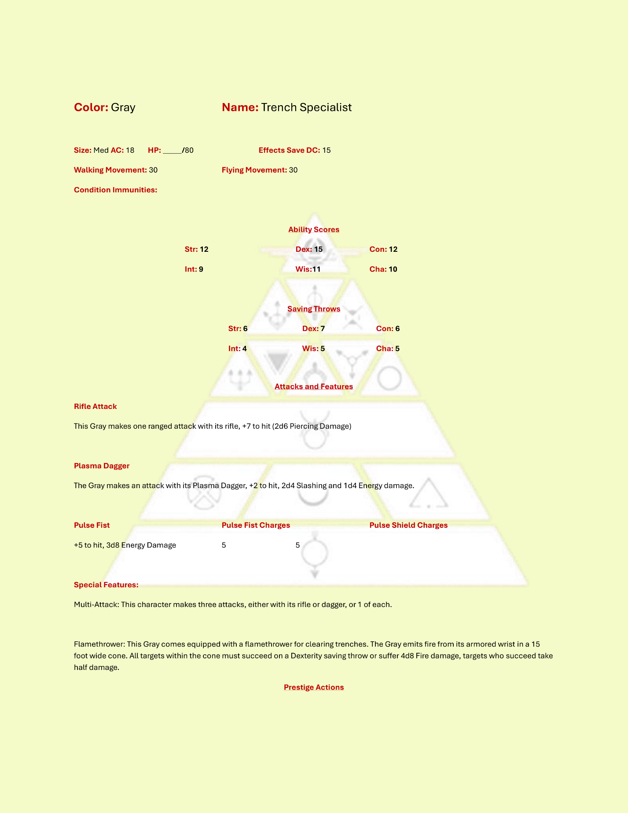

### Green

Green enemies use a pistol as their main attack action but possess the ability to hijack enemy comms, electronics, and automation. Greens are used sparingly on the battlefield but in SoM can be used as liberally as needed for combat variety.

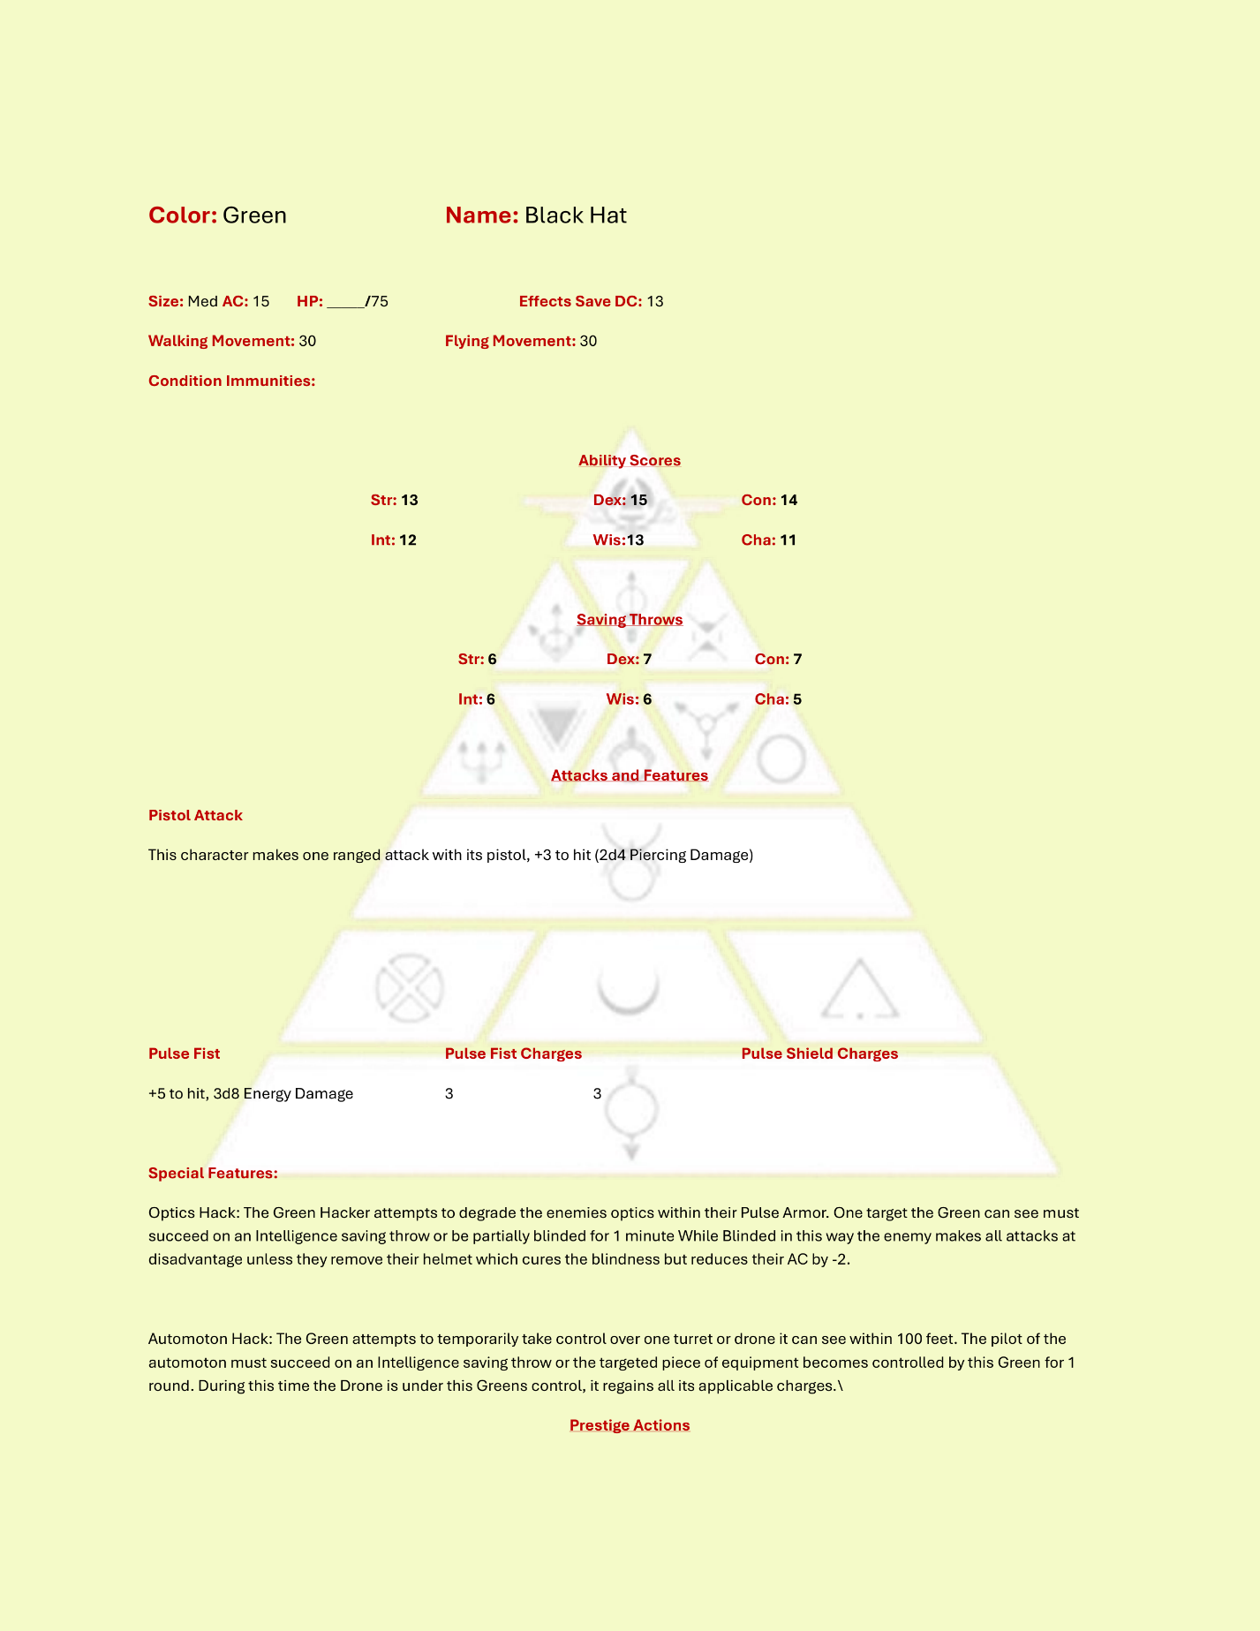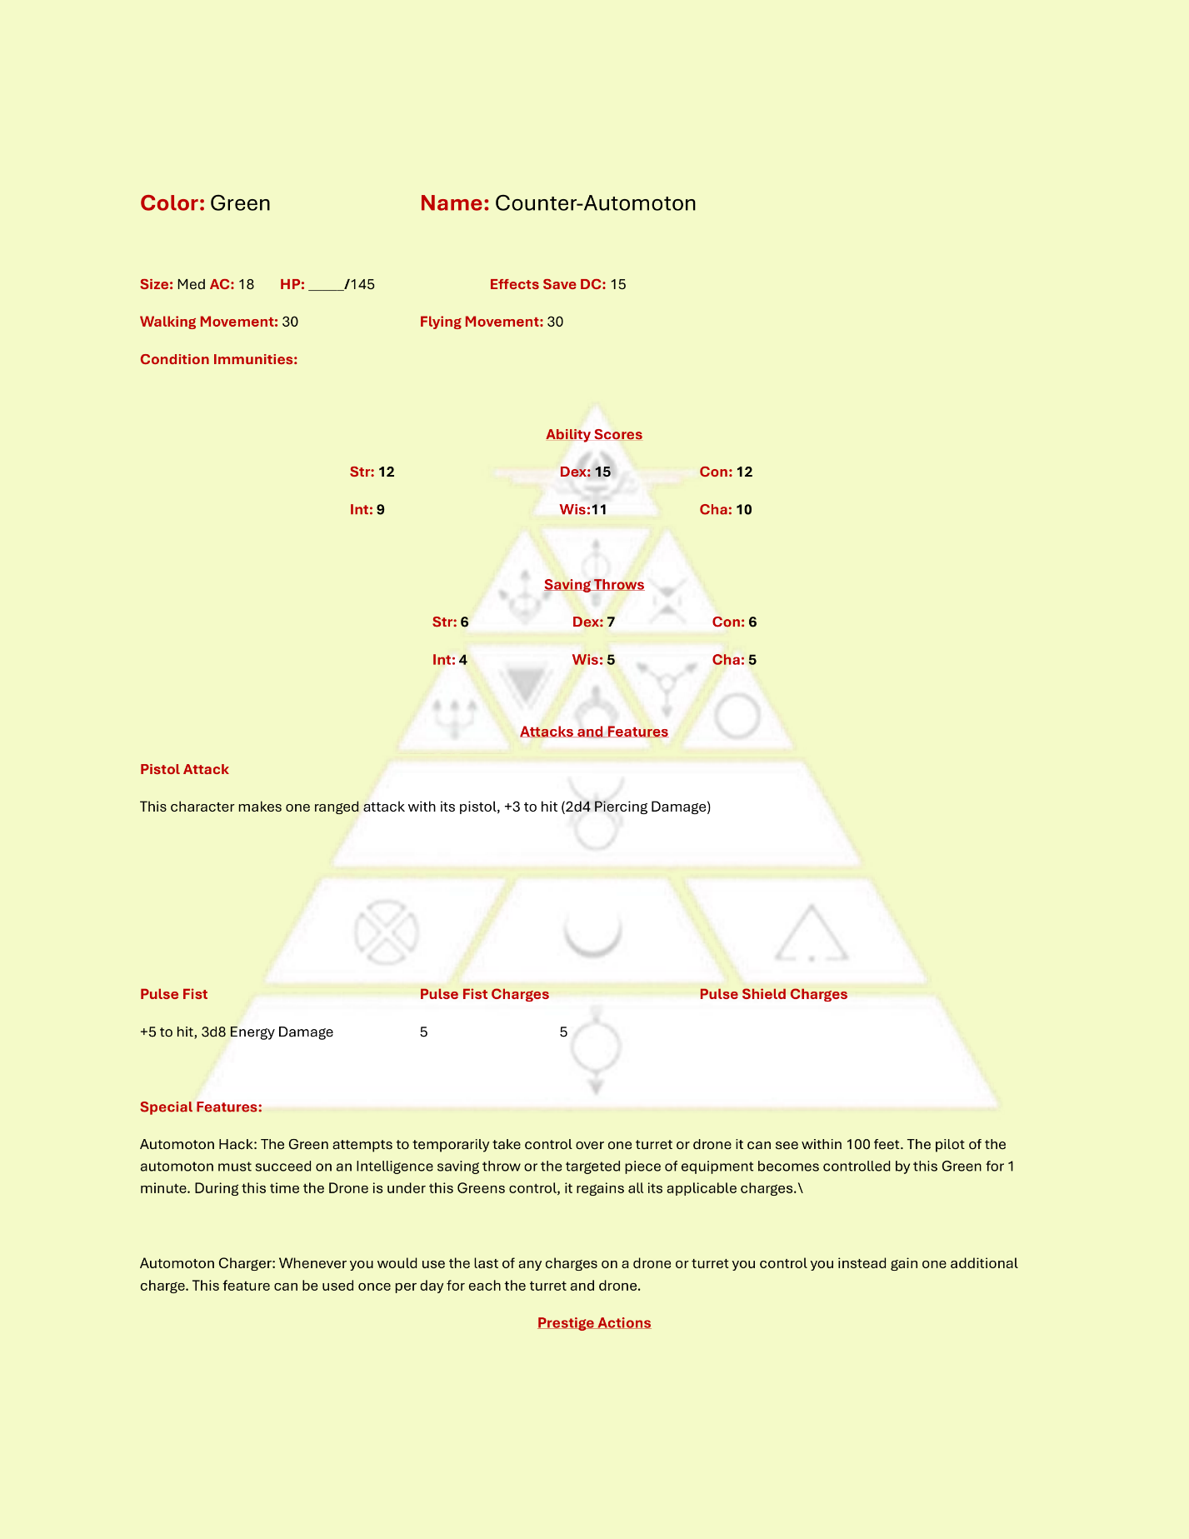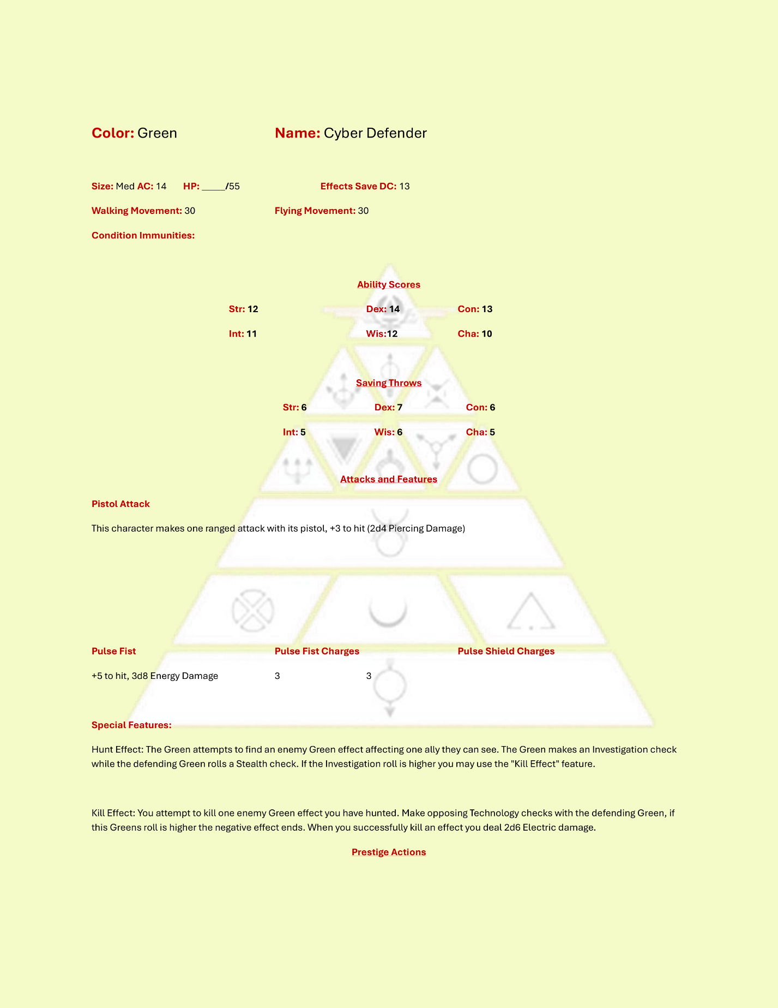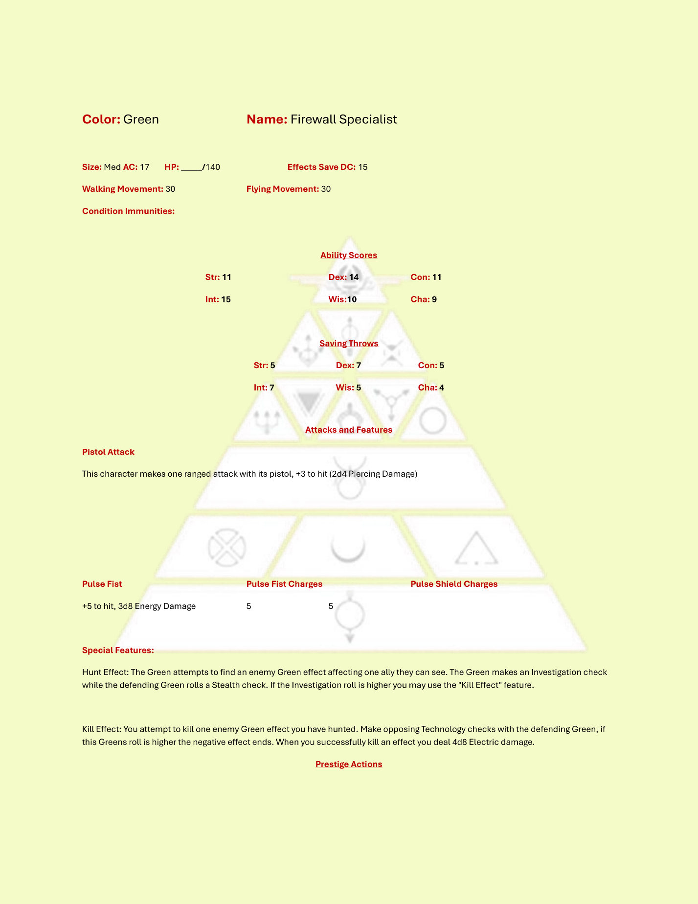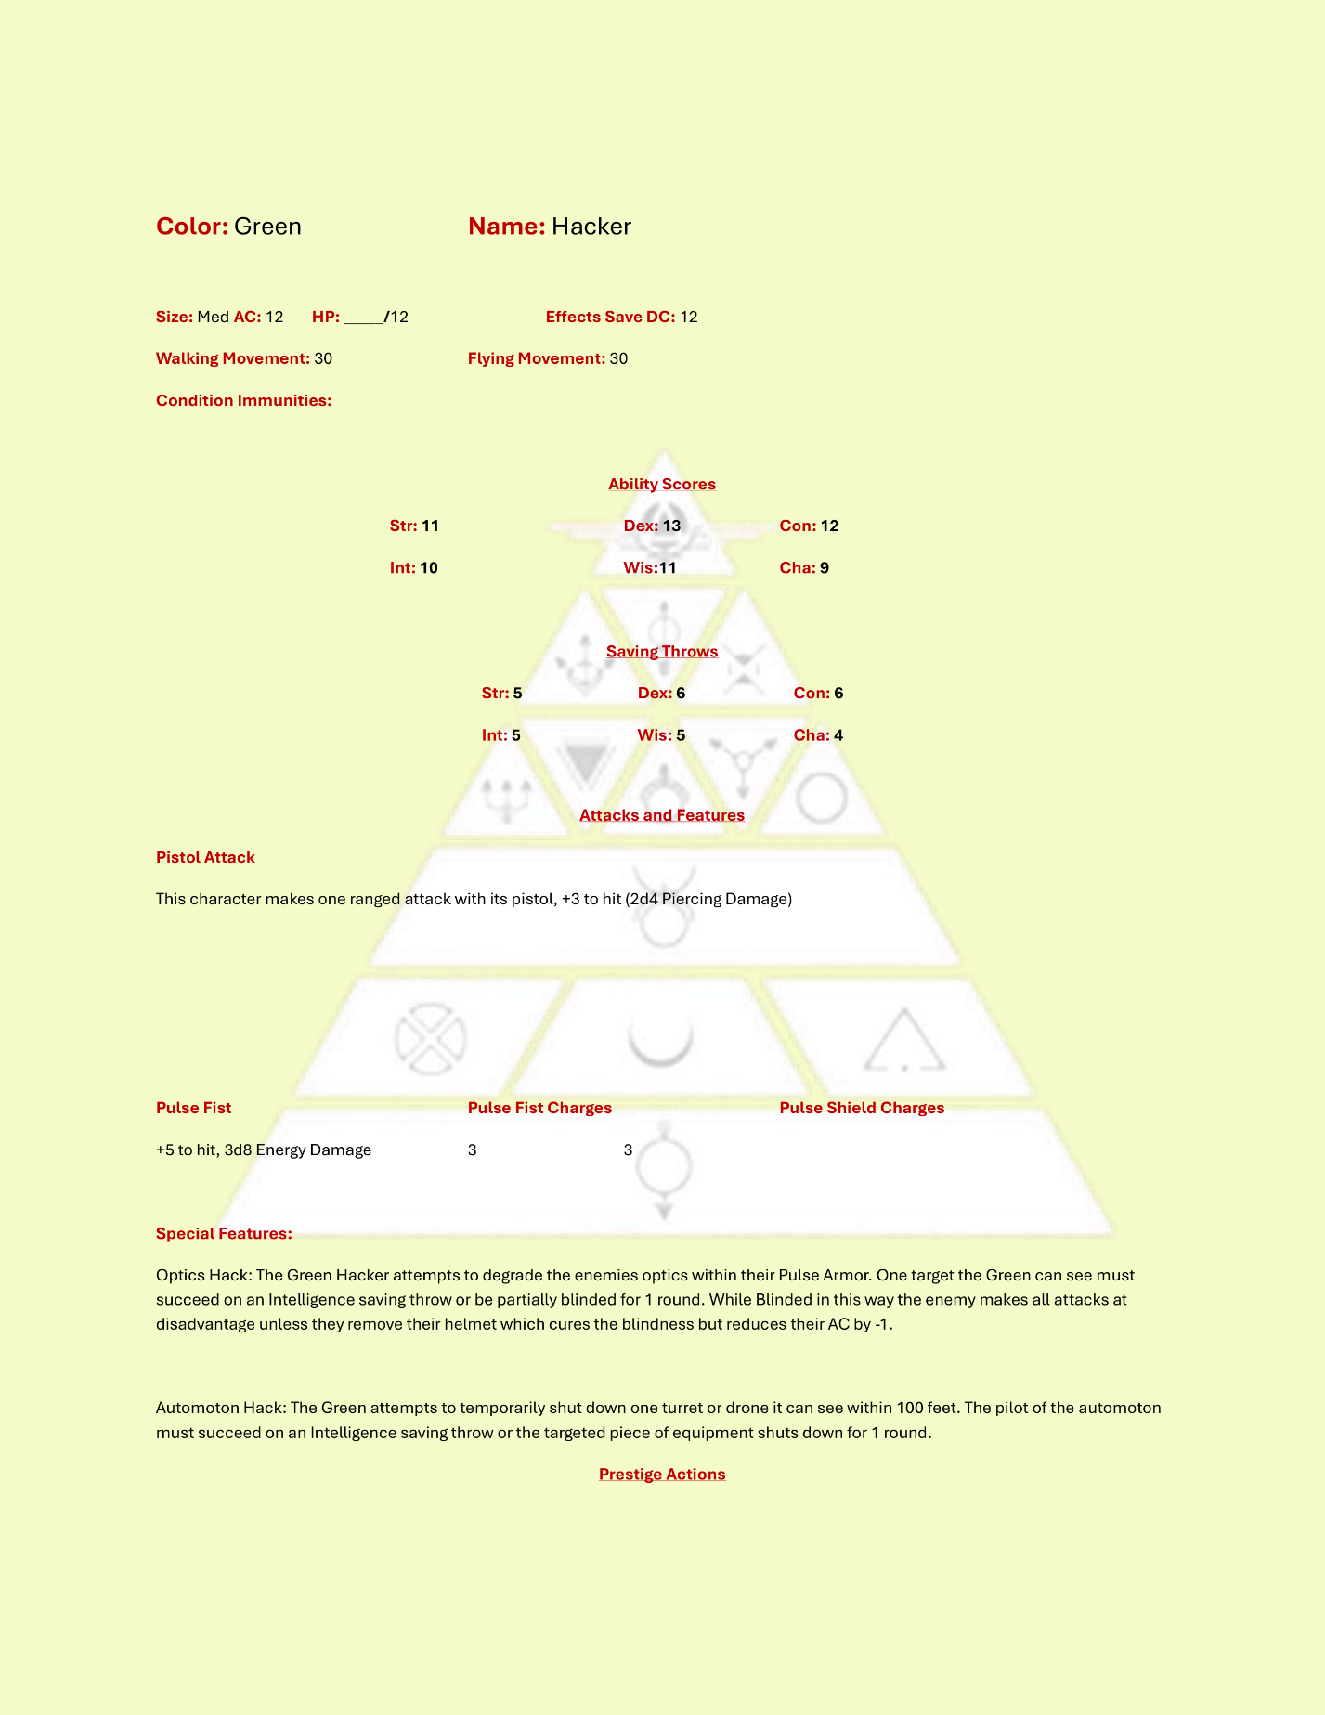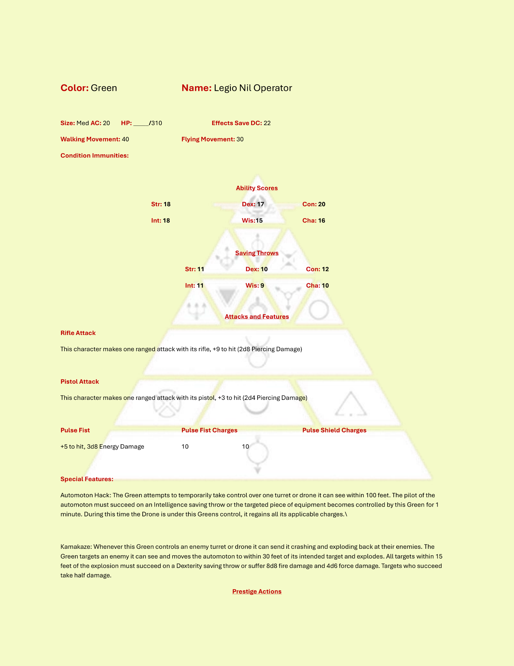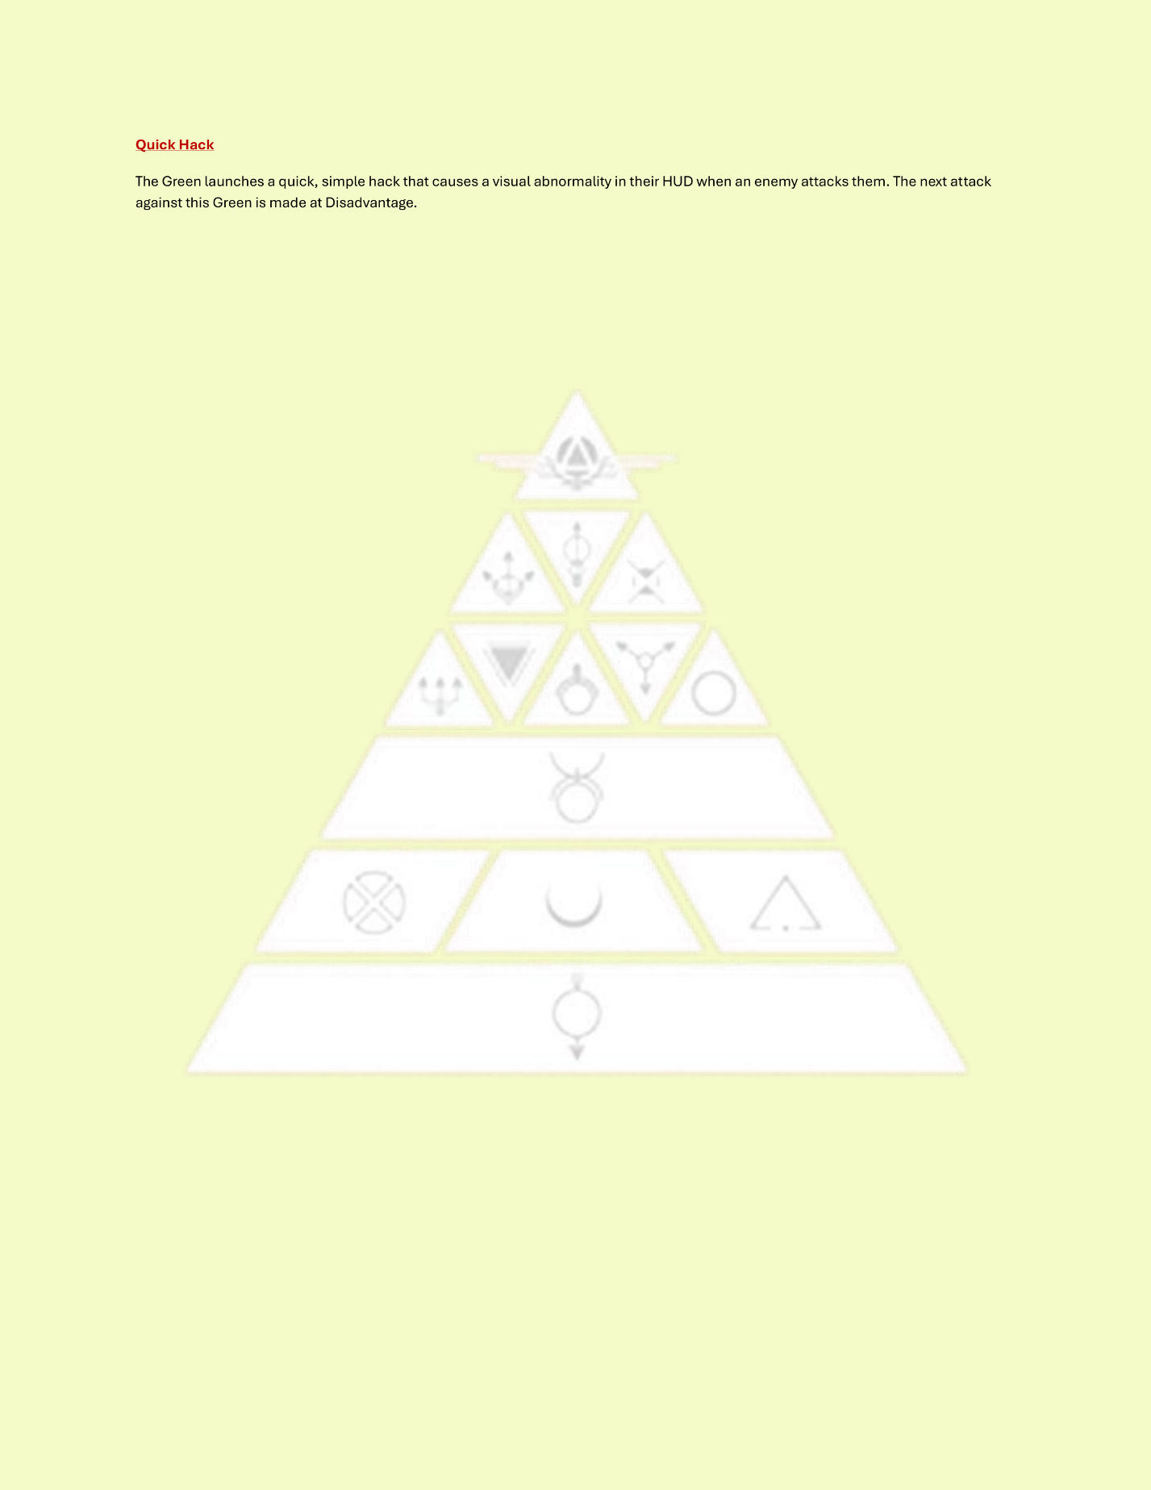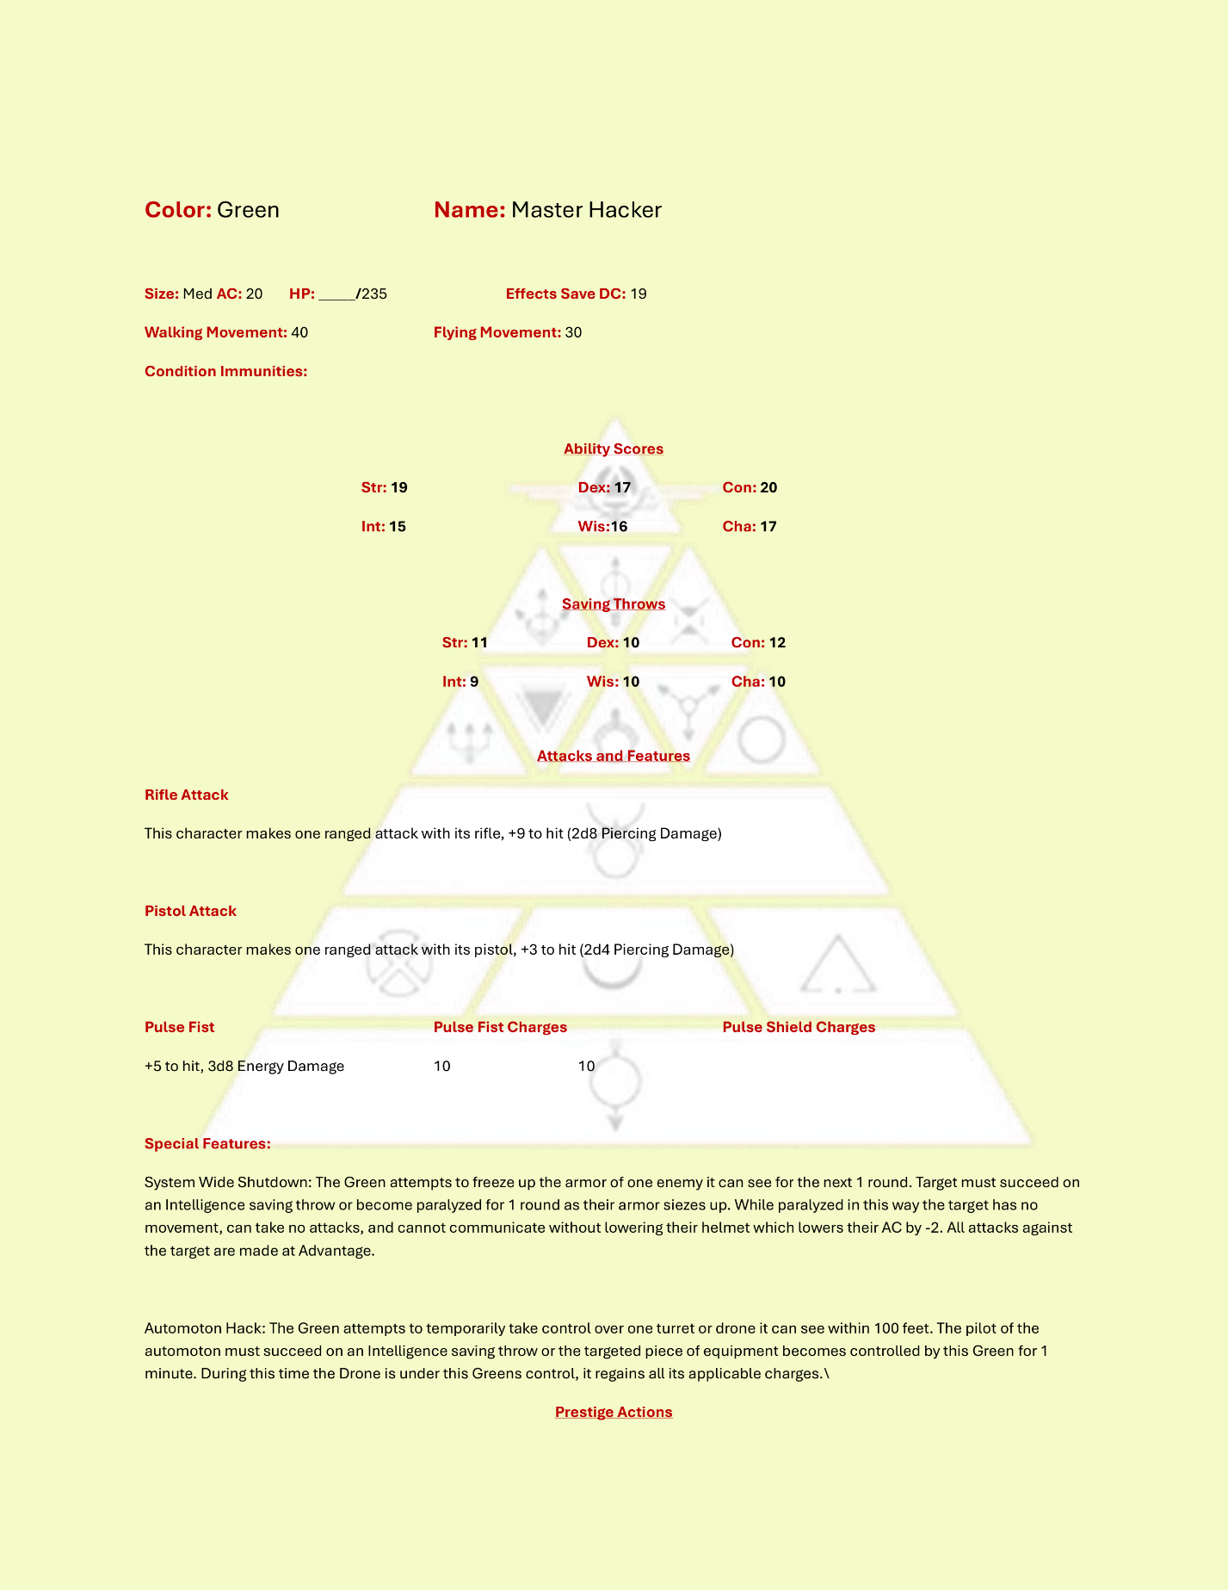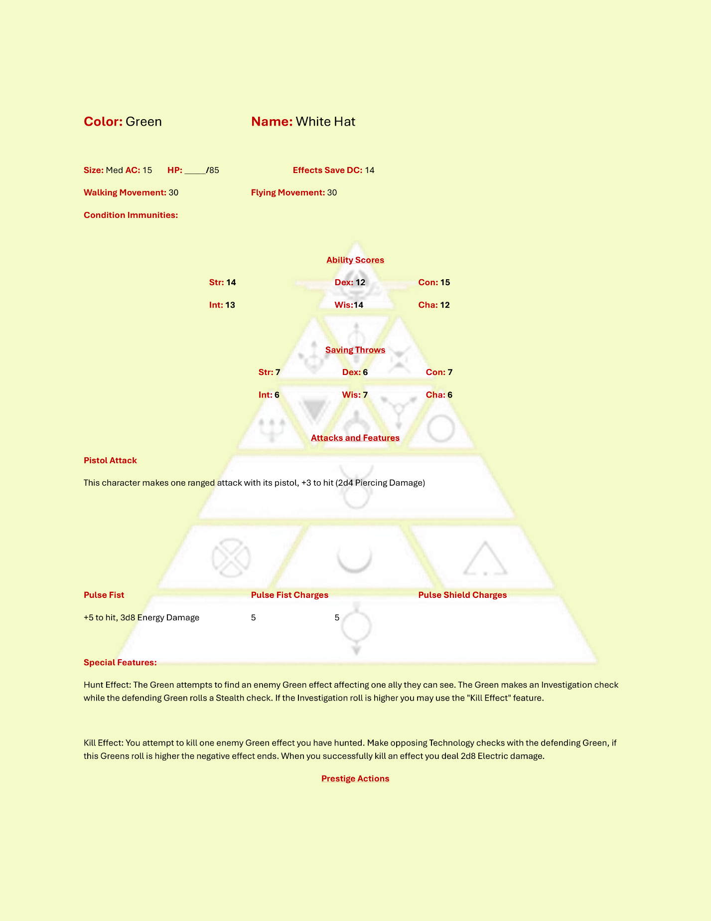

### Orange

Oranges use either a pistol or rifle as their main attack action and have access to explosives, turrets, and an exo-frame that makes them more deadly in combat. Oranges are common on spec ops teams for their prowess with munitions and affinity for auto-turrets.

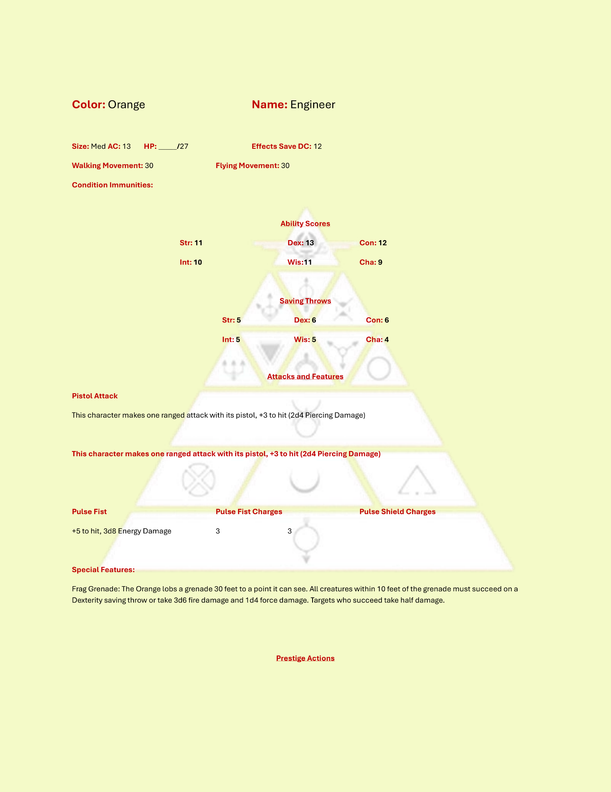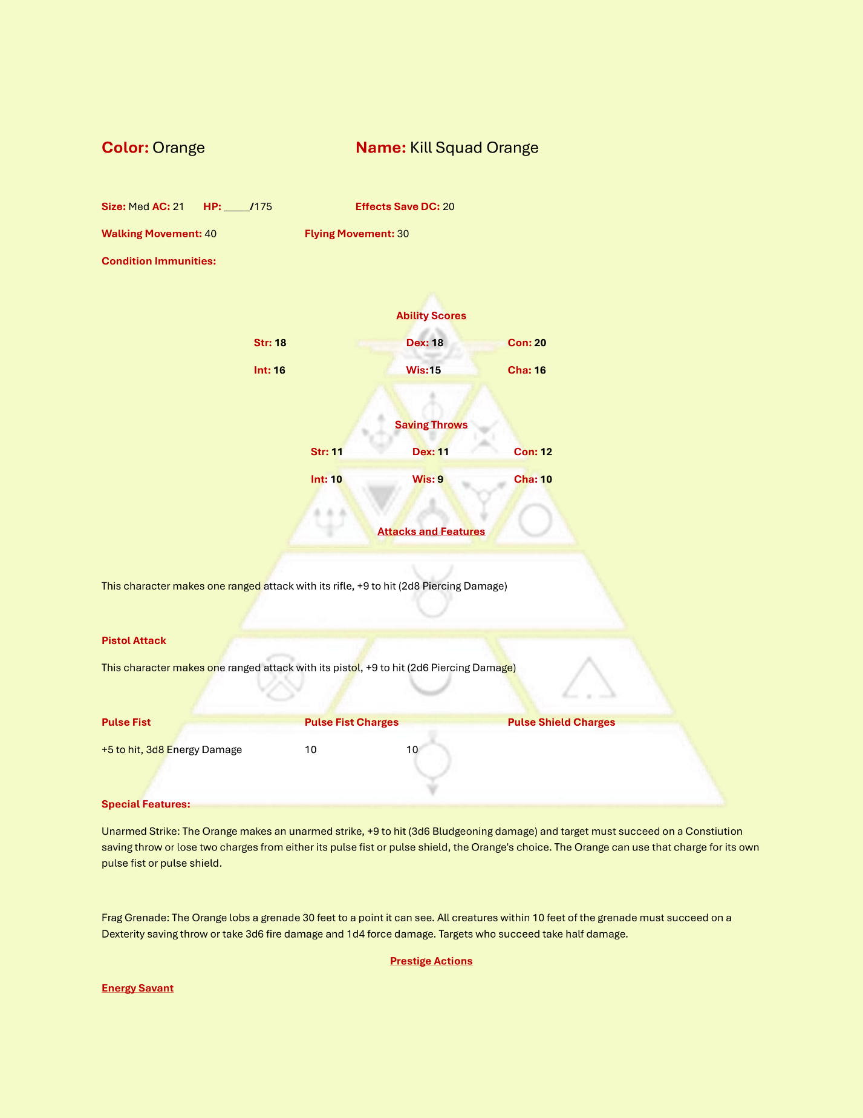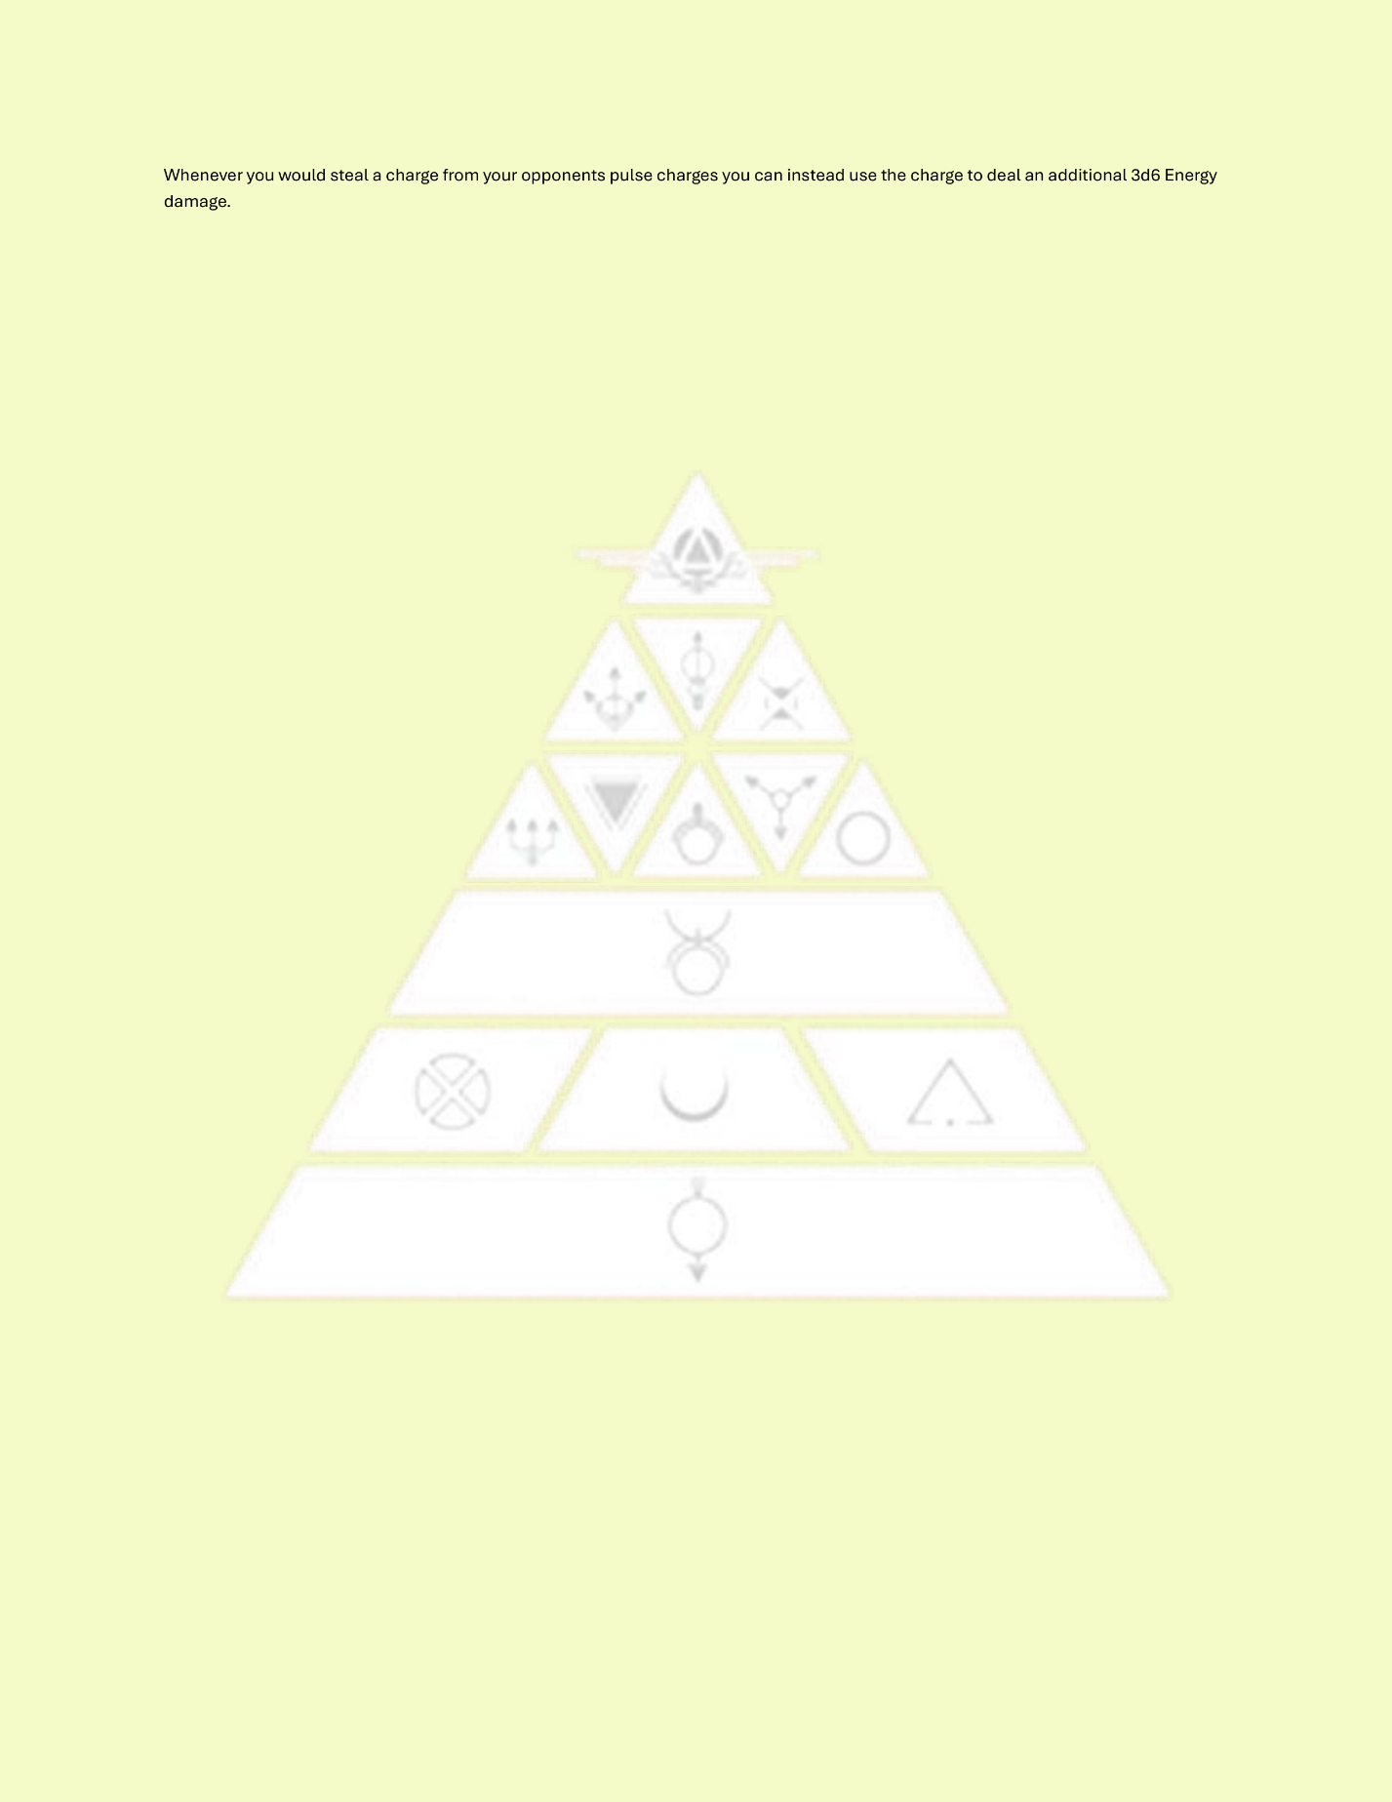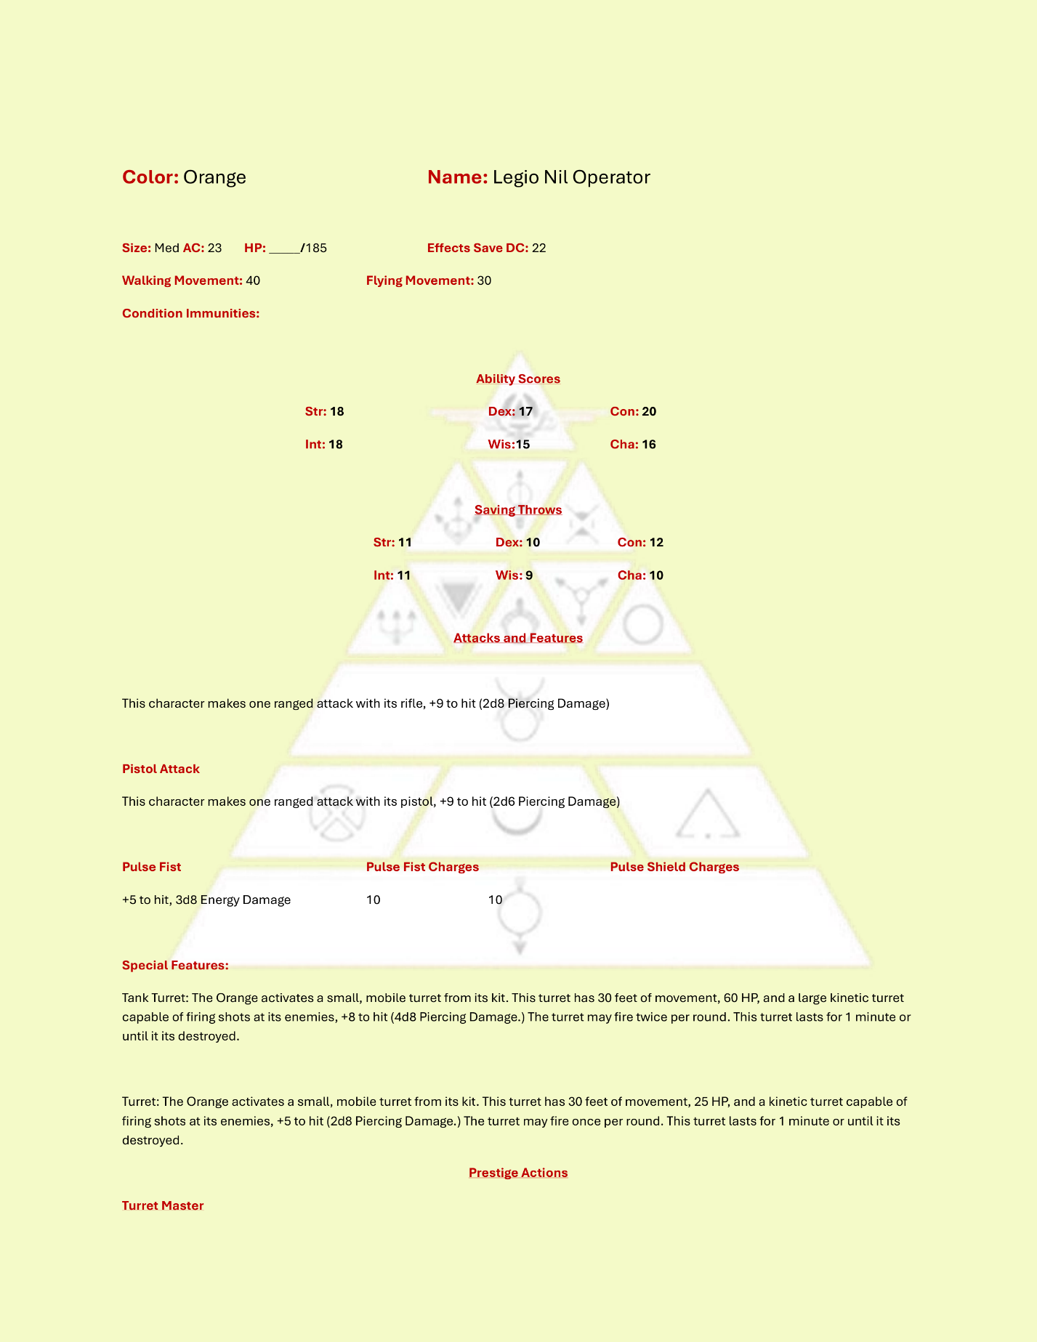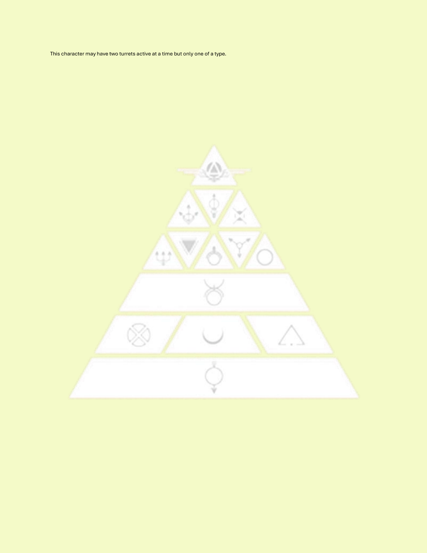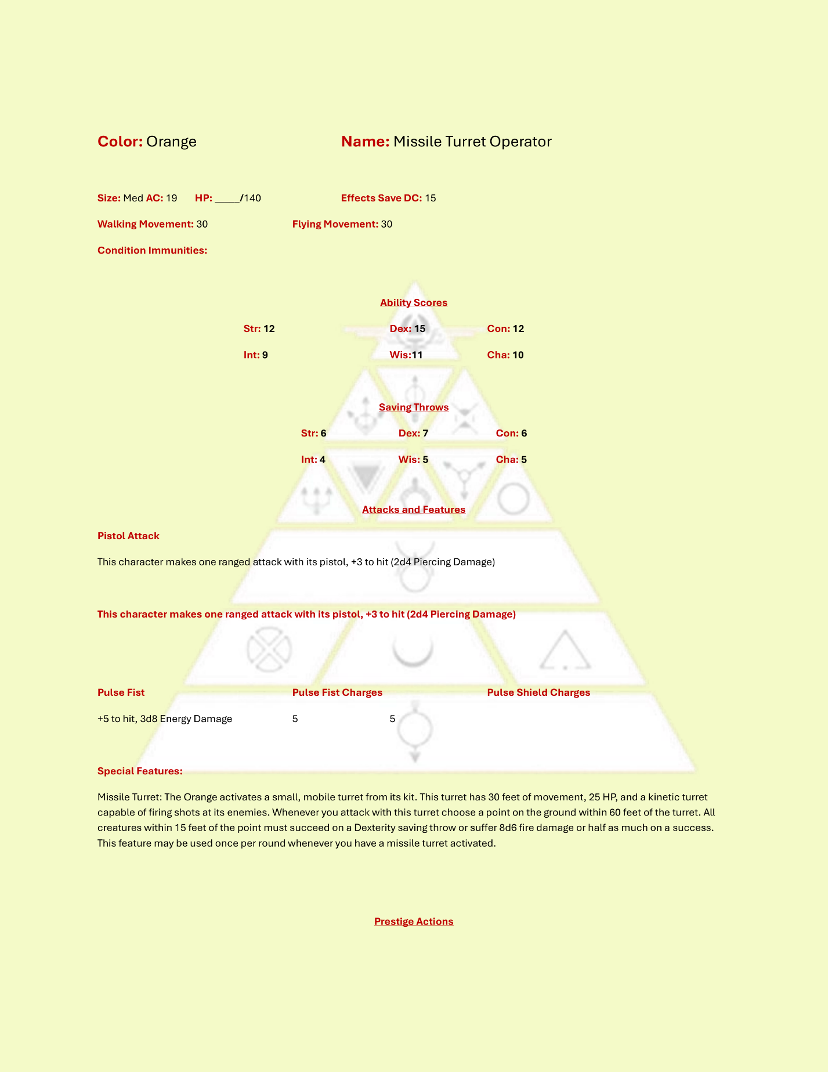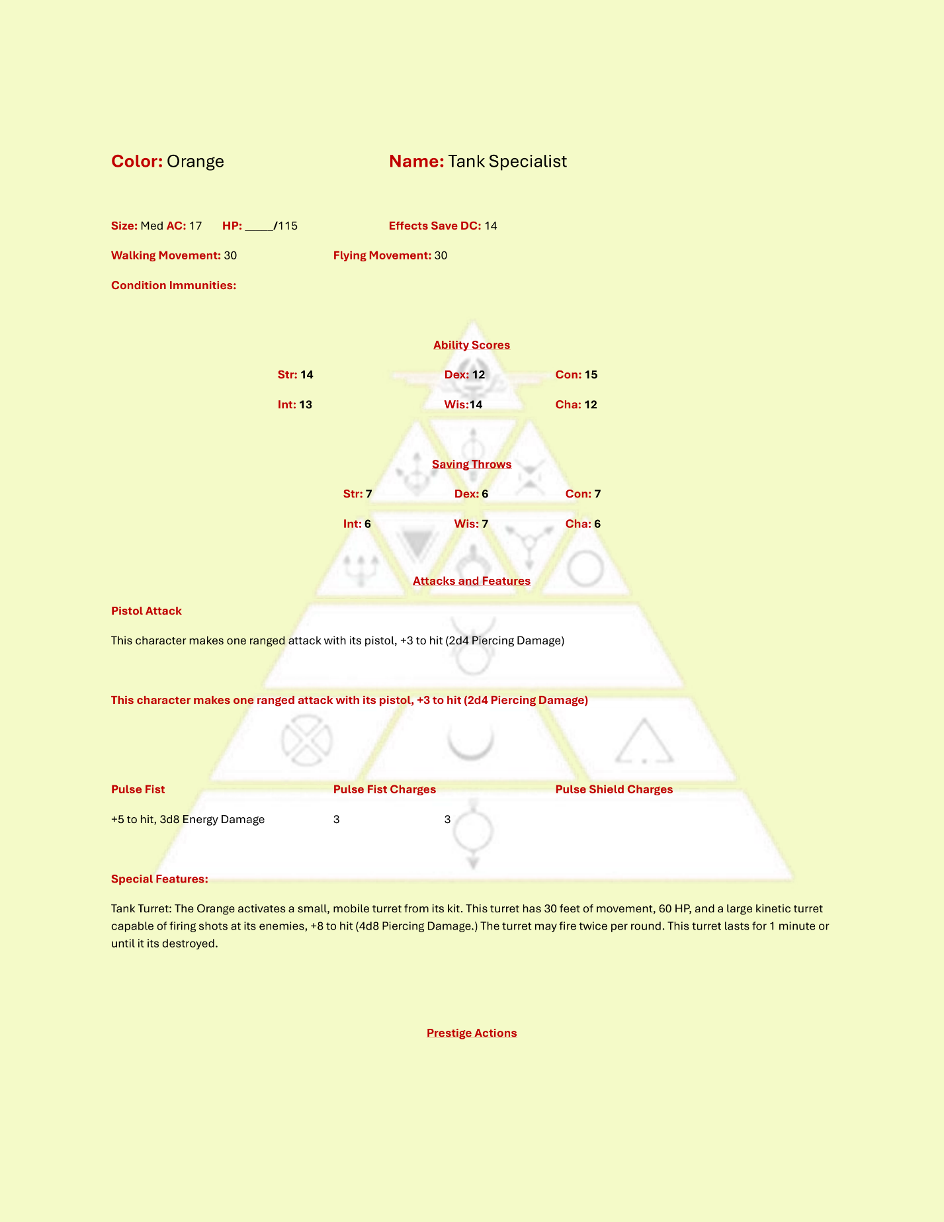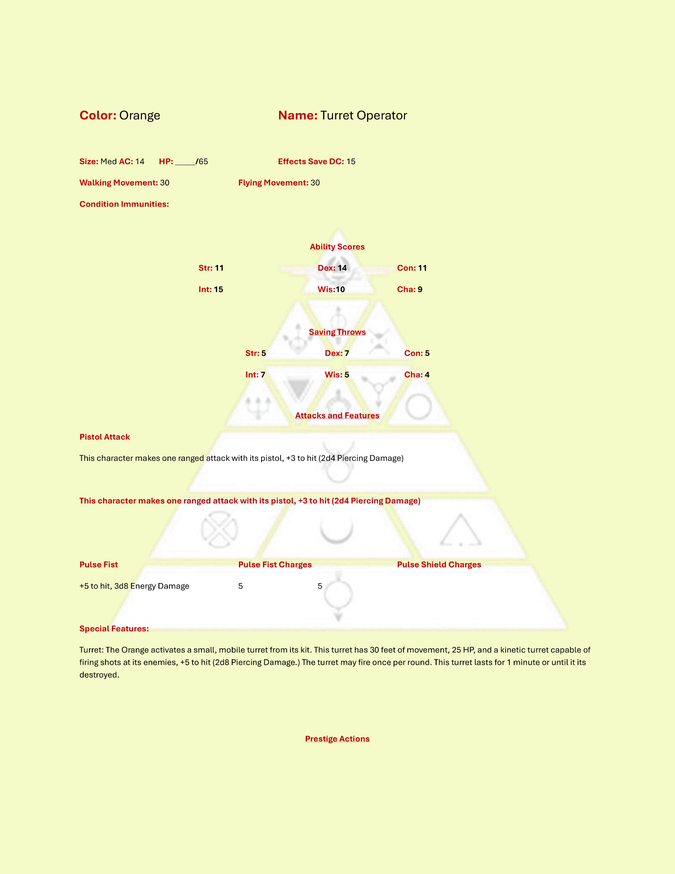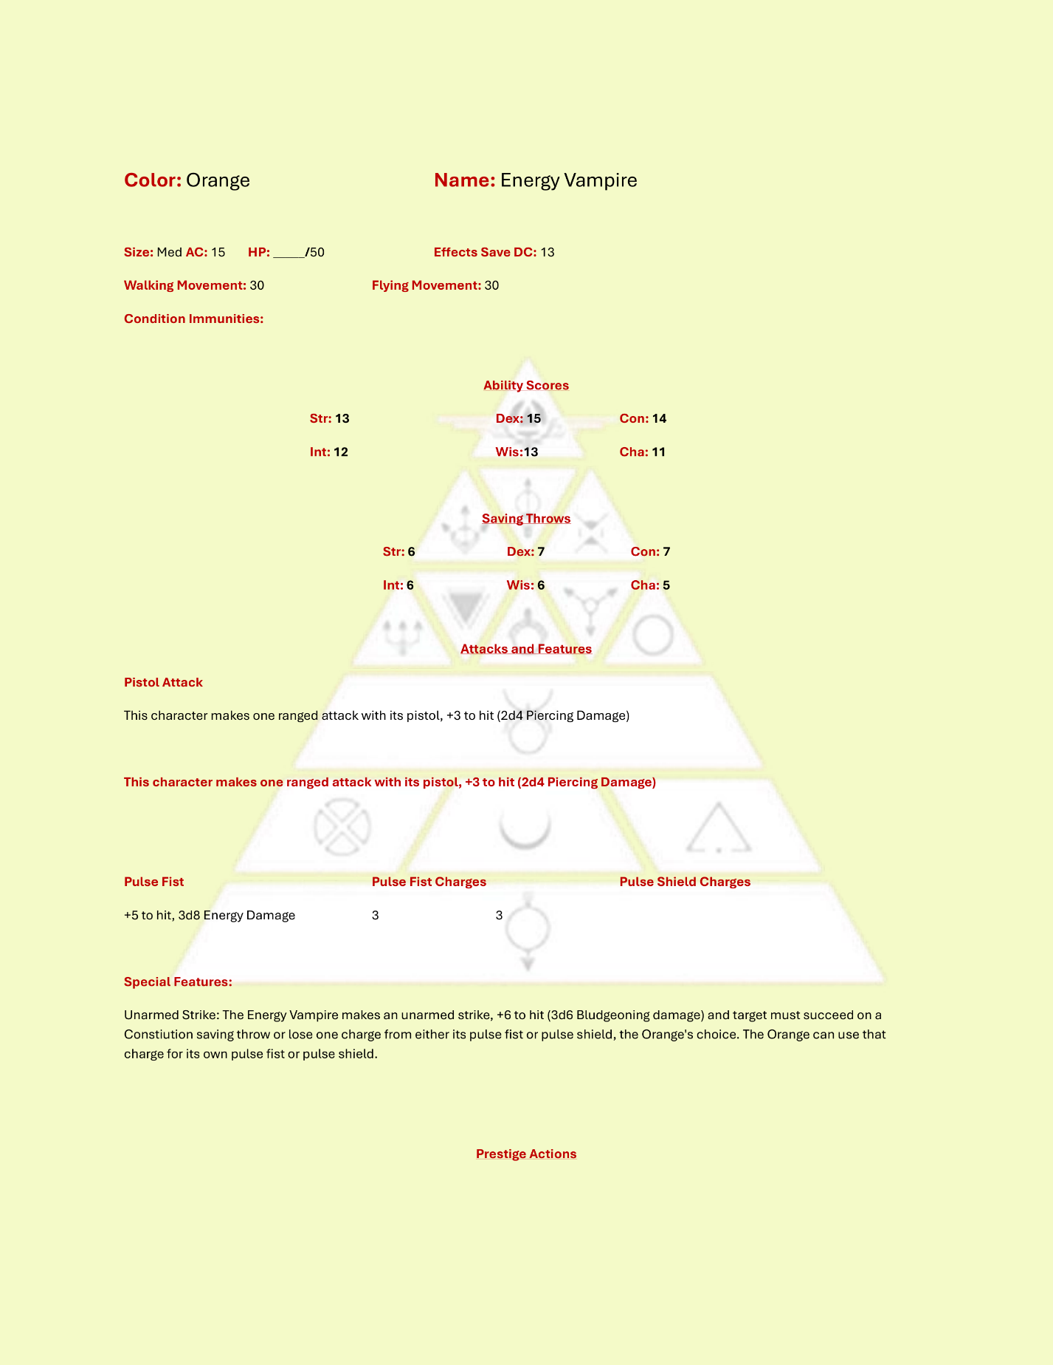

### Yellow

Yellows are the medics on the battlefield and are trained to use pistols as their main attack action. Medics keep their allies up but also have access to Needle Guns, gases, and radiation.

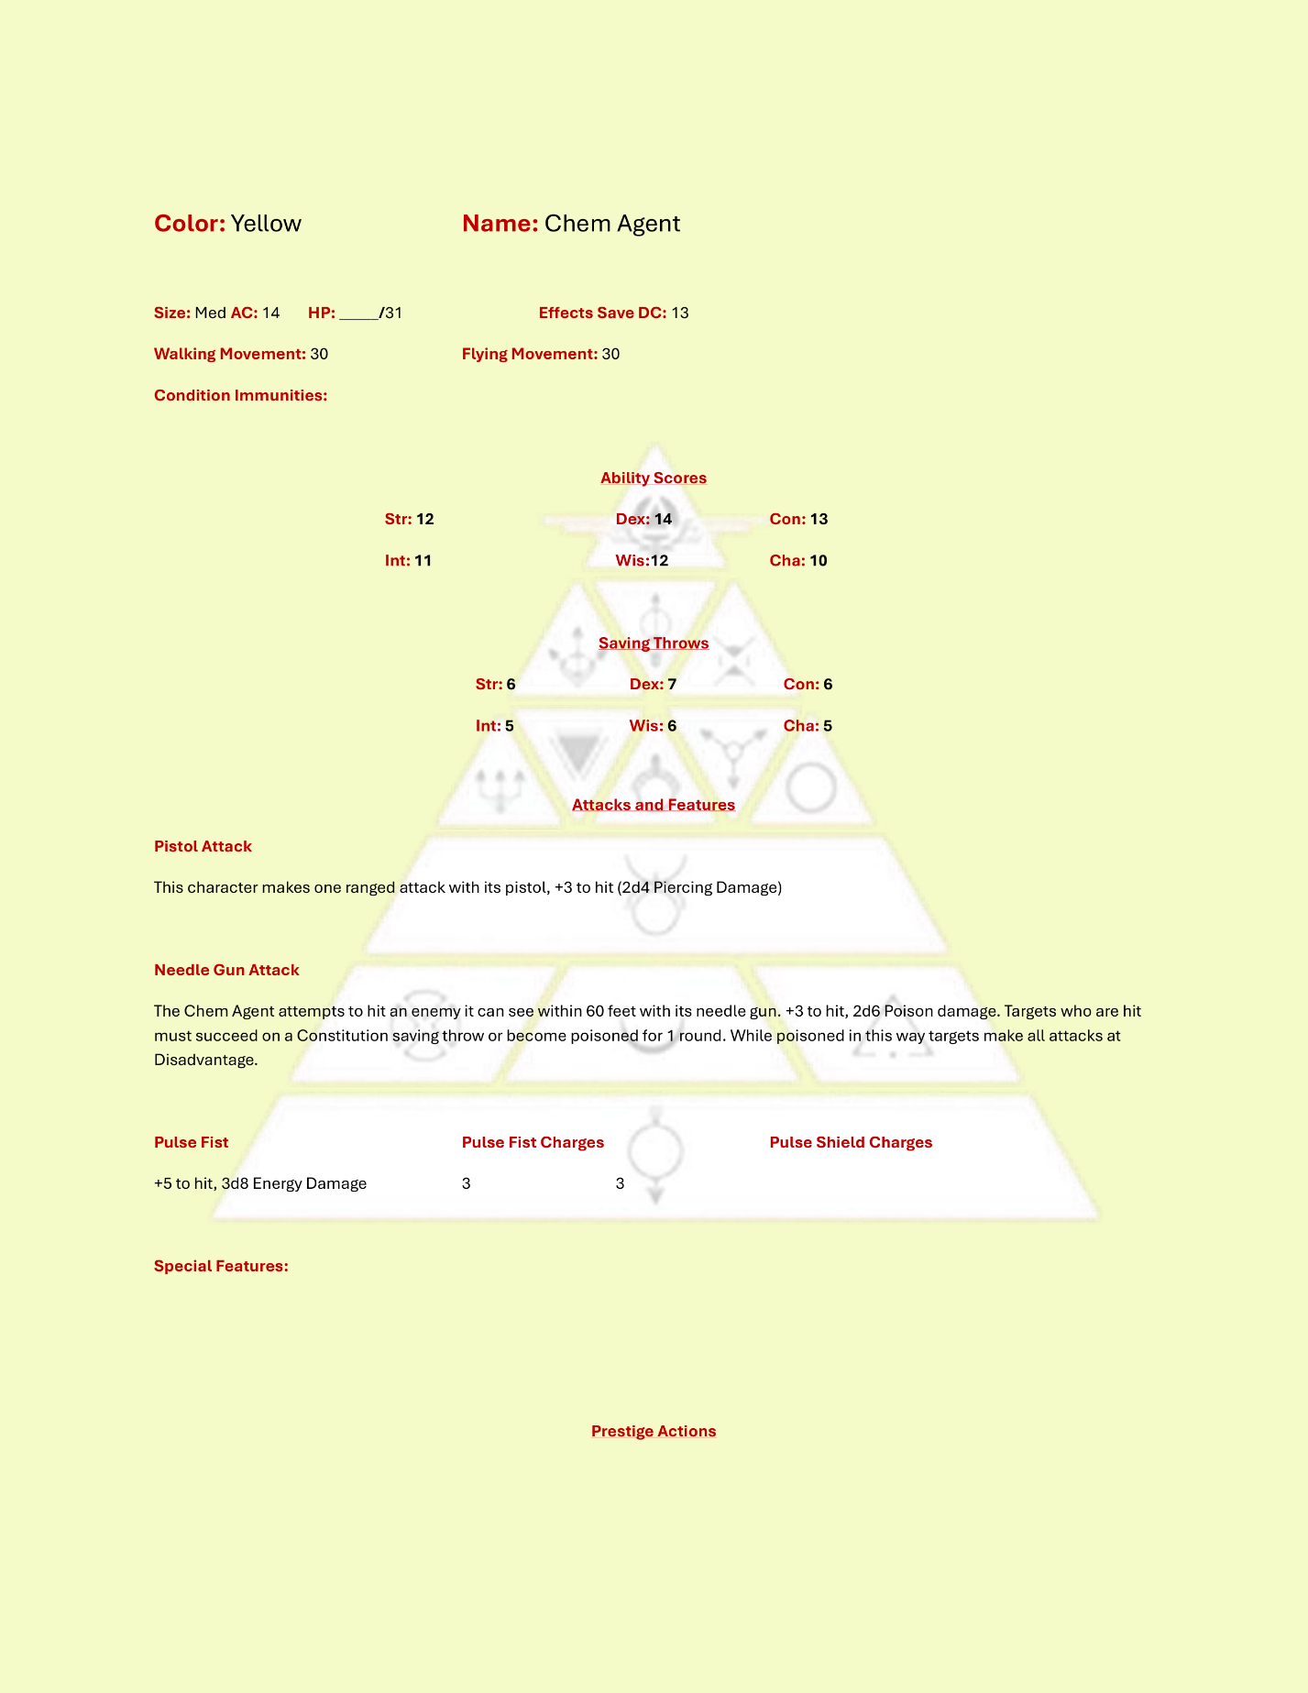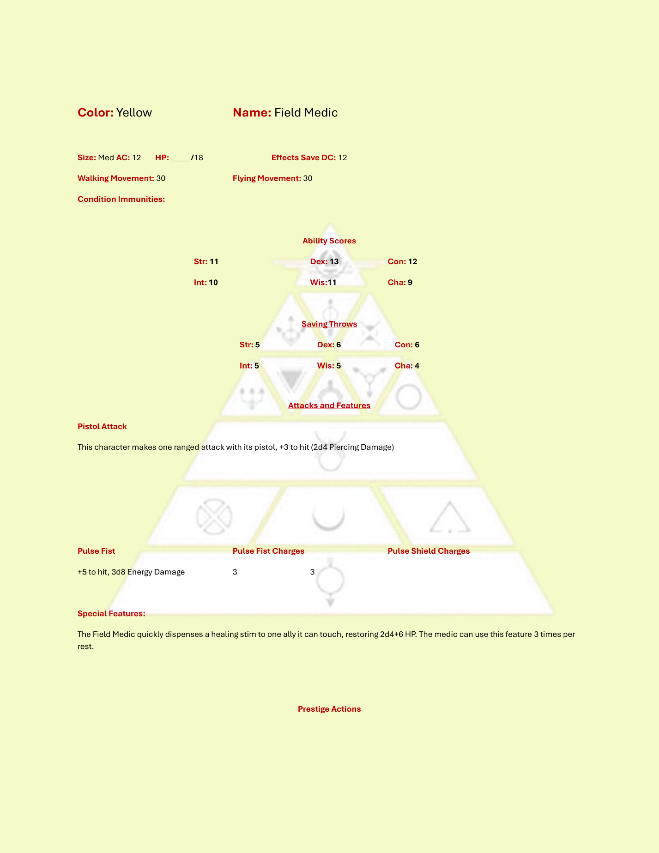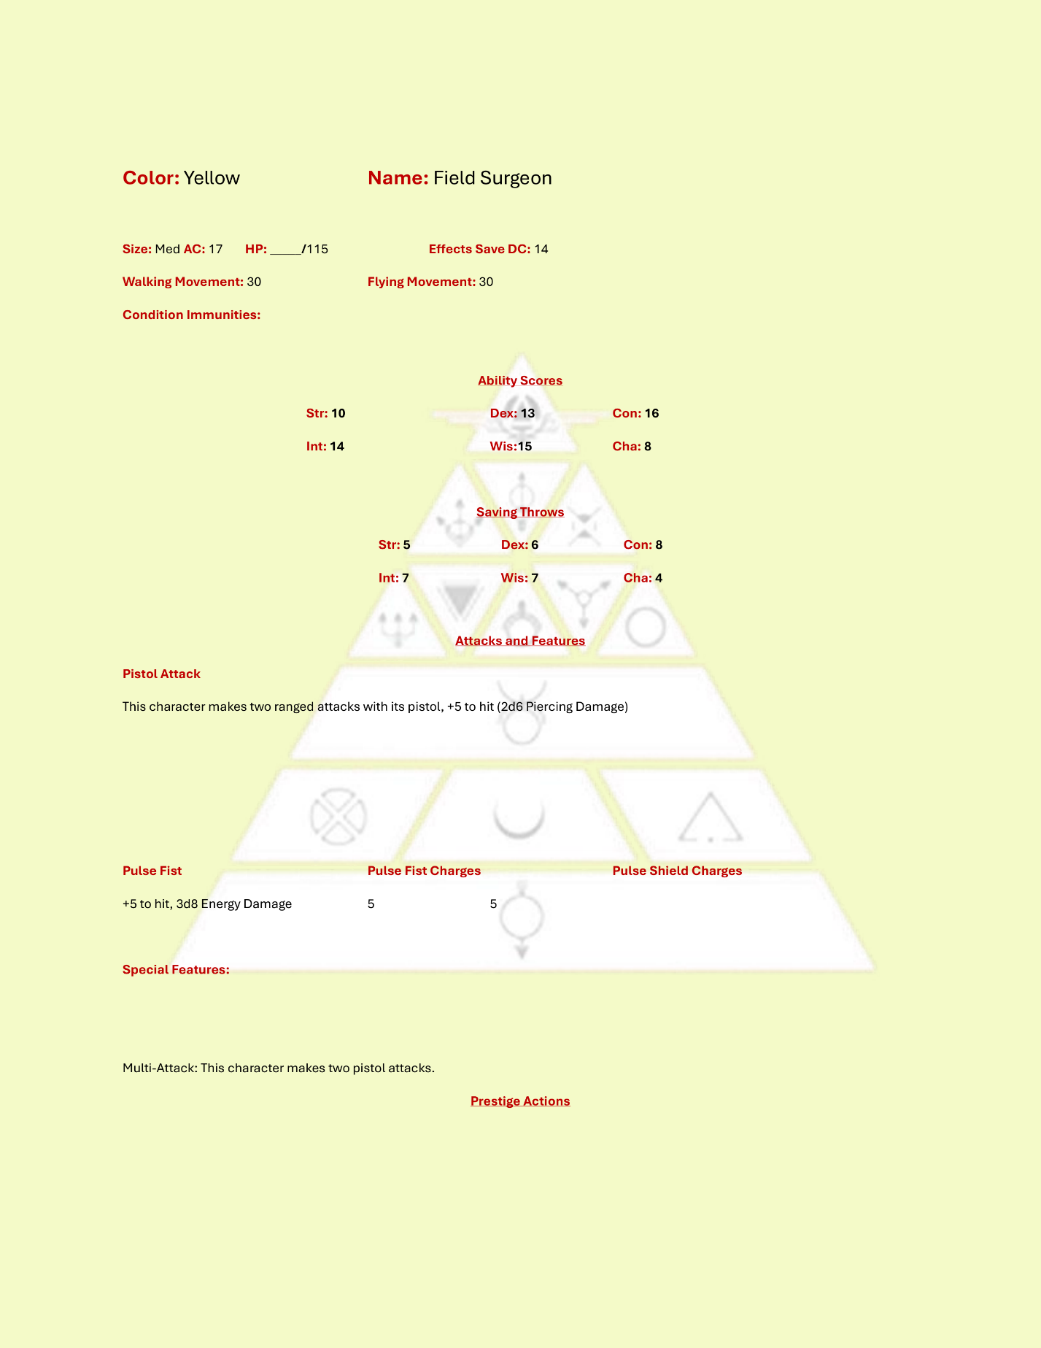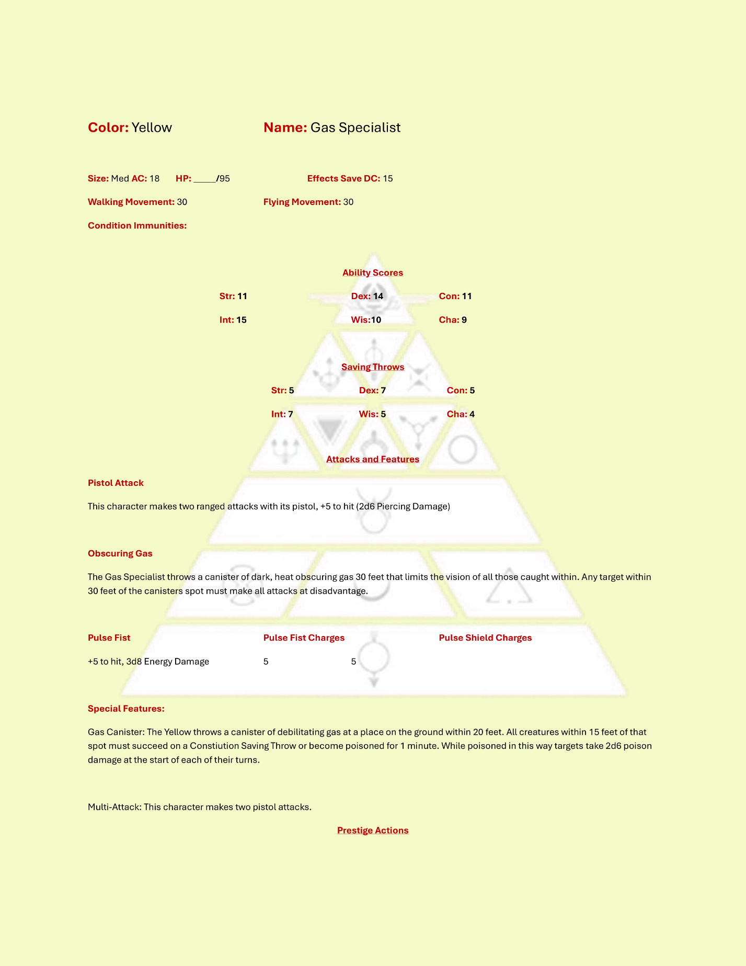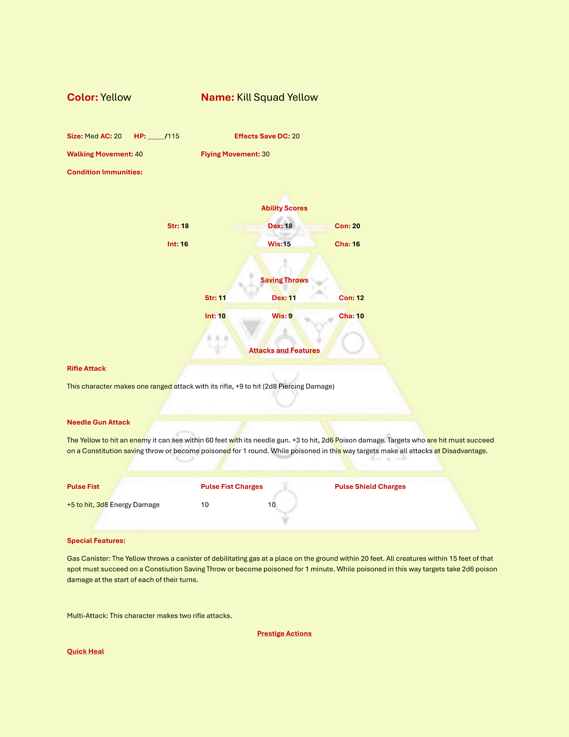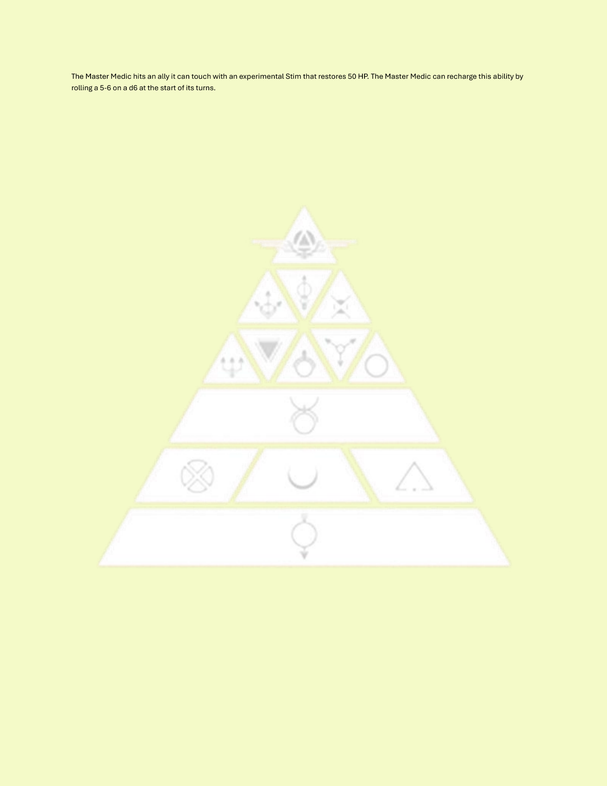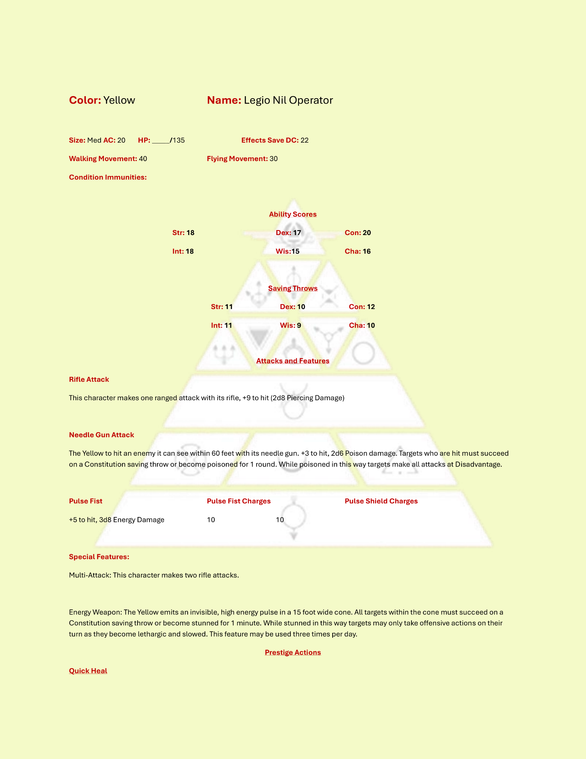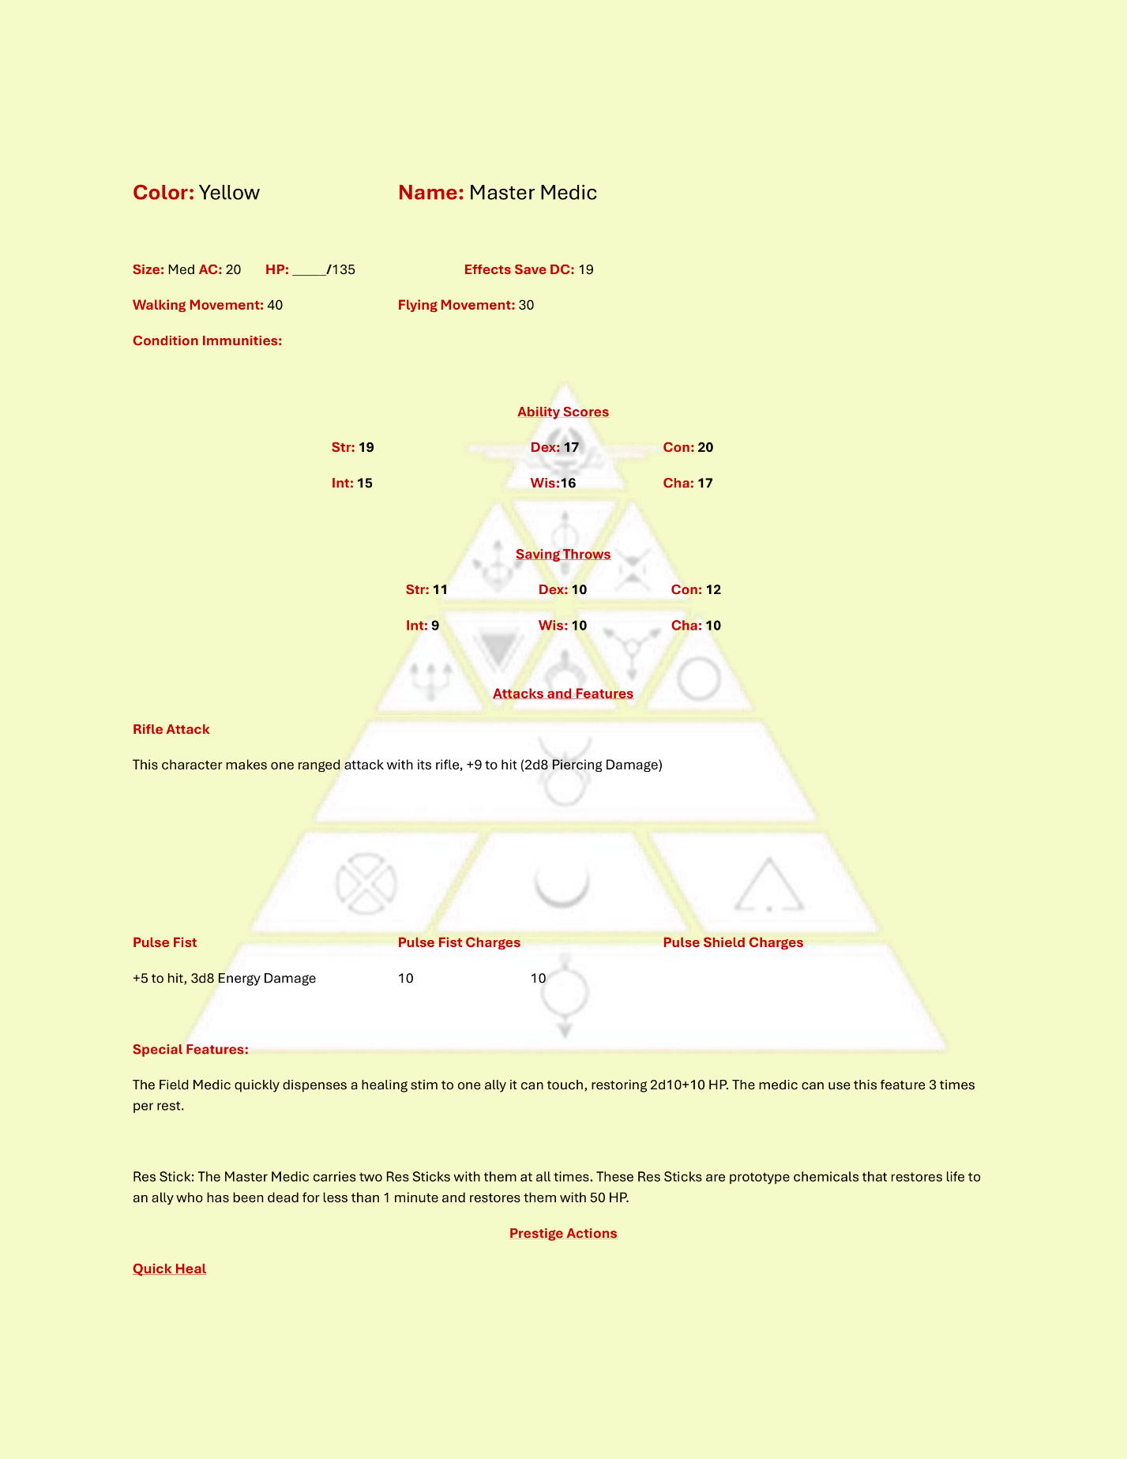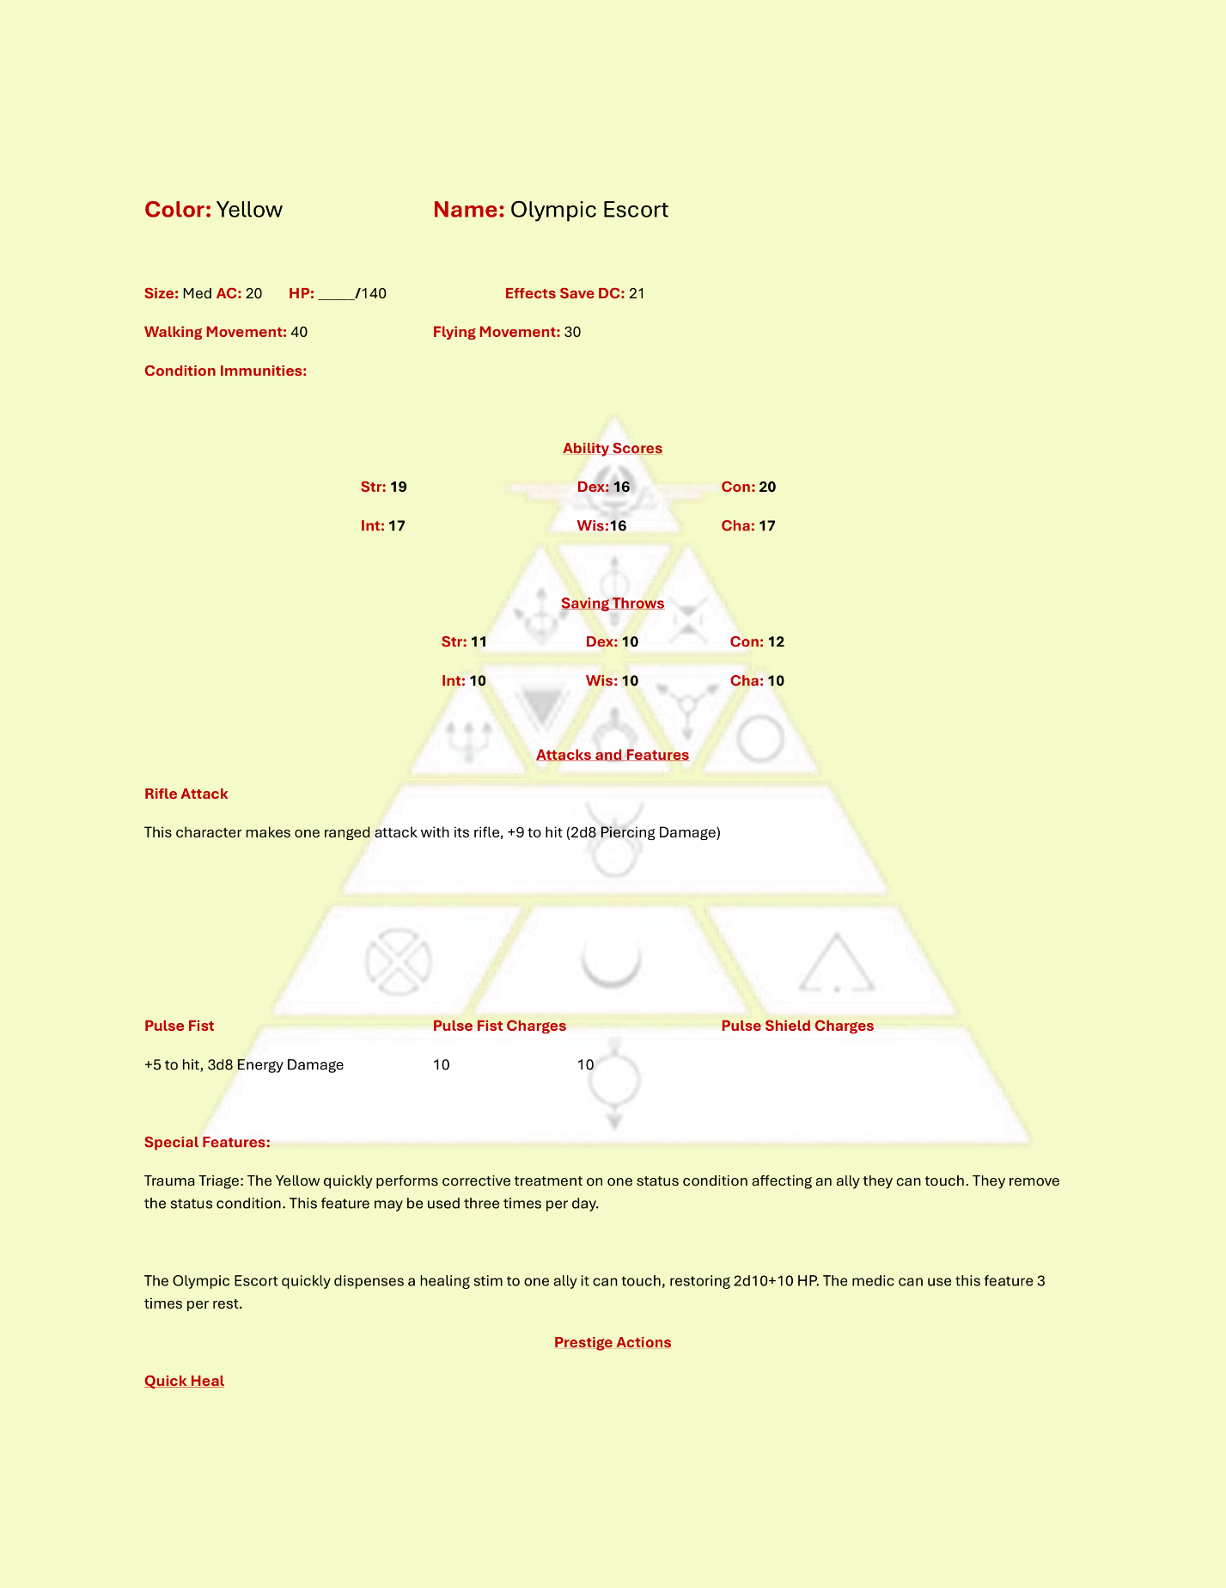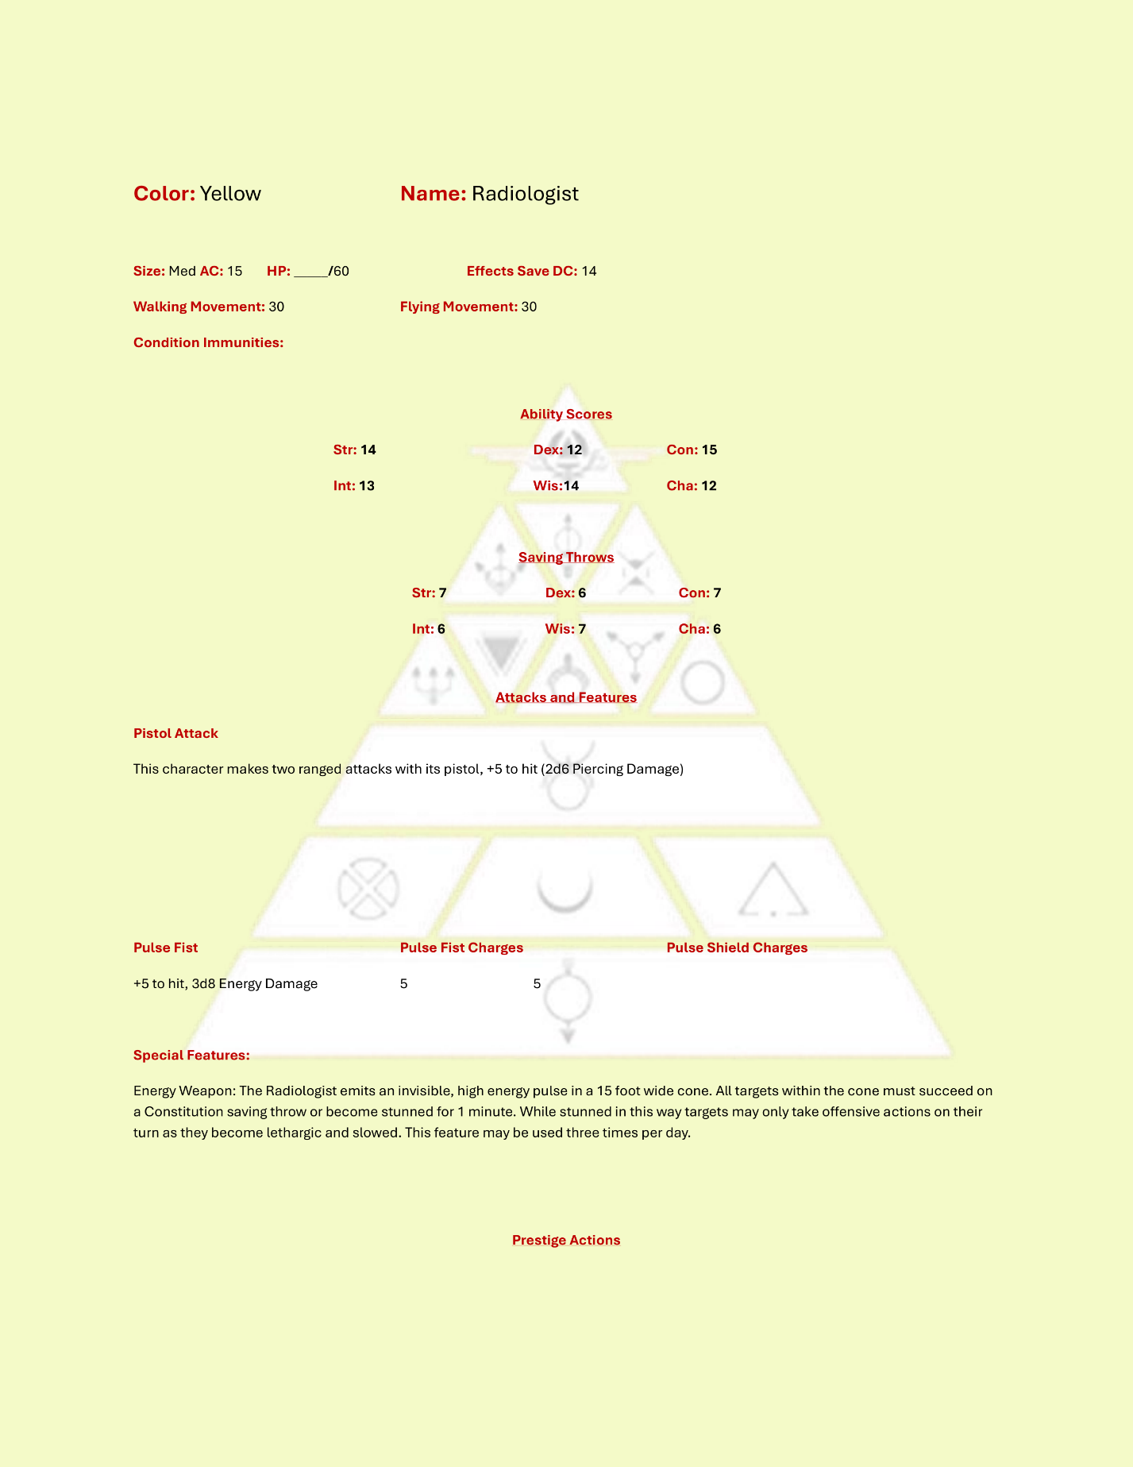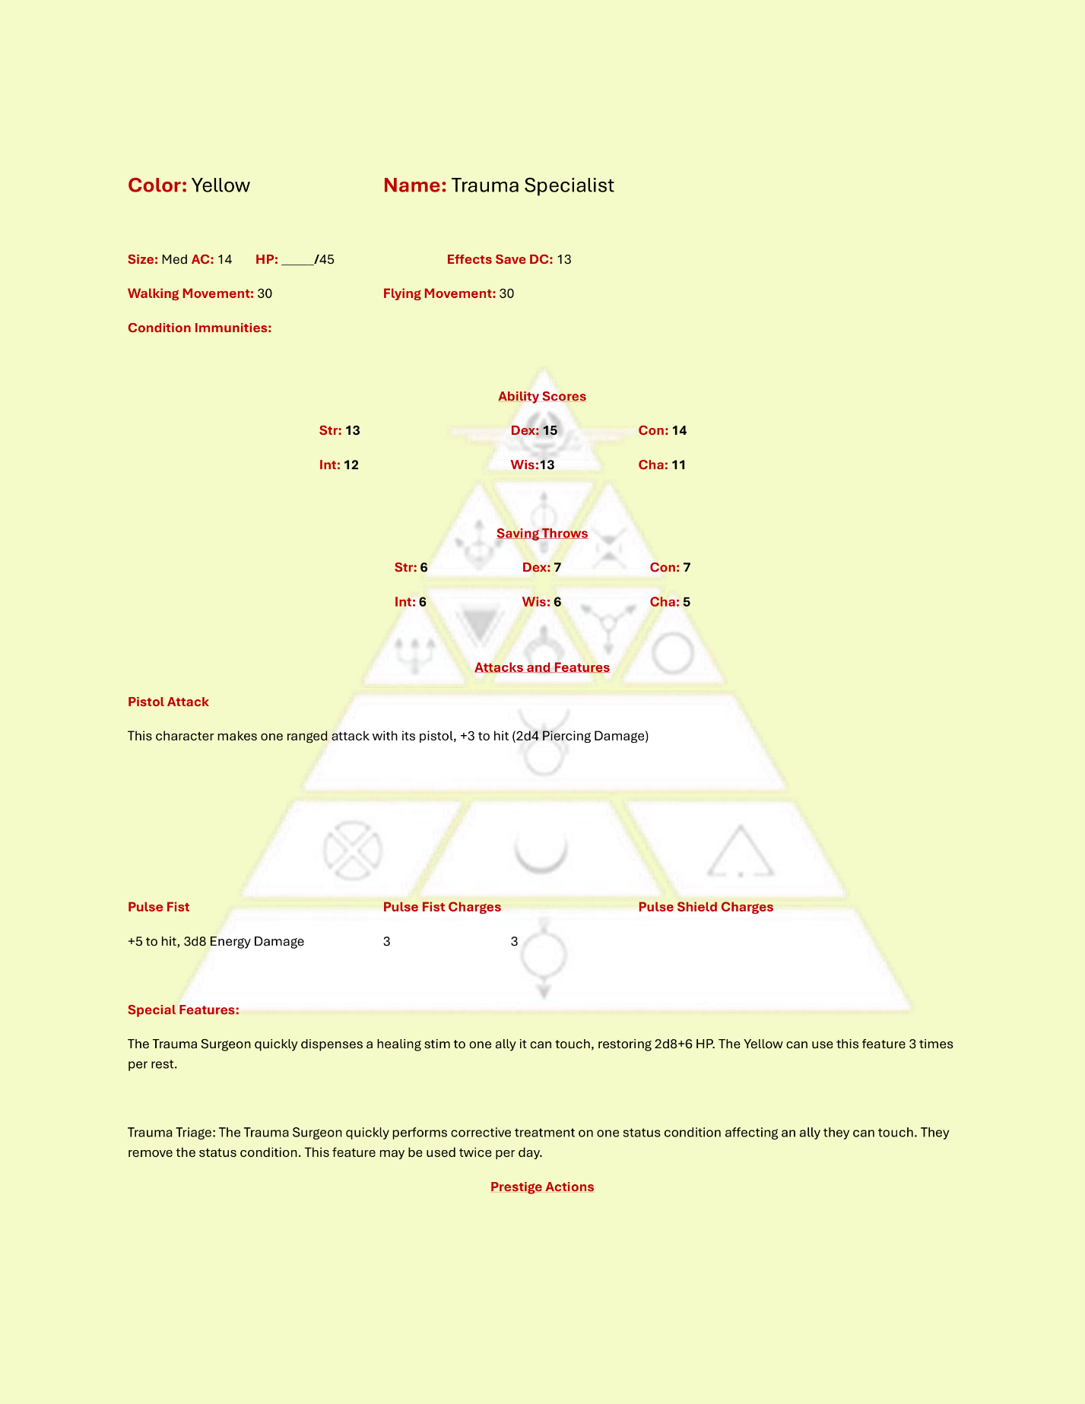

### Obsidian

Obsidians are the shock troops of the military machine. They are the first through a breech, the first into a new room. Obsidians attack with their axes and raw brute strength. The deadliest among them, the Stained, can kill you in many ways.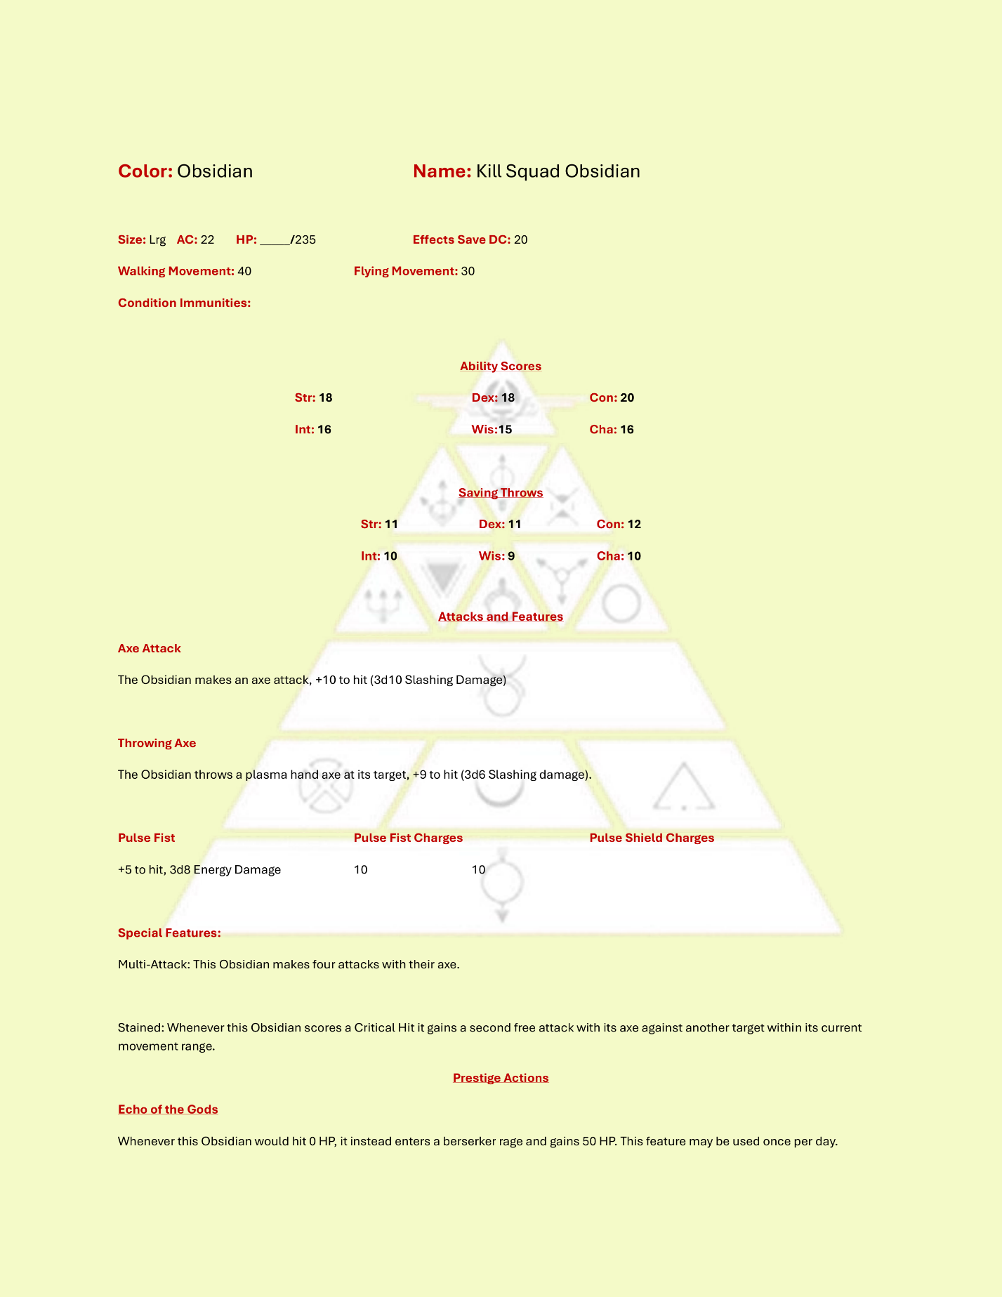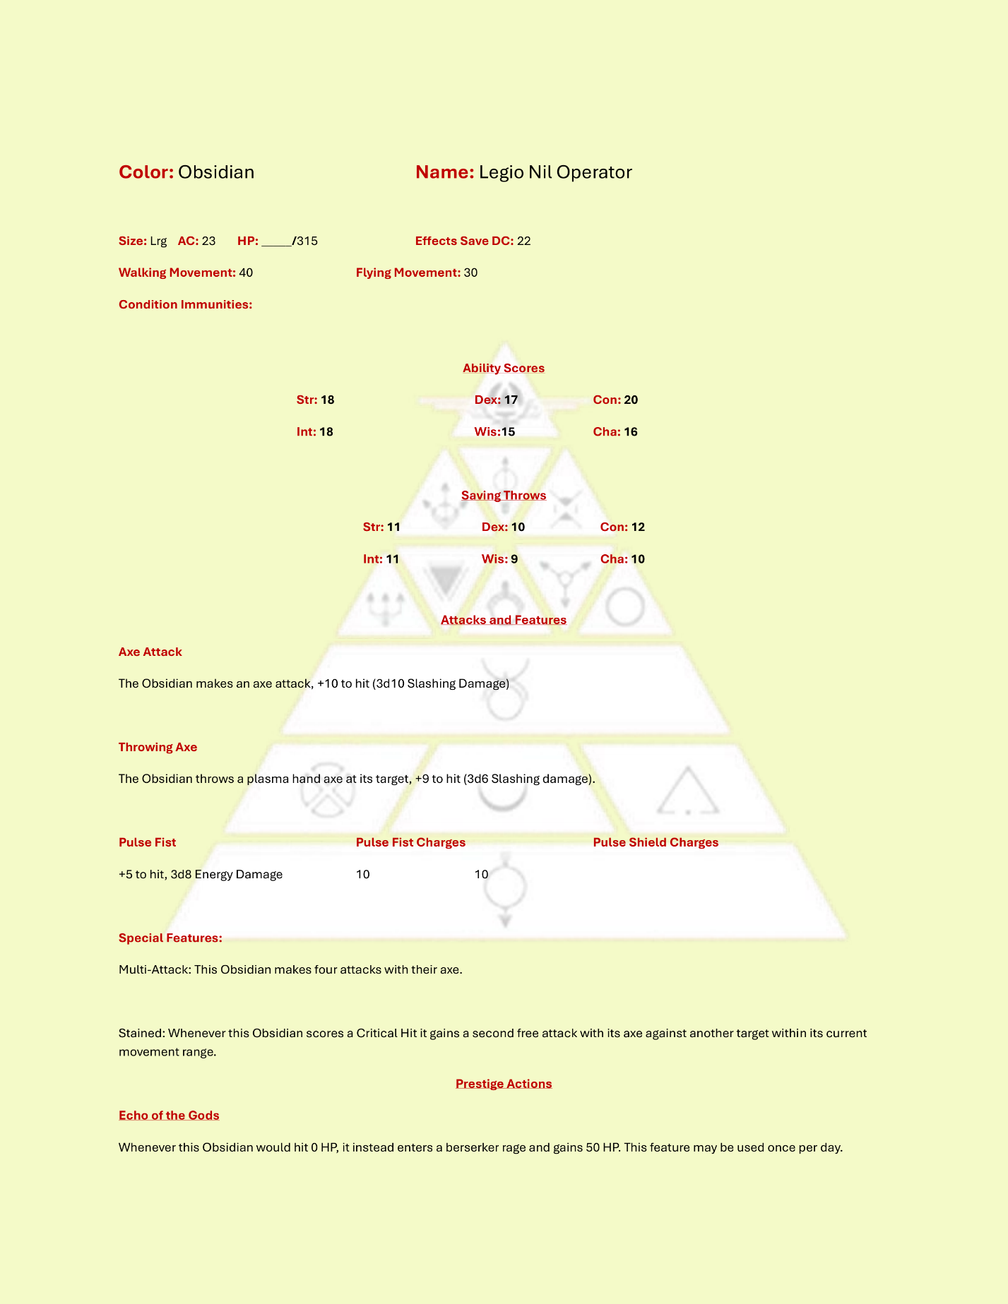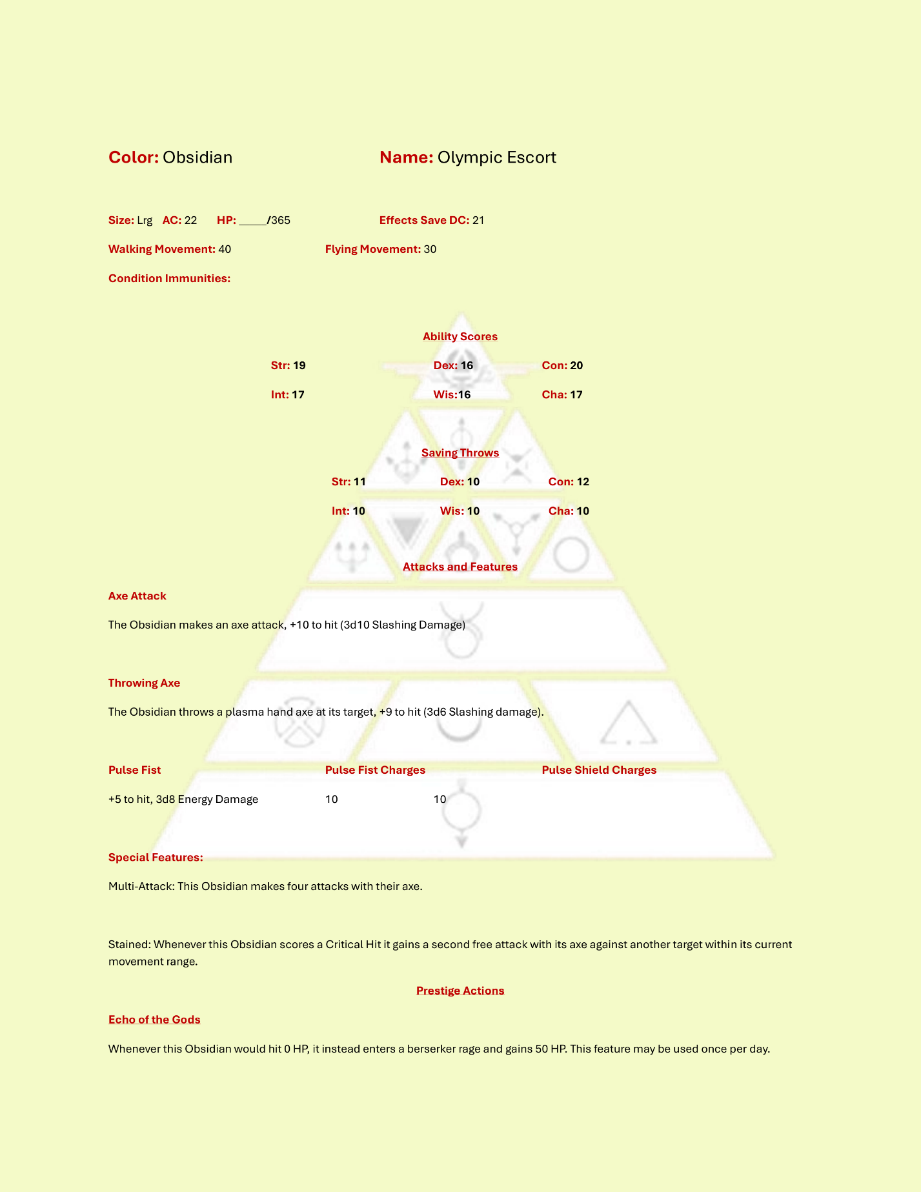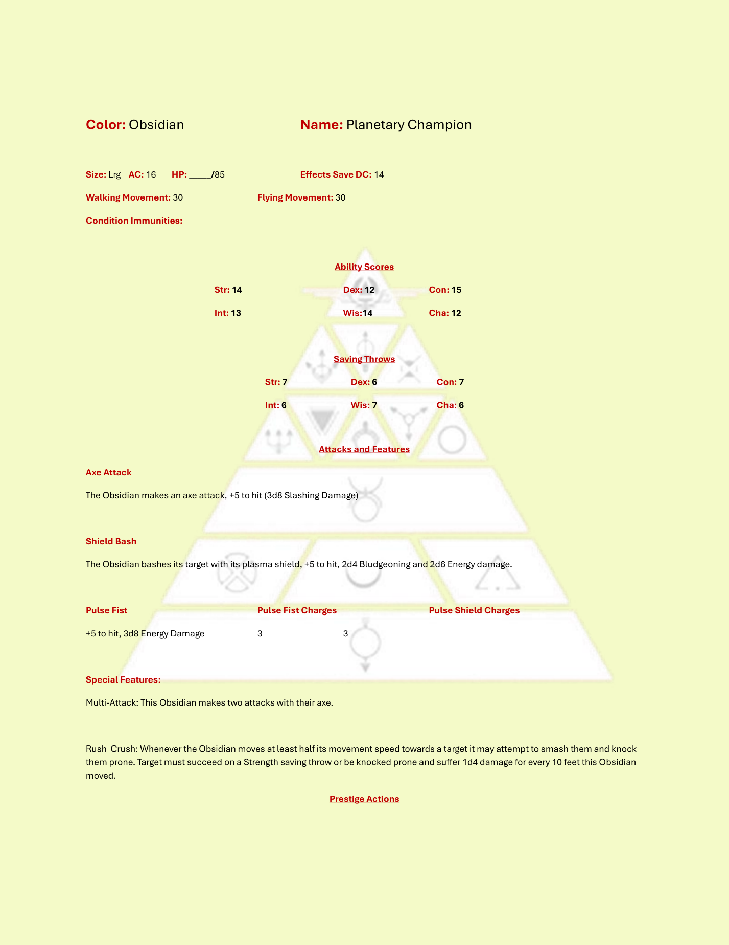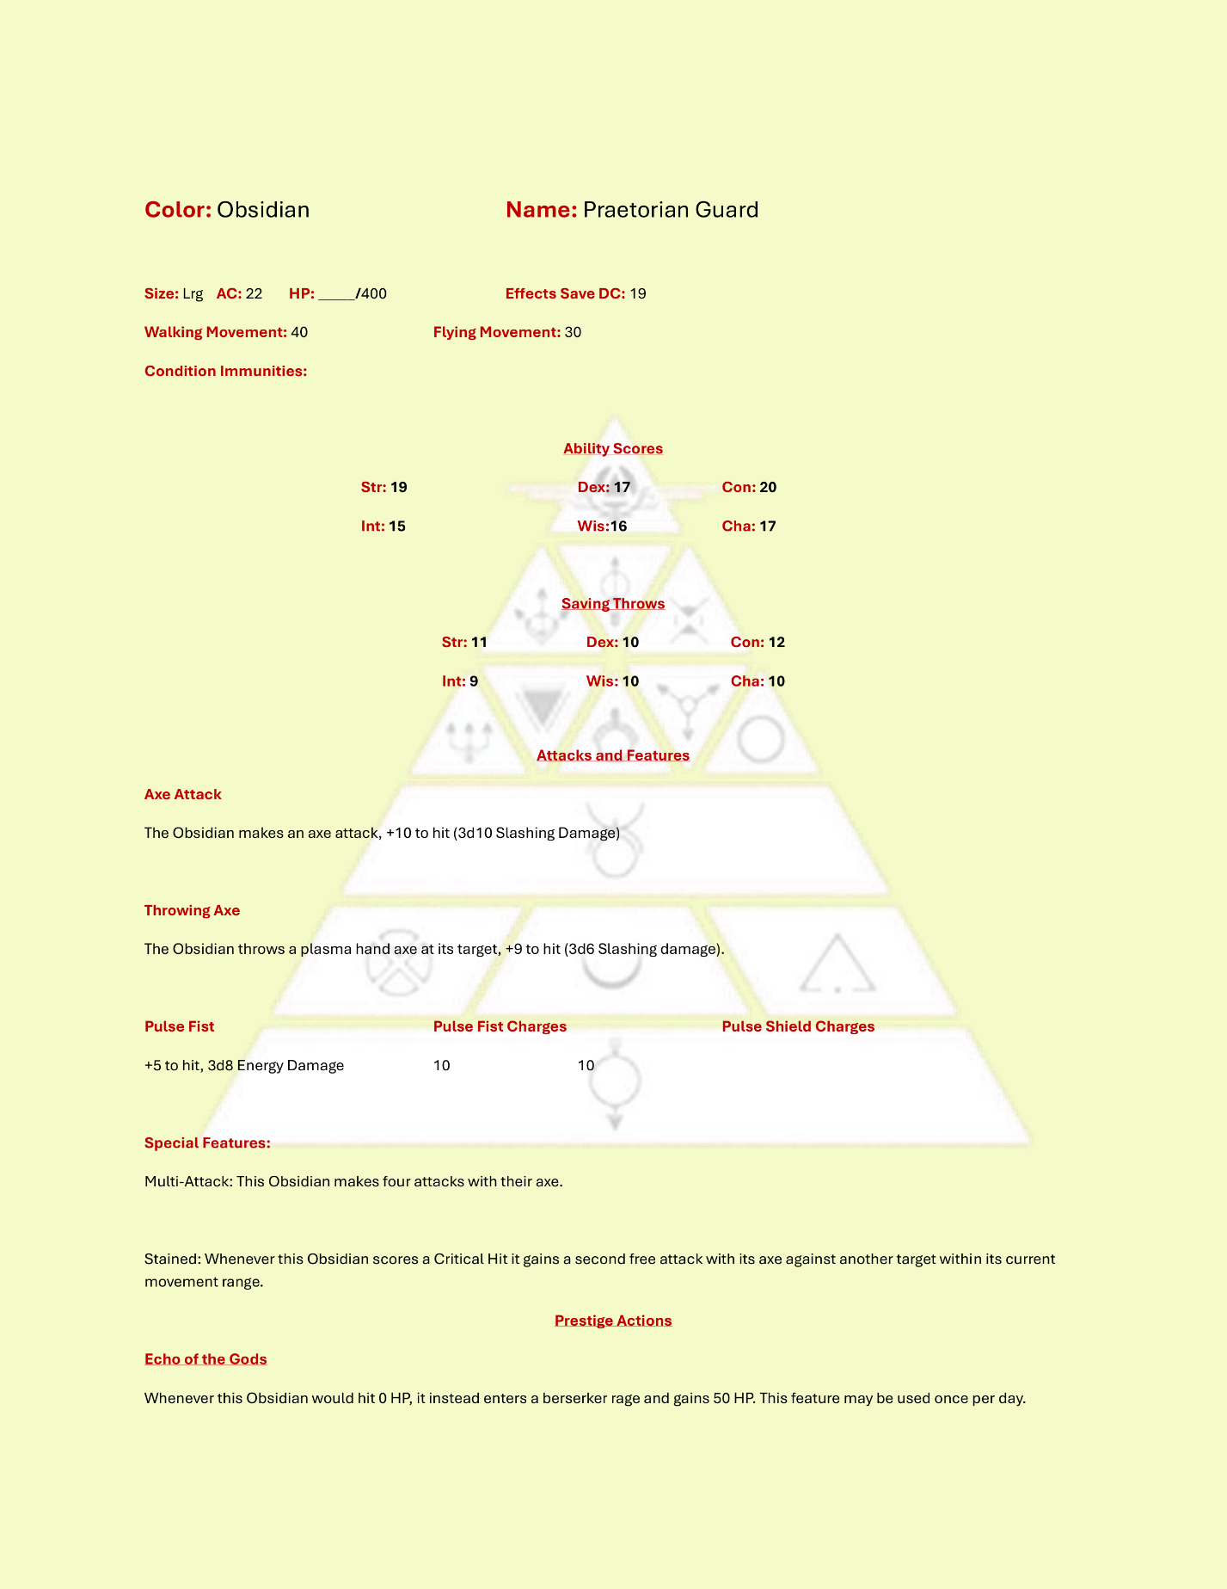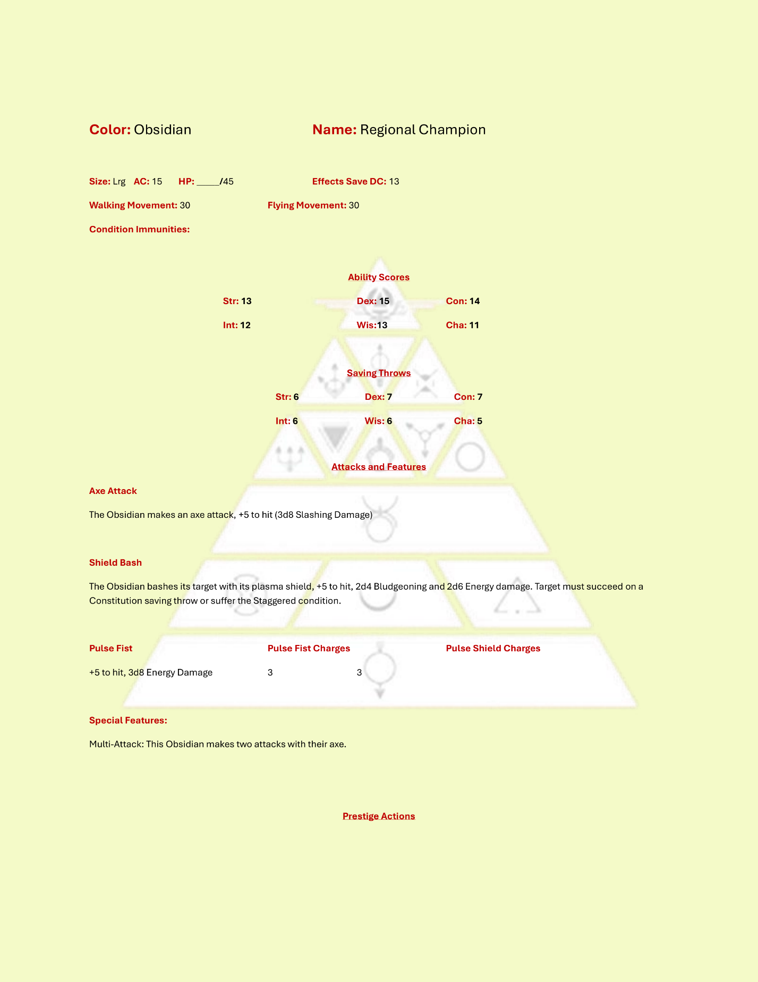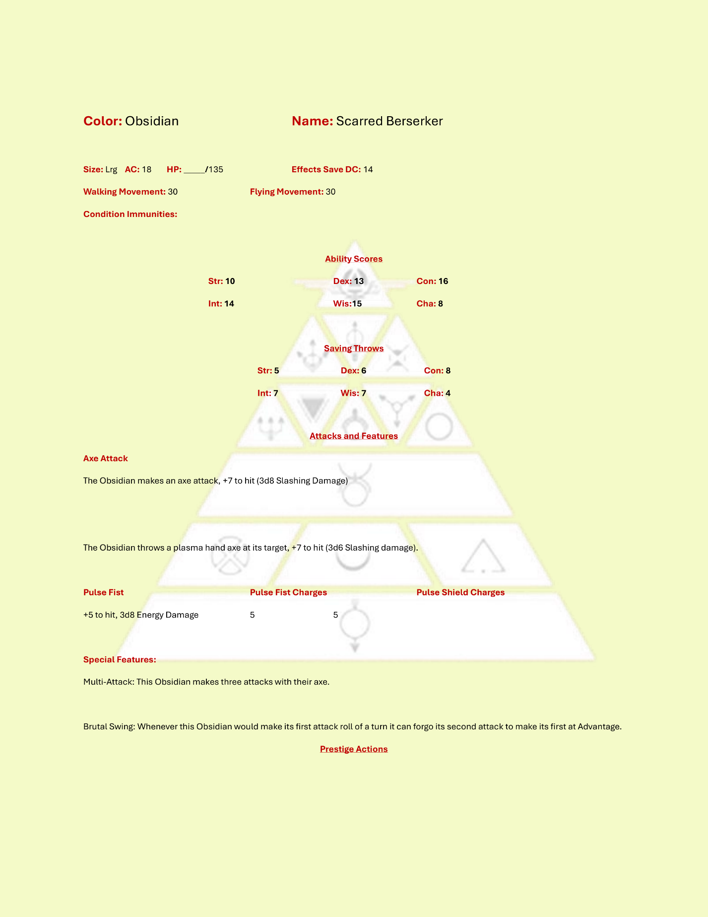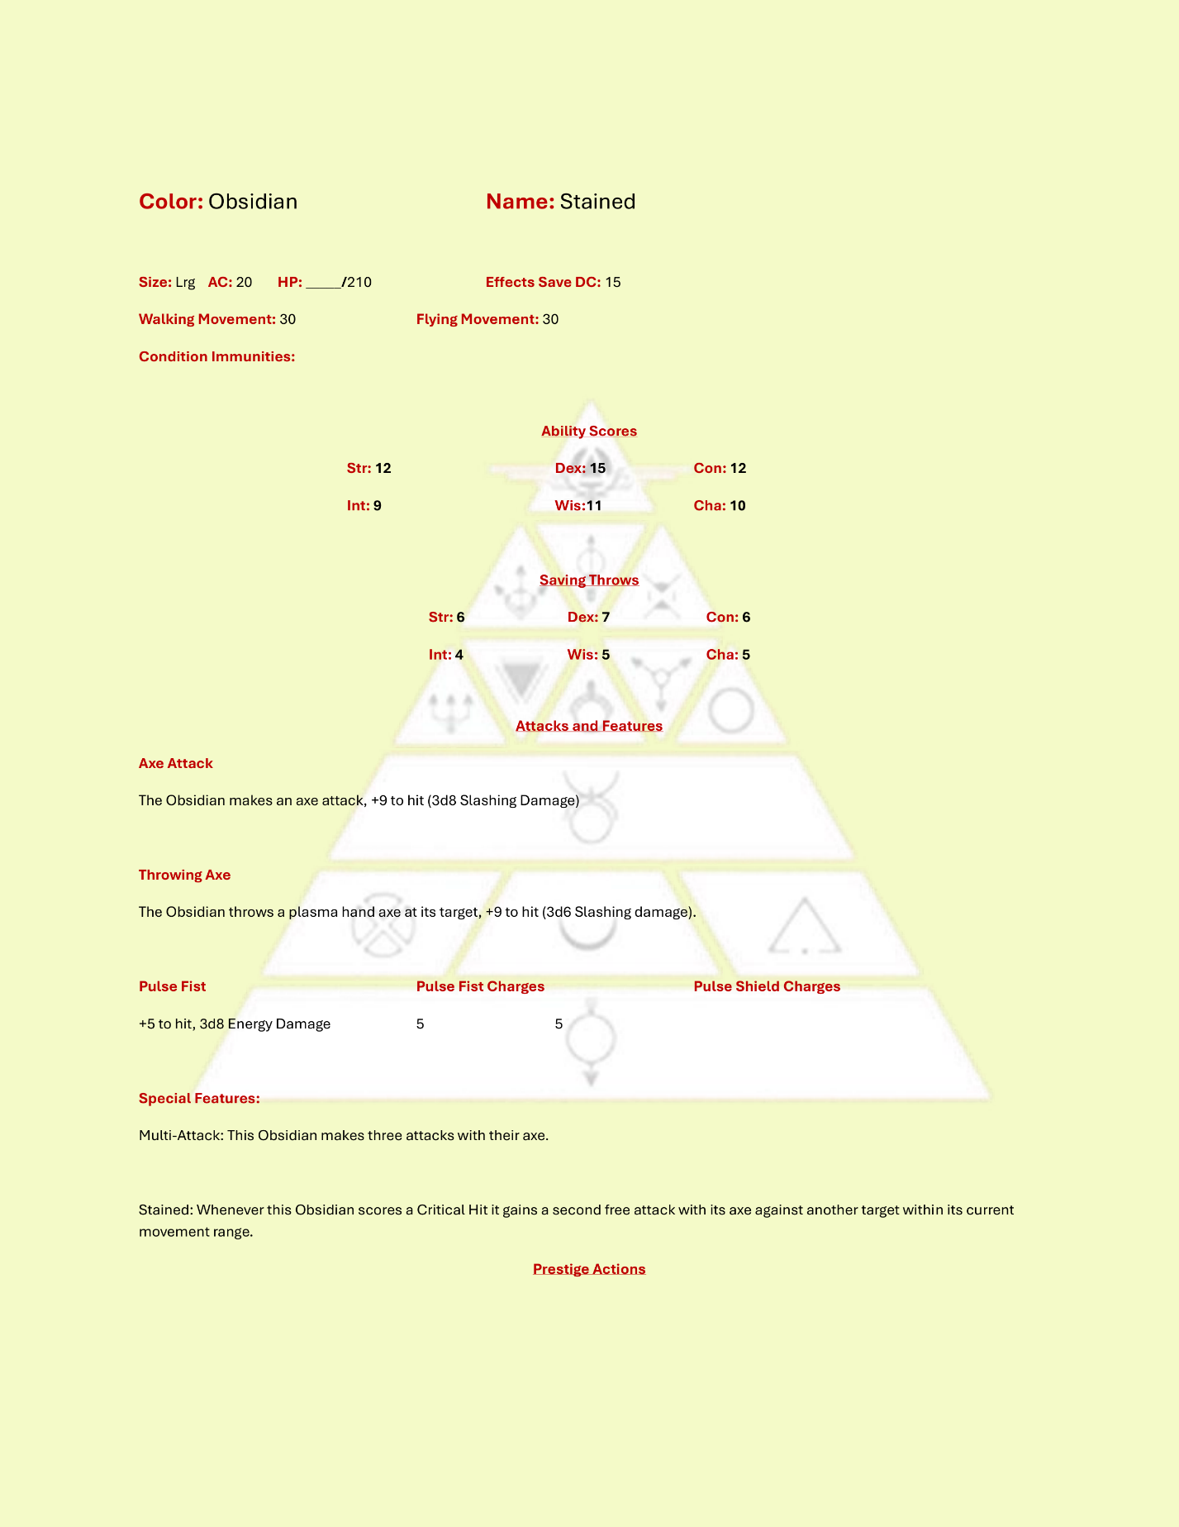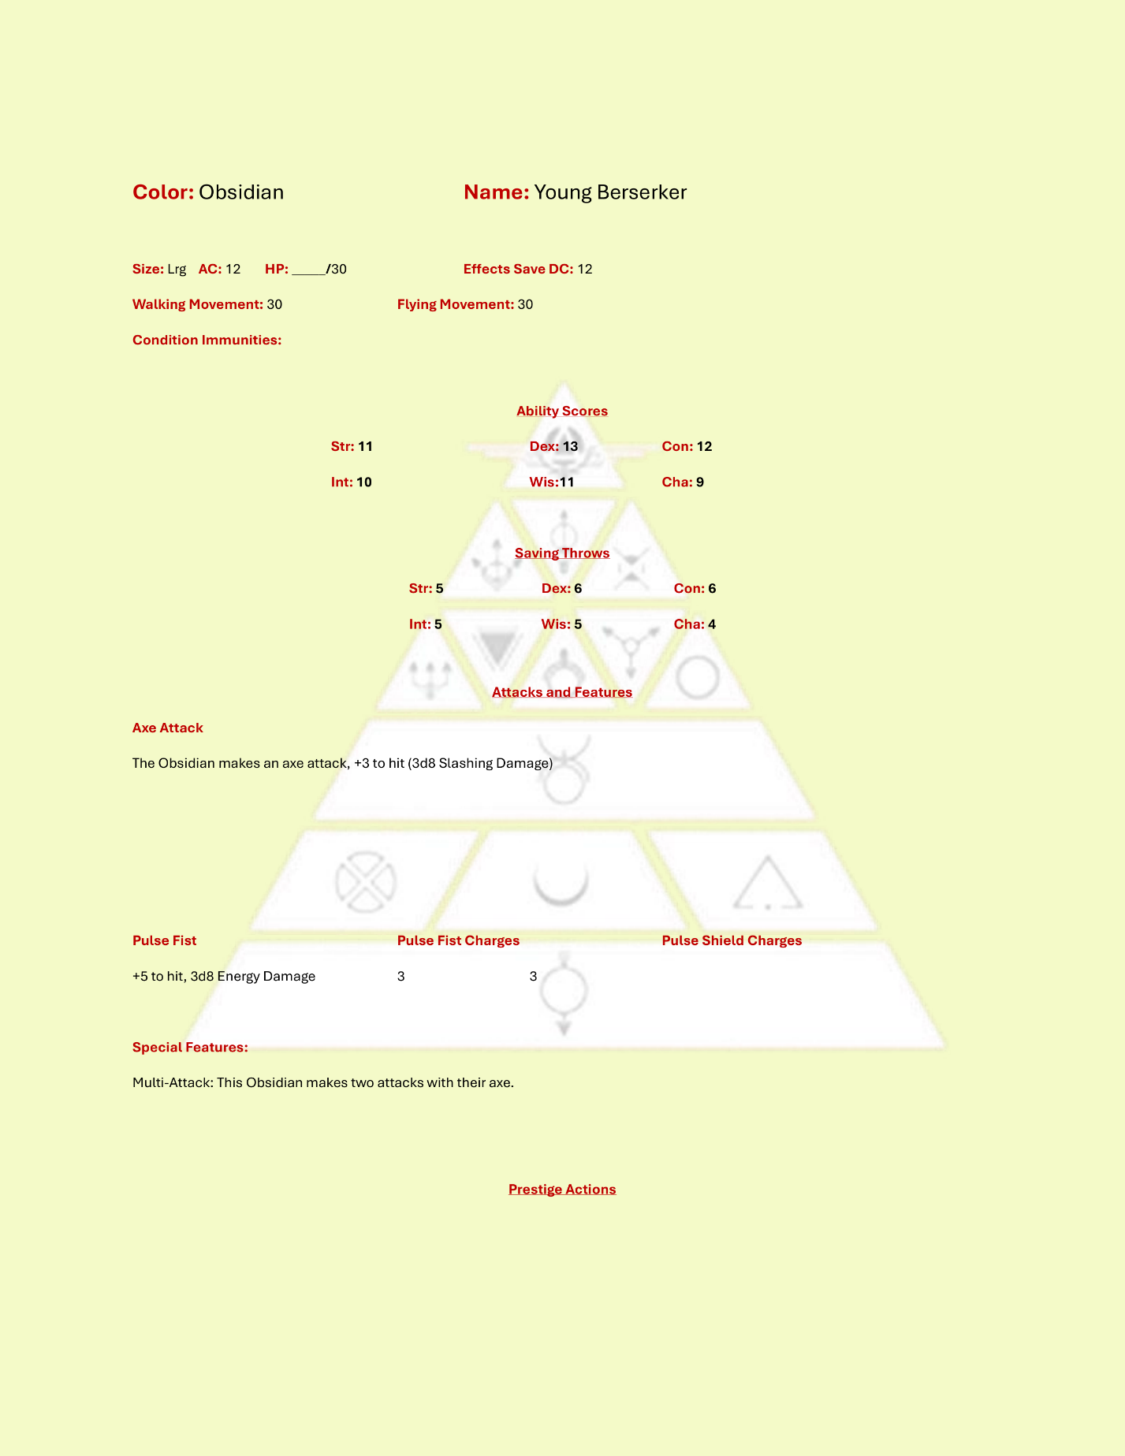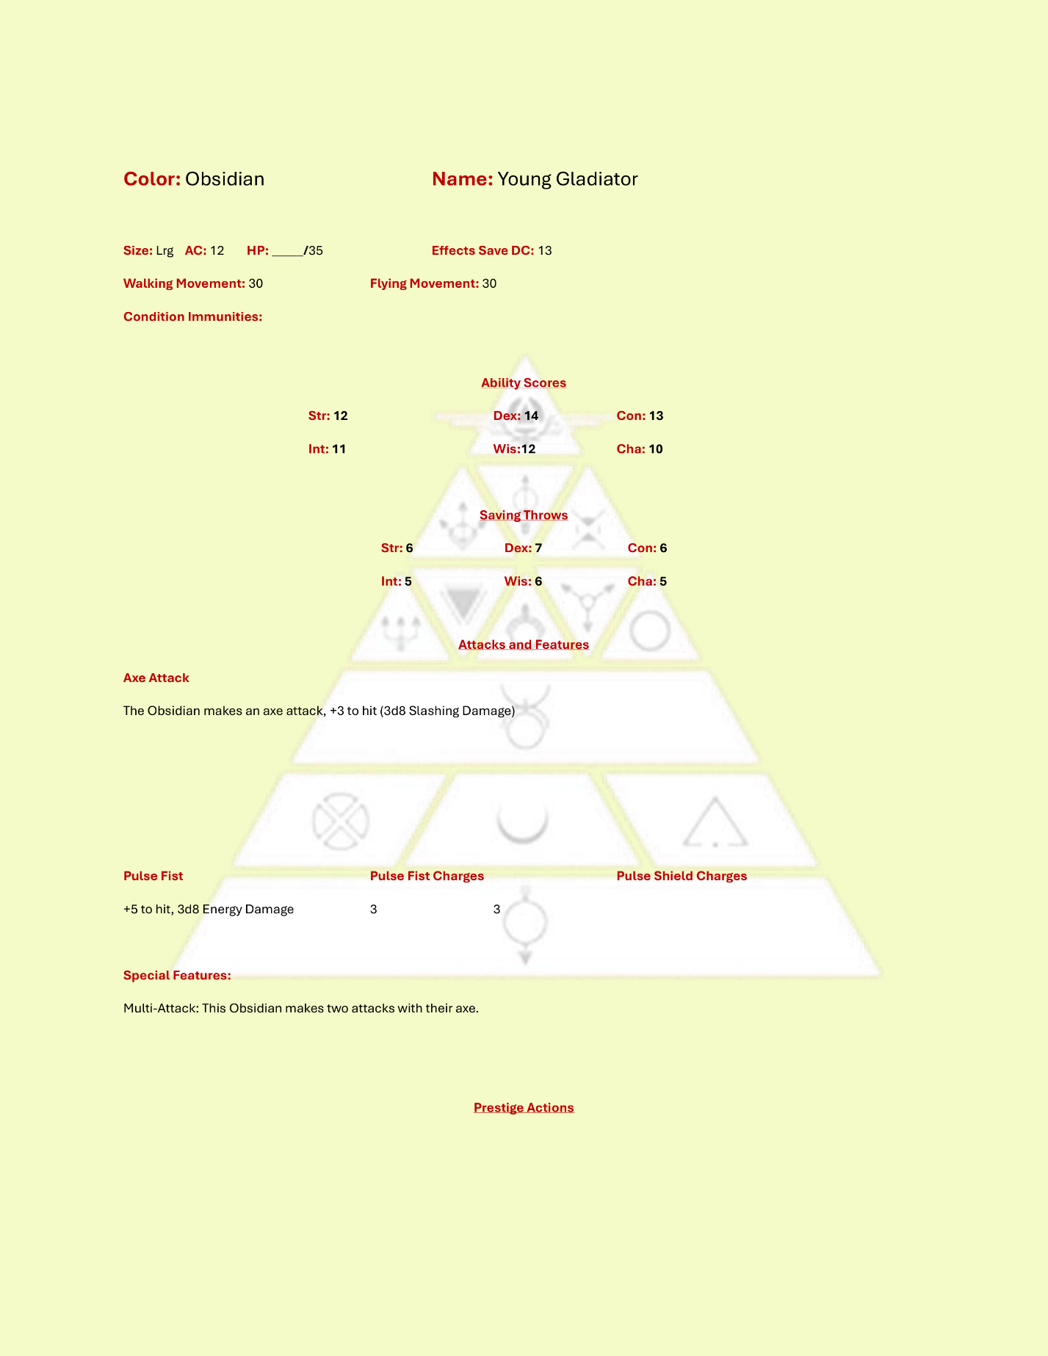

### Red

Reds are rare in the Society or Rim militaries, and if represented, they are often drugged or manipulated into serving as spies and terrorists. The Red Hand is a terror organization that believes the Republic is failing the Reds, and that all Golds must die. These elements allow red enemies to enter the game as possible saboteurs or suicide bombers in an otherwise low intensity setting or encounter.

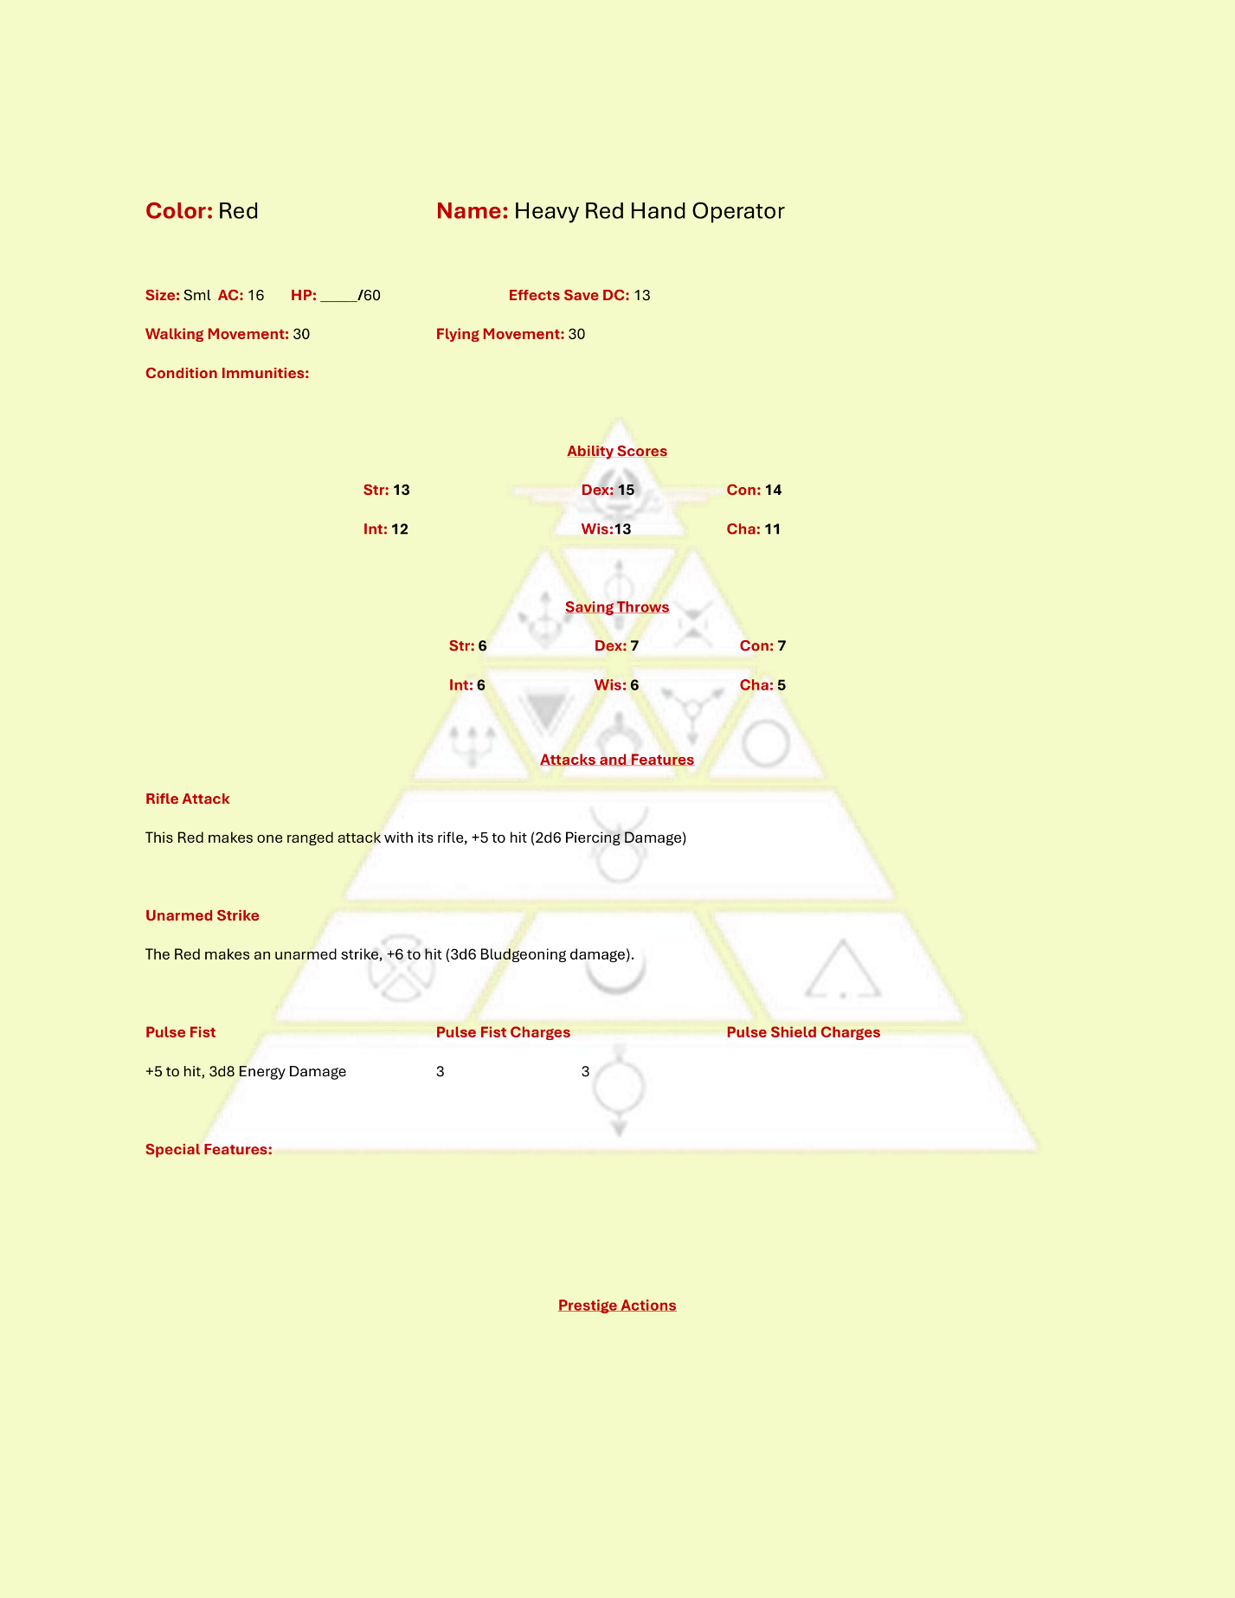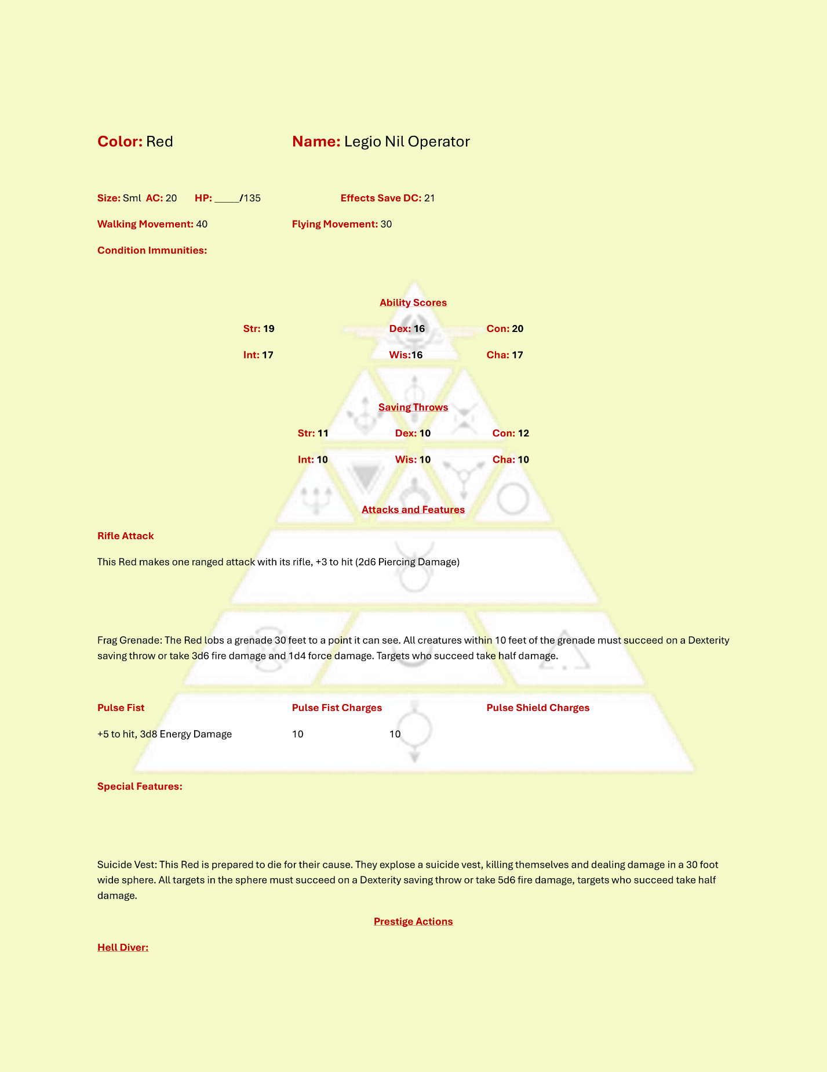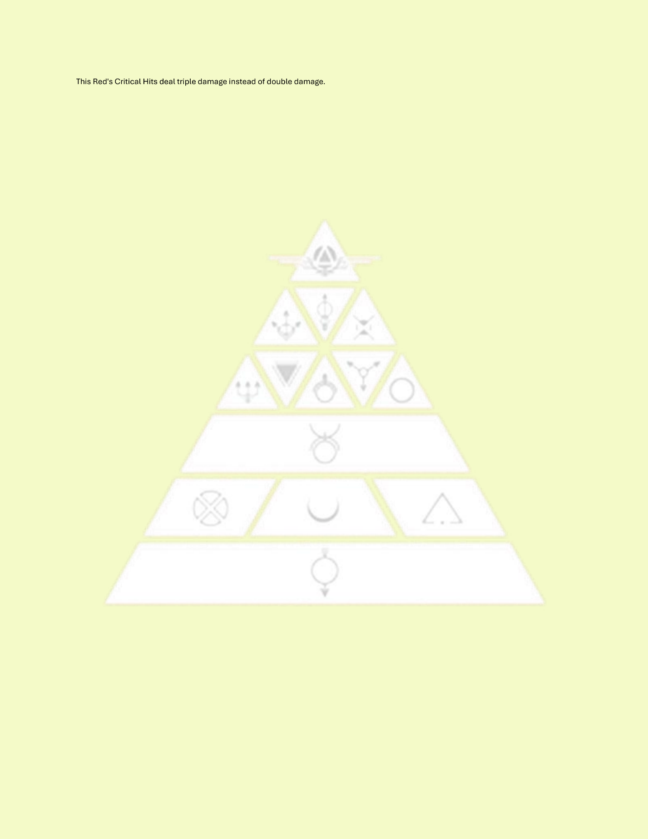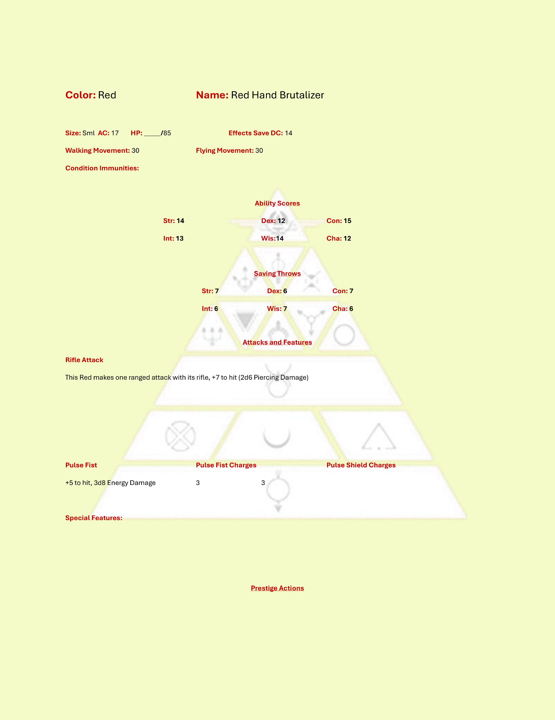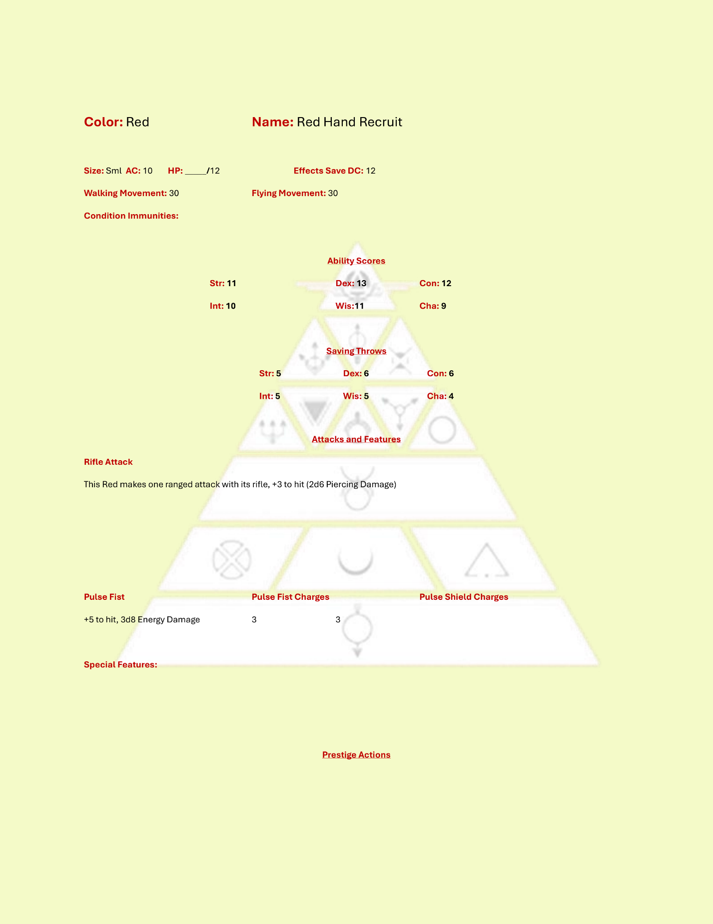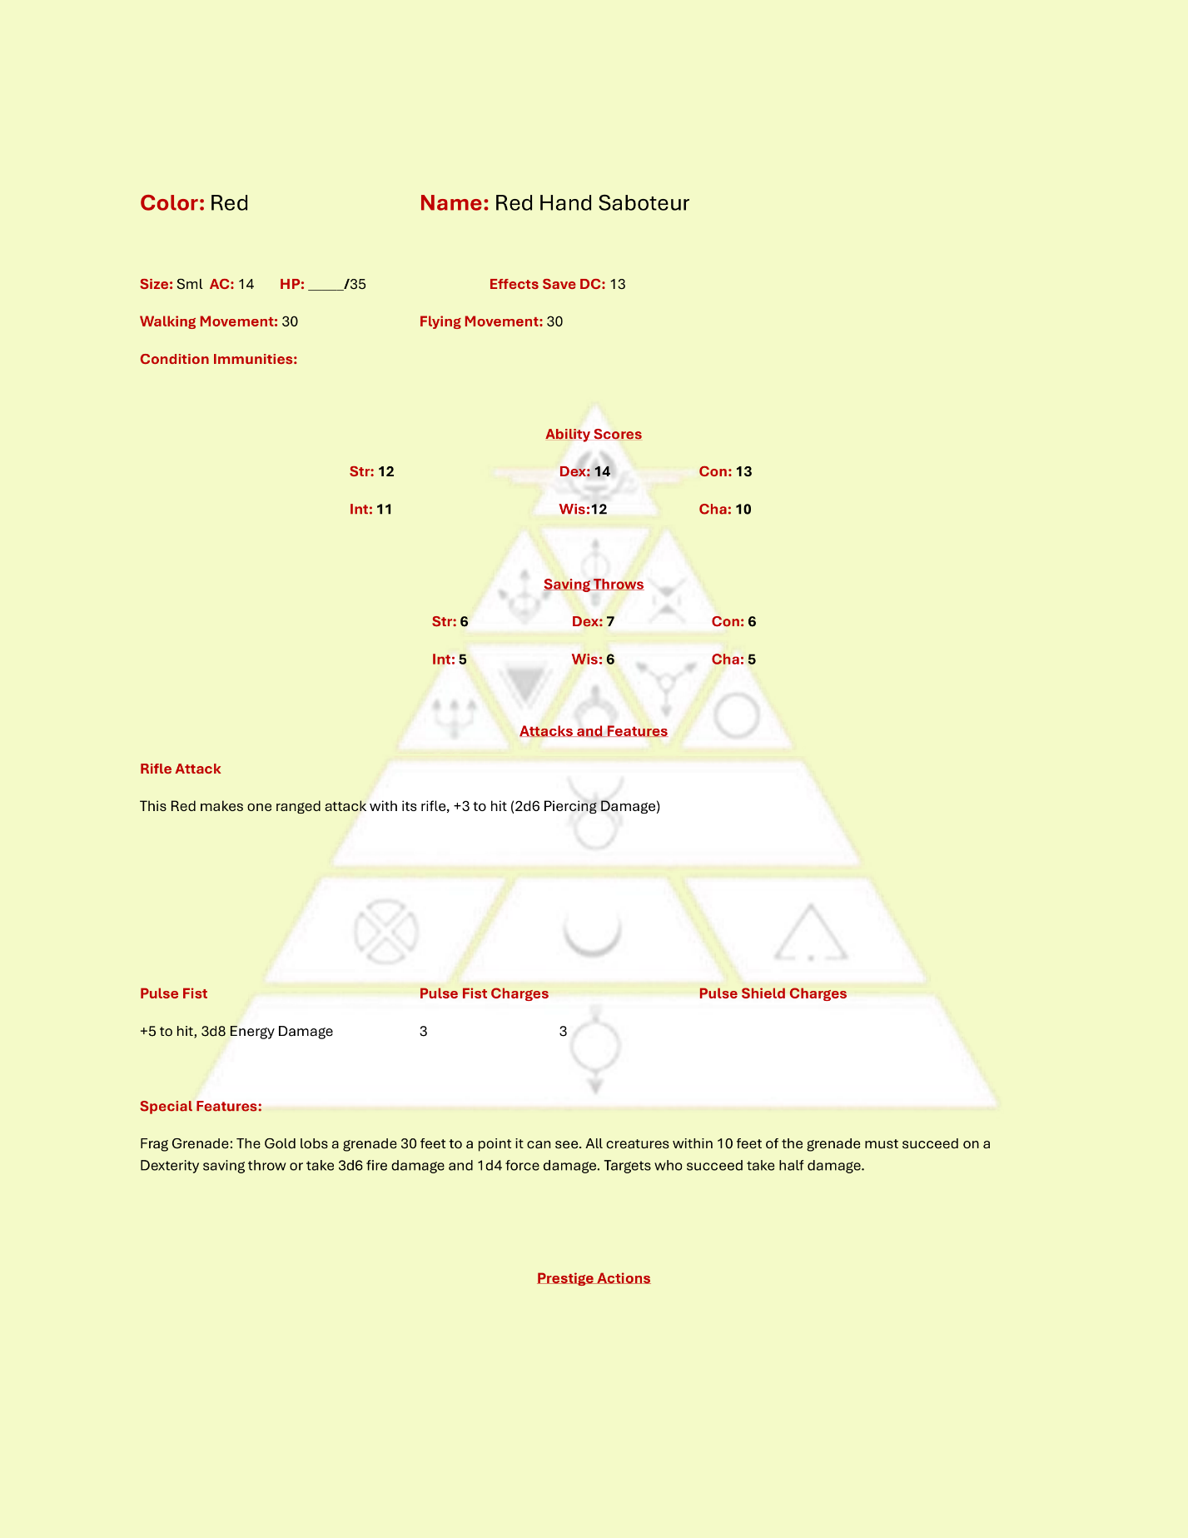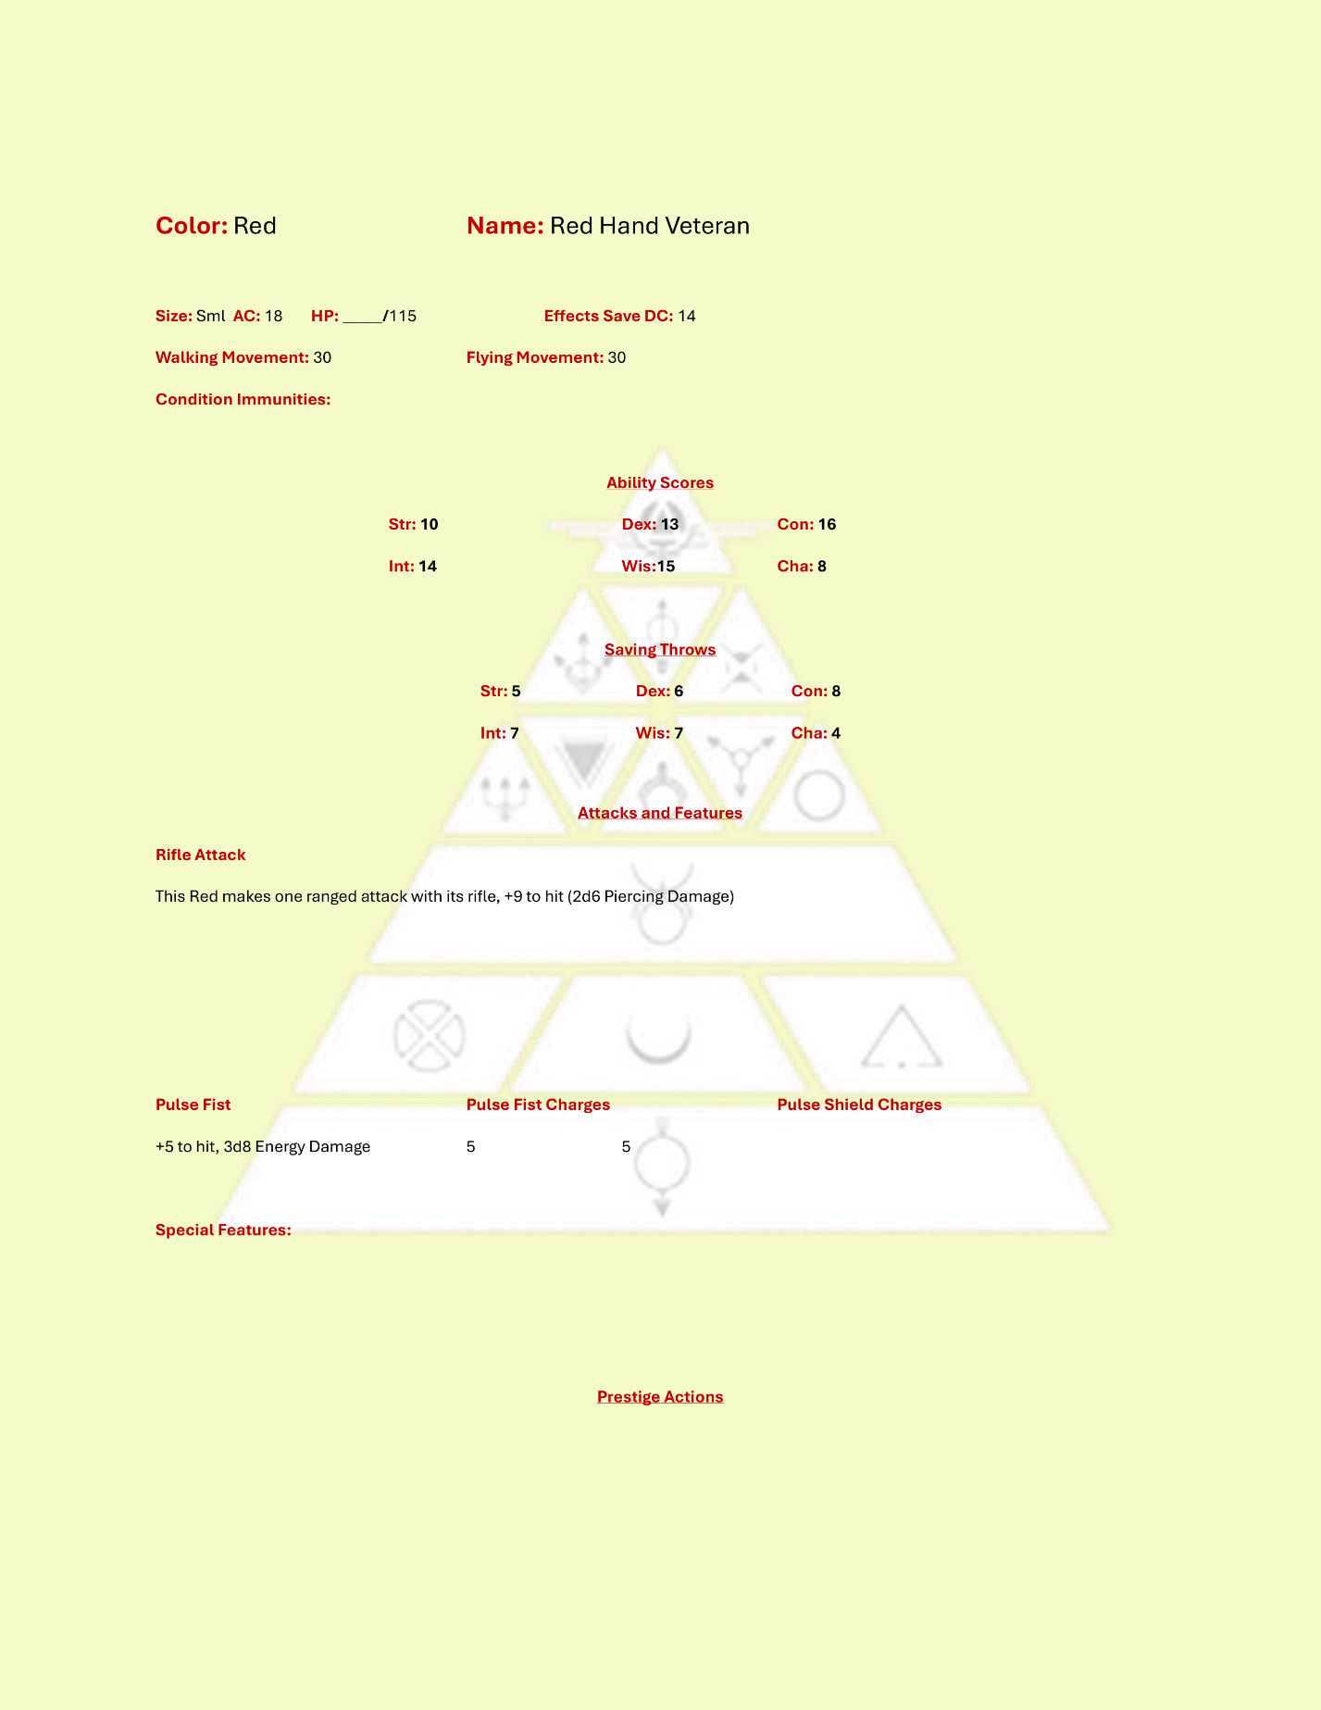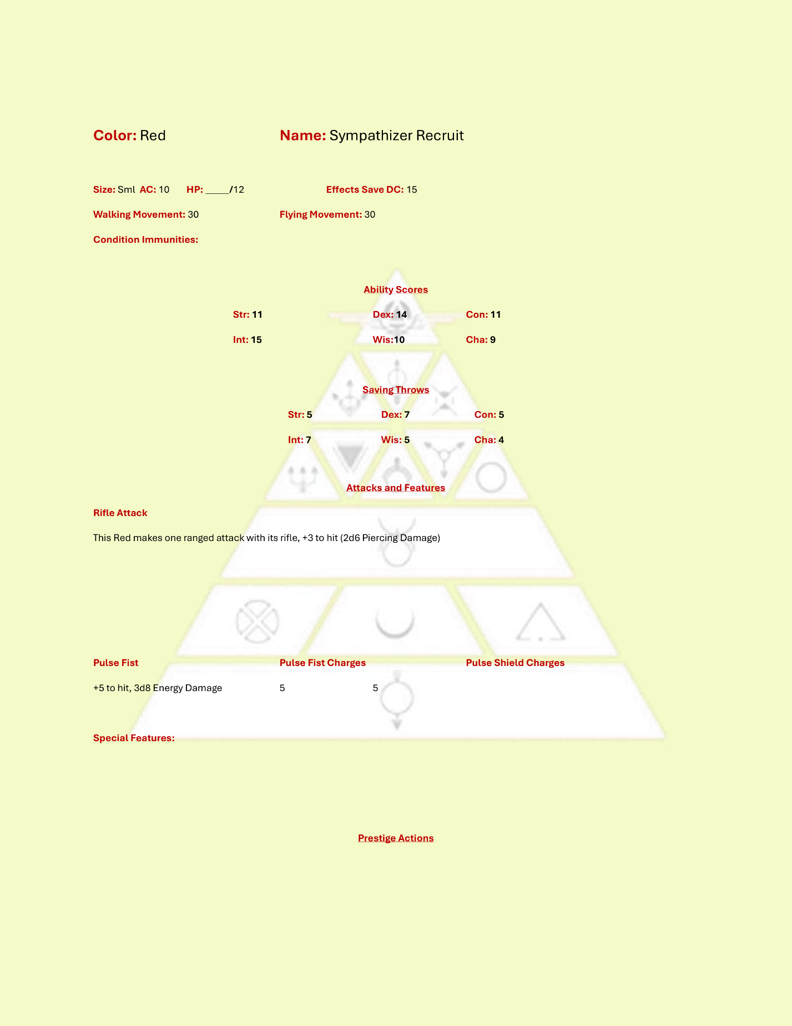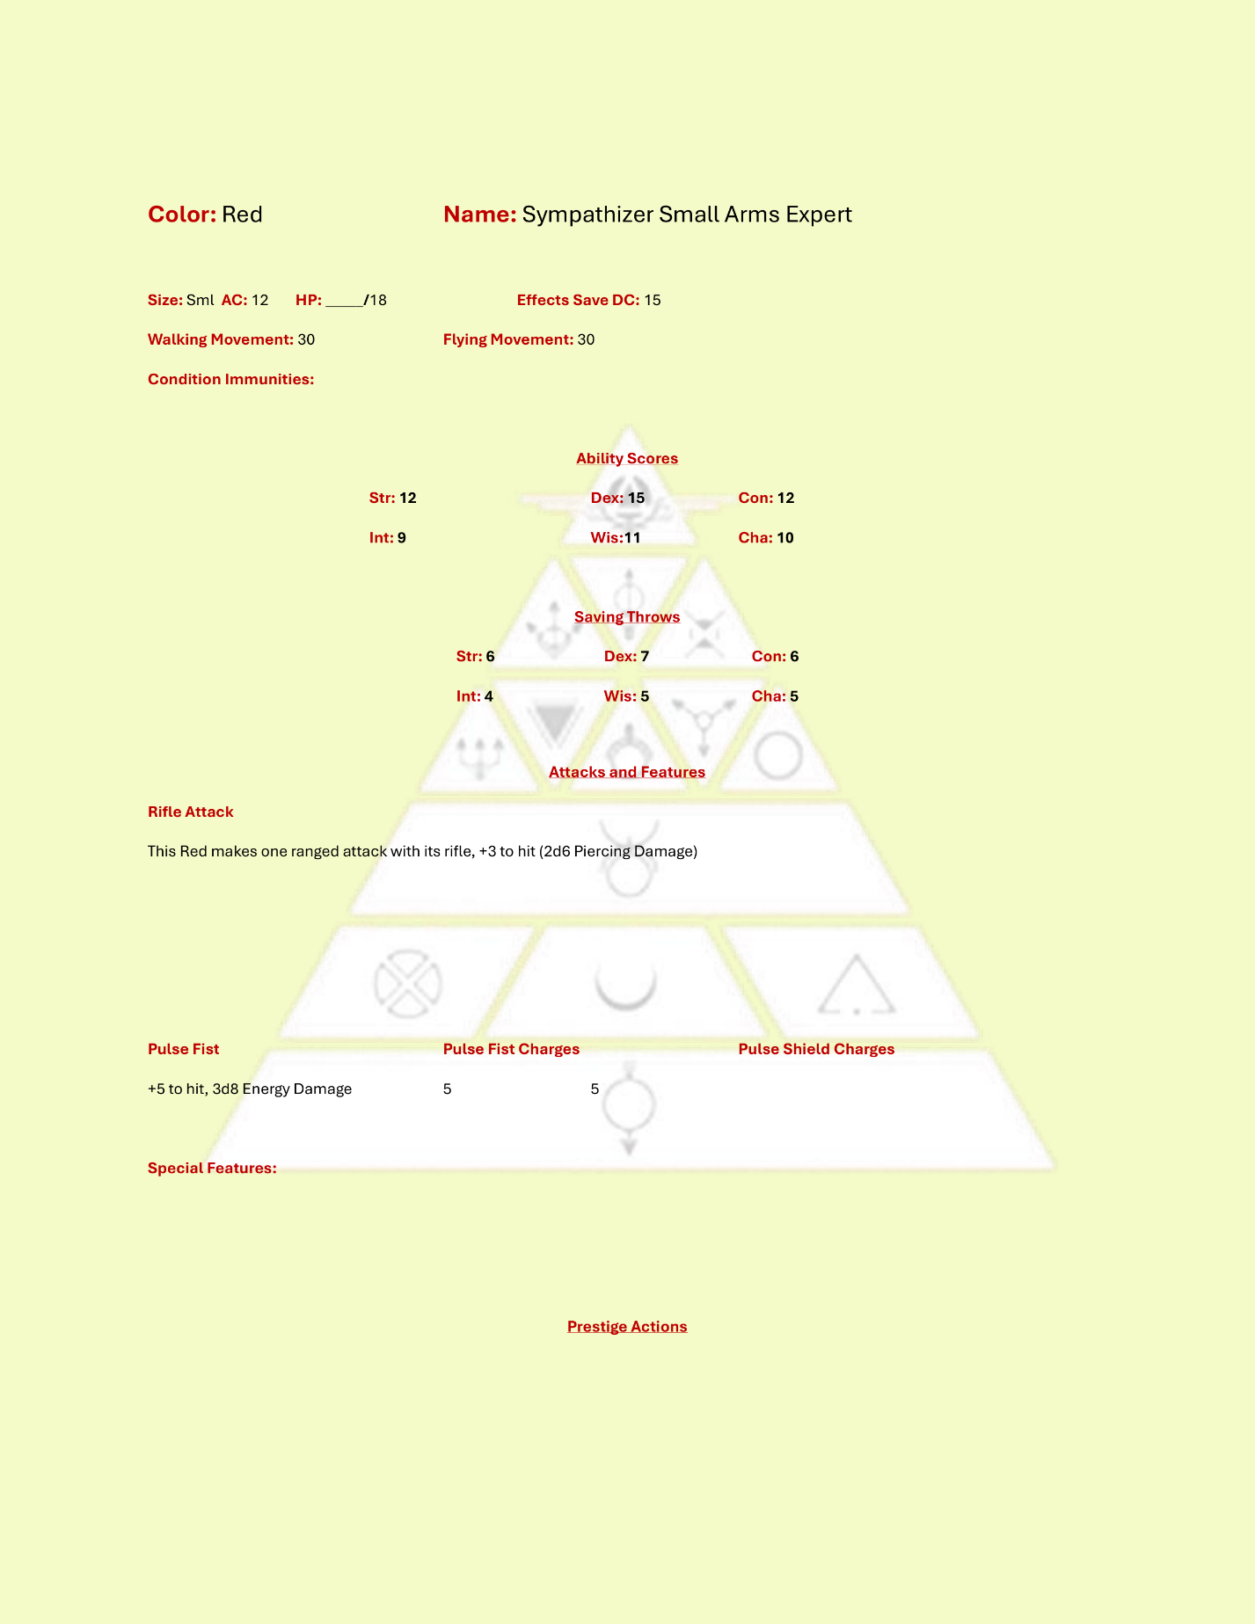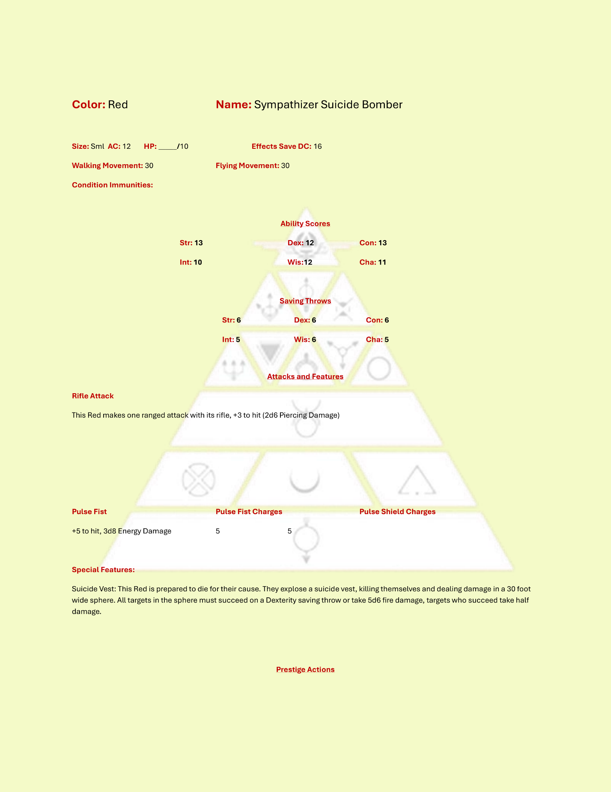

# Appendix XX: Gold Institute House Selection Table

The following table and criteria may be used to select Gold Institute houses for Gold PC backstory development.

|  |  |  |  |  |  |  |
| --- | --- | --- | --- | --- | --- | --- |
| ***House*** | **Charisma** | **Constitution** | **Dexterity** | **Intelligence** | **Strength** | **Wisdom** |
| **Apollo** | 14 | 10 | 14 | 12 | 10 | 12 |
| **Bacchus** | 16 | 14 | 12 | 8 | 12 | 8 |
| **Ceres** | 10 | 12 | 10 | 14 | 10 | 14 |
| **Diana** | 10 | 10 | 14 | 12 | 10 | 14 |
| **Juno** | 10 | 10 | 12 | 14 | 10 | 14 |
| **Jupiter** | 12 | 14 | 10 | 8 | 14 | 10 |
| **Mars** | 10 | 14 | 12 | 10 | 14 | 10 |
| **Mercury** | 10 | 10 | 16 | 12 | 10 | 12 |
| **Minerva** | 12 | 10 | 12 | 14 | 10 | 12 |
| **Neptune** | 10 | 14 | 12 | 10 | 12 | 10 |
| **Pluto** | 8 | 14 | 10 | 14 | 12 | 10 |
| **Venus** | 16 | 10 | 12 | 10 | 8 | 12 |
| **Vulcan** | 8 | 16 | 10 | 10 | 14 | 10 |